REGULAR MEETING

DECEMBER 19, 2024

The Regular Meeting of the Town Board of the Town of Hampton, County of Washington and the State of New York was held at the Town Hall, 2629 State Route 22A, Hampton, New York, on the 19th day of December 2024.

PRESENT: David K. O’Brien------------Supervisor

Donald Sady----------------- Councilman

Tamme Taran----------------Councilwoman

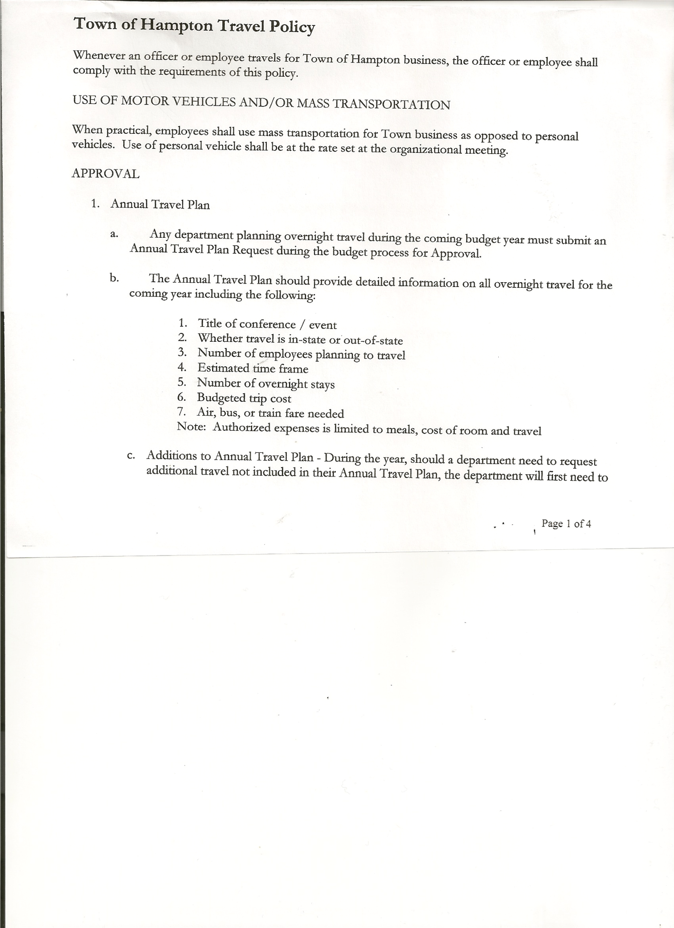 Michael Pietryka------------Councilman

Andrea Kugler---------------Councilwoman - absent

Rebecca Jones---------------Town Clerk

Camilla Shaw----------------Deputy Town Clerk

Tyler McClure---------------Highway Superintendent

Planning Board Member (s):… Bonnie Hawley, Chair; Matthew Pratt and Rene Rountree

Others present at the Town Hall: see attached sheet

The Regular Meeting was called to order by Supervisor O’Brien at 7:30pm, followed by the Pledge of Allegiance. Location of Fire Exits were given. Quorum of board members present.

Supervisor O’Brien asked for a moment of silence in memory of Joseph Panoushek (former member of the Planning Board)

**RESOLUTION NO. 108-2024**

**APPROVAL OF THE MINUTES**

On a motion of Councilman Sady, seconded by Councilwoman Taran, the following resolution was ADOPTED: AYES 4 O’Brien, Sady, Pietryka, Taran

NAYS 0

ABSENT 1 Kugler

RESOLVED, that the Regular Town Board Meeting Minutes for November 21st, 2024 are approved.

Dog Control Officer….no report

Tax Collector Report….Zero balance. The Town Clerk/Collector had Board Members review and sign bank reconciliation statements for the Tax Collector Account dated November 30th 2024.

Bonnie Hawley, Chair Planning Board….Planning Board Meeting was held December 11th, 2024, copy of the minutes is attached. Next meeting will be January 8, 2025 @7:00 at the Town Hall.

TOWN BOARD MEETING

DECEMBER 19, 2024 PAGE

Tyler McClure, Highway Superintendent…submitted his report, copy of which is attached. Following a discussion regarding the 2012 International, the following resolution was introduced:

**RESOLUTION NO. 109-2024**

**HIGHWAY – SALE OF 2012 DODGE**

On a motion of Councilman Sady, seconded by Councilman Pietryka, the following resolution was ADOPTED: AYES 4 O’Brien, Sady, Pietryka, Taran

NAYS 0

ABSENT 1 Kugler

RESOLVED, to place a legal ad in the NYVT Media Newspapers for the sale of a 2012 Dodge Model 3500 1-ton Flatbed Dump. (Copy of Legal Ad is attached)

**SUPERVISOR’S REPORT/COUNTY UPDATES/COMMUNICATIONS**

**RESOLUTION NO. 110-2024**

**APPROVAL OF SUPERVISOR’S MONTHLY REPORT**

On a motion of Councilman Sady, seconded by Councilwoman Taran, the following resolution was ADOPTED: AYES 4 O’Brien, Sady, Pietryka, Taran

NAYS 0

ABSENT 1 Kugler

RESOLVED that, the Supervisor’s Monthlyreport be accepted as submitted for **NOVEMBER**

ACCOUNT 11/01/24 Receipts Disbursed 11/30/24

Citizens Cemetery $ 3,028.59 $ .12 $ .00 $ 3,028.71

Citizens Total $ 3,028.59 $ .12 $ .00 $ 3,028.71

GFNB Fire, Trust & Agency $ 1,418.04 $ $ 0.00 $ 1,418.04

GFNB Fire, Trust & Agency ICS $ 33,805.00 $ $ $ 33,805.00

GFNB Health Insurance $ 2,591.23 $ $ $ 2,591.23

GFNB Trust & Agency $ 7,752.55 $ 4,332.88 $ 4,359.53 $ 7,725.90

GFNB General Fund $ 4,328.69 $13,494.81 $ 5,853.20 $ 11,970.30

GFNB General Fund ICS $ 52,682.59 $ 422.47 $ 5,000.00 $ 48,105.06

GFNB Total $102,578.10 $18,250.16 $ 15,212.73 $105,615.53

GFNB Highway Fund $ 10,769.41 $ 21,203.07 $ 15,945.00 $ 16,027.48

GFNB Highway Fund ICS $ 118,916.10 $ 510.73 $ 20,404.16 $ 99,022.67

GFNB Capital Reserve $ 1,005.02 $ 87,085.00 $ $ 88,090.02

GFNB Capital Reserve ICS $ 153,126.00 $ 342.39 $ 87,085.00 $ 66,383.39

GFNB Total $ 283,816.53 $109,141.19 $ 123,434.16 $269,523.56

TOTALS $389,423.22 $127,391.47 $138,646.89 $378,167.80

All Board Members present signed Supervisor’s Report.

TOWN BOARD MEETING

DECEMBER 19, 2024 PAGE 3

**NEW BUSINESS**

* Miscellaneous Info….consider raising mileage
* Highway Info….consider redoing vacation time

**Annual Audits:** Councilman Pietryka & Councilman Sady---Budget Officer

Councilwoman Kugler & Councilwoman Taran—Town Clerk & Tax Collector

Supervisor O’Brien---Judge

**RESOLUTION NO. 111-2024**

**AUDIT OF CLAIMS**

On a motion of Councilwoman Taran, seconded by Councilman Sady the following resolution was ADOPTED: AYES 4 O’Brien, Sady, Pietryka, Taran

NAYS 0

ABSENT 1 Kugler

RESOLVED that the bills have been reviewed by the Town Board and are authorized for payment in the following amounts.

General Fund No. 129 through No 145 $ 37,348.20

Highway Fund No. 166 through No.165 $ 7,634.62

Total both funds $ 44,982.82

The Town Clerk’s report for November 2024 was submitted to the Board. The Town Clerk had Board Members review and sign bank reconciliation statements for the Town Clerk Account and Special Town Clerk Account dated November 30th, 2024.

**RESOLUTION NO. 112-2024**

**MEETING ADJOURNED**

On a motion of Councilwoman Taran, seconded by Councilman Sady the following resolution was ADOPTED: AYES 4 O’Brien, Sady, Pietryka, Taran

NAYS 0

ABSENT 1 Kugler

RESOLVED that the meeting adjourned at 8:09pm.

Respectfully submitted,

Rebecca S. Jones, RMC

Town Clerk