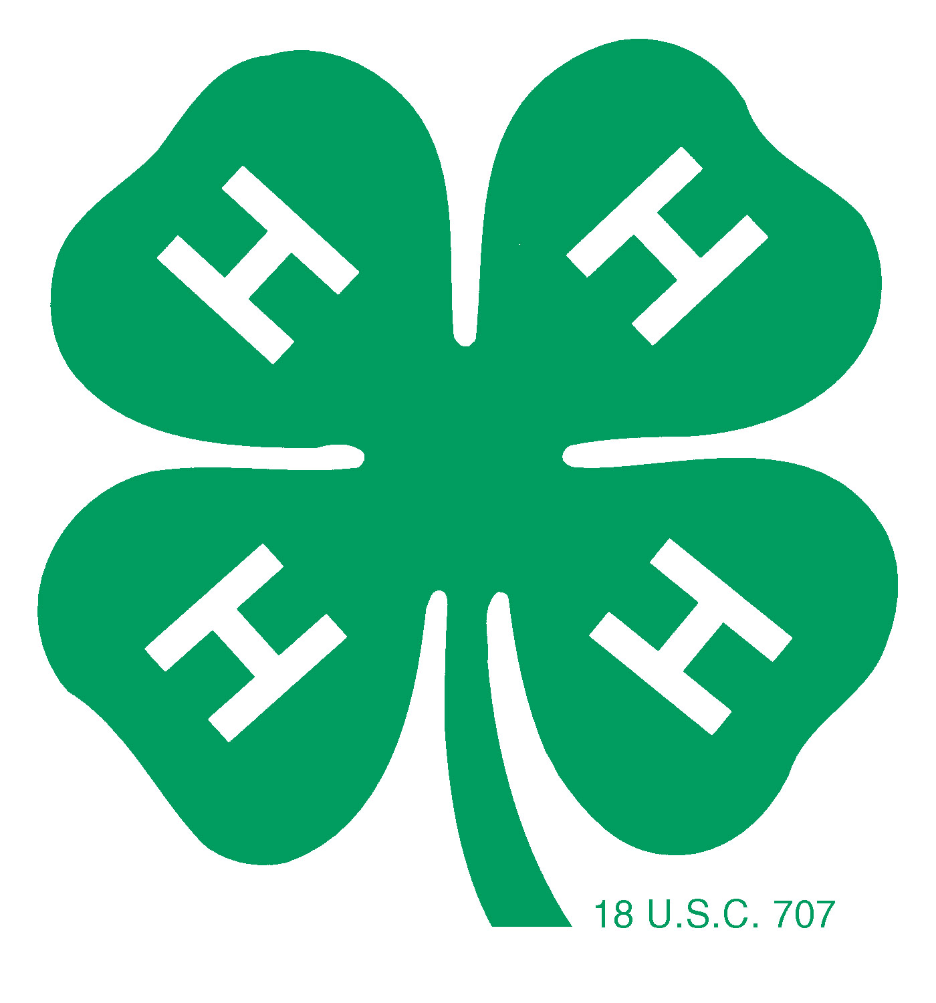

***with all proceeds to benefit***

**Operation Christmas Child**

**A community service project of**

**Meade County 4-Hers**

**5K Fun Run**

# Date of Race: Sunday, November 3, 2019

**Time: Race beginning at 3:00pm at the Meade City Park**

## Late registration & check-in beginning at 2:00pm at the city park Pre-registration accepted until October 27, 2019

Pre-registration donation is $20 and includes event t-shirt.

**Registrations will be taken up to race time for an additional $5 donation.**

Late registrations will be mailed an event t-shirt.

There is an SWFTR member discount of $2.

Silent Runner: $10 Donation (Don’t want to run? This donation gets you a t-shirt!)

$10 Entry Fee for children 12 and under.

**Hibbett Gift Cards for 1st, 2nd, and 3rd place Male & Female Runners. Medals awarded for individual age groups.**

Make Checks payable to: **Operation Christmas Child**

Questions? Call Tamra Clawson 620-482-3305 or [tamra@clawsonranch.com](mailto:tamra@clawsonranch.com)

## Mail form & fee to: Tamra Clawson 15011 P Road Meade, KS 67864

## Name: Address: Male: Female: Age: T-shirt Size:

## Phone: E-­‐mail:­­­­­­

## I know that running/walking in a race is a potentially hazardous activity. I represent that I am medically able and properly trained to participate in this event. I assume all risks associated with this event including, but not limited to, heat exhaustion, falls, contact with other participants, effects of weather, hazardous conditions, etc, all such risks being known and recognized by me. I hereby agree for myself and my heirs, executors, and administrators, to waive, release, and forever discharge Meade County 4-­‐H, Share the Bounty, and Numana, and their representatives and volunteers, sponsors, and any other personnel associated with this event, any rights, claims, or demands therefore which I may have or which I may hereafter accrue to me arising out of injury to my person or my property incurred in connection with participation in the 5K Fun Run held by the Meade County 4-Hers in Meade, KS, on November 3, 2019.

## Signature of Participant: Signature of Parent /Guardian (if under 18): Date:

## Run~Wrap~Rejoice