May 2023
Sunday  Kathie | Monday  Breanna | Tuesday  Mauricio | Wednesday  Courtney | Thursday  Amber | Friday  Honor | Saturday  Tanya
April 30 | 1. | 2. | 3. | 4. | 5. | 6.
LCSNW will send out an introduction posting and include all agencies who are participating. | Welcome to Mindfulness Mondays all May! So… What is mindfulness? Watch this video and find out! Mindfulness Animated in 3 minutes - YouTube | If you're facing a major illness or stressful life change, you don't have to go it alone. There are many support services and treatment options that may help.  NAMI Tri-Cities offers the NAMI Family-to-Family Education Program free of charge. Classes will be held each Saturday for 4 consecutive weeks; April 29th, May 6th, May 13th, and May 20th, 10 am – 3pm. Meetings will be at Lourdes Counseling Center Conference Room, 1175 Carondelet Drive, Richland WA. Lunch is provided. Register at: namitricities@gmail.com | Did you know? The National Suicide & Crisis Lifeline can now be reached by dialing or texting 988! This national network of local crisis centers provides free and confidential emotional support to people in suicidal crisis or emotional distress 24/7.  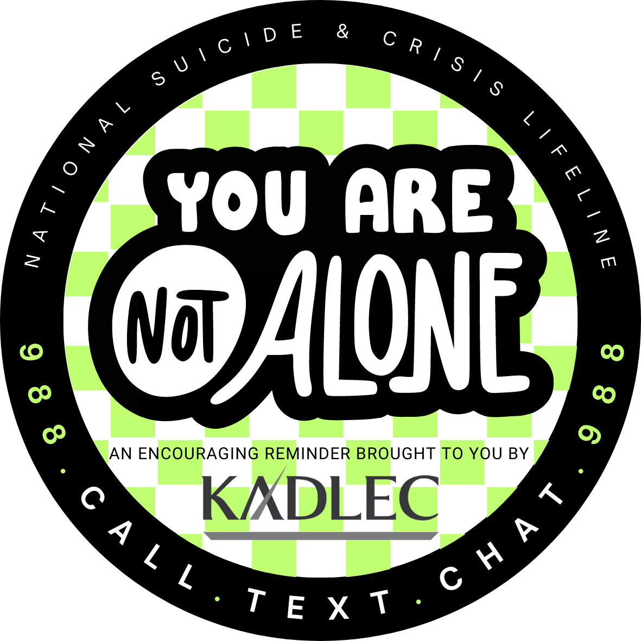 | Cyberbullying - Resources for Parents using this guide: What Is Cyberbullying | StopBullying.gov | Mental Health Shirt Friday!  Everyone feels stressed from time to time. Stress can give you a rush of energy when it’s needed most. But if stress lasts a long time- a condition known as chronic stress- those “high alert” changes become harmful rather than helpful. Learning healthy ways to cope with stress can also boost your resilience.  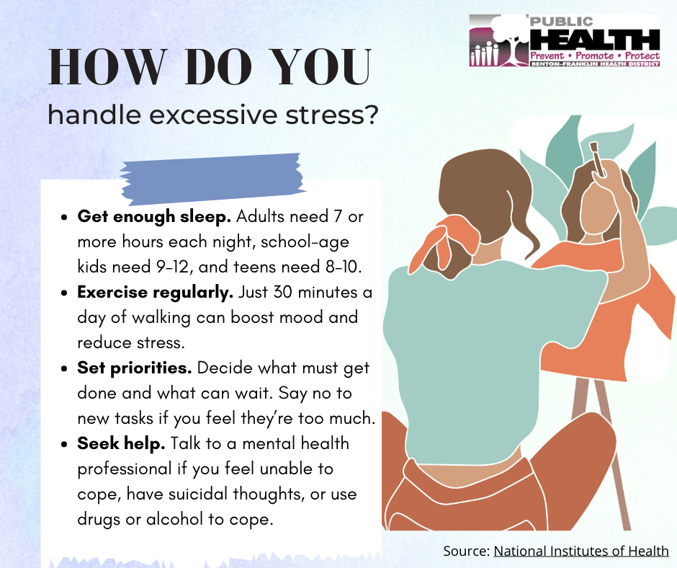 | Studies show that spending quality time in the great outdoors reduces stress, calms anxiety, and can lead to a lower risk of depression. Get outside, go for a walk, a hike, a bike ride, or simply sit outside!
7. Track gratitude & achievement with a journal, include  3 things you are grateful for and 3 things you want to accomplish each day | 8.  Breath-Counting Mindfulness Practice for teens and tweens: Go to https://ggie.berkeley.edu/practice/breath-counting-mindfulness-practice-for-tweens-and-teens/#tab__2 | 9.  When a family member is drinking too much, using drugs, or struggling with a mental disorder, your support can be key to getting them the treatment they need. Starting the conversation is the first step to getting help. If you’re unsure how to broach the subject, try these conversation starters.  SAMHSA Families Conversation Guide  SAMHSA Families Family Support Guide | 10.  Sometimes the person who has always been there for everyone else needs someone to be there for them. Thank you for all you do to make a difference in our community! The world is better with you in it!  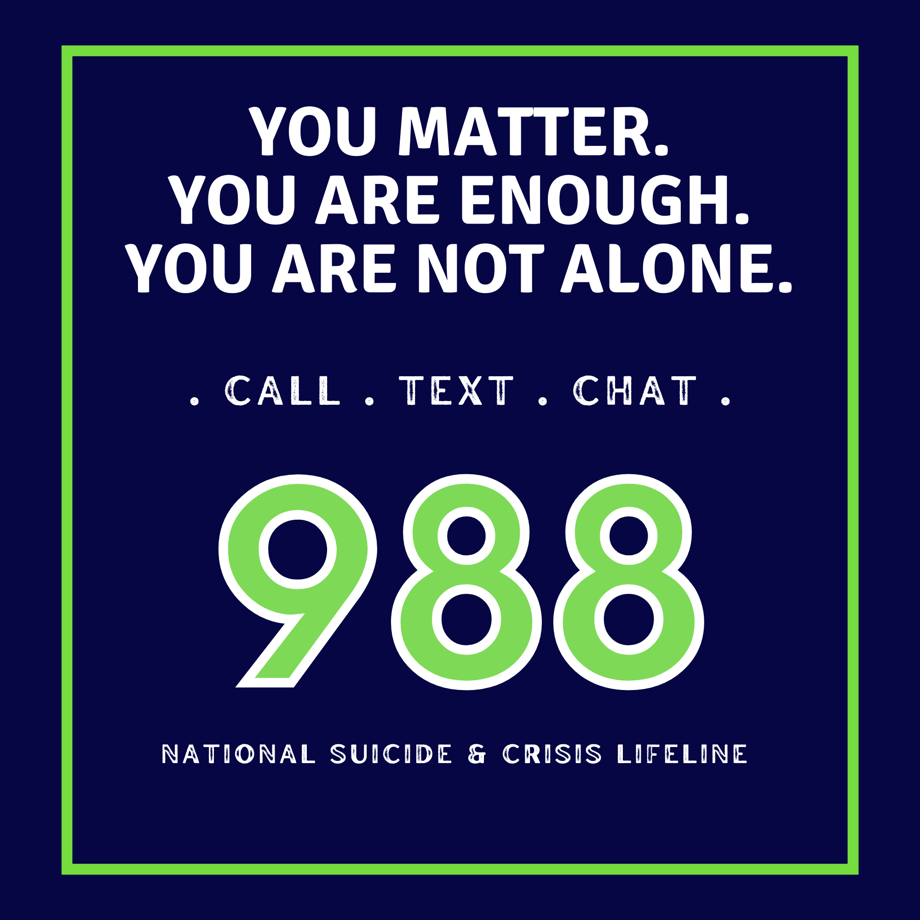 | 11.  Cultural Stigmas - How cultural stigma impacts those seeking mental health services (choc.org)  Psychiatry.org - Stigma, Prejudice and Discrimination Against People with Mental Illness | 12.  People who are emotionally well, experts say, have fewer negative emotions and are able to bounce back from difficulties faster. This quality is called resilience. Learning healthy ways to cope and how to draw from resources in your community can help you build resilience.  Mental Health Shirt Friday!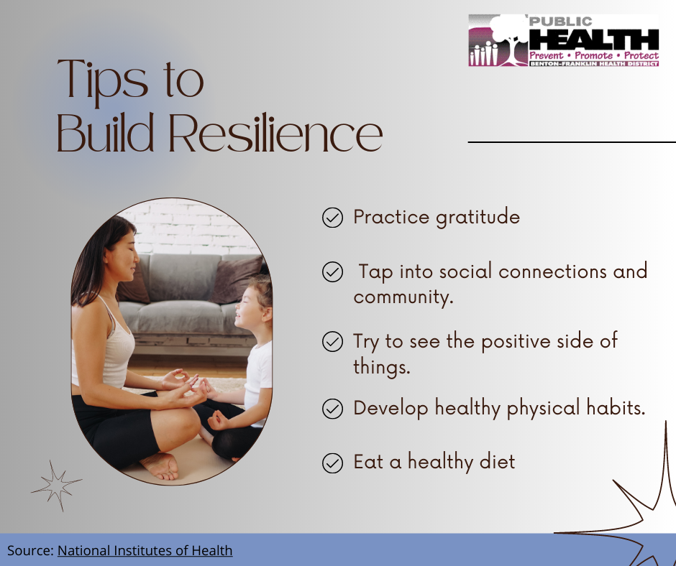 | 13.Meditation can give you a sense of calm, peace and balance that can benefit your emotional well-being and your overall health. Set aside 10 minutes each day, and enjoy the benefits!
 |  |  |  |  |  | 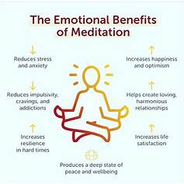
14. “You don’t have to see the whole staircase, just take the first step” Martin Luther King, Jr.  Think of something in your life you want to improve and figure out what you can do to take a step in the right direction. | 15.Mindfulness for Adults | 16.Talking about mental health issues often makes people uncomfortable. But mental illness can affect anyone, of any gender and race, at any time in life. And mental health disorders are treatable. The more people talk about these conditions, the easier the conversations will become. Watch this video and find out!  https://youtu.be/3pF5HjJvi-4?t=17 Start conversations about mental health. | 17.  Work2BeWell, a Providence initiative, is a mental health and wellness program focused on providing mental health resources and education for teens, parents, and educators. Their goal is to promote teen wellness across the country, and work to normalize the conversation about mental health and reduce the stigma that surrounds it. Contact Courtney Armstrong with Kadlec Community Health if you are interested in learning more about utilizing this resource. courtney_armstrong@kadlec.org | 18.  Connection to Community The Importance of Community and Mental Health | NAMI: National Alliance on Mental Illness | 19.  The concept of mindfulness is simple. This ancient practice is about being completely aware of what’s happening in the present- of all that’s going on inside and all that’s happening around you. It means not living your life on “auto pilot.” Becoming a more mindful person requires commitment and practice. Here are some tips to help you get started. | 20.  Sucicide Prevention Coalition - Kickball fundraiser  Studies show, keeping a gratitude and achievement Journal can lower stress, improve sleep, and lower your risk of heart disease. So, if you feel thankful, write it down, it’s a good mood booster.(Harvard Health)  TCCH Community Resource Fair  715 W. Court Street  Pasco  10:00 am- 2:00 pm
 | Visit: Mindfulness for Adults | Greater Good In Education (berkeley.edu) |  | QPR training provided by Kadlec RMC on May 17th, details and registration found here: https://www.eventbrite.com/e/qpr-suicide-prevention-training-comprehensive-covering-youth-and-adults-tickets-601707913567?aff=ebdsoporgprofile |  | 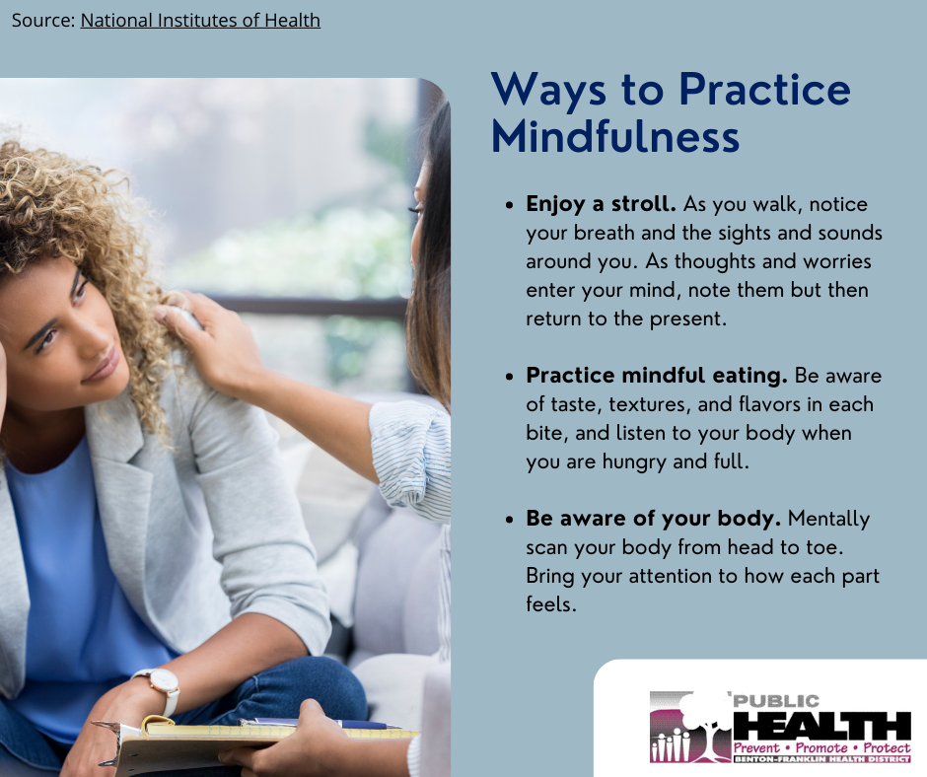  Mental Health Shirt Friday!
21. | 22. Why is mindfulness important? Mindfulness practices can help us to increase our ability to regulate emotions, decrease stress, anxiety and depression. It can also help us to focus our attention, as well as to observe our thoughts and feelings without judgment. As we become more present in our lives and in relation to others, it can help us to make better decisions, to manage our emotions and to be more fully engaged in life. #MindfulMeditation 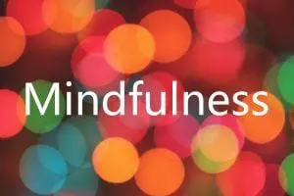 | 23. Our lives are often busy and full of stress day in and day out. If you’ve ever experienced times of high anxiety, you know how much it can affect not only your physical health, but also your mental health. Finding ways to keep yourself calm and relaxed can help keep stress from taking over your life.  5 Habits to Help Improve Your Mental Health  - Get plenty of sleep.  - Eat healthy and exercise.  - Find a connection with others.  - Relaxation techniques.  - Practice gratitude and stay positive.  5 Habits to Help Improve Your Mental Health: Carolina Wellness Psychiatry, PLLC: Psychiatrists | 24.  Visit us and other organizations tomorrow as we celebrate Mental Health Awareness Month at the first Live @ 5 of the year! Grab some food, listen to music, and learn about the local resources available to help you prioritize your mental wellness.  (Attach flier when ready) | 25.  Positive Mindset Positive Mindset: How to Develop a Positive Mental Attitude (positivepsychology.com) | 26.  To fit everything into our day, we often sacrifice sleep. But sleep affects both mental and physical health. It’s vital to your well-being. When you’re tired, you can’t function at your best. Sleep helps you think more clearly, have quicker reflexes and focus better. Take steps to make sure you regularly get a good night’s sleep.  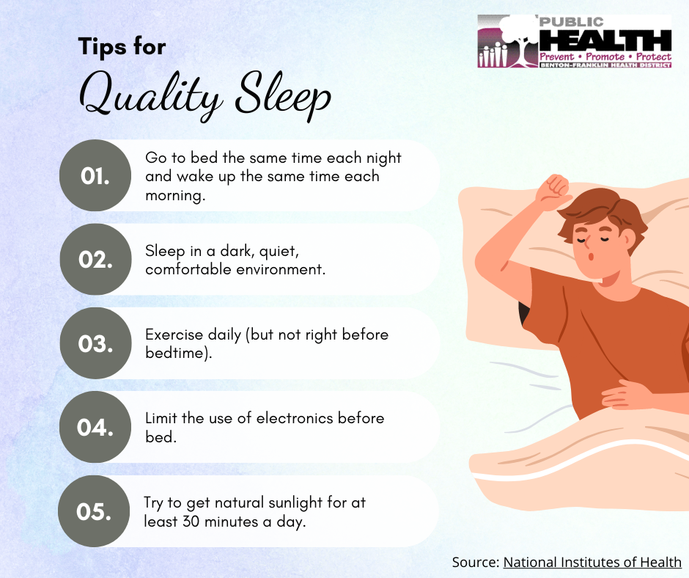 | 27.When we take deep breaths, signals are sent to our brains, telling us to calm down and relax. These messages are translated throughout our bodies, reducing tension and relieving stress when we are anxious or feel overwhelmed. It is common to have an increased heart rate, rapid breathing, and high blood pressure when we feel stressed. The practice of deep breathing decreases these symptoms, helping us to calm our minds and bodies.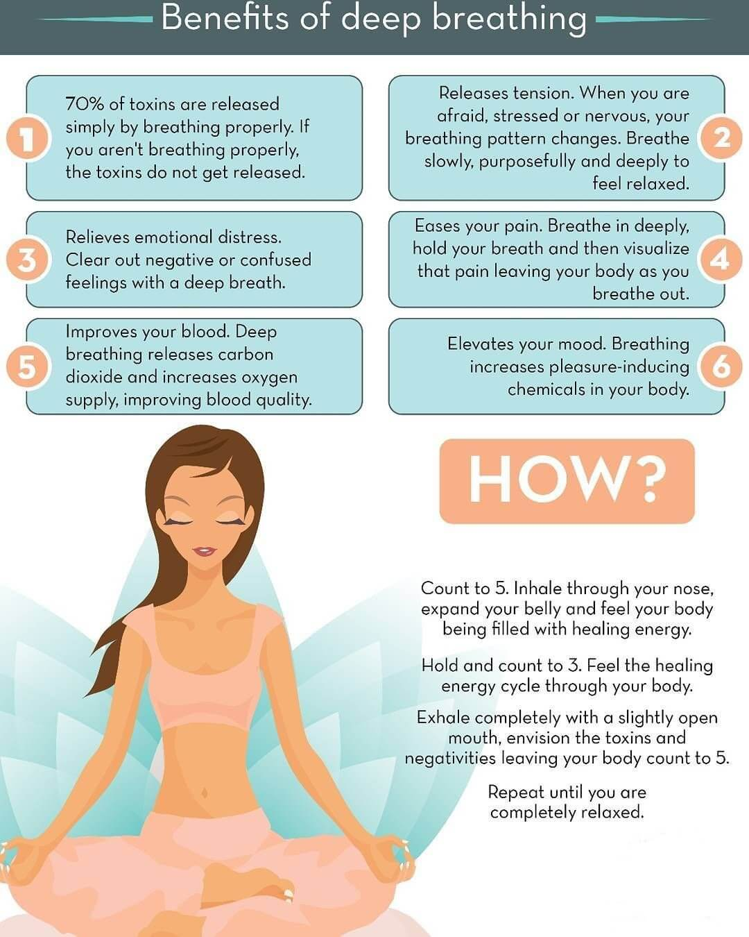
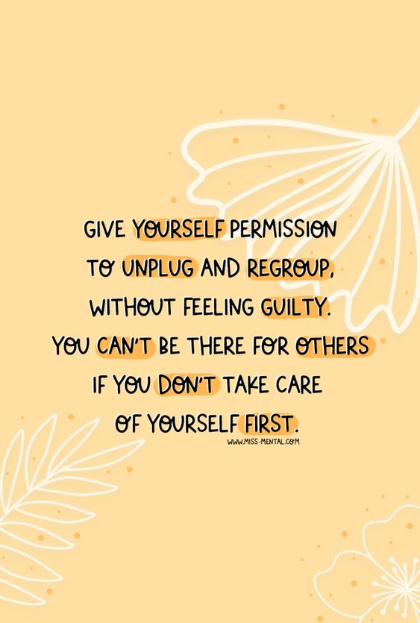 |  |  |  | LIVE @ 5 - John Dam Plaza- Highlighting Mental Health First Aid  Light up the TriCities Green for Mental Health Awareness Month. Take and share pictures on social media. | Mental Health Shirt Friday!
28. | 29. | 30. Emotional Wellness Toolkit  How you feel can affect your ability to carry out everyday activities, your relationships, and your overall mental health. How you react to your experiences and feelings can change over time. Emotional wellness is the ability to successfully handle life’s stresses and adapt to change and difficult times. Flip each card below for checklists on how to improve your health in each area. Click on the images to read articles about each topic. You can also print the checklists separately or all together to share with others or as a reminder to yourself.  Emotional Wellness Toolkit | National Institutes of Health (NIH)  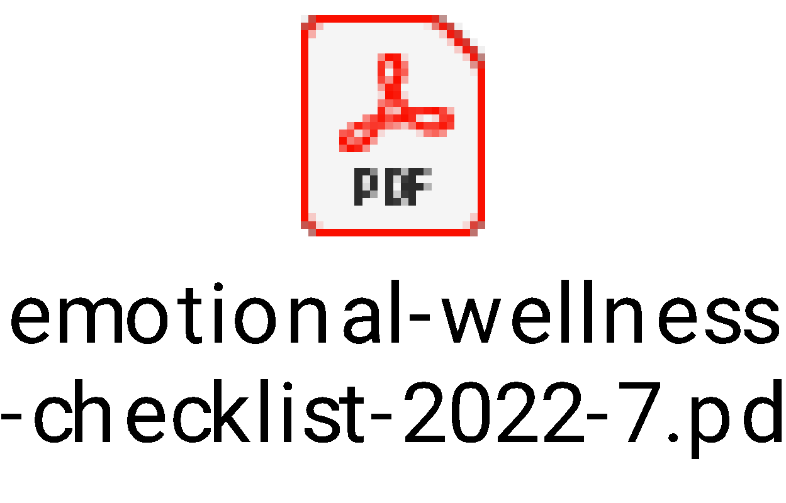 | 31.  Today is World No Tobacco Day! Cutting out tobacco not only improves your physical health, it can also improve your mood and reduce stress and anxiety. Visit the American Lung Association for tips on how to quit or help someone else quit. https://www.lung.org/quit-smoking  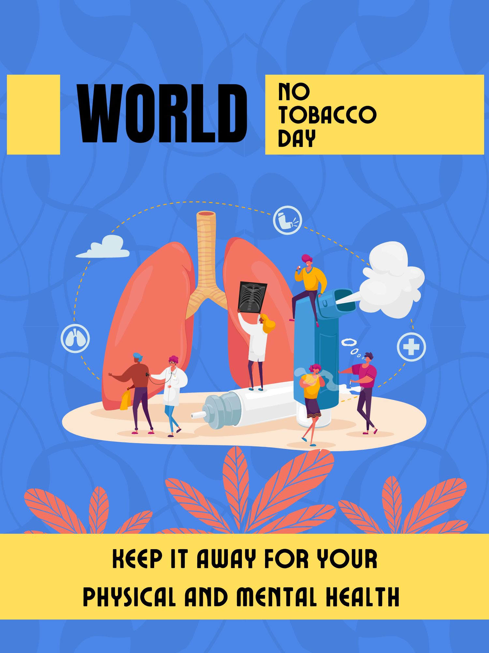
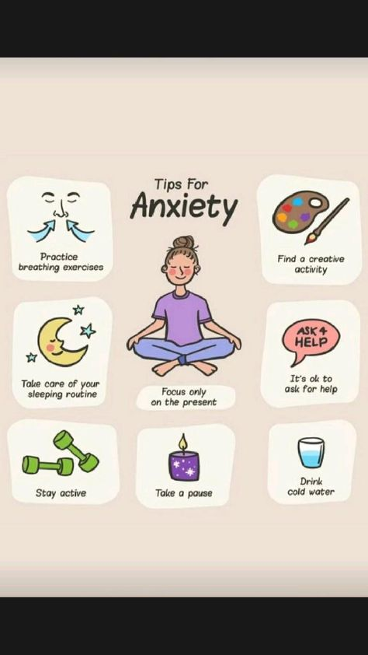 | 10-Minute Guided Meditation for Self-Compassion this morning:  https://www.youtube.com/watch?v=9TBpGiTrra8

