Tony Lorusso’s New Hampshire Motocross Park, in Lempster NH
2018 REGISTRATION FORM for MX School
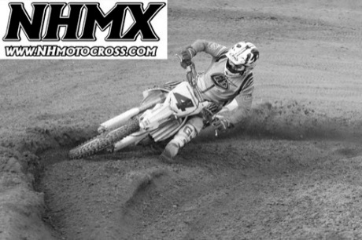 | Register NOW before spots filled up  ☐ 2-Day School June 25- 26, 2018- $300  ☐ 3-Day School July 16-18 2018 - $400  ☐ 2-Day School July 31-Aug 1, 2018 - $300  ☐ 3-Day School August 20-22, 2018 - $400  Rain date for cancelled MX School – August 27, 28, 29  Typical Day  8:30 Check-in  9:00 am Instruction & practice  Noon to 1:00 - Lunch break  1:00 to 3:30 pm – Instruction & practice  Overnight Camping available @ no additional charge
Riders Name:_________________________________________ Birthdate: _____/____/_____
Guardian’s Name (under 18)_______________________________________________________
Street Address: _________________________________________________________________
City: _________________________________________ State: ___________ Zip: ___________
Bike size: __________________ Rider level: _______________ Years riding: ____________
e-mail: _________________________________________ Contact #: _____________________
Emergency contact: _______________________________ Best Contact# :_______________
T-Shirt Size: ☐Youth M ☐Youth L ☐Adult M ☐Adult L ☐Adult XL
You must have a bike in full operating condition and proper riding gear. Minors must be accompanied by a parent or guardian at all times. Contact NHMX for any guardian exceptions
This registration form and 50% deposit due 1 week prior to school
Checks payable to NHMX LLC. Mail to P.O. Box 364, Lempster NH 03605
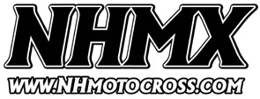
Contact: NHMXschool@yahoo.com or 603-558-9006
www.nhmotocross.com
For internal use:
Deposit paid ____/____/_____ | Minor: Yes or No | Balance Paid ____/____/____
Confirmation sent____/____/_____ | Guardian Exception:

