Bury CCG Community Lateral Flow Testing Service in Community Pharmacy: PharmOutcomes Guidance
9th November 2021, v02

Site Testing Results: Weekly Report
Pharmacies are required to report the number of tests conducted on a weekly basis.
PharmOutcomes template should be completed each week, before 5pm on a Monday evening to cover the period of Monday to Sunday for the previous week.
e.g.
Testing Period start | Testing Period end | Deadline to submit report on PharmOutcomes
Monday 29th November 2021 | Sunday 5th December 2021 | Monday 6th December 2021
Monday 6th December 2021 | Sunday 12th December 2021 | Monday 13th December 2021
Monday 13th December 2021 | Sunday 19th December 2021 | Monday 20th December 2021
Monday 20th December 2021 | Sunday 26th December 2021 | Monday 27th December 2021*
Monday 27th December 2021 | Sunday 2nd January 2022 | Monday 3rd January 2022*
Monday 3rd January 2022 | Sunday 9th January 2022 | Monday 10th January 2022
*As this deadline is a bank holiday during the festive period, it would be advisable to record any tests provided on the day provided to ensure the report sent to the commissioner automatically on the Tuesday morning includes accurate data.
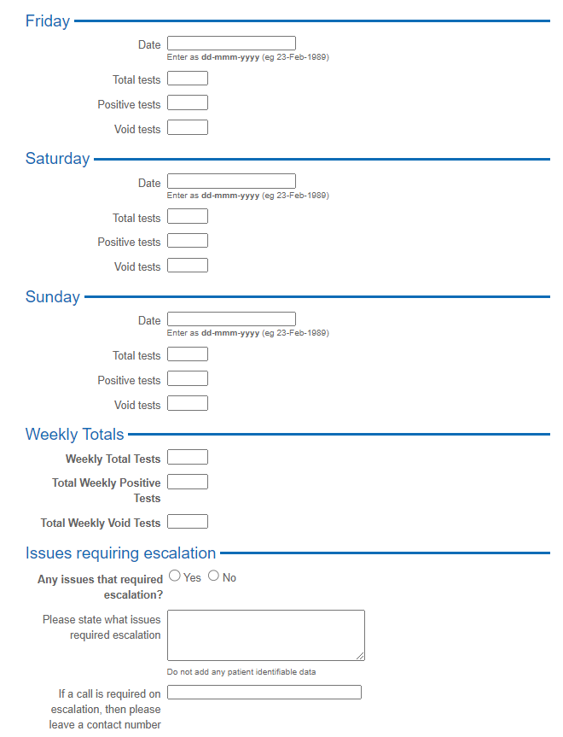
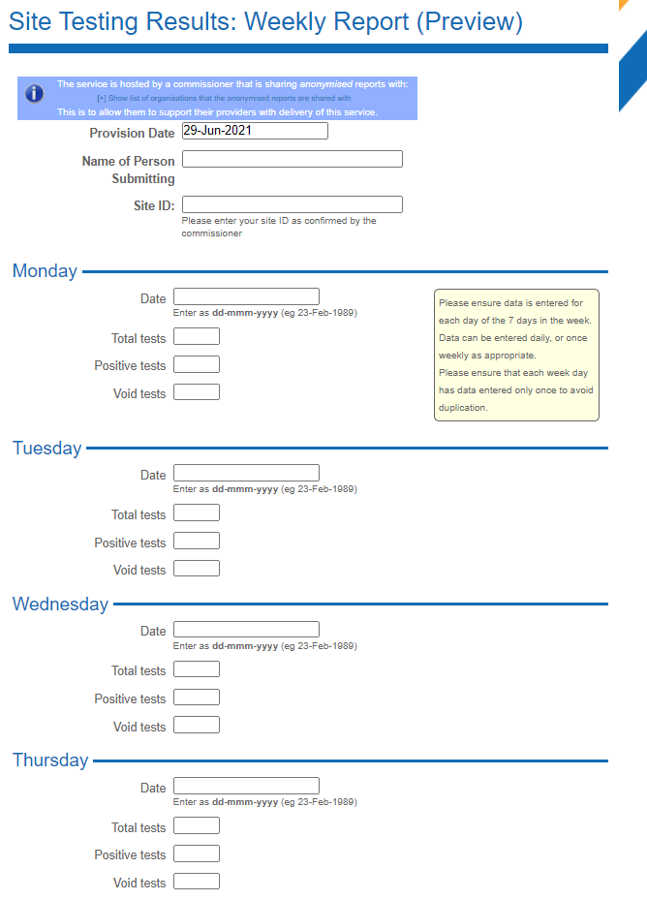
Please complete all fields as shown:

Please note the Weekly Totals are calculated by PharmOutcomes based on the information added in the daily boxes. Enter 0 if there is no number to report.

Site Testing: Monthly Claim
Please note, data submitted in the weekly report is not used for invoicing, only data submitted in the monthly claim will be included in the invoice.
Invoicing period should be a calendar month, the deadline for submitting your claim is the 6th of the month for the previous month.
Pharmacies cannot submit more than one claim per month, and there is no grace period so if you do not complete this template by the deadline, you will not be paid for that month’s activity.
Invoices will be automatically generated by PharmOutcomes on a monthly basis and emailed to CPGM Healthcare Limited (CHL) for processing and payment. It is the contractor’s responsibility to ensure that CHL has accurate bank details in order to process payments.
Please complete all fields as shown:
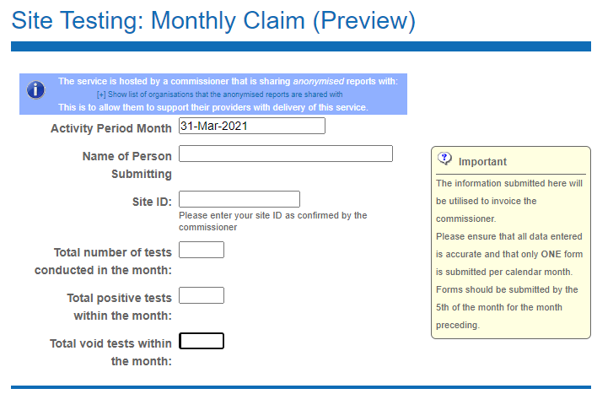

Amending a submitted record
Pharmacies can view their previously submitted claims in the Claims section of PharmOutcomes.
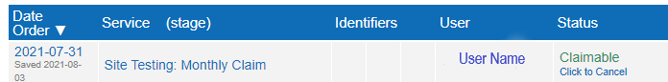
If a record is labelled as claimable (as shown above) then the pharmacy can amend this and any changes will reflect on the invoice.
The pharmacy have until end of day on the 6th of each month to edit this. Once the invoice runs and these are marked as "Claimed" any amendments will not be reflected on the invoice.
All the pharmacy need to do is click on the record to open it, amend the parts they wish to update and press "Save" at the bottom of the page.

Incident Reporting
The service specification requires pharmacies to report any incidents, complaints, compliments, or feedback to the service commissioner. A PharmOutcomes template has been prepared to support this reporting. The commissioner will receive reports submitted on a daily basis.
Please note, if pharmacies are reporting incidents, they must also notify the commissioner of the incident by telephone, as well as completing the form. Please complete all fields as shown:
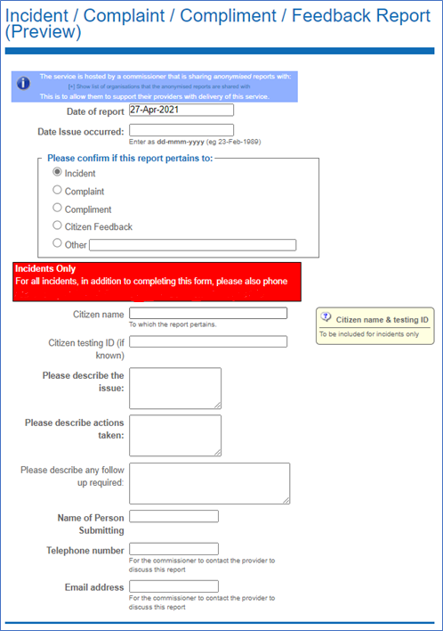

Useful Contacts
Bury CCG commissioner:
Generic Mailbox: buccg.covid19testing@nhs.net
Dominic Carter: dominic.carter5@nhs.net -or 07971 799991
Pinnacle helpdesk for general PharmOutcomes queries: helpdesk@phpartnership.com
CHL for queries specific to the PharmOutcomes templates in use for this service or for payment queries: enquiries@cpgmhealthcare.co.uk or 07597 084 014

