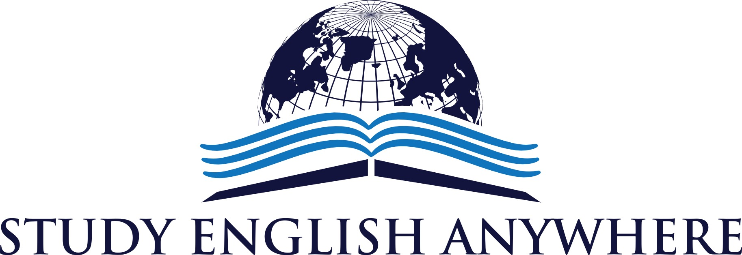
PODCAST EPISODE 1
THE NEWS
- The 2015 Acadamy Awards (OSCARS)
http://www.bbc.co.uk/news/entertainment-arts-30734124
- FIFA World Cup 2022 – Qatar
http://www.bbc.co.uk/sport/0/football/31664424
THE GRAMMAR
Present Perfect Simple
- I have been to Brazil
- I have never eaten sushi.
- Have you ever climbed a mountain?
THE VOCABULARY
- Mind your own business
- You can say that again
- Hit the road
- In the same boat
- Have you gone out of your mind?
THE HISTORY
http://www.bbc.co.uk/history/people/henry_viii/
THE MOVIE
http://www.imdb.com/title/tt0120735/
Follow us @StudyAnywhereUK
Visit us: www.studyenglishanywhere.com
Contact us: support@studyenglishanywhere.com

