SUPPORT CONSERVATION
The Mitchell Soil & Water Conservation District (MSWCD) programs are made possible by your support. Donations are accepted at any time of the year. Any amount you can give is appreciated. Checks should be made payable to “Mitchell SWCD” and you will receive a receipt for your donation. The MSWCD Commissioners thank you for your generosity. Chair Karen Damjanovic, Eric Jellum, Jarod Gasteiger, Dale Hemann, C John Schwarck and Assistant Commissioners: Milt Owen, Sandie Adams, Brad Johnson, Chelsea Ewen, Kristin Newton.

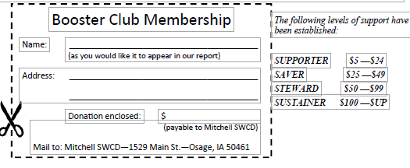

SUPPORT CONSERVATION
The Mitchell Soil & Water Conservation District (MSWCD) programs are made possible by your support. Donations are accepted at any time of the year. Any amount you can give is appreciated. Checks should be made payable to “Mitchell SWCD” and you will receive a receipt for your donation. The MSWCD Commissioners thank you for your generosity. Chair Karen Damjanovic, Eric Jellum, Jarod Gasteiger, Dale Hemann, C John Schwarck and Assistant Commissioners: Milt Owen, Sandie Adams, Brad Johnson, Chelsea Ewen, Kristin Newton.

