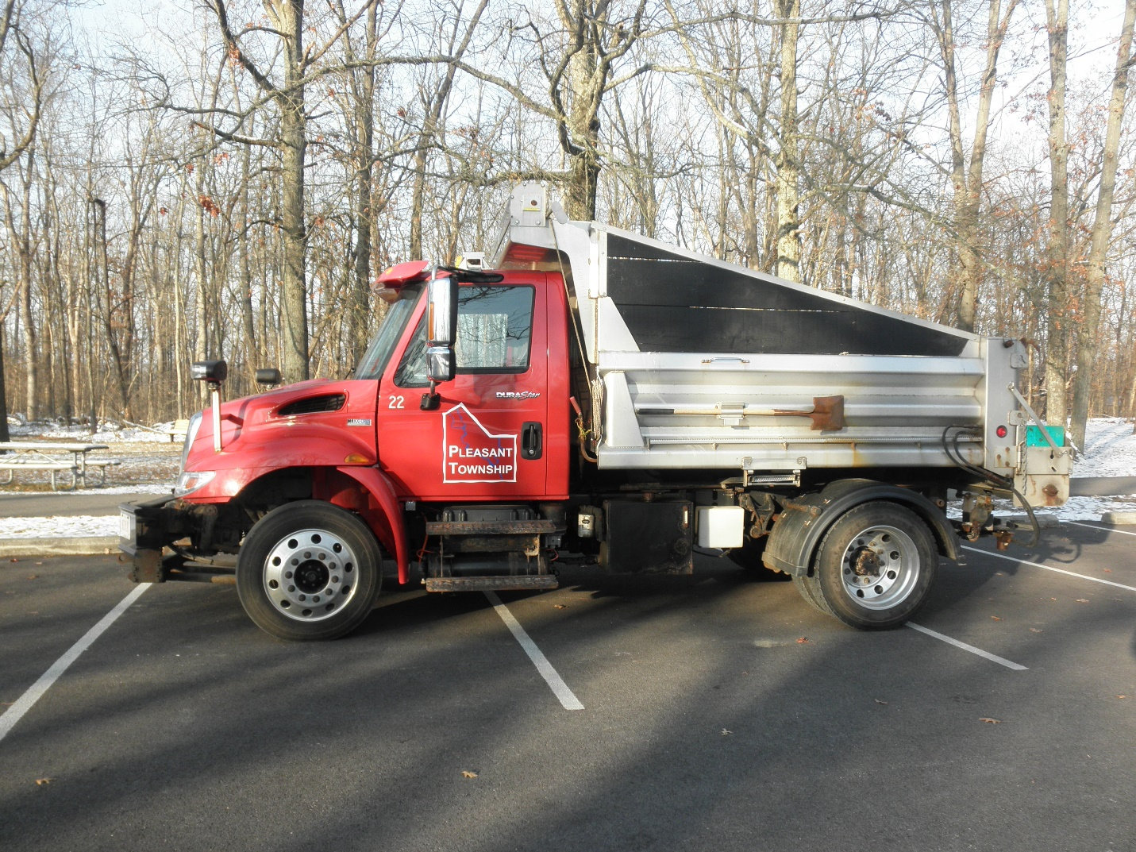

Cemeteries
Pleasant Township maintains 5 cemeteries within the township border. These include Chenoweth off of Gay rd. Gundy on Norton rd. Ebenezer M. E. on Johnson rd. Little Pennsylvania on S.R. 665 and Oak Grove on Alkire rd. For questions or information about these cemeteries contact us at 614-877-4338

Cemetery Rules
Updated and Approved October 7 2019
1 No glass containers
2 No artificial flowers from April 1st thru October 15th unless they are on the headstone. Live and artificial flowers will be permitted on graves for Easter, Memorial Day, Mother’s Day and Father’s Day for a period of 7 days
3 All plantings must be within 12 inches of the headstone
4 All plantings must be maintained by lot holder or be movable
5 No decorator rocks
6 No planting of trees or shrubbery
7 Any decorations not complying within these rules will be disposed of in 7 days
These rules and regulations have been adopted in an effort to maintain a place of beauty and a source of pride for everyone concerned.

Roads
Pleasant Township Road Department is responsible for road maintenance and drainage issues within the right of way. We currently maintain 30.8 miles of road in a 43.04 square mile area. The Township also works together with various other government agencies including Prairie, Jackson and Scioto Townships, Metro parks. Franklin County Engineers, SWACO, Franklin Soil and Water Conservation District and Franklin County Public Health.
Zoning Pleasant Township currently does not have a zoning department. We rely on Franklin County Economic Development and Planning for zoning questions and building permits.
Water quality
The majority of Pleasant Township is in the Big Darby watershed this includes Big Darby and Little Darby creeks, Hellbranch run, Smith county ditch, Lightfoot ditch and almost every ditch and small stream in the township. Due to Big Darby being listed as a National and State scenic river, it is the duty of every Pleasant Township resident to do their part to keep the waters of Big Darby and Pleasant Township clean. We need be mindful about things like washing vehicles on hard surfaces because of soaps, solvents and road grime. Dispose of household chemicals and paints properly, keeping yard wastes and pet wastes cleaned up, and keeping track of areas on your property that are prone to soil erosion. because when these items reach a storm drain they enter the water shed. If we all contribute a little bit it can make a big difference. For more tips and ideas about protecting our water quality contact Franklin Soil and Water Conservation District.
Illegal dumping
Since Pleasant Township is mostly rural, illegal dumping does sometime occur. If you witness illegal dumping get a license plate number, a description of the vehicle, and a description of what was dumped. For illegal dumping go to itsacrime.org

Useful links
Franklin County Engineers Office 614-525-3030
www.franklincountyengineer.org
Franklin Soil and Water Conservation District 614-486-9613
www.franklinswcd.org
Franklin County Economic Development and Planning 614-525-3095
www.development.franklincountyohio.gov

Franklin County Public Health 614-525-3160
fcph@franklincountyohio.gov

