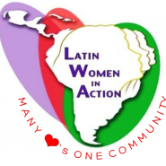
Immigration Services
In Latin Women in Action, INC., we do petitions for people who have faced devastating events in their lifetime such as domestic violence, separation of families and so much more. We also assist family members with U-Visas, Visa Vawa, Political Asylum, Family Petition(s), naturalizations such as Green Card Application and Renewals.
We also assist to those willing to apply for their Citizenship status. Applicants must undergo various classes that we also offer, in order to prepare them for the actual test.

