The Courier April 2017

Cokesbury United Methodist Church
__________________________________________________________________
Along the Way: Walking HOLY WEEK with Jesus

Many people find their most meaningful times of prayer are when they are walking; on the beach, in the woods, through the neighborhood, along a labyrinth. Like us, Jesus walked alone in the desert, by the seashore with friends, through gardens and cities with prayer and action becoming a seamless whole, “walking the talk” in every sense of the phrase.

While we are always better for walking with Jesus—all times, all places—Holy Week has special opportunities. Christians around the world mark Palm Sunday as the beginning of Jesus’ final entrance into Jerusalem. We join the crowds shouting, “Hosanna to the Son of David” as we walk and dance around the sanctuary. But the shadow of the cross stretches over our exuberance. Jesus understands how fickle we are and yet he walks steadily forward.

Palm Sunday evening the 2016 movie, “Risen,” will be shown in Courtyard Room 6 at 6 pm. Several people asked to see it after a clip was viewed in the sermon a few weeks ago. Come and walk the path of the Roman tribune as he asks how the death of Jesus could save anyone. Maybe his question has been one of your own.

Serving our sisters and brothers in need of help continues with the Food Pantry on Monday and Prayer Intercession on Wednesday. Also committee work (Finance, Worship Design) reminds us that it takes a lot of teamwork to discern and organize our journey together!

Maundy Thursday’s 7 pm worship will begin with foot-washing (John 13) for all who would like to participate. Following this a team of men will be presenting a living last supper where is the question for each disciple—then and now—is “Is It I, Lord?” as we contemplate our denial, betrayal, and desertion of Jesus. In thankfulness for his grace we will receive holy communion as his resounding YES.

Good Friday’s 7 pm Tenebrae Service of Darkness will consist of readings from the four gospels and music as we walk the Via Dolorosa—the way of suffering—in scripture. The candles are extinguished one by one as we move to Jesus’ death and burial. At the end of the service the altar is stripped of everything, portraying the totality of grief death brings to us.

On Holy Saturday Jesus laid in a borrowed tomb. Eggs remind us of tombs, with the potential of life inside. The children are invited to an egg hunt that morning at 10 am. We need help before hand to hide the eggs and to welcome our guests. Last year we had about thirty-six children. Also on Saturday the sanctuary will be decorated with signs of new life that we will celebrate the next day….

EASTER SUNDAY! Jesus rose indeed and we will celebrate that truth at 9.30 and 11! Why not wear something white or gold to represent the glory of the Light of the World, whom the darkness of death cannot overcome? We could use extra hands extended to provide a warm welcome, refreshments, and help of all kinds.

Thank you in advance to ALL who are serving, reading, singing, acting, working, hosting, praying through each stage of the walk through Holy Week and into Easter living. Be sure to invite your family, friends and neighbors to join us at Cokesbury this week—and every week—as we seek to talk the walk with Jesus.

Another thought: as we remember our sisters and brothers in SYRIA we grieve with them the deaths of so many in this war that began in 2011. The chemical weapons used understandably triggered the response of bombing. Please join me in praying for our President and those advising him, those who are serving in the military, for the Syrian people, and for world leaders to find a way to end this war. Remember, Syrian were among the first to recognize Jesus as Lord and they need our support.
Blessings for the journey, Pastor CJ

Under the wise leadership of our Church Council Chairperson, Chelsia Binns, we had a productive discussion at the March 20th meeting about the mission and vision of Cokesbury. We thank God for the good work of ALL our leaders—those who serve on the Council and those who serve in a host of ministries (including staff). Let us prayerfully continue the discussions as we discern the exciting path for which God is preparing Cokesbury in the making of disciples of Jesus Christ for the transformation of the world. Highlights of the Visioning Team’s report follow the introductory background statement about the team:

The Visioning Team met for about 3 months and talked about many different topics concerning the church and its future role in this community. We focused on prayer, reading the Book of Acts, listening to God, listening to our congregation and to the unchurched community members. The Church Council should take these recommendations (NOT guidelines!) and continue to listen to God and discern what our next steps as a church should be.

1. Mission and Vision: Statements:
Though in need of rewording to make the statements easier to answer “why” we exist as a church in a very succinct and exciting way, regardless of wording everything we do as a church should focus through these statements. Through that focus the church will be able to get almost everyone moving in the same direction. We ask the Church Council to work on this over the next 6 months.

2. Worship:
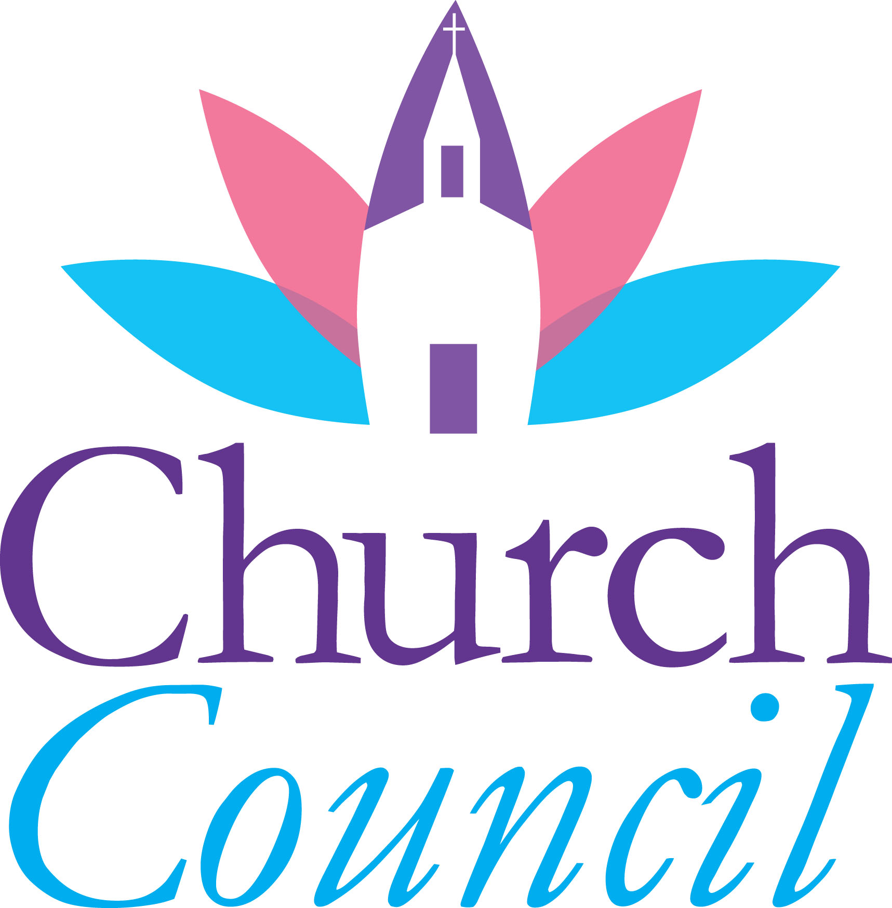
We must find ways to attract a newer, younger and a more diverse membership. All worship services should strive to become more fluid and exciting. Visitors must be intentionally greeted. A new hospitality team should be formed to make sure this is done correctly and consistently. Any funds donated to the church for remodeling of the facilities should be used to make the facilities as attractive and up to date as possible. People of a diverse background should make up the worship team at 9.30. The worship leaders should be giving the opportunities to go to trainings so that they can grow their gifts. At 11 we need to continue to find ways to get the worship to flow in a way that builds so that the congregation can fully experience God. The new Sat/Sun evening service will piggy back off of the Lenten 6 week Explore Together. We will use lessons learned from ET to start this new worship service (target launch in June) which will be focused on bringing families with children to Cokesbury.

3. Ministries:
The existing ministries should all be focused on what the church mission statement and vision statements says. If they are not currently focused correctly we need to find creative ways to get those ministries in line with those statements. We already have some dynamic ministries at Cokesbury that we do not want to get rid of or change dramatically, but small changes may be needed so that all of our ministries are in line with our mission of making disciples of Jesus Christ for the transformation of the world. M&M should make sure that each ministry is constantly striving to be more focused on this goal. We need to get our existing ministries active in inviting and reaching out to our community.

4. Committees and Organization:
A recommendation from the district training was to turn the committee meetings into small groups that do the church business. This way people in the meetings build relationships as they meet. Some of the committees’ overlap in responsibilities and either should be combined or reduced down to team style groups. We are missing a hospitality team/committee. This should include an intentional first time visitor outreach that is consistent and effective. In the current system if one person does not come to church no one knows what to do to fulfill the missing person’s roles.

5. Outside Organizations Using Campus:
The existing outside organizations coming on campus should also be brought into what the church mission statement and vision statements says. We do not expect them to change to fit our Mission Statement, but we should find creative ways to help them be a part of our Mission. We have so many people coming to this campus that we should be more active in getting to know them.
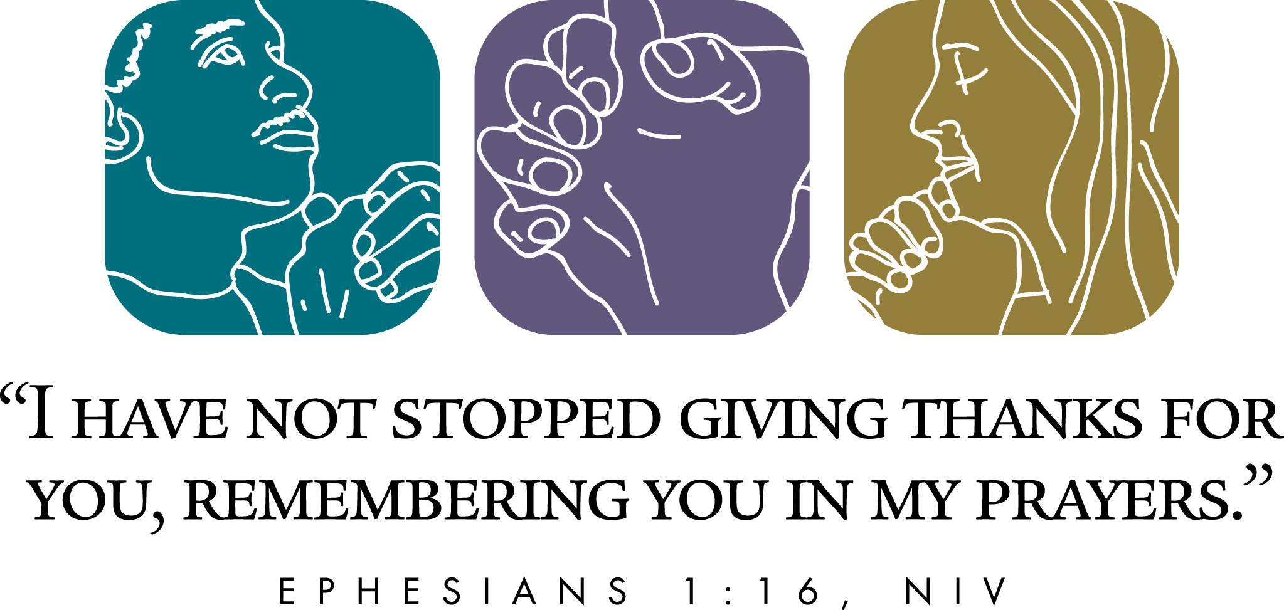
We believe God hears and answers prayer. Each of us has the privilege and responsibility to pray for one another and ourselves. Join one of the prayer ministries today.
Also know that pastors and other prayer warriors are available to pray with you and your family before surgery, or during hospitalization. Due to HIPAA regulations, hospitals do NOT call and inform us of your hospitalization. Please also pray for our church family, those serving in the military and as first responders, and those in assisted living. ALL our prayer warriors keep the concerns before the Lord in their personal prayers in addition to the methods below. Confidentiality is respected.

NOW REVIVING the PHONE PRAYER CHAIN.
Are you willing and able to receive telephone calls of urgent requests, pass on the message and pray over the concerns? We are looking for a team of eight. Please contact the Church Office and let Linda Sue know you are willing to serve in this capacity. 954.972.3424.

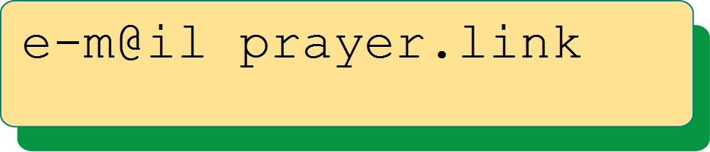
The email prayer link is coordinated by Joann O’Rourke. Please write her at <margateprayers@aol.com> if you would like to join the current ten members of the Prayer Link. Requests are sent to Joann at the email address and then she sends the concerns to everyone on the link.

PRAYER GROUP meets on Wednesdays at 4.30 in the sanctuary. Number of participants vary but the task is the same, to lift before God the concerns and joys written on prayer cards submitted in worship and during the week. The cards are prayed over for a month. Updates to situations are greatly appreciated!
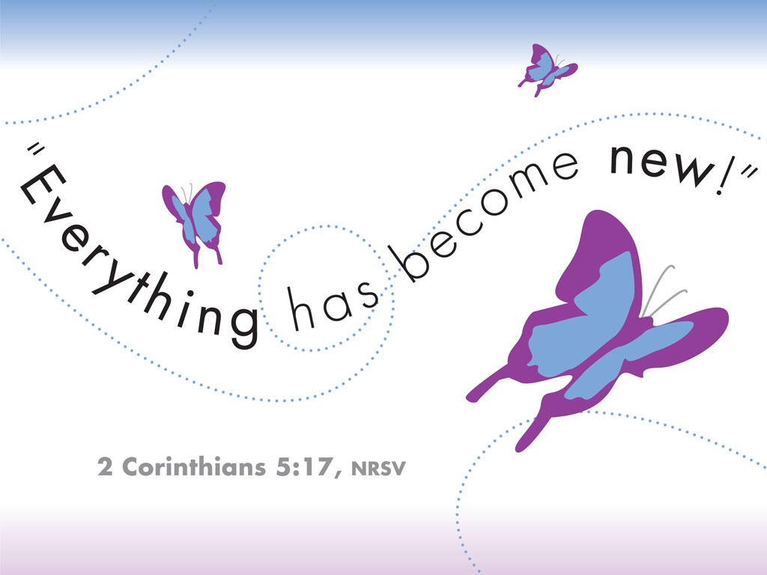
If anyone is interested in forming a group that will meet at another time please speak to Pastor CJ. Thank you.

Holocaust Memorial Program
We are invited to the Yom HaShoah/Holocaust Memorial Program and Service that will be held on Sunday, 23rd April, at 7 pm at Temple Beth Am. Speaker will be Jacques Wiesel, author of “9 Knockdowns… 5 Miracles.” Temple Beth Am is located at 7205 Royal Palm Blvd. “Never Forget! Never Again!

The National Day of Prayer in Margate is organized by MICAH (Margate Initiative for Community Action and Hope). The alliance is thrilled to announce that Dr. Glenice Glover will be our keynote speaker. Dr. Glover has worked with Margate Elementary School this past year in a pilot program empowering our young ladies through mentorship.

Observance of the National Day of Prayer will be THURSDAY, MAY 4th, at 6 p.m. in the Margate Elementary School Cafeteria. Churches will have youth lead us in prayer and schools will perform inspirational music.
Pet Blessing on Earth Day
will be hosted by Cokesbury’s
God’s Creature Keepers group.
Bring your furry or feathered friend to Lowe’s Chapel on Saturday, 22nd April at 3 pm. There will be a short time of singing, remembering our charge to be good stewards of all of God’s creation and a prayer of thanksgiving for our animal friends.
GCK is also collecting needed items for various animal welfare groups. See bulletin insert for ideas. Deadline is April 22. Thank you.

May 7th at 4: Next Steps with Pastor
Whether you are looking for care and support, a place to grow in your faith or an opportunity to serve the community – we want to help you find your fit and connect with others who share your interests. Want to learn more about Cokesbury? Join us for a casual gathering to explore the values and beliefs of Cokesbury and the United Methodist denomination. This is a great way to learn about different places to connect with our church family!
If you are considering membership at Cokesbury, the first step is to come on May 7th at 4 pm. We will gather in the Library, which is in the Church Office area. If you need child care please let us know in advance by speaking with our Church Secretary, Linda Sue, 954-972-3424. Depending on the number attending we will meet for 1-2 hours. It’s a great opportunity to get to know other and discern God’s NEXT STEP for you.

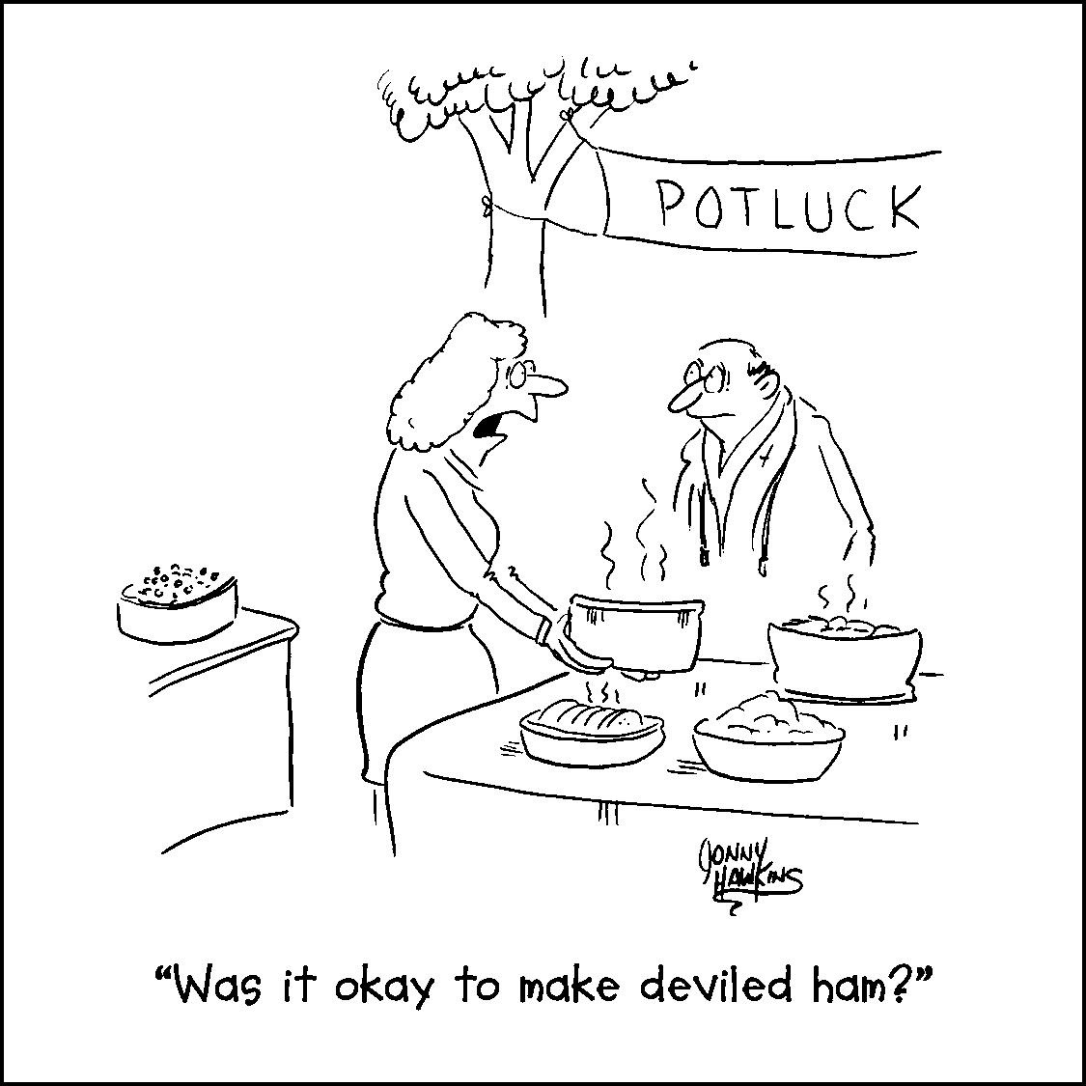

SWEET Sunday is 30th April!
Sing, Worship, Eat, Enjoy Together
when we have ONE hymn sing (10.15),
ONE worship service (10.30),
ONE potluck lunch afterwards.
This is a joyous time of fellowship and good food—even deviled ham welcome (see cartoon <^{——)}.
Needed: folks to sign up to organize, host and clean after. Please sign the chart in the Narthex (aka front hall of sanctuary) today to volunteer and help with the head count. Thank you!

CALENDAR FOR APRIL
Other Groups Sharing the Campus:
Monday through Friday, Victory Living, 7 am- 4 pm, Rooms 2, 3, 4
Mondays, Tuesdays, Fridays, Spanish Alcoholics Anonymous, 8-10 pm, Grace’s Place (Room 4)
Monday Apr. 17 and Tuesday Apr. 25 Cub Scouts—7:00 – 8:00 pm
Wednesday and Fridays, Anglo Alcoholics Anonymous, 7-8 pm, Don Lowe Chapel
Thursdays, Spanish Al-Anon, 8-10 pm, Don Lowe Chapel
Always check with our Church Secretary about room availability before you schedule usage as there are “one-off” meetings NOT listed. Thank you.

09 9:30 & 11:00 am PALM SUNDAY Worship; also Sunday School & Children’s Church
9:45 am - Choir Practice - Room 7
10:45 am - Bible Study – Lowe Chapel
6:00 pm – “RISEN” the movie - in Courtyard Room 6

10 4:30 pm – Food Pantry – Settle Hall & Room 1
6:30 pm – Finance Meeting – Library

11 7:00 pm – Worship Design/9:30 Service - Library

12 4:30 pm - Intercessors – Sanctuary

13 2:15 pm – NO Thumbs Up
7:00 pm – MAUNDY THURSDAY SERVICE: “Is It I, Lord?” (& footwashing, holy communion)

14 5:30 pm – Lent Soup Supper – Settle Hall
7:00 pm – GOOD FRIDAY TENEBRAE SERVICE (reading of the passion & singing hymns)

15 10:00 am – Easter Egg Hunt – Front Lawn

16 9:30 & 11:00 am EASTER SUNDAY CELEBRATION! also Sunday School & Children’s Church

17 1:00 pm – Lunch Bunch – Settle Hall

18 6:00 pm – Mission & Ministry Meeting – Library

19 10:00 am – Morning Bible Study – Library
4:30 pm – Intercessors – Sanctuary
6:00 pm – Evening Bible Study – Library

20 2:15 pm – Thumbs Up – Settle Hall
3:30 pm – M.I.C.A.H. – Lowe Chapel
7:00 pm – Digital Photo Discovery – Room 6
7:00 pm – Praise Band – Sanctuary

22 3:00 pm – EARTH DAY Pet Blessing – Lowe Chapel

23 9:30 & 11:00 am Worship; also Sunday School & Children’s Church
9:45 am - Choir Practice - Room 7
10:45 am – Bible Study – Lowe Chapel
7:00 pm - Yom HaShoah/Holocaust Remembrance at Temple Beth Am

24 4:30 pm – Food Pantry – Settle Hall & Room 1

26 10:00 am – Morning Bible Study – Library
4:30 pm – Intercessors – Sanctuary
6:00 pm – Evening Bible Study – Library

27 2:15 pm – Thumbs Up – Settle Hall
7:00 pm – Praise Band Practice – Sanctuary

30 10:15 for 10:45 am – SWEET Sunday Worship; hymn sing begins at 10.15, worship at 10.45
also Sunday School & Children’s Church
12:00 Noon – Potluck Lunch – Settle Hall
May
01 7:00 pm - Trustees - Library

02 7:00 pm - Evangelism - Library

03 10:00 am – Morning Bible Study – Library
4:30 pm – Intercessors – Sanctuary
6:00 pm – Evening Bible Study – Library

04 2:15 pm – Thumbs Up – Settle Hall
6:00 pm - NATIONAL DAY OF PRAYER OBSERVANCE - Margate Elementary School

06 9:30 am - GALS (God’s Angels, Loving Servants) - Settle Hall

07 9:30 & 11:00 am Worship; also Sunday School & Children’s Church
9:45 am - Choir Practice - Room 7
10:45 am – Bible Study – Lowe Chapel
4:00 pm - Next Steps with Pastor - Library

_________________________________

UPCOMING WORSHIP ON SUNDAYS

Wrestling with God: Scott Didriksen, preaching
Apr. 23 Second Sunday of Easter: Jacob at Jabok
Apr. 30 SWEET! (Third Sunday of Easter: Jacob at Jabok, part two)
30 min. hymn-sing at 10.15, potluck in Settle Hall after service at 10.45

UNAFRAID: Living with Courage and Hope
In this series, we explore the most common worries and fears experienced by Americans today, consider practical steps for overcoming these fears, and reflect upon fear in the light of scripture and a faith that promises again and again that we don’t need to live in fear. Let's live with courage and hope.

May 7 Fourth Sunday of Easter: An Age of High Anxiety: Psalm 56.3-4; Isaiah 41.10; Matthew 6.25-27
May 14 Mother’s Day/Fifth Sunday of Easter: Fear of the Other: Psalm 27.1, 14; 1 John 4.18-19; Matt. 5.43-44
May 21 Sixth Sunday of Easter: Friendless and Alone? Psalm 139.5, 8-10; Genesis 2.15, 18; John 13.34
May 28 Memorial Day Observed/Seventh Sunday of Easter: Fear of Failure: Ex. 3.10, 4.13; Jos. 1.1, 5, 9; 2 Tim. 1.7
Flags of all branches of the armed services will be presented as we remember those who have died in action.

