CANCER GAMES

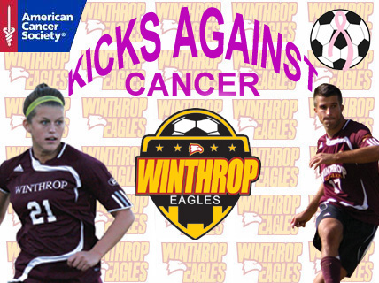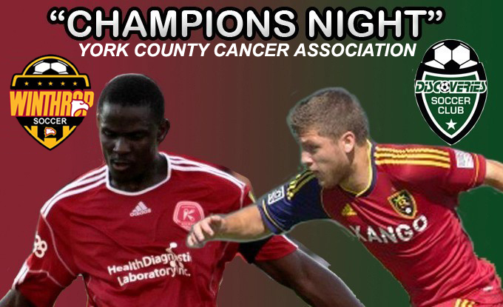

FIVE YEAR TOTAL RAISED: $65,000
****************************************
In 2014 I became involved with a group here in York County, SC that have putt together a major cancer event in our community. It is called The Carolinas Kickin It Challenge-Unite In The Fight. It is two events for one cause. The weekend starts with a kick off party at the Anne Springs Close Dairy Barn with music, dinner, drinks, auction and entertainment.

The Carolinas Kickin’ It Challenge – Unite in the Fight Youth Soccer Tournament is held at Manchester Meadows Soccer Complex in Rock Hill, S.C. This is a signature club level soccer tournament that is focused entirely on raising money for the fight against breast cancer.

All money raised from these two events goes to benefit the Susan G Komen Charlotte and the Carolinas HealthCare System Levine Cancer Institute.

http://www.kickinitchallengecarolinas.com

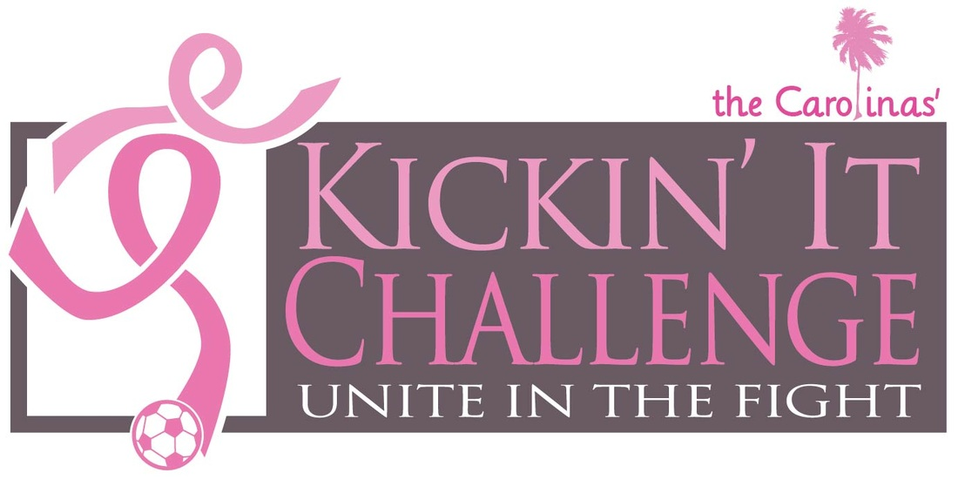

2014 YEAR TOTAL RAISED: $63,000
2015 YEAR TOTAL RAISED: $80,000
2016 YEAR TOTAL RAISED: $68,450
2017 YEAR TOTAL RAISED: $42,000

KICKN IT: $253,450
WINTHROP CANCER GAMES: $65,000

GRAND TOTAL: $318,450

