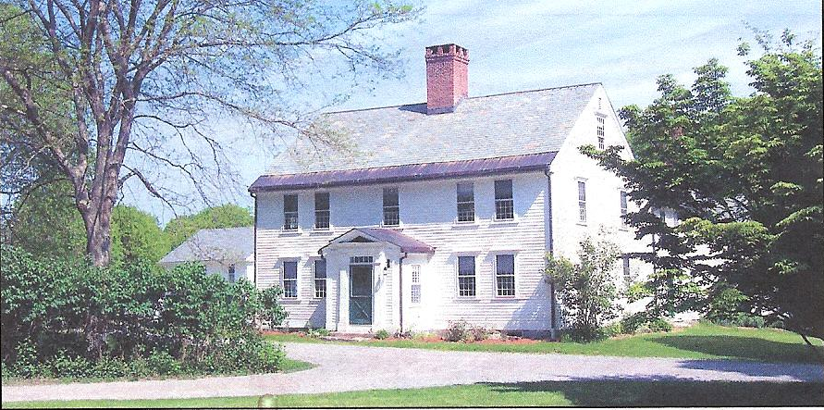

The Bullard Memorial Farm 1777
Please join us for a hands-on workshop at Bullard Memorial Farm.
Create your own custom holiday centerpiece using evergreens, berries, candles, and festive embellishments.

Sunday December 1, 2019
1pm
Bullard Memorial Farm

7 Bullard Lane
Holliston, Massachusetts
$45/person
Space is limited, advance reservations required, please email Tara Hathaway bmfaprograms@gmail.com or call 508-429-1638.

For more information about the farm visit www.bullardmemorialfarm.org



