Gary Krasilovsky, PT, PhD, SST
Schroth Physical Therapist
10 Lookout Lane
Westport, CT. 06880
203-451-3643
email: PTProfessor@gmail.com

Patient Health & History Form
(Please complete this form and bring to your first appointment)

Today’s Date: ____________________________

Name ____________________________________ Date of Birth _________________ Age _________
Address: ______________________________________________________________________________
Phone: __________________________________ Email: ___________________________________
Emergency Contact (if under 18): Name _______________Relationship _______ Phone _________
Referring Physician ________________________ Primary Physician _______________________
Insurance: __________________________________ Do you have Medicare? __________________

Current Chief Complaint or Functional Limitation: __________________________________________________________________________________________________________________________________________________________________________

When did this problem begin? _________________________________________________________

Interventions for this problem thus far? (any therapy, etc?) __________________________________________________________________________________________________________________________________________________________________________

Medical evaluations (x-rays; MRI’s)? Do you have pictures (digital or printed)?
_____________________________________________________________________________________
_____________________________________________________________________________________

What physical activity do you do regularly? ______________________________________________
__________________________________________________________________________________________________________________________________________________________________________

What is (are) your GOAL(s) for therapy? What would you like for me to be able to help you do? _____________________________________________________________________________________
_____________________________________________________________________________________

Current meds, vitamins and/or supplements you are taking, or are prescribed to take:
Name of Product | Prescription or OTC | Dosage Amount and frequency | Reason for medication | complaint?

ALLERGIES TO MEDICATIONS
Name of medication or ingredient | Type of Reaction?

Past Medical History (diagnoses, and approximate date diagnosed)
Diagnosis | Date Diagnosed (or approximate)

Comments: _________________________________________________________________________

_____________________________________________________________________________________

Past Surgical History
Surgery, (including Right or Left, if appropriate) | Date | Surgeon/Location | Any complications?

Comments: _________________________________________________________________________

_____________________________________________________________________________________

Regarding your Spine:

Cobb angles and location if known: Cervical ______; Thoracic _______; Lumbar: __________

Thoracic Kyphosis angle (side view), if known ____________________________________________
Lumbar Lordosis angle (side view), if known _____________________________________________
What bothers you most about your posture? _____________________________________________
_____________________________________________________________________________________
Risser score, if known ____________
Year or age of start of menstruation if applicable: _____________________________________

History of Bracing:
Date (from when to when?) | Type or name of brace | #hours/day told to wear | Level of compliance  (Always, Most, Some, or Not a Chance)

Please circle the images below as to how you feel it most accurately resembles your current physical presentation. For set 3, you only need to circle respective to your gender.
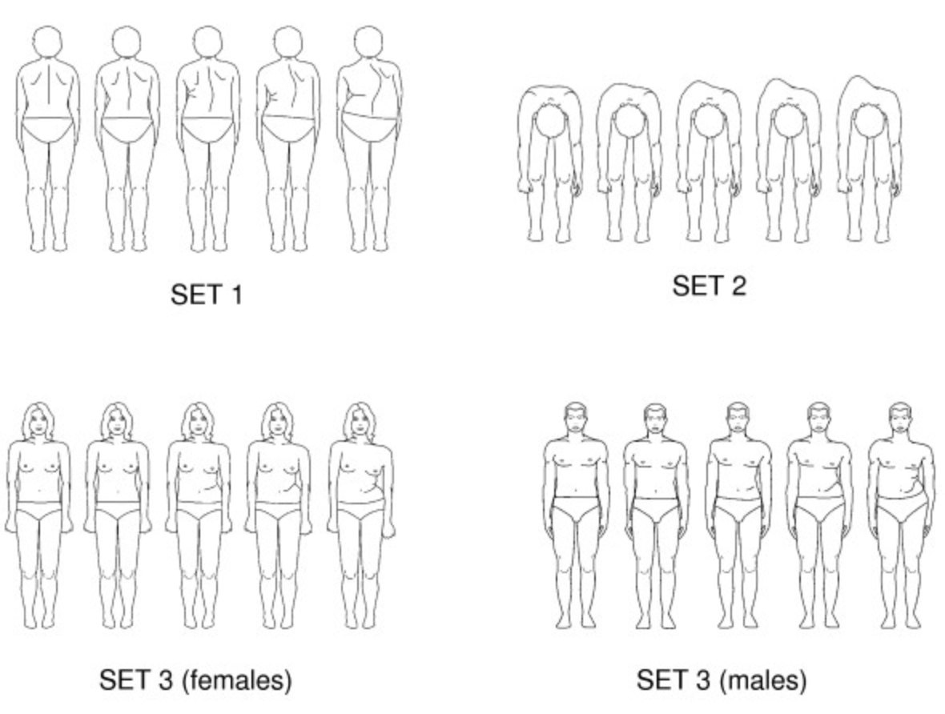

Do you have pain? No ___ (you are finished) Yes _____ (complete below)

- Do you have any pain associated with the current problem? _____________________________
- Does the pain radiate or refer to other areas? __________ If so, where and when? __________
__________________________________________________________________________________
- Please mark on the diagram below the location and type of pain.
- Does pain wake you in the middle of the night? ________________________________________
- Does pain limit your ability to get comfortable in bed? (different than above question) ______
- What makes the pain better? ________________________________________________________
- What makes the pain worse? ________________________________________________________
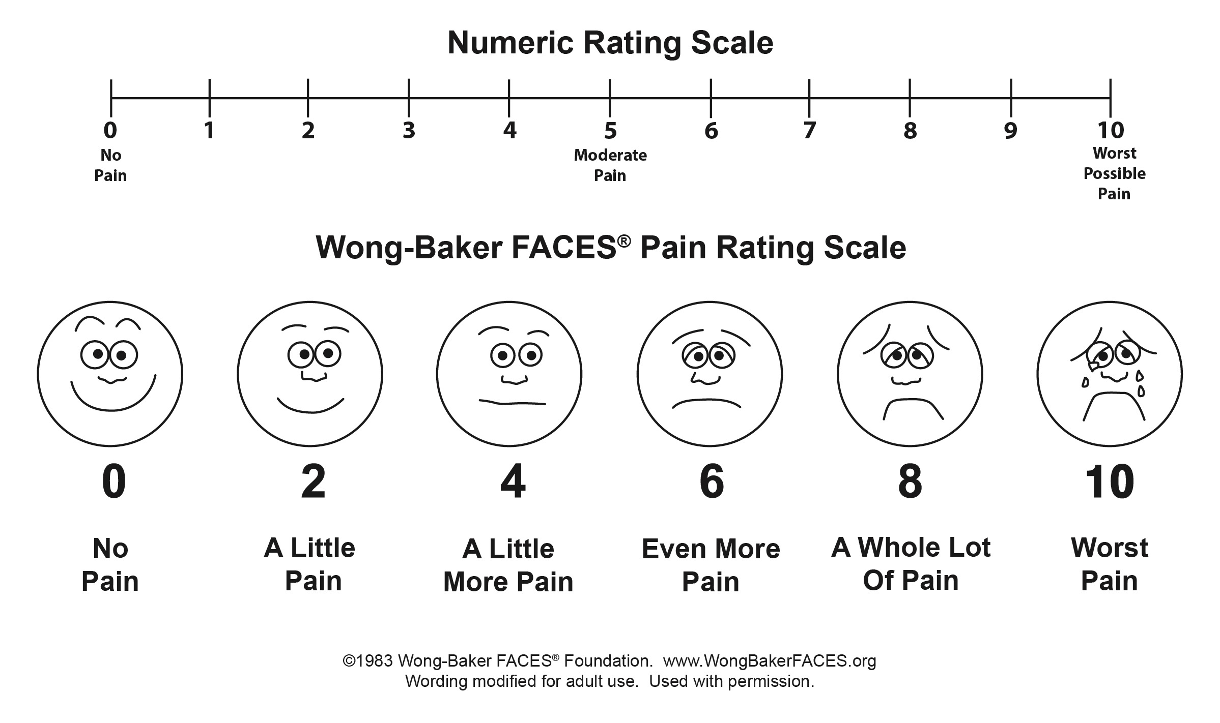
- How would you rate the pain on a scale of 1-10? (You can include a range - best to worst)
- What is your goal for pain relief considering the above scale? ____________________________
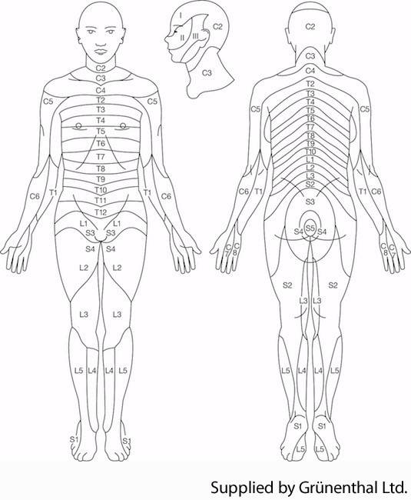
Thank you for taking the time to share this essential information!
Please denote pain or abnormal sensation on the image to the right.

x = pain
- = numbness
T = tingling/pins & needles

Please circle pain description:

stabbing
throbbing
dull
achy
sharp
shooting/radiating
pulling

