Most Creative
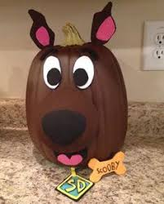
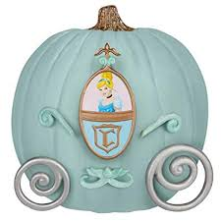
Pumpkin Contest

Dress, paint, or carve your pumpkin

Kids 10 and under may enter

Entries will be accepted on Friday, September 14th between 4:00-6:00 pm at the St. Marys Marina Building

First Place: $60 gift card and goody bag
Second Place: $40 gift card and goody bag
Third Place: $25 gift card and goody bag

Pumpkins will be on display in the Marina Building all weekend

