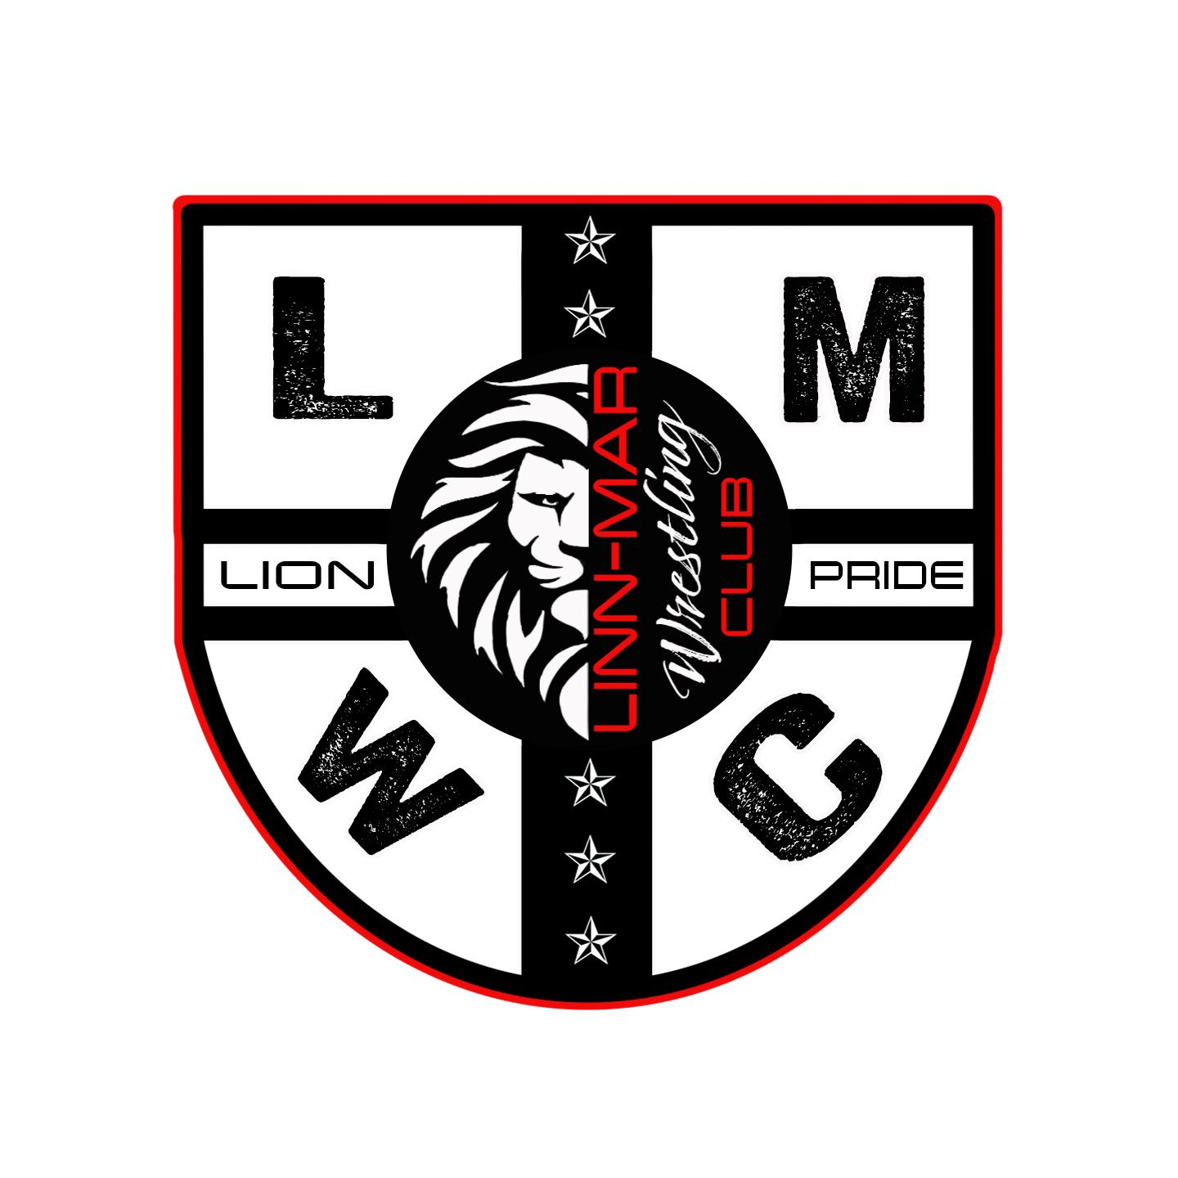 | LMWC  Board of Directors: Jim Borschel, Mike Geers, Ryan Gotto,  Matt Kluesner, Kevin McCauley, Matt McDonough,  Erik Naaktgeboren, Doug Streicher, Beau Westpfahl  President: Matt Kluesner  Vice President: Beau Westpfahl  Secretary: Jim Borschel  Treasurer: Doug Streicher  E-mail: linnmarwrestling@gmail.com  www.linnmarwrestling.com  Established 2023

Dear LMWC Supporter,

Thank you for supporting the LMWC and the first year of our annual Linn-Mar Wrestling Club endowment campaign. Money raised from the endowment campaign will be used to support Linn-Mar Men’s and Women’s wrestling in grades K-12. Supporters of our endowment campaign will be recognized on signage inside the wrestling complex at L-M High School, at the gate of all home L-M wrestling events and on our website (linnmarwrestling.com). Our goal over the next few years is to raise $100,000 to create an endowment that will fund our programs for years or decades to come. All donations are tax deductible through the LMWC, which is a 501c3 non-profit.

The yearly return on our endowment investment will be used for costs associated with running our wrestling programs:

Yearly Men’s and Women’s Poster | Middle School warm-up shirts
State recognition shirts for the team | State meet expenses
Spring wrestling team training | Scholarships for LMWC enrollment
Equipment for the wrestling room | Fund LMWC coaching stipends
Fund Fargo expenses for athletes | Fund lodging for LMWC coaches at AAU State
Charter buses for competitions 70+ miles from L-M | Linn-Mar Coaches apparel

Name/ Business: _______________________________

Donation Amount: $ ___________

Date: _______

LMWC EIN (tax ID #) 93-3753439

Send Checks To: Thanks for your support!

LMWC Linn-Mar Wrestling Club Board of Directors
3465 Cottonwood Lane
Marion, Iowa 52302

