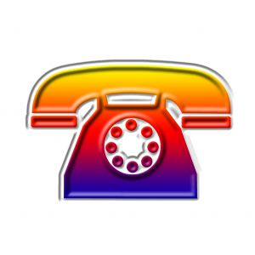

My address __________________________________________________________________
My telephone number _________________________________________________________
My mother’s cell phone number _________________________________________________
My father’s cell phone number __________________________________________________
My grandmother / grandfather’s telephone number _________________________________
I.C.E. Adult # 1 ________________________________________________________________
Telephone number _______________________________________________________
I.C.E. Adult # 2 ________________________________________________________________
Telephone number _______________________________________________________
I.C.E. Adult # 3 ________________________________________________________________
Telephone number _______________________________________________________
Police ________________________________________________________________________
Fire Department _______________________________________________________________
Doctor _______________________________________________________________________
E.M.S. _______________________________________________________________________
C.A.T. (Caution / Action / Tell)
What Would You Do? A Kid’s Guide to Staying Safe in a World of Strangers
… by Melissa Harker Ridenour

