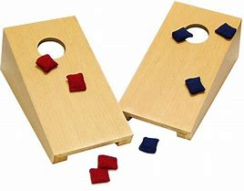
2021/2022 Calumet County Tavern League Bean Bag Schedule

First team listed is home team

- Neighborhood Pub 1 6. Neighborhood Pub 2
- Ethel’s Pub 1 7. Ethel’s Pub 2
- Gene & Helen’s 8. Split Happens
- Chilled Stein 9. Cheers
- Eagles Club 10.Quinney Quencher

Oct. 27th Nov. 3rd Nov. 10th Nov. 17th
2-1 2-3 6-9 10-6
3-10 1-7 7-8 2-5
4-9 8-6 3-1 3-4
5-8 9-5 4-2 1-8
6-7 10-4 5-10 9-7

Dec. 1st Dec. 8th Dec. 15th Dec. 22nd
5-3 1-9 5-1 5-6
6-2 10-8 6-4 1-10
7-10 2-7 7-3 2-9
8-9 3-6 8-2 3-8
4-1 4-5 9-10 4-7
Jan. 5th Jan. 12th Jan. 19th Jan 26th
9-3 1-2 3-2 9-6
10-2 10-3 7-1 8-7
6-1 9-4 6-8 1-3
7-5 8-5 5-9 2-4
8-4 7-6 4-10 10-5

Feb. 2nd Feb. 9th Feb. 16th Feb. 23rd
6-10 3-5 9-1 1-5
5-2 2-6 8-10 4-6
4-3 10-7 7-2 3-7
8-1 9-8 6-3 2-8
7-9 1-4 5-4 10-9

March 2nd March 9th
6-5 3-9
10-1 2-10
9-2 1-6
8-3 5-7
7-4 4-8

Banquet is March 23rd at Chilled Stein.

