St. Paul’s Episcopal
Preschool
Parent Handbook
2019-2020

NOTES:

Table of Contents
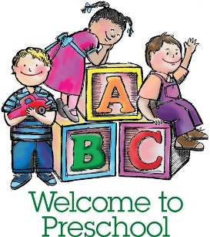
Mission Statement 3
Philosophy Statement 3
Curriculum 4
Hours of Operation 5
Preschool Open/Orientation 5
Holidays Observed 5
Special Events 5
Admission Policy 6
Policies for Arrival & Departure of Children 6
Pick-up and Drop-off Policies 6
Absence 6
Late Arrival 6
Late Pick-up 7
Authorized Pick-up 7
Discipline Policy 7
Termination Policy 7
Family Dispute Resolution Program 8
Tuition Policy and Other Fees 8
Inclement Weather 9
Medical Concerns 9
Sick Children 9
Medications 10
Topical Medications (sunscreens, diaper ointment, etc.) 10
Food Allergies Action Plan 10
Asthma Action Plan 10
Transportation Policy 10
Recognizing Child Abuse and Neglect 11
Open Door Policy 11
Parent’s Agreement 12
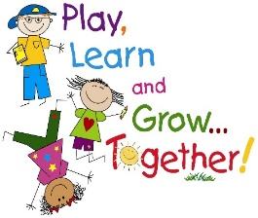
Inserts
Preschool Mission Statement
Saint Paul’s Episcopal School (SPES) also known as Preschool and Kindergarten strives to provide a loving environment in which children can grow and mature spiritually, socially, emotionally, intellectually, and physically. We know that a child’s early years provide a critical foundation for growth and development for the rest of the child’s life.
The school’s program is based on a belief that the seeds for creativity, tolerance, neighborliness, and acceptance are all planted early and must be nurtured through a program that continually models these values.
Philosophy Statement
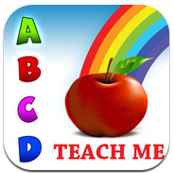
As an outreach ministry of Saint Paul’s Episcopal Church, we believe that early childhood programs involve a community of learners with a commitment to childhood education. We are dedicated to providing the best possible environment for the education and development of young children.
The guiding principles that underscore our commitment to all young children are:
- Young children learn and construct knowledge as a result of meaningful and purposeful experiences.
- Young children reach different levels of learning and development at different times.
- Learning in the early childhood years develops on a continuum.
- Learning is both individual and social and takes place within a social/cultural context.
- Play is an integral part of quality programs serving young children.
- Skills and concepts are developed and enhanced through child-initiated and teacher-initiated activities.
- Programs for young children must provide opportunities for individual activities and flexible groupings.
- There must be exposure to a print-rich environment which facilitates literacy development.
- The dignity of young children and their personal circumstances and diversity must be respected and affirmed.
- Families of young children are essential partners in the educational process.
- Children are best served in a safe, nurturing, and inclusive environment.
- Developmentally appropriate assessment of young children’s learning is essential for planning and implementing appropriate curriculum and celebrating children’s learning.
- Program practices for young children must reflect sound research and findings about young children and learning.
The early childhood years are very special, during which children make great developmental strides and become increasingly independent. Improvements are continually evident in emotional growth, social skills, verbal communication, intellectual awareness and physical capabilities. In recognition of the crucial importance of these early years, we strive to create a program that is tailored to meet the needs of the whole child. The lesson plans developed by each teacher cover all areas of importance to the children’s growth. The program is designed to provide children with ample opportunity to learn, enjoy, and become comfortable in their expanding world. St. Paul’s Preschool follows Fairfax County Early Learning Guidelines. Our curriculum is focused on bringing out the best in each child. We follow Thematic Units to teach:

Language and Literacy
- Logic, Mathematics, Science
- Creative Representation
- Dance & Yoga
- Social Relations
- Moral Guidance and Emotional Problem Resolution
- Health and Physical Development

Goals of Curriculum
- To inspire delight, curiosity, celebration and inquiry in the learning environment.
- To build intrinsic motivation and a long-term love of learning in children.
- To help children craft an internal compass to guide them as a learner.
- To inspire children to be authors, inventors, illustrators, dancers, singers etc. and to celebrate their unique talents and abilities.
- To encourage consistent self-reflection and professional growth among teachers, so they may always improve the quality of learning experience.
- To maintain a teaching staff well-versed in the fundamentals of how and what children learn, so they can support and guide learning as it emerges naturally inside the school, in the natural world, and in our community as a whole.
- To allow the natural pace of individual and group learning to emerge.
- To create cooperation, partnership, resource-sharing and amiability between staff, students, parents and the community.
- To give children an organized environment in which to use all of their senses and faculties to learn, to promote learning through play.
- To recognize that critical learning takes place during conflict, negotiation, brainstorming and resolution in a safe environment.
- To provide adequate play time inside/outside daily.
- To support the varied learning styles (visual, auditory, sensory, and verbal, etc.) in ways that are also aware of gender differences.
- To carry out assessment in the form of student portfolios and documentation of learning
- To practice supportive social learning rather than punishment.

This is how we make it happen…
- Weekly folders, progress reports and observation
- Weekly classroom documentation dispalyed.
- Child-led expeditions, inquiries and investigations
- Activities in our dramatic play, block, science, sensory, literacy and manipulative areas in school, as well as on the playground.
- Parent-teacher conferences

Hours of Operation
St. Paul’s Episcopal School is open Monday through Friday, from 7:00 a.m. to 6:00 p.m.
- Regular school program 8:45 a.m. to 2:45 p.m.
- Before care program 7:00 a.m. to 8:45 a.m.
- After care / extended care 3:00 p.m. to 6:00 p.m.
Preschool Orientation/Open *September 3, 2019*
- Parent Orientation/1st day 9am-a10am
- September 3, 2019 (8am -6pm Full day)

Preschool Closings/Holidays Observed (We follow Fairfax County School Holiday Closings)
- Labor Day September 2, 2019
- Columbus Day October 14, 2019
- Thanksgiving break November 27-28,29,2019
- Christmas Program December 20- 10am-12pm *Early release
- Christmas/ New year Break December 23-January 3, 2020
- Parent Teacher Conferences January 17,2020 *Early Release
- Martin Luther King Jr.’s day January 20, 2020
- Presidents’ Day February 17, 2020
- Easter break April 6 - April 13, 2020
- Parent Teacher Conferences May,25 2020 *Early release
- Memorial Day May 25, 2020
- End of Year program June 19,2020 * Early Release 12:pm
- School Closed for Students June 22, – July 26, 2020
- Summer Camp 2020 June 29, 2020 – August 21,2020

Special Events
- Preschool Fundraisers T.B.A.
- Burke Farm Field Trip October 25,2019
- Picture Day October 28,2019
- Halloween Parade/Party October 31, 2019, (10:am-12:pm)
- Thanksgiving Food Baskets November 11-26, 2019 (driver volunteers needed)
- Christmas Program/Party December 20, 2019 (10:am-12:pm) *Early release 12:pm
- Parents/Teachers Conference January 17, 2020 (1:pm – 6:pm) *Early release
- Valentine’s Party February 14, 2020, (10:am-12:pm)
- Easter Party April 3, 2020 - 10am-12pm
- Mother’s Day Breakfast May 10, 2020 - (8:am – 10:am)
- Parents/Teachers Conference May 22, 2020 (1:pm – 6:pm) *Early Release
- Year End Program June 19,2020 Last Day (10am-12pm) *Early Release
- Summer Camp 2020 June 29,2020 – August 21,

Admission Policy
Enrollment is on a first-come first-served basis due to limited class size and space. The ages range from 2½ years to 5 years old. All students must be registered to their appropriate age group and program hours. All preschool applications forms must be filled out completely. Applications not completed and signed will be placed on hold and possibly delay your child’s enrollment.

The Preschool/Child Care Agreement, Registration Enrollment Forms, School Entrance Health Form and Medical Forms may be picked up from the office and are also available at our website at
- http://stpaulsbxr.org/Preschool/

Policies For Arrival and Departure of Children
Pick-Up and Drop-Off Policies
All registered families will receive an access code to enter the building. Your

The assigned door codes must not be shared with any unauthorized person to gain entry into the building. Please do not let anyone in the building/All visitors must press the intercom button to announce the nature of their visit.

At drop-off/pick-up the parent/guardian or designated authorized adult must sign the child In/Out using the daily attendance book located on the lower level by Fleming Hall.

Please do not allow your child to write in the attendance book.

The school places great importance on communication between the staff and families, however, keep in mind that the pick-up and drop-off times may not be the best times for conferences. Families should always feel free to schedule a meeting with the child’s teacher or the Director.

Absence
The preschool requires all families to notify the school by 9:00 am if a child will be absent for the day.
You may notify your child’s teacher directly via email, or at: gabra@stpaulsbxr.org.

Late Arrival
Should a child arrive after an off-site scheduled activity or field trip, the child will join the classroom nearest to his/her age with available space until the class returns. If the school is on an off-site activity the child will not be left at the school.

Late Pick-Up
If a child is not picked-up at the designated time according to your agreement, an immediate late fee of $20 will be charged and $1.00 per minute will be added
until the child is picked up. Habitual tardiness is unacceptable and could result in termination of agreement.

Authorized Pick-Up
The registration form includes space for the parent or guardian to add additional individuals authorized to pick up their child. If other individuals, other than those listed are requested to pick up, a written permission clearly stating their name from the parent must be presented to the office (a form of I.D will be requested as verification).

Discipline Policy
Children are not expected to immediately understand or fully comply with all of the rules; rather they are to be gently taught, reminded, and when necessary, redirected. The school’s staff members are responsible for setting up an environment that encourages cooperation and sharing, rather than aggressive behavior.

There are times when children may actually endanger themselves or others by their actions. Due to these possibilities, specific behavior guidance steps have been set up. Logical consequences will be established for problematic behavior. For example, a child who throws or damages a toy may be prohibited from the use of that toy for the rest of the play period in question. Staff will speak with the child regarding unacceptable and acceptable behavior. At times, a child may just require a little time away from the other children to calm down.

The SPES believes families, teachers and the director must work together to address persistent behavioral issues such as biting, unusual or dangerous aggression, or other health/safety issues. Families will be contacted for a conference when a child appears to be unusually stressed, anxious, or otherwise motivated to engage in inappropriate behaviors. Children, who cannot adjust to the group environment or endanger the safety and well-being of others, may be dismissed from the program at the Director’s sole discretion after the Directors and teachers have made an effort to work with the child and the family.

Termination Policy
If a family desires to terminate their contract with SPES, they must give the school a two weeks written notice prior to the date of termination.

The preschool’s staff will make every effort to work with the family to prevent situations in which the school must initiate termination of a child from the program. However, the Director has the right to immediately terminate a student for aggressive or violent behavior towards an instructor or another student.

Family Dispute Resolution Program
Purpose: The Family Dispute Resolution Program seeks to provide a means by which families may present and seek prompt resolutions to childcare-related problems and disputes, without fear of restraint, interference, coercion, discrimination, retaliation, or reprisal.

Procedures:
Step 1: Discuss the problem with the Director.
Step 2: If the issue cannot be resolved through discussion or, if the issue specifically concerns the Director, the complaint in writing to the SPES Board of Directors. The complaint must be made within 20 calendar days after the occurrence giving rise to the complaint. The SPES Board of Directors will respond within ten working days after receipt of the complaint. The decision made by the Board of Directors is final.

Tuition Policy
Tuition shall be paid on a monthly basis and is due by the 5th day of each month.
Payments received after the 5th day is subject to a late fee of $30.
A child can be terminated from the program for nonpayment of tuition.

Monthly Tuition Fees:
Five Day Program (Monday – Friday)
8:45 a.m. to 2:45 p.m. $755.00
8:45 a.m. to 6:00 p.m. $1065.00
7:00 a.m. to 6:00 p.m. $1190.00

Three Day Program (Monday, Wednesday, Friday)
8:45 a.m. to 2:45 p.m. $545.00
8:45 a.m. to 6:00 p.m. $715.00
7:00 a.m. to 6:00 p.m. $815.00

Additional Fees and Charges:
Registration Fee: $75.00 Application fee (non-refundable)
$25.00 Additional sibling fee.
Yearly School Fee: $280.00 per child (supplies, activities, snacks).
Monthly Lunch Fee: $75.00 per month (due by 5th day of month with tuition)
Late Payment Fee: $30.00 (tuition received after the 5th day of the month)
Returned Check Fee: $35.00 (NSF)
Late Pick up Fee: $20.00 immediate charge + $1.00 per minute until pick up.
Late fees must be paid directly to the staff member.

*Special activities and field trips are announced in advance and may carry an additional charge.

Inclement Weather
St. Paul’s Preschool follows the “Fairfax County Public Schools” Schedule for school closings and delays. In case of a 2-hour delay, The Preschool will open at 9 a.m.

Medical Concerns
It is important that all health concerns are communicated to the preschool so that we may work together to prevent further illness in the Preschool.

Sick Children
Sick children should remain home. Please do not bring a child to the preschool who is showing any signs or symptoms of illness. Some clearly unacceptable signs and symptoms include but are not limited to:
- Temperature of over 100° within the last 24 hours.
- Unusual spots or rashes on the skin
- Continuous mucus from the nose accompanied by upper respiratory symptoms
- Diarrhea
- Vomiting
- Unusual behavior
- Child is lethargic
- More crying than normal
- General discomfort

A child with two diarrhea movements must be picked up within an hour of parent or guardian notification.

If a child is sent home for any of the following reasons, they may not return to the center until symptom free for 24 hours.
- Diarrhea
- Conjunctivitis (pink eye)
- Fever

Please Note:
- Some communicable diseases must be reported to the Public Health Authorities.
- In case of an emergency and the parents or guardians cannot be reached, the necessary emergency care will be provided. The family will be notified as soon as it becomes possible.

Medications
The preschool will only administer medications that are prescribed by a physician and required more than twice per day.

Only staff members certified with Medication Administration Training (MAT) are permitted to administer medication to the children.

*If a child is to receive any type of medication while at the Center, an “Authorization for Dispensing Medication” form must be completed and signed by a parent or legal guardian and the child’s physician. All medical forms can be downloaded on the church/preschool website: http://stpaulsbxr.org/Preschool/ and are available in the preschool office, and once completed it needs to be returned to the preschool office, along with the medication to be administered. A separate form needs to be completed for each type of medication that is to be administered.

All medications must be in the original containers and must be clearly marked with the
Child’s full name and dosage to be administered.

Topical Medications (Sunscreens, Diaper Ointment, etc.)
Non-prescription, topical medications do not require a MAT certified staff member. The procedure for the application of sunscreen, diaper cream, moisturizer, or insect repellant is:
- The parent of each child must have a completed “Over the Counter (O.T.C.) Topical Medication Form” on file.
- The teacher will match the Topical Medication form to the type of medication provided.
- The teacher will apply (or assist in the application of, for school-aged children) the medication.
- The teacher will check the children after application to ensure that there is no reaction to the medication.

Food Allergy Action Plan
A Food Allergy Action Plan Form must be filled out by a physician and returned to the preschool office along with the medication or Epi-Pen with the prescribed dosage to be administered.
St. Paul’s Preschool is a “peanut butter” and “pork” free school.

Asthma Action Plan
An Asthma Action Plan Form for your child must be filled out and returned to the preschool office with the prescribed medication and dosage.

Transportation Policy
Parents must complete the transportation or field trip “Permission Form” allowing the preschool permission to transport the children. Field trips will be announced in advance.

Recognizing Child Abuse and Neglect

If a staff member suspects that a child is being abused or neglected, the law (VA Code S63.2-1509) mandates that he/she must immediately report the suspected abuse or neglect to the Director of the preschool. The Director will take prompt action to investigate and make a determination as to whether a report is necessary. Reports will be made to the Department of Family Services-Children and Families.

Child Protective services: 703-324-7400

All staff members must take The Child Abuse and Neglect: Recognizing, Reporting, and Responding for Educators course by logging onto www.vcu.edu.

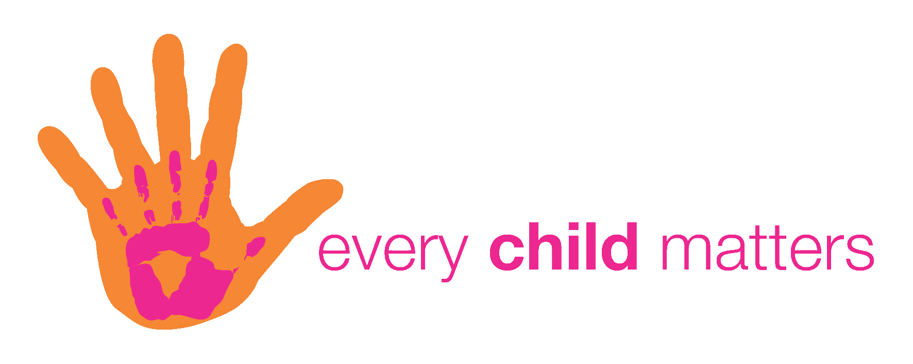

Virginia Department Of social services child abuse hotline 1-800-552-7096

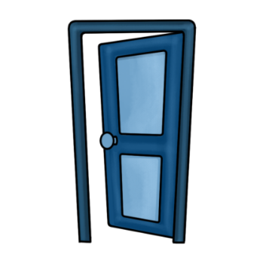
Visitors
You may schedule a time to visit/ participate in a classroom event in advance with your child’s lead teacher and coordinated with the Director for approval.
We encourage you to volunteer in our many events throughout the year, a list of events is posted outside Fleming Hall for your convenience.
Access to the classroom and children is with the teacher’s full particiaption and responsibilty.

At no time will the children be left in the care of a visitor, or volunteer.

Our teachers will follow St. Paul’s Preschool Guidelines and rules of conduct at
all time. The children’s well-being and safety is our primary concern.

St. Paul’s Episcopal preschool is licensed by the Virginia Department of Social Services.

*Please sign and return this page to the preschool office.

Parent’s Agreement:

____ I consent to the enrollment of my child in St. Paul’s Episcopal Church Preschool and agree that the preschool shall not be responsible in case of illness or injury of the child while in attendance of the preschool or in transit to and from the facility.

____ I give my consent to having pictures taken of my child while at the Preschool and the pictures may be used as the preschool so chooses.

____ I agree to carry out the rules and regulations of the Preschool as set forth in the Parent Handbook and other accompanying material.

____ I would like to receive the weekly electronic newsletter from St. Paul’s Episcopal Church.
Please send email to this address email address: ___________________________________________.

Child’s Name _________________________________________ Age______

____________________________________________________ ____________
Parent/Guardian Signature Date

