The Colorado: A River in Peril
January 8, 2024 Member Program

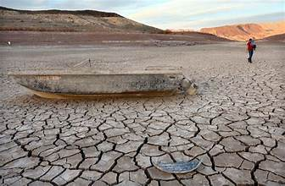
WHAT: January 2024 RMGA MEMBERSHIP MEETING –
WHEN: January 8, 2024
6:00 pm – Networking
6:30 pm – Short Meeting
6:45 pm – The Colorado: A River in Peril presented by RMGA Member Steve Kaverman
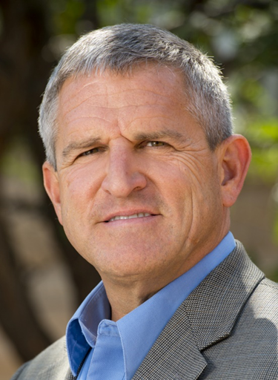
Steve Kaverman | Tourism Champion | 2024 Professional Biography
Steve Kaverman, founder of Tourism Champion, has enjoyed over 20 years as a tour director and tourist guide. He is thankful for having had the opportunity to be part of the management and tour development team for well-known tour companies with U.S., Colorado, and international operations. He is also happy to have served as a destination marketing executive, and on the Colorado Tourism Office Board of Directors. His programs and instruction have been shared on the trail, from tour conveyances of all kinds, in auditoriums, classrooms and conference rooms. Best of all says Steve, he never tires of guiding and managing tours for clients in the Denver area, where he lives, and to other favorite destinations in North America.
WHERE: The Forum Theater at Koelbel Library in Centennial and via Zoom. See below
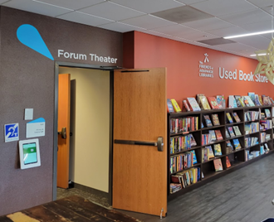
5955 S. Holly St.
Centennial, CO 80121
Phone: (303) 542-7279
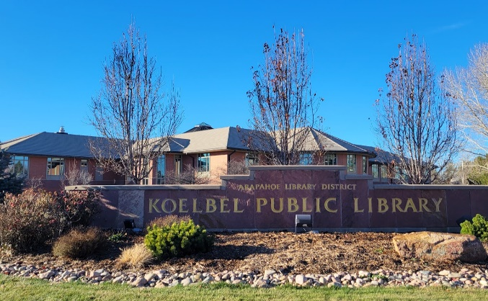 The Library
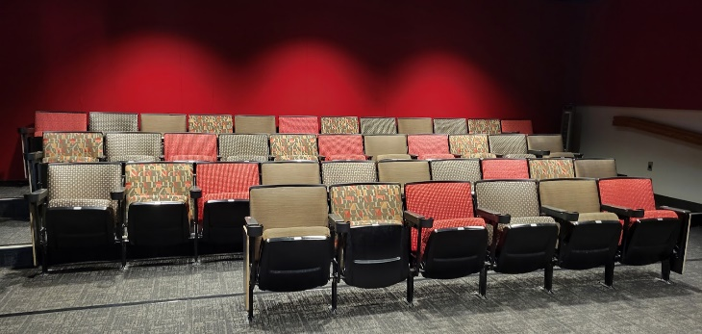 The Auditorium

ZOOM: Topic: Rocky Mountain Guides' January Member Zoom Meeting
Time: Jan 8, 2024 06:30 PM Mountain Time (US and Canada)
Join Zoom Meeting -- https://us06web.zoom.us/j/89159575176
PROGRAM: The Colorado: A River in Peril
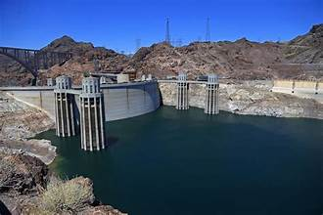
This special program will provide a perspective on the Colorado River, the dire effects of historically low water levels, and impact beyond the western U.S. More than 40 million people in seven states directly rely on water from the Colorado River.
Water conservation and agricultural productivity that benefits all Americans are key issues surrounding the Colorado River. Its water irrigates much of the richest farmland in the southwestern U.S., keeping vegetables on tables across the nation in wintertime. We will consider the prospect of low water level in the Grand Canyon and the effect on tourism. Recreation on Lake Powell and Lake Mead, the nation’s two largest reservoirs, has been impacted in recent years.
Join us for a look at these topics and learn what you can do as a destination marketing/management organization, tour operator, tour director or tourist guide to raise awareness and help preserve and protect the Colorado River.
This session will be presented by Steve Kaverman
FOOD: Bring your own water
PARKING: Parking is available in the adjacent parking lot.

GUESTS: Members are encouraged to invite potential members as guests to meeting.

GUEST FEES: 1st and 2nd Time Guest: Free, Third thru Fifth Time, Same Guest Visit is $10 each time. Succeeding Times, Same Guest Must Join RMGA.

MEETING NIGHT CONTACT: Mike Pearl (303) 868-0023 voice & text or Tom Jensen (303) 968-0515l

