REGULAR MEETING
AUGUST 13, 2014

A Regular Meeting of the Town Board of the Town of Hampton, County of Washington and the State of New York was held at the Town Hall, 2629 State Route 22A, Hampton, New York on the 13th day of August, 2014.

PRESENT: David K. O’Brien----------Supervisor
Tamme Taran--------------Councilwoman
David Jensen---------------Councilman
Donald Sady----------------Councilman
Andrea Sweeney-----------Councilwoman
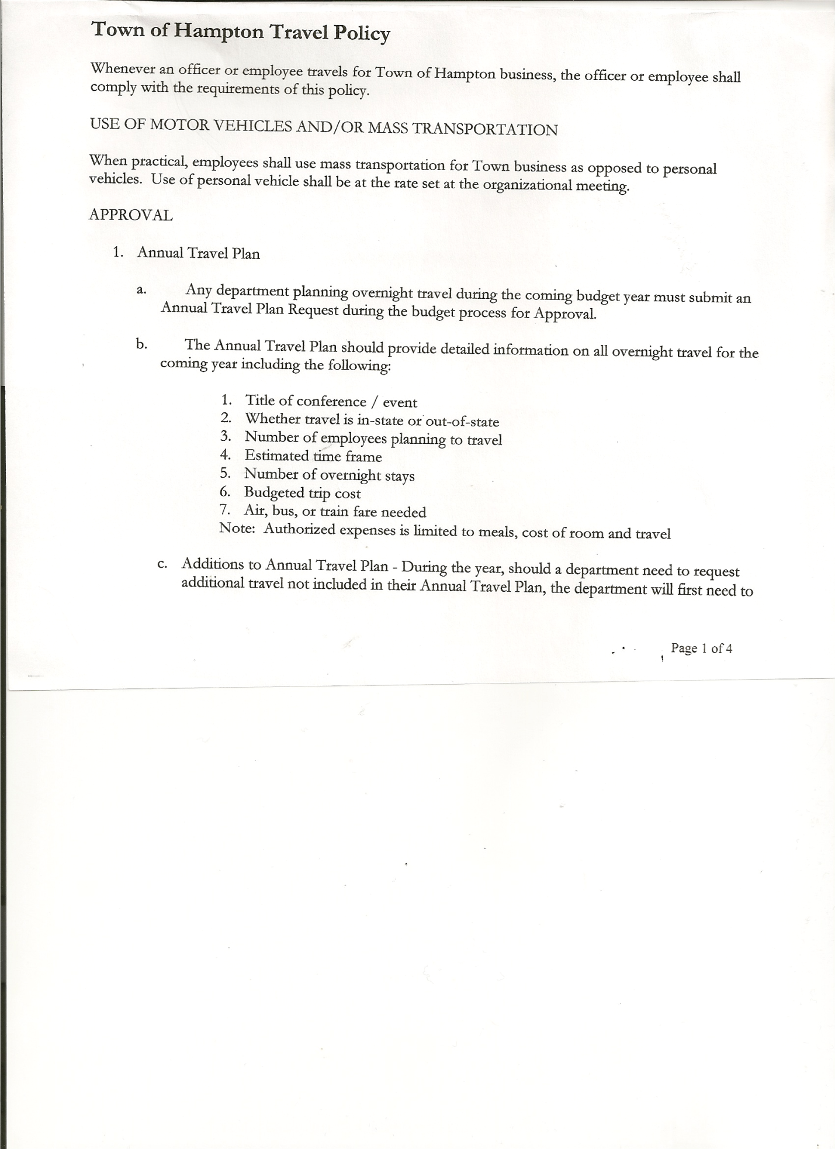
Rebecca Jones--------------Town Clerk
Camilla Shaw---------------Tax Collector/Deputy Town Clerk
Herbert Sady, Jr.------------Highway Superintendent

Planning Board Member(s): Frank Baker

Also present: See attached list

The meeting was called to order by Supervisor O’Brien at 7:30pm followed by the Pledge of Allegiance. Location of Fire Exits were given.

RESOLUTION NO. 67-2014
APPROVAL OF THE MINUTES
On a motion of Councilwoman Taran, seconded by Councilman Jensen, the following resolution was
ADOPTED: Ayes 5 O’Brien, Taran, Jensen, Sady, Sweeney
Nays 0
RESOLVED that the Regular Town Board Minutes for July 16th, 2014 are approved.

Supervisor O’Brien asked for a moment of silence in memory of past and present residents… Rita O’Rourke, Stanley Casey and Dawn Clark.

Supervisor O’Brien opened the meeting by reading the following statement:
“Before we take any comments, I wish to make a short statement. The board will not be making any comment on what remains an ongoing process. The Town Board and I have a responsibility to the taxpayer, residents, and our employees to ensure that we protect every individual’s interest, rights, and property. In the event an issue arises where there have been charges of potential misdoing, illegal action, or not following the directions or policies of any employer, we have a responsibility to ensure that any charges are investigated in accordance with established procedures and guidelines in order to protect the individual and to ensure that their rights are protected and, additionally, ensuring that the town and the its taxpayers are protected from any potential liability.

Under New York State Law the Highway Superintendent is responsible for all aspects of employment for the highway department workers. The Towns employees are part of New York State Civil Service. Civil service provides many protections for the employees. When there is a need to investigate any charges or potential wrongdoing, Civil Service has a detailed process to follow from investigation to resolution. This process is detailed in Section 75 of the State Civil

TOWN BOARD MEETING
August 13, 2014 PAGE 2

Service code. In dealing with any potential areas that may involve accusations or potential charges the Town is required to follow this process from the moment any issue is brought to the attention of the Highway Superintendent. There are strict guidelines provided through every phase of the process. Our employees covered by civil service also have the right to also reach out for assistance to the civil service office at the county or to the New York State Civil Service Commission.

As both the Chief Elected Official and Chief Financial officer of the town, I am charged to ensure that the town is in compliance with all laws and regulations including civil service and legal guidelines. My role as your supervisor is to ensure that during this process the rights of the individual and the best interests of the town are protected by adhering to both Legal and Civil Service Section 75. Failure to do so could cause violations of civil service law and Department of Labor violations.

We will limit the speaking time of those who wish to speak. We look forward to hearing your comments.”
Supervisor O’Brien also stated that no decision would be made tonight and that the Town Board only has Budget authority over Highway Department.

Cynthia Hollister, 80 Chapman Road, Hampton, stated she had been a resident since 1994 and was a previous Planning Board Member she then read the following letter..
“Members of the Hampton Town Board
Dave O’Brien, Town Supervisor
Herbert Sady, Highway Superintendent
Town of Hampton
Route 22A, PO Box
Hampton, NY 12837

Good Evening Gentlemen:

I am writing on behalf of the taxpayers and towns’ people of Hampton for answers to some questions that have come to light recently.

- In the past, it was my belief that any person employed by the town of Hampton had to be a resident and reside in the town. I am stating this, because when Malcolm Pratt was hired by the Town of Hampton, my family gave him land in Hampton for a residence so that he was able to be an employee of the Highway Department. When did a change in town law occur to allow hiring someone who does not reside in the town of Hampton? Since when is it allowed for town equipment (truck) to be used to travel outside of the town boundary to a personal residence during the work day?

- Since when is 3-4 years of experience justifiable to be given the title of “Deputy Highway Superintendent” versus 40 years of experience? Please respond with the criteria that was used to make the decision?

- When a person is elected by the people of the town to fulfill the obligations of a title “Highway Superintendent” I would expect that the person elected realizes that the responsibility that goes with the title is to ensure that all employees under his

TOWN BOARD MEETING
August 13, 2014 PAGE 3

supervision are being productive on a daily basis. In order to ensure that employees are productive and held accountable as a taxpayer I would expect that there be clearly outlined/defined expectations on record of what tasks are to be completed by each employee individually and within a certain time frame on a daily basis by all highway workers. The plans should be posted one week prior to expected completion to provide opportunity for discussion with the Highway Superintendent. If plans/tasks are changed due to weather demands, the change should be recorded as modified, not erased. The records need to be available for review by all taxpayers.

I realize that there is disagreement about how things should be done and who does what between the employees. There are times when employees must work together regardless of whether they want to or not and times when each one individually apart can complete work that needs to be done as well. It is the responsibility of the supervisor to ensure that the highway work gets done in a fair, equitable and safe manner!

Thank you for your responses in advance!
Sincerely,
Cynthia Hollister”
Cynthia also suggested that the Highway Department consider a Wood Furnace for the Highway Garage with oil furnace as a backup.

Supervisor O’Brien replied to above questions:
- Regarding residency…not aware of any policy
- Highway Superintendent can chose his own deputy
- Not answering at this time
- Wood furnace has been considered

Eric White, 137 Hills Pond Road, Hampton
- Stated he was missing wood after the storm..he helped clear road and put wood to the side… hard wood was all gone, soft wood was still there, where did the wood go? Saw town pick up and backhoe by his property
Doran Pratt, 161 Hills Pond Road, Hampton
- Stated wood was gone from his property…questioned if it was at Tatkos?
John Thomas, Jr. Hills Pond Road, Hampton
- Stated he cut 32 trees on the Hills Pond Road and South Road, only hard woods were cut back…questioned why wood was taken to Pete Tatkos..
Mary Holland, Greenfield Lane, Hampton
- Thanked everyone for coming to the meeting, saw a lot of goodness after the storm, hopes everyone will come back to next month’s meeting and that questions not answered at this meeting will be answered

Supervisor O’Brien stated that the Hearing Officer would not be from Hampton, would be a neutral individual.

Leonard Reed, 35 Queens Way, Hampton
- Asked who initiated the Executive Session last month…Supervisor O’Brien stated that Highway Superintendent Herb Sady discussed the issue with him and Supervisor O’Brien decided to call the Executive Session.

TOWN BOARD MEETING
August 13, 2014 PAGE 4

- Also commented about the ditch on Pratt Road by Warren Cemetery being hazardous…Highway Superintendent Sady replied that it was dug out after storm and will get some fill in there soon
Melissa Pratt, 160 Hills Pond Road, Hampton
- Stated that as winter approaches, people plowing across roads needs to be addressed
- Questioned the work done on South Road if it was complete
Arthur Pratt, III, 2398 County Route 18, Hampton
- Commented on the Warren Cemetery…needs to be cleaned up and fence needs to be fixed
Susan Saxton, 142 South Road, Hampton
- Commented that there were only two employees in town, can’t do everything

Supervisor O’Brien stated that New York State has no set hours for elected officials.

Cynthia Hollister further stated that all workers should be being productive and that the Highway Superintendent needs to give guidance.

Permits/Subdivision
John Mashak of Hickey Road, came before the board regarding a Subdivision. The SEQRA short form was completed.

RESOLUTION NO. 68 - 2014
SUBDIVISION – NEGATIVE DECLARATION
On a motion of Councilman Sady, seconded by Councilwoman Sweeney, the following resolution was ADOPTED Ayes 5 O’Brien, Taran, Jensen, Sady, Sweeney
Nays 0
RESOLVED to adopt a negative declaration and finding that there will be no adverse environmental impacts and to consider it a minor subdivision, therefore waving the public hearing.

RESOLUTION NO. 69 - 2014
APPROVAL OF SUBDIVISION
On a motion of Councilwoman Taran, seconded by Councilman Jensen, the following resolution was ADOPTED Ayes 5 O’Brien, Taran, Jensen, Sady, Sweeney
Nays 0
RESOLVED to approve John Mashak’s subdivision.

Justin Perry, President of Hampton Fire Department submitted request for Fire Department for 2015 budget, along with projected info for 2016 & 2017.

Planning Board Report…Francis Baker, Member
- Working on mobile home campground law
- Next Planning Board Meeting will be Tuesday, August 26th, 2014 at 7:00pm at the Town Hall

Larry Carman, Dog Control Officer submitted his report, which was read by Supervisor O’Brien… copy of report is attached for July.

TOWN BOARD MEETING
August 13, 2014 PAGE 5

Dog Renewals and Dog Enumeration….
- County cannot do a Rabies Clinic in town this year..no monies available, will work on getting one next year in our town. Supervisor will check with local vet to have a Rabies Clinic here this year.
- Will work on sending out letter to all residents regarding licensing their dogs and the concern about Rabies, Public safety and getting pets back safely

COMMUNICATIONS RECEIVED
- Workmen’s Compensation fee for 2015 will be $2294.00
- Town of Hampton’s Equalization rate for 2015 will be 105.5%
- NYS Property Tax Freeze Credit Fact Sheet

Herbert Sady, Jr., Highway Superintendent gave his report: (a copy is attached)
- Mowing Town and County road sides
- Grading roads
- Surepac on sides of South Road, Ballard & Staso Roads
- Filling potholes
- A new Alternative Sentencing person, who has 75 hours of Community Service to do
- Francis Hayes of Poultney is in the sand and gravel business if Town is interested in purchasing, price is $10 a yard not delivered
- Unifirst Corporation has indicated that there will be a substantial increase for uniform service…Town has a Contract until March 2017
- American Rock Salt, price going up, should buy early and store

RESOLUTION NO. 70-2014
APPROVAL OF SUPERVISOR’S MONTHLY REPORT
On a motion of Councilwoman Taran, seconded by Councilman Sady, the following resolution was ADOPTED Ayes 5 O’Brien, Taran, Jensen, Sady, Sweeney
Nays 0
RESOLVED that the Supervisor’s Monthly report be accepted as submitted for JULY 2014.
06/30/14 07/31/14
ACCOUNT BALANCE RECEIPTS DISBURSEMENTS BALANCE
General Fund $ 70973.40 $ 4813.21 $ 5640.85 $ 70145.76
Highway Fund $108280.89 $ 6.67 $ 59290.06 $ 48997.50
Equipment Reserve $ 85109.63 $ 7.23 $ 0.00 $ 85116.86
Fire #1 $ 15992.50 $ 0.00 $ 0.00 $ 15992.50
Fire #2 $ 4724.00 $ 0.00 $ 2362.00 $ 2362.00
Totals $ 285080.42 $ 4827.11 $ 67292.91 $ 222614.62

All Board Members present signed Supervisor’s Report.

OLD BUSINESS:
Municipal Banking…. Moving most active accounts to Citizens Bank (Town-General and Trust Accounts; Tax Collector; Town Clerk and Town Justice), leaving Highway Reserve and Highway Account at Glens Falls National.

TOWN BOARD MEETING
August 13, 2014 PAGE 6

RESOLUTION NO. 71-2014
THIRD PARTY CUSTODIAN AGREEMENT
On a motion of Councilwoman Sweeney, seconded by Councilman Sady, the following resolution was ADOPTED Ayes 5 O’Brien, Taran, Jensen, Sady, Sweeney
Nays 0
RESOLVED that Supervisor David O’Brien and Deputy Supervisor Tamme Taran sign the Third Party Custodian Agreement for Citizens Bank.

RESOLUTION NO. 72-2014
ADDITIONAL DEPOSITORY FOR THE TOWN OF HAMPTON
On a motion of Councilwoman Taran, seconded by Councilman Jensen, the following resolution was ADOPTED Ayes 5 O’Brien, Taran, Jensen, Sady, Sweeney
Nays 0

RESOLVED that Citizens Bank is an additional depository of Town funds.

RESOLUTION NO. 73-2014

MOTION BY: Councilman Donald Sady
SECONDED BY: Councilwoman Andrea Sweeney

TITLE: A RESOLUTION INTRODUCING A PROPOSED LOCAL LAW NUMBER 5 OF 2014, A LOCAL LAW TO REPEAL LOCAL LAW NUMBER 2 OF 1989.

WHEREAS, the Town of Hampton (the “Town”) adopted Local Law No. 2 of 1989, setting forth a local law entitled Amending the Ordinance Regulations of Mobile Homes and Mobile Homes and Trailer Parks of the Town of Hampton, New York; and

WHEREAS, it is the intention of the Town to repeal Local Law No. 2 of 1989 of the Town of Hampton; and

WHEREAS, a proposed local law repealing Local Law No. 2 of 1989 of the Town of Hampton has been prepared.

NOW, THEREFORE BE IT RESOLVED THAT the proposed local law repealing Local Law No. 2 of 1989 of the Town of Hampton is hereby introduced. A public hearing shall be noticed and held by the Town Board on September 17th, 2014 at 7:25 p.m. at the Hampton Town Hall to consider the proposed local law; and be it

FURTHER RESOLVED, that this resolution shall take effect immediately.

DATED: August 13, 2014 Supervisor O’Brien AYE
Councilwoman Sweeney AYE
Councilman Sady AYE
Councilwoman Taran AYE
Councilman Jensen AYE

TOWN BOARD MEETING
August 13, 2014 PAGE 7

Budget Worksheets were distributed.

The Town Clerk’s report for July 2014 was submitted to the Board. The Town Clerk had Board Members review and sign bank reconciliation statements for the Town Clerk Account and Special Town Clerk Account dated July 31st, 2014.

Tax Collector submitted Tax Collector Report for July 2014.
Board Members reviewed and signed bank reconciliation statement dated July 31st, 2014.

RESOLUTION NO. 74 -2014

AUDIT OF CLAIMS
On a motion of Councilwoman Taran, seconded by Councilwoman Sweeney the following resolution was ADOPTED Ayes 5 O’Brien, Taran, Jensen, Sady, Sweeney
Nays 0
RESOLVED that the bills have been reviewed by the Town Board and are authorized for payment in the following amounts.
General Fund No. 113 through No. 125 $ 3292.65
Highway Fund No. 82 through No. 95 $ 3125.99
Total both funds $ 6418.64

On a motion of Councilwoman Sweeney, seconded by Councilwoman Taran, the meeting adjourned at 9:17pm. All in favor Aye.

Respectfully submitted,

Rebecca S. Jones, RMC
Town Clerk

