

**SUMMER 2024 SEASON**

**WEEK 7 – 15th May 2024**

**PRECISION SHOOTING CUP**

19 Players took part this year, the same as last year with some new players taking part which is good to see.

Five separate disciplines are undertaken in the Precision Shooting with a maximum available score of 100 points, although the world record is 67 achieved by Christophe Sevilla in July 2011.

After Round 1 the scores were as follows:

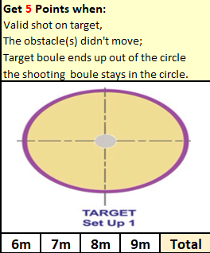

|  |  |
| --- | --- |
| Andrew Bellamy-Burt | 9 |
| Branden De La Haye | 0 |
| Brian Harris | 6 |
| Callum Stewart | 4 |
| Cassie Stewart-Le Gallais | 1 |
| Daniel Deveau | 3 |
| Francis Corbally | 0 |
| Gary Cowburn | 0 |
| Geoffroy Buffetrille | 6 |
| Jean Stewart | 3 |
| Keith Pinel | 3 |
| Keith White | 3 |
| Laurent Pellaton | 0 |
| Lorna Limbrick | 1 |
| Matt Pinel | 0 |
| Ross Payne | 6 |
| Toby Northern | 7 |
| Tommy Walsh | 0 |
| Wendy Ritzema | 3 |

An impressive start for Andrew with 9 points, but shows the importance of starting off well with several players failing to score.

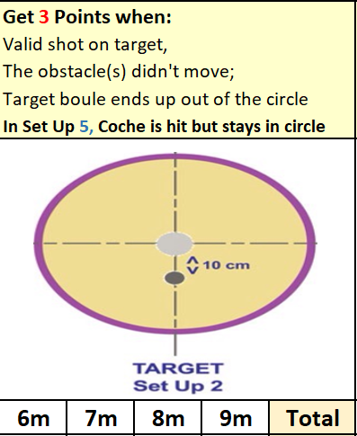

|  |  |  |
| --- | --- | --- |
|  | Round 2 Score | Total |
| Andrew Bellamy-Burt | 5 | 14 |
| Branden De La Haye | 0 | 0 |
| Brian Harris | 5 | 11 |
| Callum Stewart | 0 | 4 |
| Cassie Stewart-Le Gallais | 3 | 4 |
| Daniel Deveau | 3 | 6 |
| Francis Corbally | 0 | 0 |
| Gary Cowburn | 0 | **0** |
| Geoffroy Buffetrille | 0 | 6 |
| Jean Stewart | 1 | 4 |
| Keith Pinel | 0 | 3 |
| Keith White | 2 | 5 |
| Laurent Pellaton | 3 | 6 |
| Lorna Limbrick | 3 | 4 |
| Matt Pinel | 1 | 1 |
| Ross Payne | 3 | 9 |
| Toby Northern | 5 | 12 |
| Tommy Walsh | 1 | 1 |
| Wendy Ritzema | 3 | 6 |

A few 5 point shots for a number of players in this round with a much more difficult shot required showing in the low scores.

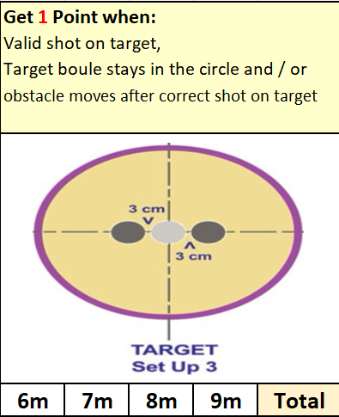

|  |  |  |
| --- | --- | --- |
|  | Round 3 Score | Total |
| Andrew Bellamy-Burt | 1 | 15 |
| Branden De La Haye | 0 | 0 |
| Brian Harris | 2 | 13 |
| Callum Stewart | 2 | 6 |
| Cassie Stewart-Le Gallais | 4 | 8 |
| Daniel Deveau | 1 | 7 |
| Francis Corbally | 1 | 1 |
| Gary Cowburn | 6 | **6** |
| Geoffroy Buffetrille | 10 | 16 |
| Jean Stewart | 0 | 4 |
| Keith Pinel | 0 | 3 |
| Keith White | 3 | 8 |
| Laurent Pellaton | 0 | 3 |
| Lorna Limbrick | 0 | 4 |
| Matt Pinel | 11 | 12 |
| Ross Payne | 3 | 12 |
| Toby Northern | 6 | 18 |
| Tommy Walsh | 3 | 4 |
| Wendy Ritzema | 1 | 7 |

After three rounds Toby lead the way scoring 6 points but big scores from Matt Pinel with 11 put him back in contention as well as Geoffroy with 10.

|  |  |  |
| --- | --- | --- |
|  | Round 4 Score | Total |
| Andrew Bellamy-Burt | 0 | 15 |
| Branden De La Haye | 0 | 0 |
| Brian Harris | 8 | 21 |
| Callum Stewart | 6 | 12 |
| Cassie Stewart-Le Gallais | 3 | 11 |
| Daniel Deveau | 0 | 7 |
| Francis Corbally | 0 | 1 |
| Gary Cowburn | 0 | **6** |
| Geoffroy Buffetrille | 6 | 22 |
| Jean Stewart | 1 | 5 |
| Keith Pinel | 1 | 4 |
| Keith White | 0 | 8 |
| Laurent Pellaton | 3 | 6 |
| Lorna Limbrick | 0 | 4 |
| Matt Pinel | 3 | 15 |
| Ross Payne | 0 | 12 |
| Toby Northern | 0 | 18 |
| Tommy Walsh | 0 | 4 |
| Wendy Ritzema | 0 | 7 |

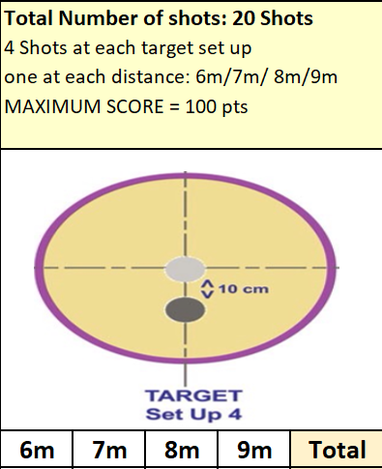

Probably the most difficult one of the five disciplines saw low scores but Brian Harris scored an impressive 8 points and made the required score to go through with still the jack to go as did Geoffroy & Toby.

|  |  |  |
| --- | --- | --- |
|  | Round 5 Score | Total |
| Andrew Bellamy-Burt | 0 | 15 |
| Branden De La Haye | 0 | 0 |
| Brian Harris | 0 | 21 |
| Callum Stewart | 5 | 17 |
| Cassie Stewart-Le Gallais | 0 | 11 |
| Daniel Deveau | 3 | 10 |
| Francis Corbally | 0 | 1 |
| Gary Cowburn | 0 | **6** |
| Geoffroy Buffetrille | 5 | 27 |
| Jean Stewart | 5 | 10 |
| Keith Pinel | 5 | 9 |
| Keith White | 0 | 8 |
| Laurent Pellaton | 3 | 9 |
| Lorna Limbrick | 3 | 7 |
| Matt Pinel | 5 | 20 |
| Ross Payne | 8 | 20 |
| Toby Northern | 5 | 23 |
| Tommy Walsh | 0 | 4 |
| Wendy Ritzema | 0 | 7 |

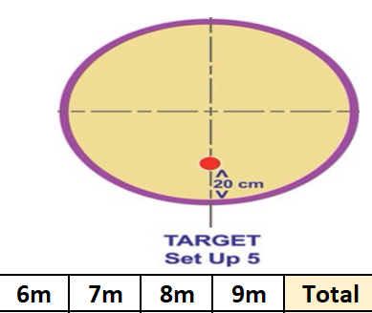Ross Payne was the Jack master hitting 8 points to score very well in this round and go through. This was the same for Matt Pinel whose 6m hit got him through.

Some disappointing scores though with 13 players all surprisingly failing to get the minimum required. Several players one hit away from getting through though, with Andrew finishing on 15.

So this year 6 players qualified for the knockout stage compared to three players last year. This meant a second qualifying round with the top two going through to the final and the third highest finishing third.

Brian Harris topped the score on 31 to make the final, joined by Geoffroy. The third place went to Ross Payne for the third year running.

In the final Geoffroy lead all the way and finished with two Jacks to score the competitions highest this year with 32 to Brian 20.

**Winner – Geoffroy Buffetrille**

Huge thank you to Geoffroy Buffetrille, Laurent Pellaton and Matthew Pinel for helping run the event, very much appreciated by all those taking part.

**NEXT WEEK - SINGLES LEAGUE**

Club email address - [liberationpc@gmail.com](mailto:liberationpc@gmail.com)

Club Website - [www.liberationpetanque.co.uk](http://www.liberationpetanque.co.uk)

Kind Regards

Toby Northern

Chairman

Liberation Petanque Club