

2017
Liberation Singles Open

The 2017 Liberation Singles Open saw 36 players take part, in the glorious sunshine. It was the clubs first competition on the newly laid terrains.
Some interesting results in round one as Tom McMinigal beat Toby Northern 13-8, Andrew Bellamy-Burt fannied Matt Scholefield and Geoffroy Buffetrille lost to Mike Fennel.
Round 2 saw another fanny certificate as Matt Pinel beat James Rondel 13-0 as did Geoffroy over Lorna Limbrick. Gordon De Gruchy made it two wins beating Keith Pinel 13-12 and Andrew Bellamy-Burt lost in successive years to Brian Harris.
Tom McMinigal continued in fine form beating Chris Romeril and Toby Northern beat Ian Black.
Round three saw Tom lose 13-1 to Mark Nicol and Ian Foster become the forth player to get fannied, this time Michel Morel was the one handing out the certificate.
Ross Payne beat Richard Williams and Keith Pinel beat Geoffroy and Matt Pinel made in three wins in a row over Brian Harris.
Round 4 Ross Payne beat Seb Renaud to move into contention as did Toby Northern beating Neil Selby 13-9. Tom McMinigal made it 3 wins in 4 with a win over Andrew Limbrick as did Gordon De Gruchy over Brian Harris.
Final round of the SWISS System saw Mark Nicol beat Matt Pinel 13-12, but both were already guaranteed a place in the quarter finals.
Despite losing 13-4 against Joey Le Clech 13-4 Keith Pinel pipped Gordon De Gruchy to 8th place on points difference. Chris Romeril beat Bob Morel to make 7th place winning 4 of his matches as did 6th place Andrew Bellamy-Burt 5th place Michel Morel beat Ross Payne 13-2, Joey LE Clech 4th, Tom McMinigal beat Jake Romeril to make 3rd.
Last years Winner Matt Buesnel finished 28th place with just 2 wins - 3

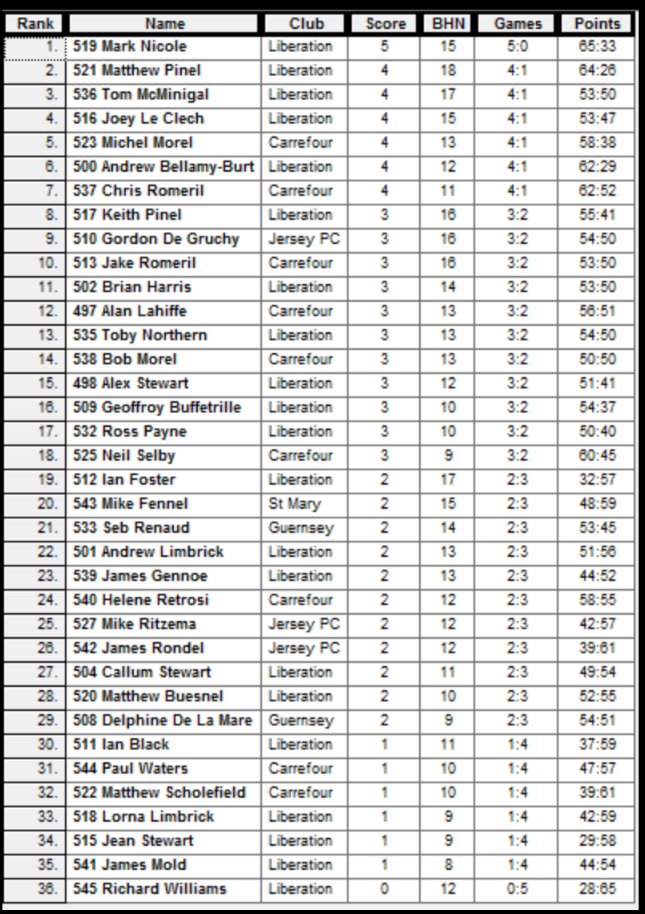

In the quarter finals Joey Le Clech beat Michel Morel 13-12 in a surprise result and Keith Pinel admitted defeat before he even played against Mark Nicol.
Andrew Bellamy-Burt didn’t let Tom McMinigal get into the game winning comfortably and Matt Pinel also got through beating Chris Romeril.
The semi-finals saw Mark Nicol start and finish well against Joey Le Clech whose form dipped in the Semi-Finals. Matt Pinel though was thoroughly out played by Andrew who played the game of his life to beat Matt.
Matt Pinel beat Joey to take 3rd place.
The final was end to end in a great display of placing and firing but Andrew fell just short missing a placing to take it to the final end, so Mark ran out 13-11 title winner. Mark is the first top ranked player (after the Swiss rounds) to go on to win the tournament, well done Mark.
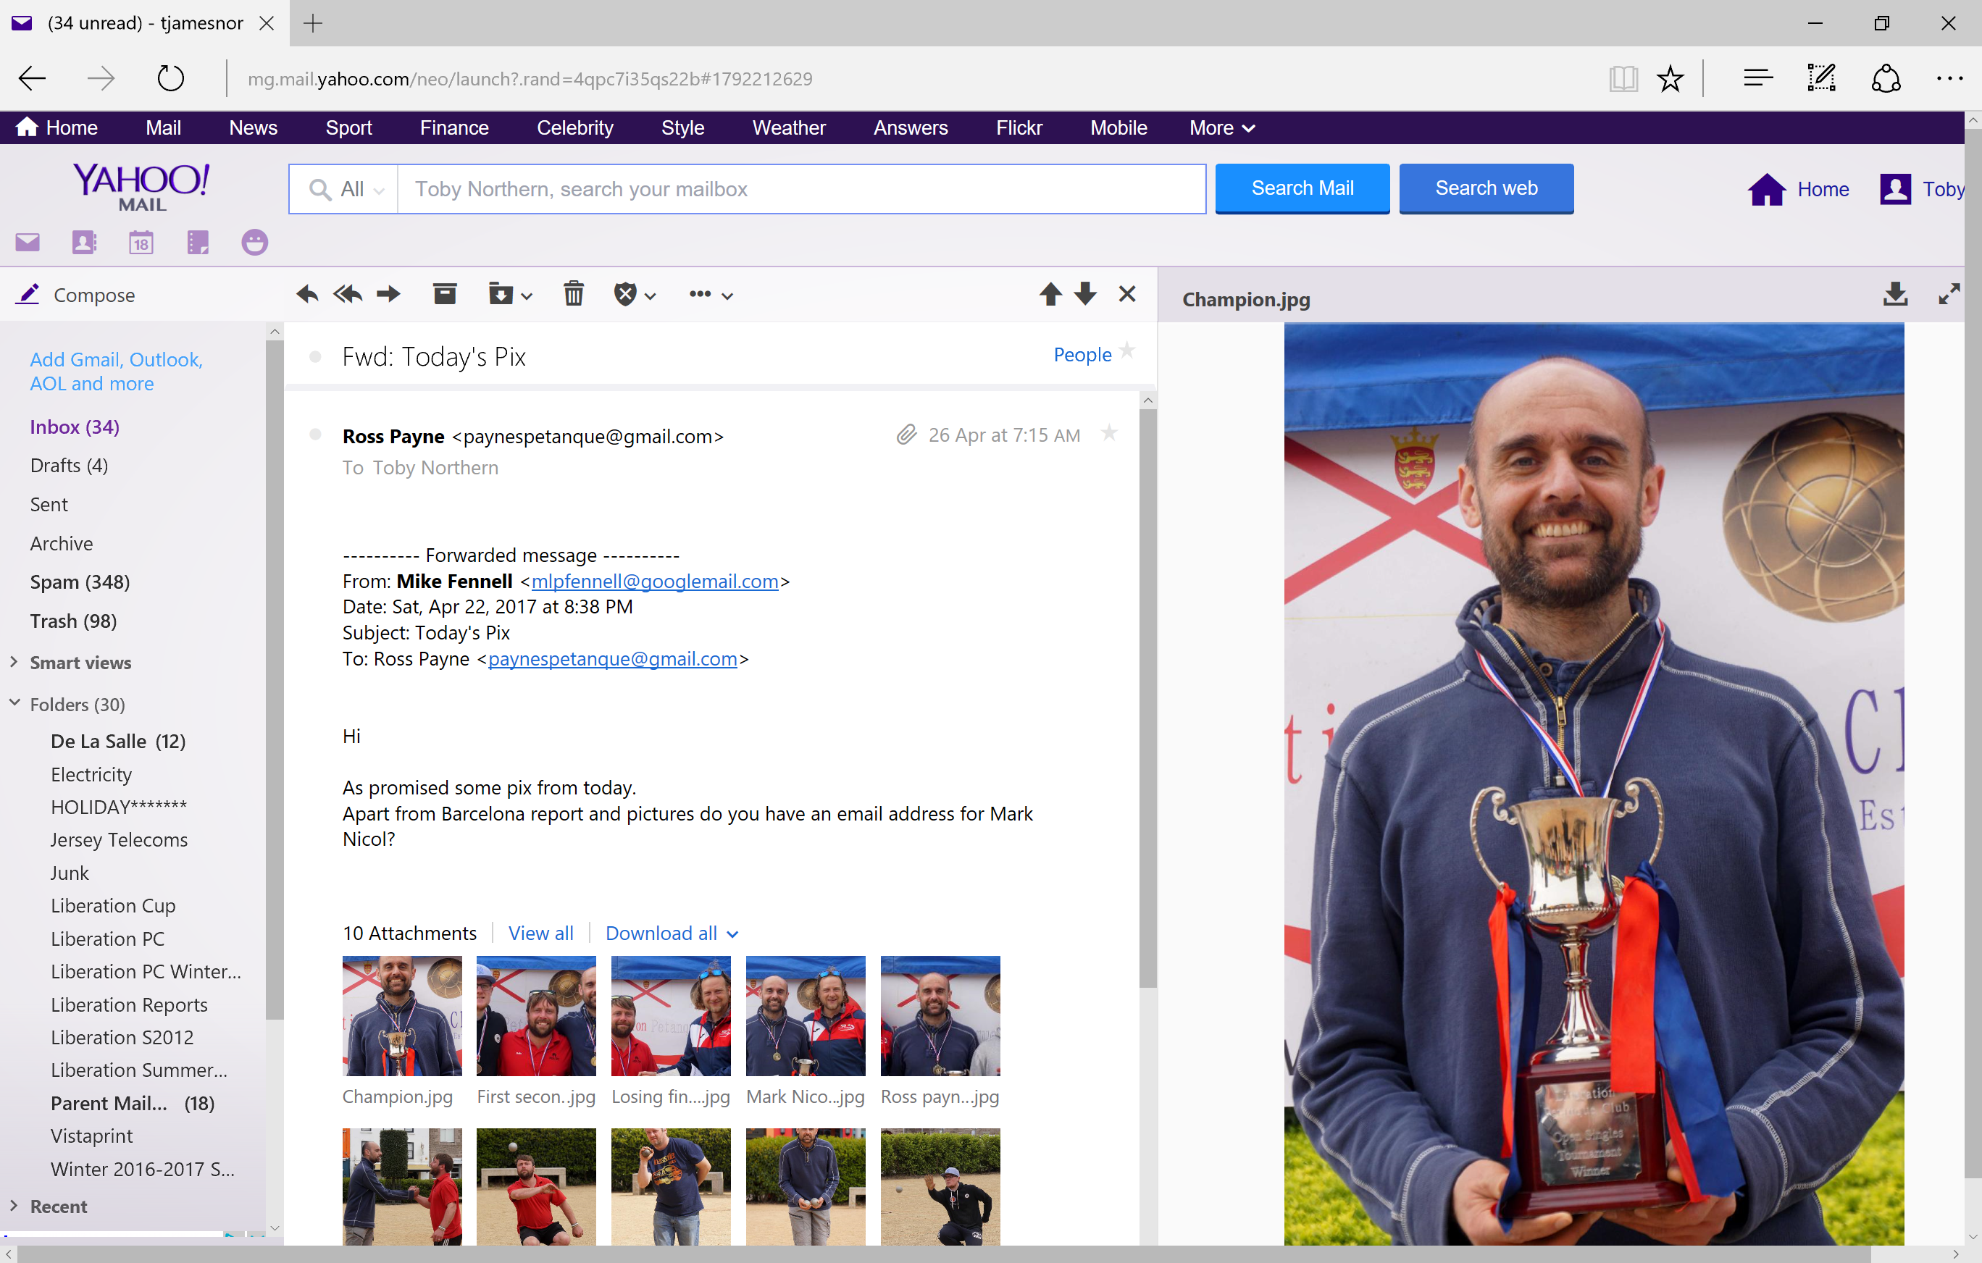

Club email address - liberationpc@gmail.com

Club Website - www.liberationpetanque.co.uk

Kind Regards

Report Editor

Toby Northern

Liberation Petanque Club

SPONSORED BY

