+

**A Word in Your Ear**

The Swindon Hearing Support Team’s Newsletter Issue 7, October 2019

**Welcome Back!**

We hope you have had a brilliant first term. It has been extremely busy here with lots of training for settings and other professionals.

**HST**

**Hearing Support Team**

[HSTAdmin@swindon.gov.uk](mailto:HSTAdmin@swindon.gov.uk)

01793 544021

**Logo Competition Winner**

Some of you may have noticed that we have been using a new logo on our reports.

Well done to Tanmaiyee for your outstanding design –thanks for your help with our new logo!

Your logo ideas were really good and we have been able to use lots of your ideas.

We would have loved to have used as many colours as you did in your design but the ink would be very expensive every time we printed out something with our logo on. We print out lots and lots of things with it on. We used your hands idea to be a tree trunk and thought it also looked like signing hands. We made it into a tree trunk as it grows and supports the branches. We thought this was like us supporting the pupils we visit. We made the canopy of the tree out of ears for all the different pupils we support who have all have different hearing losses and use lots of different equipment to help them. We tried to make the ears/leaves look like the ear you had in your design.

We also put HST under the logo as we liked the way you had done that.

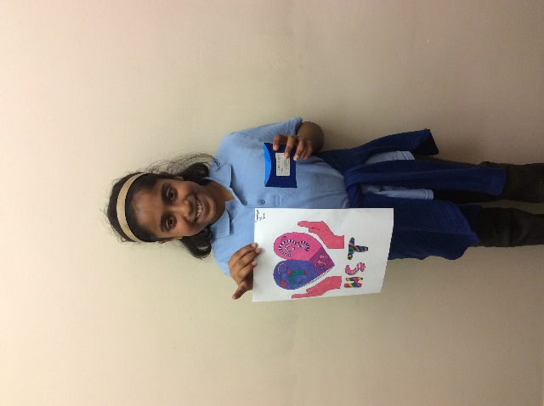

**Advisory Service Review**

Swindon Borough Council are currently reviewing all of the Advisory Services, including the HST. As part of the process they will be seeking feedback from the people who use the services. Please take time to respond, it is important that you views are heard.

Dates for the Diary 

22nd- 4th November- HST staff will be on October Break 6th November – Little Steps begins again, 9:30-11:30am weekly at The Dorcan Academy

14th November – Children’s Hearing Services Working Group (CHSWG) Meeting at Salt Way Centre, 9.30 – 12.00. Everyone welcome!

20th December – 6th January- HST Staff will break for Christmas.

**Privacy Notice**

Our privacy statement (to comply with GDPR) was distributed in the summer term. We would be very grateful if families could complete the form return it to us (a SAE was included) so that we can fully support your child. Please contact your AToD or [HSTAdmin@swindon.gov.uk](mailto:HSTAdmin@swindon.gov.uk) for an electronic copy if you have misplaced it.

Swindon

**Little Steps Trip to Roves Farm**

Little Steps had their first summer trip to Roves Farm in July and great fun was had by all! The pre-schoolers enjoyed Toddler Time before heading off to meet the animals. The children fed the goats and their kids!

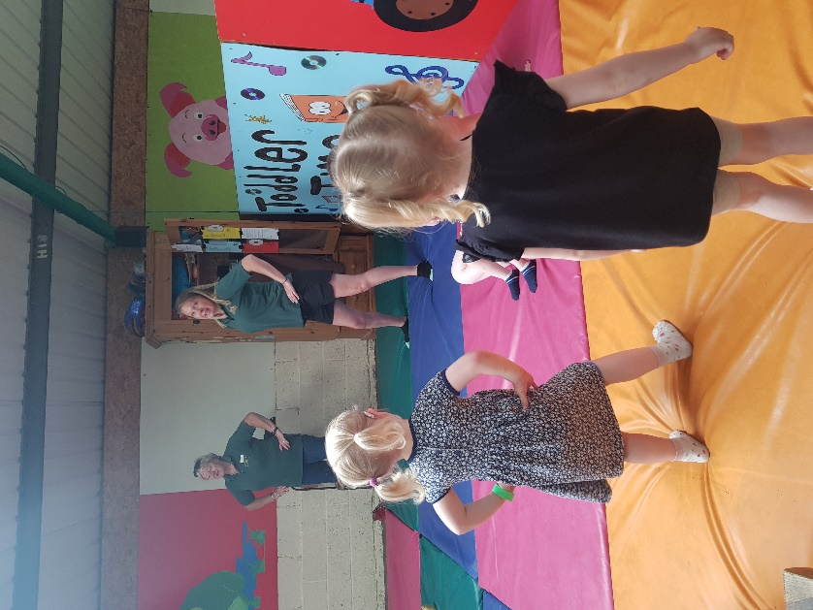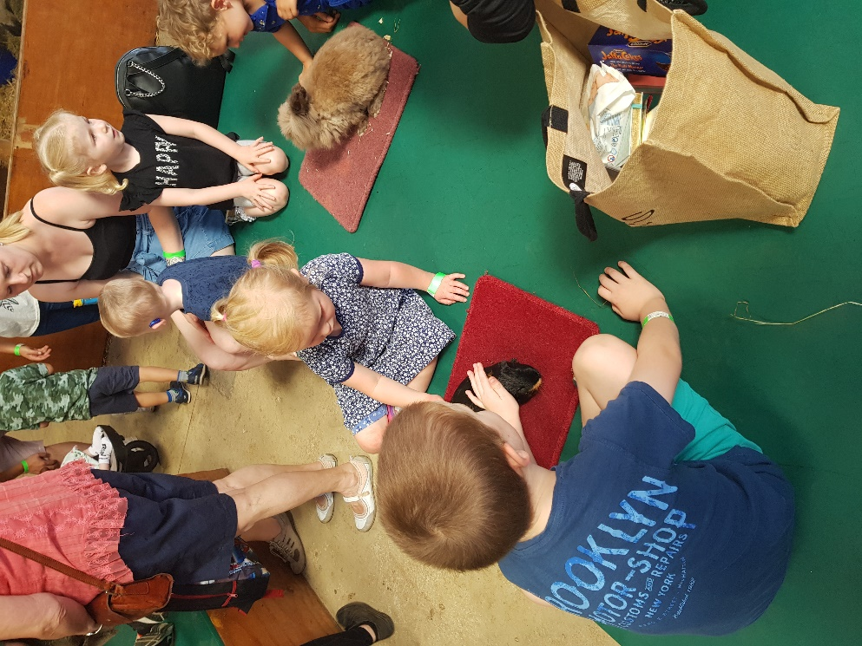

One of the highlights of the day was hitching a ride on the tractor for the Bear Hunt! We went through the long, wavy grass, the splashy river and the squelchy mud. We couldn’t go over it, we couldn’t go under it we had to go through it! Finally, we found the bear hiding in the cave! What a beautiful day!

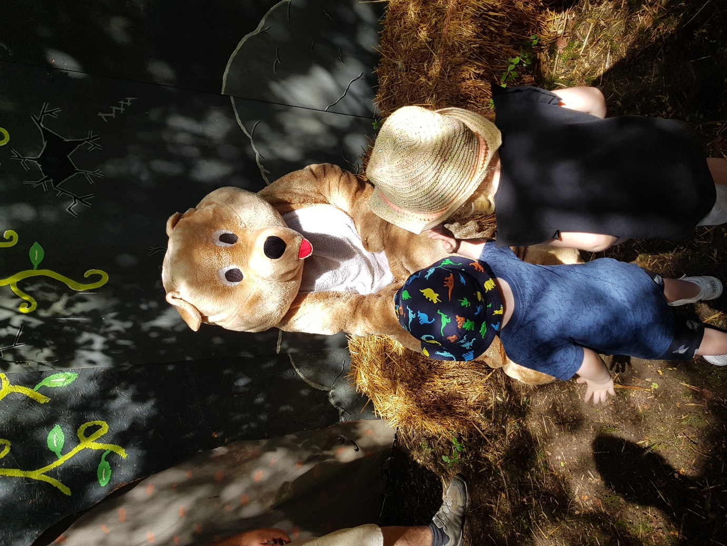

Little Steps will resume weekly from the 6th November 9:30am-11:30am. Our theme for next term is **vehicles.**

Look out for special visitors and upcoming trips!

Keep in Touch

Our main office is now located at:

The Dorcan Academy

St Paul’s Drive

Swindon SN3 5DA

Heather Campbell 07727 197219

hcampbell@swindon.gov.uk

Jill Nokes 07727 188395

jnokes@swindon.gov.uk

Jo Coote 07727 189143

jcoote@swindon.gov.uk

Nida Batchelder 07727 099584

nbatchelder@swindon.gov.uk

Jenny Wilkins 07727 112245 (text only)

jwilkins2@swindon.gov.uk

Joanne Cooke 07727 127439

Jcooke3@swindon.gov.uk

Local Deaf Children’s Society Events

**TECHNOLOGY EVENING** –28th November

A casual evening with meal & presentations from suppliers of fabulous technology for deaf children.

**FATHER CHRISTMAS OUTING** – 8th December

A great day out to meet Father Christmas and have fun with friends for younger members.

**How to book**: All of DCS events are shown on their website: <http://www.swindonandnorthwiltsdcs.org/events.html> and further details will be updated nearer to the time on the website, Facebook Group and by email.

**VOLUNTEERS**…The SNWDSC are always on the lookout for volunteers for their events and to join the exciting committee.

If you think there is something you can offer or you can just come along and lend a hand, then please contact them by email at any time.



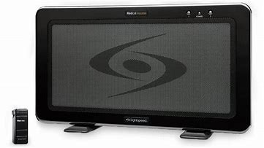 **Portable Soundfields**

The HST have 4 portable Soundfield systems that are available, where appropriate on a 6 week loan trial to settings.

Please be aware due to budget constraints systems cannot generally be provided by the HST for long-term use in the same way as we provide radio aids. The Soundfields benefit the whole class and staff.

They can be purchased from the manufacturers for about £1000 and we already have settings who have funded their purchase through various routes.

Please let your Advisory Teacher of the Deaf know if you would be interested in borrowing a system.

**Phone-in Wednesdays**

One of our team will be available every Wednesday from **9.30am – 11.30am** to answer queries that you may have on deafness, support, education and hearing technologies for deaf children in Swindon. We will do our best to support you and answer your queries.

Please feel free to contact us on 01793 544021.

**Please note the change of time**

Have you seen…? **999 Text Service**

This is a service where you can text to get help from the Emergency Services.

Look at these websites for more information and how to register:

<https://www.signhealth.org.uk/health-information/emergencies/>