

# 2020

# Ladies Singles Open

# 

Liberations 3rd Annual Ladies Singles Open had 10 entries playing in much better weather than last years rain and muddy puddles..

Round 1 saw Margaret Robinson provide a shock as she beat Jean Stewart, 2019 Runner Up 13 – 10. Current champion Joy Hart won comfortably against Lorna 13 – 5 in what was expected to be a much closer match.

Mo De Gruchy picked up a big win over Vanessa Nash 13 – 4 for a great start to the competition. Janet Gallichan beat namesake Kim 13 – 8 for as good start to the tournament with Kim playing her first ever tournament.

In Round 2, a result that made all the difference at the end of the qualifying rounds as Jean beat Janet 13 – 0 for a vital points difference boost. Joy won again this time over Margaret for a good start to her defence of the title.

Brigitte lost heavily to Vanessa 13 – 5 and Nicky beat Kim as a host of players on one win after two rounds but leading the way was Mo who beat Lorna 13 – 2.

Round 3 saw Joy beat Jean in a result which looked to have ended Jean’s chances of a top four place. Nicky moved onto two wins with a 13 – 8 result against Janet and Lorna won her first match against Brigitte for her second loss, both players on one win.

The final round saw Nicky beat Joy to go through with three wins in 3rd place with Joy retaining 2nd place after Mo won her fourth straight match but only just 13 – 12 over Kim. What a difference a year makes as Mo finished bottom last year with 1 win -30 but finished top with 4 wins +28, what an improvement and great performance.

Lorna had a big 13 – 3 win over Margaret to finish the competition strongly with two wins, unfortunately a -6 points difference though saw her finish 7th with Margaret finishing 8th with one win.

Brigitte also won her last match 13 – 6 over Janet to finish on two wins with a level points difference to finish 6th.

Vanessa’s 13 – 10 defeat to Jean meant she finished 5th with two wins +2 to fourth place Jean who had 2 wins +7 thanks to the 13 – 0 in round 2.

FINAL STANDINGS

1st Mo De Gruchy 4 wins +28

2nd Joy Hart 3 Wins +15

3rd Nicky Maindonald 3 Wins +12

4th Jean Stewart 2 Wins +7

5th Vanessa Nash 2 Wins +2

6th Brigitte Ibitson 2 Wins +0

7th Lorna Limbrick 2 Wins -2

8th Margaret Robinson 1 Win -20 (points scored 29)

9th Janet Gallichan 1 Win -20 (points scored 27)

10th Kim Gallichan 0 Wins -18

So the semi finals were as follows:

Ranked 1st Mo De Gruchy v Jean Stewart Ranked 4th

Ranked 2nd Joy Hart v Nicky Maindonald Ranked 3rd

The first semi final saw a very close match, but Mo fell foul of the top ranked curse just losing to Jean 13 – 11.

Well Nicky had just beaten Joy in the final round of qualifying 13 – 8, so would have been confident, however Joy is very experienced in the latter stages of competitions but a close match with Joy just edging it 13 – 10.

Mo De Gruchy capped off a fine tournament with a third place finish beating Nicky 13 – 3for that Bronze medal and prize money.

So a repeat of the 2019 final between Jean & Joy which Joy won 13 – 10. Despite losing to Joy 13 – 7 in round 3 Jean played really well taking the title 13 – 8 to become the second person to get their name on the trophy.

Well done to everyone who took part and special thanks to Matt Ryan for running the competition on the day.

So Jean Stewart is the new Ladies Singles Open Champion

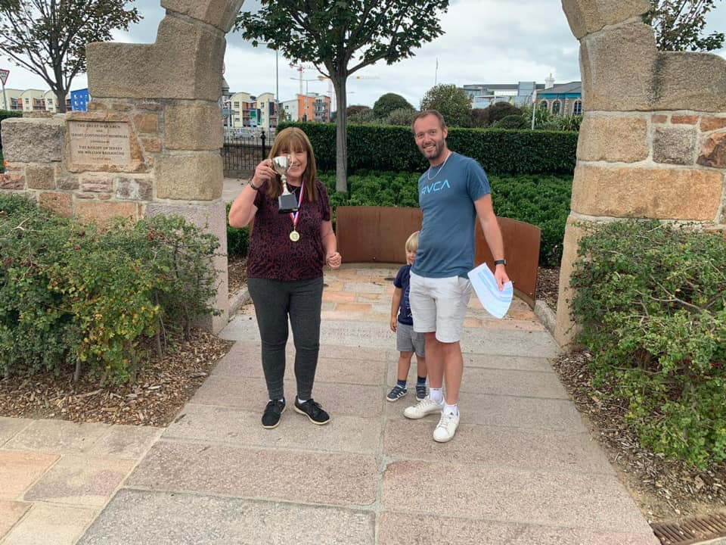

We hope you will all be back next year and hope you can help make it bigger and better.

**WEBSITE** [**www.liberationpetanque.co.uk**](http://www.liberationpetanque.co.uk)

**EMAIL** [**liberationpc@gmail.com**](mailto:liberationpc@gmail.com)

**Kind Regards**

**Toby Northern**

**Chairman**

**Liberation Petanque Club** SPONSORED BY

# http://nebula.wsimg.com/135a1bd6338e1b589a50cdec98bd84d1?AccessKeyId=C6E923731F1A482DD910&disposition=0&alloworigin=1