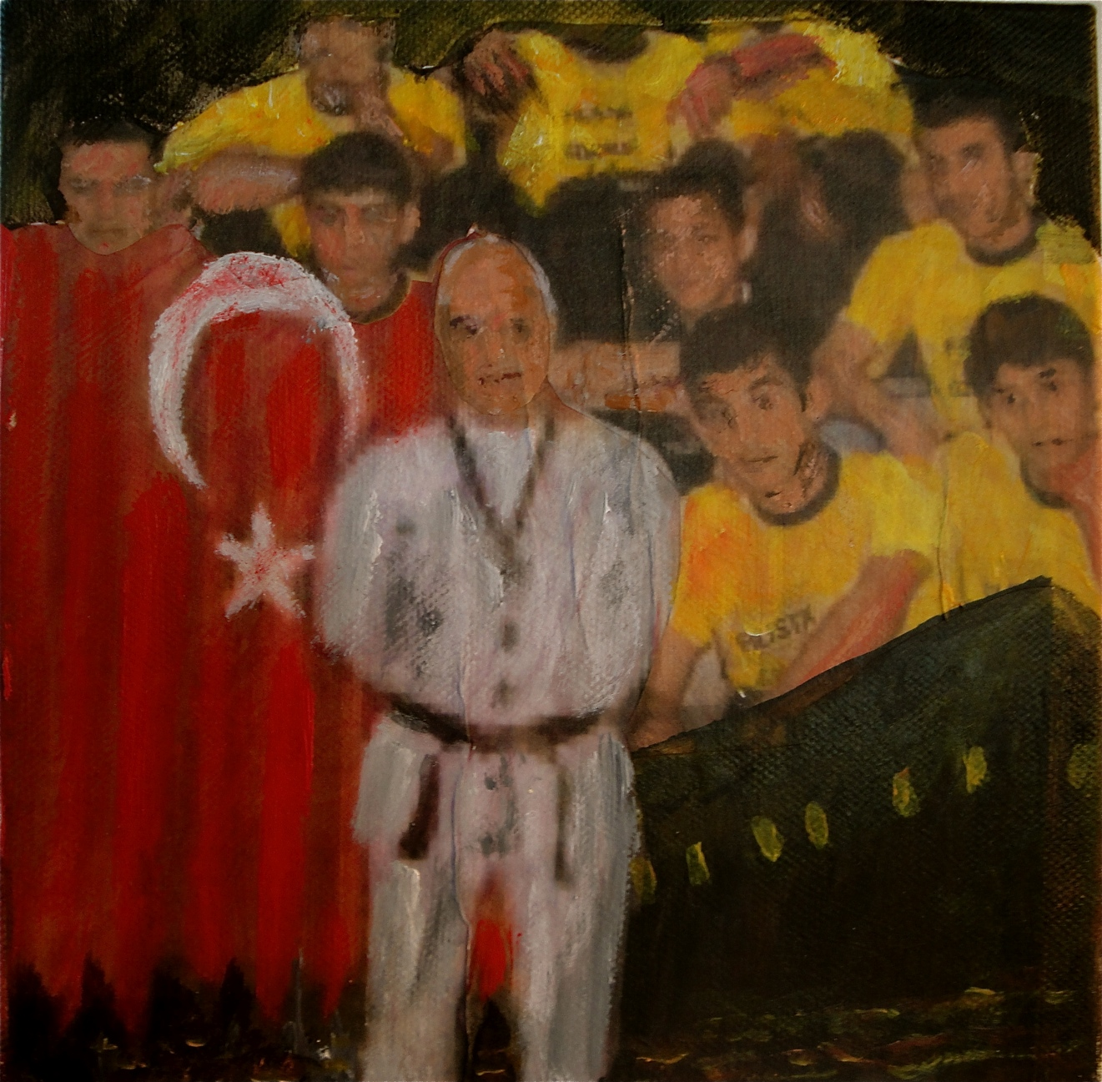
ÇETIN TOPÇUOĞLU, 54

Çetin was a gifted athlete who was both a world champion of Taekwondo and an award-winning referee and coach. Born in 1956 he worked as a public worker and his entire life was dedicated to humanitarian activities. He was an advocate for the disadvantaged and abused. He and his wife were dedicated to working with youth in cultural, educational organizations. They had worked as volunteers with the IHH Adana Humanitarian Aid Organization for years. Çetin had the discipline and determination of an athlete when focused on causes as the situation of the Palestinians and challenging the blockade of Gaza. When asked what they could offer for the Flotilla, he said “As much as we can.” He and his wife offered all their abilities for the Flotilla campaign to show solidarity with Palestinians.
His last words on boarding the flotilla, bidding goodbye to his friends were, “We conquered the world of taekwondo and now it is time to conquer the hereafter, Allah willing.”
Çetin was shot in the back of the head, on his left side and his right belly. A Sports Hall Project is being sponsored in his honor by IHH in Turkey. A street was named in his honor by the Greater Municipality of Ankara in the Çukurambar quarter of Çankaya district as Şehit ÇetinTopçuoğlu.

