Being Systematic About Outdoor Gear
(Provided by: HighCountryExplorations.com)

Nothing dooms a trip like slipshod preparation. It only takes one or two little mistakes. Many a veteran backpacker has seen a trip ruined for lack of a map, knife, salt or match. Still more common is the beginner who, determined to camp in comfort, can barely stagger up the trail under a gargantuan load. . . . By systematizing the job to reduce the work, one can make getting ready a pleasant prologue to the trip.
—Robert S. Wood, “Getting Ready,” The Best
About Backpacking, page 13

A system is a set of components that work together to achieve one goal. These components may change with climate or personal needs. Systems needed for backpacking include a cooking system, a sleeping system, a shelter system and a pack system.
—Carol Wellman (“Brawny”), My Journey to Freedom and
Ultralight Backpacking (Fire Creek Press), page 112

Central Issues Addressed in This Article
What does it mean to take a highly systematic approach to outdoor gear? How useful would be the idealized nine-step approach to outdoor gear recommended in this article? What approach do you currently use in dealing with your outdoor gear and how effective is it? Do you maintain a computerized master list (spreadsheet?) of all your gear? What are the pros and cons of being quite systematic in organizing gear for trips into the wilderness? When, if ever, should you take such an approach?
Introduction
Most hikers will take a systematic approach to their gear at some time or other (e.g., preparing for long trips or expeditions farther away from civilization). Most will not be systematic when going on a short day hike of only a few hours. But what is involved in being systematic, either for all trips or only on special trips?
This article is based upon two closely related concepts: being “systematic” (an adjective) and conceptualizing and utilizing a “system” (a noun). The Oxford American Dictionary defines the former as “done or acting according to a fixed plan or system; methodical.” It defines the latter as “a set of connected things or parts forming a complex whole, in particular, a set of things working together as parts of a mechanism or an interconnecting network.” In this article, I will use both concepts, sometimes independently and sometimes together.

Systematic Process for Selecting and Organizing Gear: Short Version
The body of this article describes an idealized nine-step process for selecting and organizing gear. To provide an initial understanding of this recommended process up front, here is a highly condensed version:

• Carefully select your CATEGORIES for developing gear lists.

• Construct a MASTER GEAR LIST using the chosen categories.

• From your master gear list, develop a CUSTOMIZED GEAR LIST for each trip of any duration.

• Develop detailed SUBSYSTEM LISTS of gear options (e.g., cooking, sleeping, packing, footwear, navigation) for the most important and most problematic categories.

Why Use a Systematic Approach?
Before getting into the details of my recommended systematic approach, it is important to answer the Why? question. Especially, why should an experienced hiker be concerned with such a mundane topic as gear lists and gear organization? Isn’t this something that properly belongs in How To articles for novices?
There are many reasons for being systematic, but the short answer is: our life and well-being, as well as the well being of others, may depend upon it. The reference to “others” here includes search and rescue (SAR) personnel. Here are four more reasons:

- • The longer the journey and the further from the trailhead, the more important our gear choices become.

- • Being systematic becomes much more important if going light or solo.

- • Well-constructed gear lists are essential to fully enjoy backcountry adventures, especially those that are different from our usual trips.

- • The more gear we accumulate and the more skilled, knowledgeable and experienced we become, the more choices we are faced with regarding effective use of our gear.

The above provides some concise answers to this Why? question. A more detailed and in-depth answer will be offered in a later section after an exposition of my recommended nine step processes.

Preparing for Longer Backcountry Trips Systematically: a Nine-Step Process
Consider the following idealized and highly systematic approach to organizing and selecting gear. These nine steps are most important if you regularly take longer trips into the backcountry. The steps are listed in a logical, but not rigid order.

STEP ONE—Careful Selection of Gear Categories (Subsystems)
There are many ways to organize and select gear for a trip. Some are very elaborate spreadsheets; others scribble a few notes on a piece of paper at a planning meeting. One recommended list uses six basic categories: carried clothing, worn clothing, essentials, luxury and comfort items, consumables, shared group gear. Colin Fletcher, in his Complete Walker series, has constructed an extensive master gear list using the analogy of house and home to categorize: foundations, walls, kitchen, clothes closet, furniture and appliances, etc. Even though breakdowns like these are interesting and make sense, my research and gear priorities lead me to select the following longer list of categories for my gear lists.

Footwear System
Packing System
Shelter and Sleeping System
Base-layer Wicking Clothing
Mid-layer Insulating Clothing
Outer-layer Shell Clothing
Cooking and Hydration
Health and Hygiene
Navigation System
Emergency/Survival
Consumables
Utility/Miscellaneous
Special Needs

Instead of adopting my list of categories or someone else’s, consider selecting your own. The specifics in your chosen category list will then reflect your own unique priorities and what works best for you in the field. For example, some go with only cold food, so no “Cooking” category would be chosen. Those who use only one pair of boots or shoes and one type of socks for all trips will probably not have a “Footwear” category. Some use one pack for all trips, so there is no need for a “Packing System”. Those hiking in hot or temperate climates will probably have no need for three clothing categories. My gear closet contains many options in my chosen categories so they become important priorities on my gear list. To assist your category selection process, see the website article “Constructing Gear Lists.”

STEP TWO—Develop a Master Gear List
Obtain a digital weighing scale that has the capacity to weigh in tenths of ounces as well as in grams. Proceed to construct a comprehensive master gear list that includes the weight (in ounces or in grams) of every item in your gear closet, no matter how small. (Write the weight on each piece of gear with a Sharpie?) Include gear items currently used, items you might use on future trips and items desired for future acquisition. However, do not include items you haven’t used in the last couple of years, even though they are in your gear locker. For an example, click on the link “Suggested Format for Master Gear List” to see the first page of my multi-page master list. If your master gear list turns out to be many pages like mine, consider formatting those items you take on most trips in bold print to make them stand out. I highly recommend using a computerized spreadsheet document to input this data into your master gear list. This way you will be able to add, subtract and edit items without redoing the whole list.
Your master gear list should have several columns. Consider using these four columns at a minimum: category (e.g., “Outer Layer Shell Clothing”), function (e.g., “waterproof and breathable parka”), brand, model, size (e.g., “royal blue, REI three-layer Goretex parka”), gear weight (e.g., 18.0 oz.). Under the function of “waterproof shell parka,” my personal list has separate lines for the three models of waterproof parka I currently own and use. Over the years, I have accumulated three different styles of sleeping pads (closed cell foam, self-inflating mattress, insulated air mattress). Within these three styles, I own ten different pads, each providing different levels of insulation, comfort, length, width and weight. Weights range from 2 to 46 ounces. Lengths range from 18 to 76 inches. Of the ten sleeping pads, six deserve a line on my master gear check-off list because I use each on occasion. The older I get, the more often I take an air mattress (so these are bold printed), but insulated pads are still an option.

STEP THREE—Prioritizing Trip Goals
To assist in making decisions about what gear to take and to target pack weight, think carefully about such things as your basic hiking philosophy and the specific goals for an upcoming trip. Talk with party members about their expectations. Here are some examples of common goals: go fast and light; loaf around in comfort; stay warm and dry in predicted stormy weather; climb some summits in the area; record the trip for posterity; fish and forage for food. Consider writing out and prioritizing these goals, if there are more than a couple. Encourage the leader (if there is one) to make decisions about conflicting goals and priorities and to communicate clearly to all in the group his or her choices. Writing down the trip goals will keep them more firmly in mind for the next step of this recommended nine-step process.

STEP FOUR—Customized Trip Gear List
Using the Step Three goals as a guide, develop a customized gear list for trips of any duration (e.g., “Two Week Fall Backpacking Trip on the John Muir Trail” or “Ten Day Summer Backpacking Trip”). Start by making a copy of your Master Gear List (Step Two). Save it with the label representing your current trip (e.g., John Muir Trail). Proceed to add any additional columns desired for your trip. Add at least a column titled, “Carried or Worn Weight”. Add the weight of specific items in this column as they are selected. Assuming you are using a computerized spreadsheet, set it up to automatically recalculate the total weight as items are added and subtracted. Add and subtract gear items in the weight column to get close as possible to your target weight, to achieve your trip goals, and to stay within your own safety and comfort parameters.

STEP FIVE—Pack Using Customized Trip Gear List
Even though it should be obvious, the next step is to go to your gear storage area and organize your pack using the customized list you have prepared for the upcoming trip in the previous step. When you are to the point of fitting everything into your pack, weigh it (with or without consumables) to see if you have achieved your target weight. Surprisingly, your pack will often weigh significantly more than expected because of numerous small, often unlisted items that can sneak into your pack. Revise your customized list if you add or subtract items during the packing process.
Be careful about packing too tightly. Besides the problem of access to items at the bottom of the pack, serious compression of insulated items (especially synthetic quilted items) can significantly reduce their loft over time.

STEP SIX—Reevaluating and Revising
Since conditions can quickly change, make a last minute reevaluation of your gear choices at the trailhead before heading out. More importantly, reevaluate and revise at the end of the just completed trip (at camp, at trailhead, on the drive back home or when unpacking), preferably in the company of those who accompanied you. Though one is often tired and busy after returning, it is easier to make gear list adjustments at this time rather than to depend upon memory at a later date. Make written notes for use when planning the next trip. If you find it difficult to do the reevaluation at the end of the trip, consider taking notes while in the field on needed purchases, repairs, adjustments, etc. Make desired changes in both the Customized Trip Gear List (Step Four) prepared for that trip and your Master Gear List (Step Two) as needed.

STEP SEVEN—Specific Subsystems Checklists
Consider preparing separate, highly detailed spreadsheets (i.e., matrix charts with many rows and columns) for specific gear categories (subsystems). Insights about ideal combinations of gear, needed gear and possible weight reductions can often result from viewing gear in separate subsystems rather than as individual items.
Will Rietveld and Janet Reichl (Backpackinglight.com staff members) apply this recommended process to lightweight footwear and describe it as follows:

Herein we assemble model lightweight footwear systems for different conditions and activities. A model system is an example - a set of footwear components that meets our criteria and needs for a particular application. To facilitate our presentation of lightweight footwear systems, we break it down by temperature conditions, activities and exertion level in the following sections.
—“Lightweight Footwear Systems for Snow Travel Part 1: Principles and Techniques for Keeping Feet Dry and Warm,” Backpackinglight.com

In their systematic analysis, Rietveld and Reichl considered the following elements: boots or shoes, socks, insoles, gaiters, overboots and traction devices.
Click on the link “Shelter/Sleeping System Gear Options Charted” for another example, this time one of my own subsystems. In this example, most of the individual components of a shelter/sleeping system are listed across the top of a matrix chart and the types of trips I commonly take during the year down the left side. The first tier of my sample is titled “Summer Unplanned Bivouac” to identify the minimum overnight gear I carry on most day hikes. The next tier identifies the minimum unplanned bivouac gear for fall and spring day hikes. The last tier on my matrix chart identifies the specific gear needed for “Winter Camping in the Snow.” The first tier incorporates the fewest and lightest items; the last tier the largest number and heaviest weight items. Incidentally, the hardest type of trip to plan for in my sample subsystem has been the “Winter Unplanned Bivouac” (i.e., winter day trips). I don’t want to carry a lot of extra gear in the winter, but I also don’t want to be too uncomfortable in emergencies.

STEP EIGHT—Develop Wish Lists
Go to various resources for new gear (e.g., Backpacker and Outside magazine’s annual gear guides— either hard copy or electronic form) and add to your wish list items that would add quality to your entire gear system. As part of this process, consider developing a written personal definition of a Quality Outdoor Gear System. Here is mine:

A comprehensive selection of well constructed gear in a specific gear category area that provides significant weight savings and increased safety margins while being easy to use.

Consider also incorporating a weighting factor (from 0-10?) into your wish list to reflect the importance of each wish list item relative to your overall hiking and backpacking goals. For example, how important is photography to my backpacking goals if it costs $300 to save six ounces over my current camera system? Wish lists are now common on the websites of your favorite online gear stores. I find that developing wish lists is a favorite winter pastime, even if I seldom follow through with actual purchases.

STEP NINE—Systematically Obtaining New Gear
Even though it can be easy to make an impulse purchase of a cool piece of outdoor gear at a great price, consider being highly systematic and disciplined with this step. If you are motivated to this end, review the “Additional Observations” for STEP NINE at the end of the next section.

________________________________

The above nine-step process is an idealized conceptualization of systematic gear selection. Few will undertake all nine steps, at least as presented. Also, it is fair to assume that many experienced backpackers will have already done many of these recommended processes, in one form or another, but maybe not as systematically as portrayed. If interested in more detailed information and insights on several of the recommended nine steps, read on.

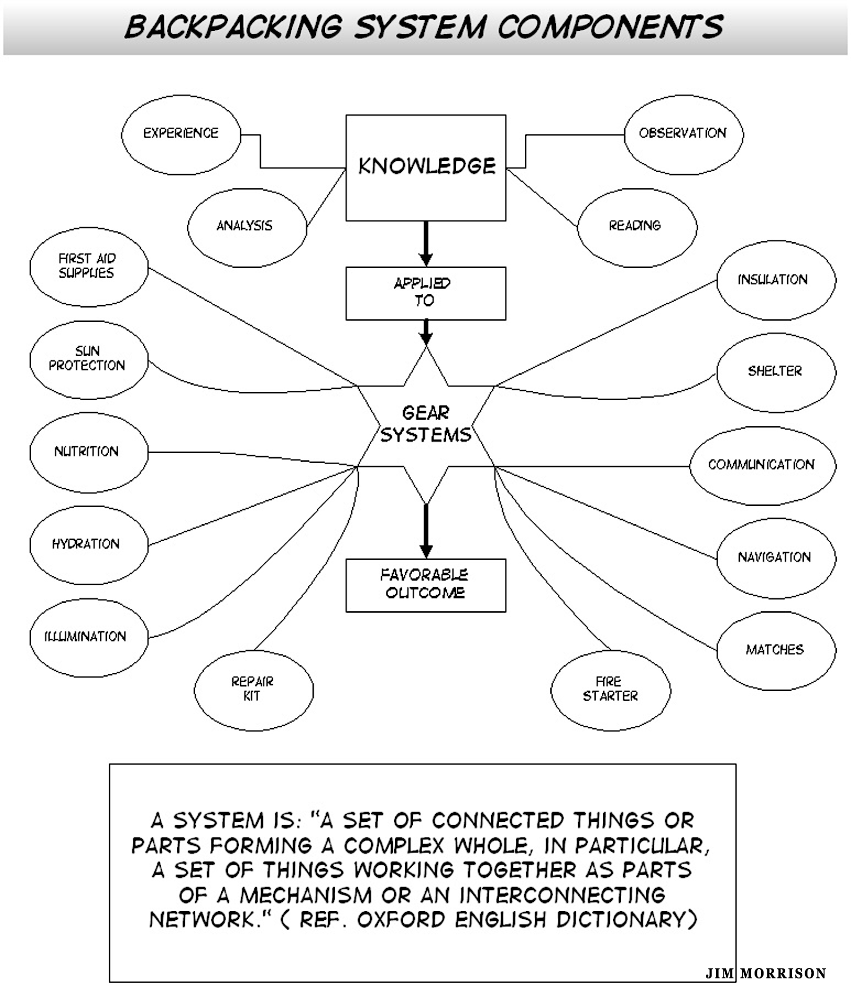

Additional Observations on STEP ONE: Careful Selection of Gear Categories
Since getting started on the right foot is so important, I have several observations about Step One. The first has to do with how your gear lists are organized. For a long time, my master gear list was organized as to specific types of items (e.g., sleeping bags, packs, stoves and pots, underwear, water containers). Consider that a more useful approach might be to group gear items into categories or sub-systems similar to those offered in Step One. This approach is potentially more useful because it looks at gear items as operating in a larger system. One choice in the subsystem often dictates other choices.
The number of categories is indicative of how serious one takes this process. The specific choices for categories are indicative of what is most important to the list maker. How many separate categories or subsystems are best? One web site (Backpacker.com) keeps it simple with only four categories in a recent sample check-off list: three clothing categories and all the rest lumped under “gear.” The KISS (“Keep It Simple Stupid”) principle is counterproductive in this enterprise. Some gear items will likely be shortchanged if a whole bunch of different gear items are lumped together. The more categories there are, the more likely one will think carefully and systematically about each area. On the flip side, as the number of categories multiply, so might the total number and weight of items. I choose to start the process of gear selection on the long side, paring it down as needed when my pack becomes heavier than I want. The ideal is to have the number of gear items listed in each category in your master gear list between 5-15.
Because clothing is usually a long list (unless traveling mostly in the hot or temperate climates) and since I strongly emphasize the concept of layering, I recommend breaking CLOTHING down into at least the three common “layering” categories: base layer, middle layer, outer shell layer. Granted, this breakdown is sometimes hard to apply because of overlap. Also, some high performance clothing items claim to belong in all three layering categories.
A common clothing category alternative is to distinguish between “Clothing Worn” and “Clothing Carried.” A similar distinction is sometimes made between other gear items carried in your pack and those worn on your body or in your pockets (e.g., knife, camera, poles, GPS). But what is the point? It doesn’t make much difference whether an item is usually worn or usually carried. It is still weight that needs to be muscled up and down hills. Besides, what is worn can vary a lot during the day and night. For example, some wear little clothing during the heat of the day, but almost all of their clothes on a frosty morning or at night for sleeping. Since these kinds of category distinctions are so common, they can be useful when comparing pack weights with others (but why bother?). One compromise would be to include a separate “Worn on the Body/Carried in Pockets” category to be able to properly separate out these items.
Some like to break the Emergency and Survival category down into subcategories (e.g., “First Aid Kit,” “Blister Kit,” “Fire Starting Kit,” “Repair Kit,” “Emergency Communication”). This type of breakdown is especially useful if one is a more traditional packer with lots of different items in each kit. It is also important if preparing for potential emergencies is a high priority when preparing for a backcountry adventure. For the lightweight packer, these kits can be quite minimal and not worth the breakdown.
It is often good to have separate categories (subsystems) for Special Needs. Examples: having dogs or kids along, being in a leadership position with relatively inexperienced hikers, fishing, photography, mountaineering, and search and rescue.

Additional Observations for STEP TWO: Develop Master Gear List
Using a computerized spreadsheet program to construct the MASTER GEAR LIST is highly desirable for adding and subtracting items with ease and for using it as a template for constructing customized trip gear lists. If the spreadsheet will be used as a template, consider adding the following vertical columns:

(1) weight of specific item chosen for specific trip
(2) weight of shared or group gear items
(3) check-off column (check off as item actually goes into either the pack)
(4) comments/needs column.

This would make eight columns total (added to the four columns recommended earlier in Step One of the previous section: category, function, brand/model/size, gear weight). Use the “Comments/Notes” column to identify gear items needing attention. If a computerized spreadsheet is not being used, consider listing gear on separate sheets of lined paper, one for each category (subsystem).
To make sure you cover all bases on your master list (i.e., every item that might be taken on any trip), check out the published gear lists of others. Colin Fletcher (The Complete Walker IV), includes a comprehensive list with page number references so you can read about any specific item on his list.
When should a complete kit be listed on just one line of your master list without breaking out the components? Consider not breaking out kits that either seldom change components or are minimal in weight. On my list, I do not break out my first aid, fire starting or repair kits. I do break out my personal health and hygiene kit because that changes considerably from trip to trip.
Consider using separate lines in your master gear list to break out all different forms or combinations one item might take. For example, under the “Shelter” category, a double-walled tent might take three forms: (1) full tent, tent fly, ground cloth, poles, stakes, tent bag (“trail weight”); (2) tent fly only with ground cloth (“fast pack”); (3) inner tent only.
Finally, consider not organizing your master gear list into seasons and types of trips (e.g., winter day snowshoe trip). This practice will be discussed later in another context.

Additional Observations for STEP THREE: Prioritizing Trip Goals
Caution! Ultralight backpacking (commonly defined as less than ten pounds base pack weight without consumables) is a popular goal in some circles. Be aware that most ultralight (UL) and superultralight (SUL) experts claim that these standards can be safely met only if you have the necessary knowledge, skill and experience. Also, be forewarned that as some keep pushing to go ever lighter and lighter, others experimenting with this philosophy (and its often expensive gear) end up going back to more traditional pack weights (i.e., become lighter weight traditionalists?).
Another interesting problem with making goals explicit is finding out that what appeared at first to be a compatible group might turn out not to be so. If there is some incompatibility, understanding this in the planning phase can make it more workable.

Additional Observations for STEP FOUR: Customized Trip Gear Lists
Some will be tempted to use gear lists from previous trips rather than starting anew from the Master Gear List developed in Step Three. This might be necessary if one is short on time, but consider the following reasons not to make this a regular practice. Consider that each trip, even though similar to others taken, can have different goals. Also consider that your equipment options and philosophies might be constantly evolving (especially if you like to experiment) and might have changed since the last trip of a similar type. Finally, consider that it is always good to rethink equipment choices for trips of any duration. After making a new list, compare it with lists from similar trips taken in the past. Evaluating the differences should take your gear selection to a higher level.
Consider taking as many double duty items as possible. For example, could a pair of extra socks be used as a pair of mitts? A trekking pole used as a tent pole? What about biodegradable soap and a large plastic clothes-washing bag substituting for a change of clothes? A bandana used as a bandage and as a pre-filter for water treatment? A hefty tent stake used as a potty trowel? A sleeping bag used as a cape to double for an extra insulation layer in camp? A poncho-tarp functioning as the primary shelter, rain gear or a ground cloth for the tent? A more extreme example might be that of a water treatment chemical (Hydration) also being used to disinfect wounds (First Aid) and sanitizing hands (Personal Hygiene). When one item fits in several different spreadsheet categories, consider including it in all categories in which it might work, but only listing the weight in its first occurrence (placing an “x” in all subsequent occurrences?).
What about shared party gear? If this is a significant element, consider including at least one line (or one column?) in your customized gear list for this category. Add the total weight into your calculations when this data becomes known.
Sharing sometimes gets messy when deciding who will actually carry what on longer trips. One sequential scheme for getting around potential difficulties is the following.

- 1. Make a decision as to exactly what will be shared and calculate the total weight of these items.

- 2. Decide if any members of the group will likely be carrying more or less than their fair share, for whatever reasons. Consider reviewing the article “Resolving Situations of Unequal Pack Weights” for a discussion about purposely engineering unequal loads.

- 3. One person then takes responsibility for calculating the weight of each person’s share based on the total weight of shared items. He or she then divides out (on paper) who gets what specific items before the actual packing process begins, giving priority to the owner carrying their own shared items.

- 4. One option when sharing consumables is to divvy these items up first. Food packages would then be used up in some systematic way (e.g., a new person contributes a food packet for each group meal until everyone has contributed).

- 5. During the actual packing process, expect some trading back and forth to better fit individual packing capabilities.

Additional Observations for STEP NINE: Systematically Obtaining Gear
It is pretty easy to see a cool piece of hiking gear and make an impulse buy. But what would a highly systematic approach look like for obtaining new gear? Following is an idealized process with a natural, but not rigid, order to follow. Which steps make the most sense to you?

- 1. Develop your own gear purchasing criteria. For example, my criteria are to obtain high quality gear for a reasonable price, gear that provides either a significant weight savings or an increased safety margin over my current kit.

- 2. Develop a prioritized wish list of new gear (brands, models, weight, costs, store) that fit the criteria established in step one above. The list should be fluid, continuously adding and subtracting items and raising and lowering priorities.

- 3. Research the market for the latest innovations and the newest models of the gear items on your wish list; research your favorite gear stores or manufacturers for their latest products; especially consult recently published gear guides to get a comprehensive view of what is available.

- 4. Consult online gear finders (e.g., Backpacker magazine’s Gear Finder) and use them to narrow your search.

- 5. Wait for a while to purchase new models and innovative products. Wait for others to test and share their experiences. Wait for the manufacturers to work out the bugs. Wait for cheaper knockoffs or competing companies who are able to do it better. Wait for used gear to become available. Wait for sales on last year’s models. Wait to make sure you know exactly what you want. Wait! Wait!

- 6. While waiting, locate gear reviews of the items on your wish list; talk to knowledgeable individuals with expertise on the specific gear items.

- 7. Do a weight and cost analysis. Determine the cost per ounce of weight saved compared with current gear. Give higher priority to items that come out lower a cost-per-ounce measure.

- 8. Carefully examine the product descriptions to make sure the gear items really fit your needs. If possible, go to “brick and mortar” stores where you can get up close and personal with potential purchases.

- 9. Select stores with good return policies.

- 10. Check the price of an item at competing stores, including taxes and shipping and handling costs. Try to find free shipping deals and discount coupons.

- 11. Send your wish list to family members at key times: birthday, Father’s or Mother’s Day, Christmas.

- 12. To have even more fun, become a qualified gear tester where you often end up with high quality gear that is free for the testing.

- 13. Impulse buy an occasional item totally on a whim, whether or not it fits your criteria.
_______________________________________

This recommended nine-step systematic approach to obtaining new gear can be viewed in different ways. I choose to look at it as a challenging intellectual process that transcends the value and functionality of the actual gear obtained. Getting excited about a new piece of gear, researching it thoroughly and shopping around to get the best deal is the name of the game!

Reader Participation: Sequence of Adding Gear to Gear Closet
First, add any steps I missed to the above gear purchasing (also making?) sequence. Second, write out your own sequence in an order that best fits your needs.
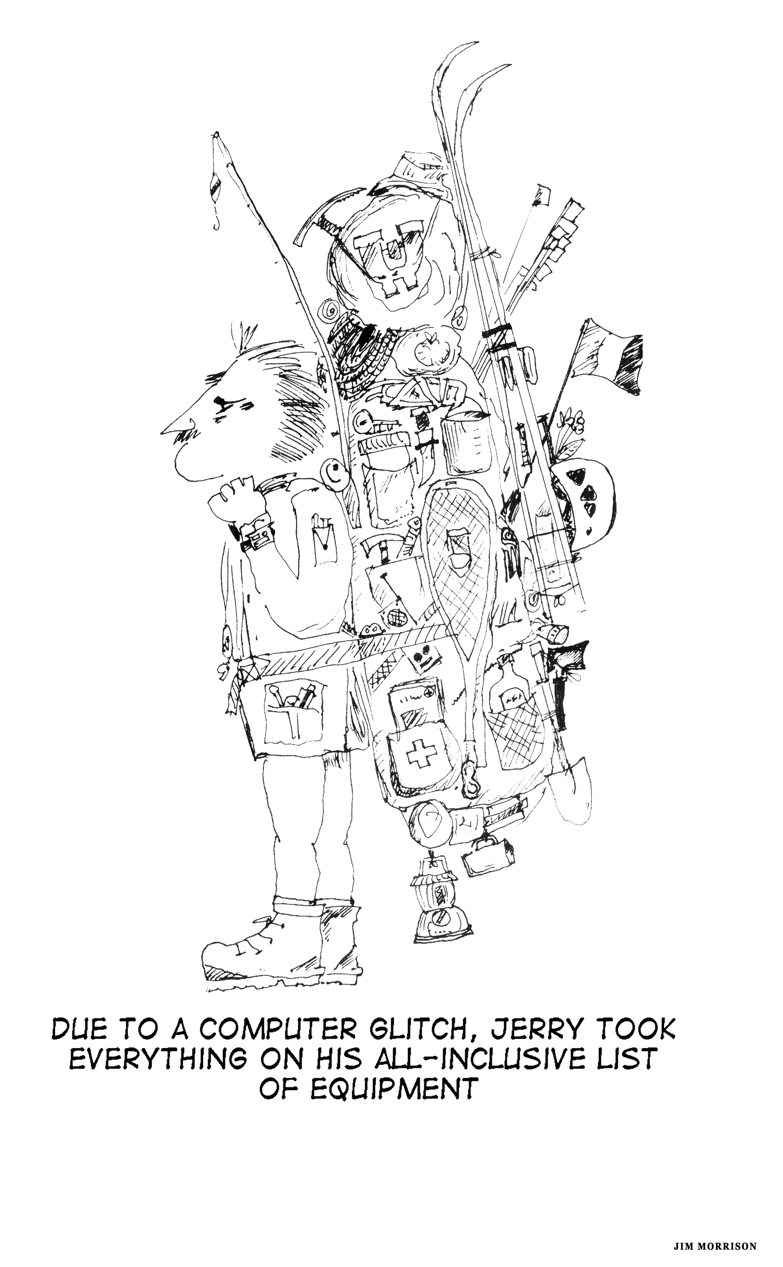

Advantages to a Systematic Approach: an In-Depth Answer
The idealized, nine-step process described in this article is only one example of being highly systematic in gear selection and organization. Others will have their own variations. But why take such an approach? For example, why should an experienced hiker construct multiple gear lists and separate gear lists of subsystems? As stated early in this article, the short answer is that our life and well-being, and that of others, may depend upon it. Gear lists assist us in thinking more carefully about what is essential for any specific journey. In addition, customizing gear lists each time will more likely result in having precisely what is needed while not carrying unnecessary weight.
A more interesting type of answer lies in human creativity and imagination. For the experienced backpacker, putting together the “just right” gear list is a creative process with many subtle choices. It usually forces us to think hard about the real goals for a selected trip. The more gear and knowledge we accumulate, the more challenging the thought process. The more experienced we are, the challenge often becomes what we can safely leave out.
Those interested in serious pack weight reduction often use a systematic approach. A systematic process encourages us to evaluate the functionality of a piece of gear in relationship to its weight and the other gear in the same category. A gear list with the total weight calculated at the bottom also challenges us to find lighter weight substitutes.
A final advantage (there are probably others) for taking a systematic approach has to do with viewing the gear chosen for a trip as a whole system. Putting together an effective gear list is not just deciding what to stuff into our pack. It is artfully weaving together a careful synthesis of gear, knowledge and experience. The analogy that comes to mind is that of a symphony conductor meshing all the different instruments together to make a rousing and moving performance. In the backcountry, we perform (make our choices and take our trip) and then come back ready do it all over again, making subtle changes based upon our recent experiences and perhaps adding a new piece of gear or two.
The strategy of looking at the whole system can also be applied to each gear category (subsystem). This perspective provides an opportunity to think about how different gear combinations work together as a functional system. It provides perspective for deciding backups in case one or more components fail. When we throw some things in a pack and go, we are less likely to see how each piece of gear in a specific subsystem interrelates with all of the other pieces.

Criticisms of Systematic Approaches to Gear
There are many reasons why hikers and backpackers do not use extensive gear lists or multifaceted gear selection processes. Here are many of them (with short rebuttals).

Criticism #1: What is wrong with an experienced packer just throwing a few things in a pack and going, especially for shorter, spur-of-the-moment trips? I have other priorities and do not care about taking my gear selection process to any higher level.

Rebuttal: There is nothing right or wrong with this approach, especially for short day trips. But for longer and more complex trips, the strategy of throwing a few things in a pack is often counterproductive, often resulting in less success and satisfaction than with a more systematic approach. The biggest problem is carrying gear that is not really needed.

Criticism #2: What ever happened to keeping things simple (i.e., the KISS principle)? This nine-step process is way too complex and confusing. Besides, I take pretty much the same kit year-round. I may add and subtract a little according to the time of year and the nature of the trip, but most of the gear in my pack remains constant and is always ready to go for the next trip.

Rebuttal: Again, there is nothing right or wrong with simplicity, but what about getting out of one’s comfort zone by experimenting with new gear and new ways of doing things? What about bringing some challenge and creativity to the trip planning and gear selection processes? Once one gets into the spirit of it, there is nothing simple about gear selection. It can be a very challenging and creative process. In addition, you don’t have to do the whole nine-step process—only the parts that might provide benefit. It can be as simple or as complex as you make it. Granted, if one does the same type of trip year after year, does not experiment much and has already developed a comprehensive gear list, then there is little reason to spend much time with gear selection.

Criticism #3: I am not a gearaholic. I don’t have a huge gear closet. I don’t have to have the latest fads. I use basically the same gear until it wears out.

Rebuttal: It is true that the nine-step process recommended above assumes one has accumulated quite a bit of gear over the years and that one has many gear choices for different trips. It also assumes one has a long wish list of gear to eventually acquire. However, being a “gearaholic” is not the same as being systematic. A “gearaholic” can be quite unsystematic, steeped in chaos, disorganization and impulse buying.

Criticism #4: A systematic process takes too much time and effort, time better spent out in the backcountry.

Rebuttal: Granted, working with gear systematically in this way can take a lot of time. It can also be quite confusing and thought-provoking because there are so many different backcountry styles and so many different competing ideas about gear selection. It is surely a good task for a blustery winter evening. However, one can easily do system and subsystem analysis during the off-season or periods of bad weather doing bits and pieces at a time.

Criticism #5: This approach is too rational and analytical, especially when dealing with my recreational activities. I do better relying on my intuition and years of experience.

Rebuttal: There is no reason why reason and intuition can’t complement one another; this is not an either/or proposition. Consider that a reasoned “systems” approach might be necessary to take one’s highly intuitive approach to a higher level (or vice versa).

________________________________________

In this article I have provided several arguments in favor of a systematic approach to outdoor gear (briefly at the beginning and more in-depth later on). Above I have replied to five criticisms of this approach. My biases should be obvious. What were your biases coming in? What is your position now, assuming you have read through the entire article?

Reader Participation: Customized Step-By-Step Sequence
Assuming you are basically in favor of a systematic approach to outdoor gear, consider constructing your own step-by-step sequence or process for dealing with your outdoor gear. If a logical, step-by-step format doesn’t seem appropriate, simply list the important elements without priorities or logical order.

Utilizing a Systematic Decision Making Process to Resolve a Specific Gear Oriented Problem: Limited Financial Resources
Following is another example of approaching backcountry gear selection systematically. Let’s start by assuming that one or more members of the party are extremely limited in their financial resources. How could this issue be approached systematically? Consider the following idealized ten-step decision process:

- 1. Clearly state the issue (e.g., I can’t afford to purchase the necessary and desired gear for an upcoming trip.)

- 2. Brainstorm options (e.g., buy used, buy cheap on eBay, rent, borrow, beg, buy on credit, sell your blood, change the trip so the gear is not needed).

- 3. Select the best option and state the best arguments in favor of the selected option and against the other options.

- 4. Select a second next preferred option and do the same.

- 5. Rate the strength of each argument from 0-6.

- 6. Construct criticisms for only the strongest rated arguments.

- 7. Reevaluate the arguments that were initially claimed to be strongest based upon the constructed criticisms.

- 8. Make the best decision based upon the actual strength of your arguments.

- 9. Analyze any discrepancies between one’s feelings in the matter and this logical analysis.

- 10. Make the decision the right one (i.e., commit yourself and do not look back unless forced to).

The above is an idealized decision-making process fleshed out with only a few examples. Again, few would utilize it in its entirety. This idealized decision process is offered as another example of approaching things systematically in a backpacking context. Even more importantly, it can be used for life impacting decisions of any kind.

Additional Issues for Reflection
- In acquiring gear, is it best to find one specific item that will function reasonably well for most trips (e.g., shelters or footwear or packs) or plan on obtaining multiple variations of the same type to have a higher level of functionality for specific types of trips? Should the goal be to develop a relatively simple gear locker containing few options or one with multiple options to cover all occasions?

- When is the best time for actually packing your gear for a planned trip using your prepared lists? A few days in advance? The night before? At the trail head?

- Gear lists can be quite simple or extremely complex and detailed. What best fits your personality? What about no written gear lists at all, preparing for a trip just from the list in your head?

- Under what circumstances is it wise to share your gear list with your hiking partners without their asking? Or ask to see their gear list? What if you are highly organized and others are not? When should a group discuss the pros and cons of taking specific items (both individual and party gear)?

- When is it wise to construct a generic gear list for a group planning for a specific trip? When is it wise for a trip leader to construct such a list?

- Is there a defensible rationale for leaving a total weight calculation entirely off of gear lists? Does listing gear weights tempt me to compromise safety when my pack gets heavier than my target weight? Should weights be listed only for the non-essential (comfort, optional, luxury) items?

- How useful is it to calculate the weights in commonly used categories like the following? Total Worn While Hiking (1); Total Base Weight in Pack (2); Total Initial Weight of Consumables (3); Full Skin-Out Base Weight (1 + 2); Total Initial Pack Weight (2 + 3); Full Skin-Out Weight (1 + 2 + 3)?

- Is it best to develop a unique gear list for each outing starting from one master list or to simply tweak master “template” lists for each type of trip (e.g., week-long summer backpack; winter day snowshoe; long distance, resupplied thru-hike)?

- Assuming two people know each other quite well (e.g., significant others, close friends), which items can be safely shared and which not? What about first aid kits? Repair kits? Eating utensils? Personal health and hygiene items? What if serious reductions of weight are desired? What is the best way to organize a gear list when two or more people decide to share a number of gear items?

- Is it worthwhile to develop menu lists similar to gear lists (e.g., food category, specific food item, portion size and weight, ingredients, yumminess grade)? For those who go out a lot, how useful is it to purchase in advance, store and organize backpacking food? Can this cataloging do double duty for emergency preparedness at home, to have on hand adequate food supplies for long-term emergency situations?

- What is the best way to store outdoor gear to most easily prepare for a trip? If one is involved in many different sports, is it best to segregate gear according to the sport or according to the gear category (e.g., first aid, shelter, footwear)? Is it a good idea to store most of the gear for specific types of trips (e.g., winter cross country skiing, summer overnight backpacking) into separate bins that can be dumped into the vehicle for a quick getaway?

- What is the best way to organize and store guide books, articles, maps and other trip information, especially if one has accumulated a lot of this?

- Is there a serious problem with being (becoming) a Type A personality who tends to be super-organized with a detailed list for everything?

- Is there a serious problem with becoming a gear head (gear addict, gear junkie, gearaholic)? What if you see yourself moving in this direction?

