**A TRAVESTY OF JUSTICE**

**by**

**Marguerite dar Boggia**

On July 17, 2014 a Boeing passenger plane, operating Malaysia Airlines Flight 17, crashed east of Donetsk in Ukraine. All 298 on board, including the crew, were killed. The flight departed from Amsterdam-Schiphol Airport, The Netherlands, at 12:14 PM hours local time (10:14 AM UTC) bound for Kuala Lumpur, Malaysia.

A Joint Investigation Team (JIT) from the Netherlands, Australia, Belgium and Ukraine was established. When Malaysia complained, they included Malaysia. They reached their decision in December 2015, which was that a high energy object hit the plane; that it was a Buk missile and that the Russians were responsible.1 They demanded that Russia compensate the families of the victims.

The investigation was a TRAVESTY of JUSTICE. They never interrogated the air flight traffic controller,2 nor inspected the body of the pilot. The family of the pilot was refused permission to inspect the pilot's body.3 (It might show bullet holes). They disregarded the evidence submitted by Russia to wit: a high resolution image of the cockpit riddled with bullet holes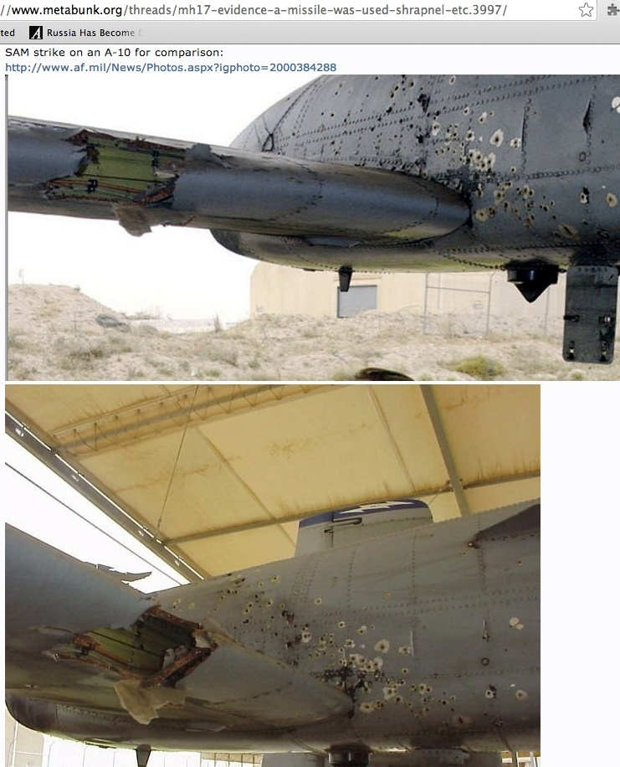. The picture showed unequivocally that some of the bullet-holes were inbound while others of them were outbound: No high-powered missile (or shrapnel therefrom) hitting the airliner could possibly have produced firing into the cockpit from both sides of the plane. It had to have been a hail of bullets from both sides, that brought the plane down. You can’t have projectiles going in both directions — into the left-hand-side fuselage panel from both its left and right sides — unless they are coming at the panel from different directions. This is what rules out any ground-fired missile.

The JIT provided no information as to who ordered **a change of flight path**. The purpose of that change was to place the aircraft closer to Donetsk, where there was fighting. They never interrogated the people on the ground who saw the two jet fighters in the air.

The courageous air traffic controller, whose life and the lives of his family, were immediately threatened, when interviewed by reporters in Spain, his own country, said that two jet fighters escorted the plane. When the planes disappeared from his radar screen, he tweeted that the two jet fighters caused the crash of the MH17. Immediately his twitter account was revoked. He said he wondered why the place was immediately filled with foreigners after the crash. He indicated that there was conflict between the Ukraine Ministry of Defense and the Ministry of the Interior. The Ministry of Interior is controlled by the Neo Nazis.3a Today Israel is arming the Neo Nazis in Ukraine.3b The Neo Nazi Party changed its name to the Svoboda Party. (Svoboda means freedom)

In May, 2018 the JIT produced fragments of the engine and nozzle of a 9M38 missile, allegedly launched by a Buk missile system. From the nozzle and engine numbers, the Russian Defense Ministry was able to find the missile's number. The missile was made in Dolgoprudny in 1986. It was delivered by rail on December 29, 1986 to military Unit 20152 deployed to Ukraine, and never returned to Russia. The Ukrainian military unit is now called the 223rd anti-aircraft defense regiment of the Ukrainian armed forces, renamed by a decree from the Ukraine presidential office. It is noteworthy that **units of the** **223 regiment have since 2014**, **repeatedly been involved in the so-called anti-terror operation in the Donetsk region.** The Russian Investigative Committee has challenged the video footage used by Bellingcat, a UK-based citizen journalist group, allegedly proving a self-propelled firing system of the Russian 53rd anti-aircraft missile brigade, was involved in the downing of MH174.

The chart of the downing of MH17 validates the big lie of the JIT. The data for the chart is 7/17/2014, 12:14 PM -02:00 (EET) 004E07; 52N03' (10:14 UTC).

 We have a tragic grand cross in cardinal signs involving the ascendant, the ruler of the ascendant, the MC, the ruler of the MC, and planets in the 10th house. The ascendant signifies the passenger aircraft: the MH17. The Midheaven denotes the government of Ukraine, the country, where it crashed. The 7th house signifies 'open enemies'. The 4th house denotes the owners of the airline and Venus, (the ruler of the Libra ascendant) denotes the passengers and crew. Venus is in the 10th house under the domination of the Ukraine government. (A planet within 5 degrees of the following cusp can be considered in the next house.) Venus (passengers & crew) squares the ascendant (MH17). This is a **self against self aspect**. The passengers are doomed. Their fate is sealed. Venus (passengers) is besieged by a square aspect from the Moon, the ruler of the MC (the government). The passengers (Venus) are to be martyrs to the plans of the government (MC and Moon). The Moon opposes the ascendant. The MH17 (ascendant) is attacked by the Ukraine government (Moon).

**There is conflict within the government**. The Ministry of defense disagrees with the Ministry of the Interior. The Neo Nazis and the extreme right sector in the Ministry of Interior are denoted by Mercury. Mercury represents 'youth' and/or the possibly inexperienced in government policies. It conjoins the MC. That makes it extra potent. The Ministry of Interior dominates. They have the guns and they make the decisions. The Midheaven (government) is in a square aspect to the ruler of the MC (Moon). This **is a self against self aspect**. It signifies CONFLICT in the government between themselves. They both symbolize leadership. Conflict is said again with Mercury (Neo Nazis) in a square aspect to the Moon (government). The Neo-Nazis are at a divergence with government officials (Moon). Saturn (Authority) sesquisquares the MC (Government). This reinforces conflict in the government between themselves. The Sun in the 10th house also signifies the government. It forms a square aspect to Mars, the ruler of the 7th house of opposing enemies. The enemies of Ukraine are the Neo Nazis, the extreme right sector, and the Forces governing the foreign policies of the U.S. who desired a coup.

Mercury conjoins Venus. Suddenly the Neo Nazis (Mercury) have money (Venus). The U.S. gave $5 billion dollars5 to the Neo Nazis and to the extreme right sector to create a coup through street violence. Their hatred of Russia, because of the actions of Stalin, is intense. The motto of one of the parties is "kill all the Russians". Mercury squares the ascendant. The Neo-Nazis (Mercury) attack the MH17 (the ascendant). They are convinced that with the help of the mainstream media, the demise of the MH17, will bring victory over the Russian Eastern rebels.

The No. Node conjoining Mars gives it extra ferocity. The So. Node conjoins Uranus. It endows it with greater hostility. Both besiege the Sun, which is in a T square. The life (Sun) of the plane is sucked out when the bullets cause depressurization of the aircraft causing the plane to split apart. Mars, ruler of the 7th house of open enemies, trines Venus. The enemies of the airliner (Mars) have money (Venus) to wit: Five billion dollars.

Uranus inconjuncts Saturn in the 2nd house of money. Saturn signifies the government. An inconjunct connotes a change of some kind. Uranus, in the 7th house denotes the enemies, to wit: the Neo Nazis and the Forces governing the foreign policies of the U.S. The Neo Nazis (Uranus in 7th house) through violence, cause a sudden change (inconjunct aspect) in government (Saturn) with the help of $5 billion dollars (2nd house).

Saturn and Pluto are in mutual reception. Saturn is in Scorpio and Pluto is in Capricorn. Saturn semi-squares the ascendant. The fighter jets of the government (Saturn) attack the MH17 (ascendant). If Saturn and Pluto change places, then Pluto is the other fighter jet. It decimates the plane.

Sun conjoins Jupiter in the 10th house of government. This suggests that the government (10th house) desires good fortune, foreign trade and business. (Jupiter). Jupiter in the 10th house sextiles the ascendant. The government (10th house) wants good fortune for the MH17 (ascendant). The Moon trines Jupiter. This again signifies that the government (Moon) desires foreign trade (Jupiter). Saturn trines the Sun in the 10th. Saturn is in the 2nd house of finance. The government (Sun in 10th) aspires to financial success (2nd house).

The 4th house signifies the owners of the airliner. Mercury (the Neo Nazis) opposes Pluto, in the 4th house (the owners). The owners sustain a loss in reputation (opposition aspect), however there are very favorable aspects to Pluto in the 4th house. Neptune is the ruler of the 12th house of **secret enemies**. The U.S. and its allies (secret enemies) working through the Joint Investigation Team, financially compensate the owners of the airliner, to consent that it was a buk missile that caused the crash. Neptune sextiles Pluto, co-ruler of the 2nd house of income and Pluto sextiles Saturn in the 2nd house of 'money'. These favorable aspects indicate that **the owners were 'paid off' with money.**

The chart indicates that the mainstream media (3rd house publicity) was favorable to the perpetrators of this crime. Pluto, the co-ruler of the 3rd house of publicity forms a sextile to Saturn (government). Jupiter, the co-ruler of the 3rd house conjoins the Sun in the 10th house (government).

In June, 2015, President Poroshenko (the former chocolate billionaire) requested the Supreme Court of Ukraine to declare that his predecessor, Viktor Yanukovitch, as the legal representative and **that his Administration** **is a COUP6**. Poroshenko cannot control the Neo-Nazis in his government. The NATO Nations have placed in Ukraine NUCLEAR WARHEADS directed at Russia. He realizes that if there is a war, that his country would be devastated. Since Poroshenko is still the President and has in September, 2018 signed a decree not to extend an official friendship agreement with Russia, we can assume that his Petition to be released as President, was denied by the Supreme Court of Ukraine.

The mainstream media is controlled by the shareholders of the corporations of the GOLBAL ELITE7, who make the decisions for the world. It is also known as the "Cabal" in the documentary movie: "Thrive"8, and elsewhere. They are preparing the public, through both political parties of the U.S. and through their media, for a war against Russia, possibly starting in 2023. They require puppet governments, especially in Russia. Their goal is **One World Government** ruled by themselves, in order to control the masses through their rigged economic system, where the rich become richer.9

How long must we tolerate the lies and crimes of the Forces that are preparing the public for the devastating World War III?10

∆ ∆ ∆

*Marguerite dar Boggia* formerly served as Secretary and Membership Chairperson of ISAR (the International Society for Astrological Research). She formerly served as publisher of Kosmos, the ISAR Journal and as Secretary and Director of ISAR and UAC, (the United Astrology Congress). She is a co-founder of UAC. Her articles are published in the ISAR journal and in other publications. They are on her website, which she created at the age of 90**:** [**www.FreePythagorasTeachings.com**](http://www.FreePythagorasTeachings.com)At this time she offers **FREE** of charge **three pages weekly online** of the Ancient Wisdom Teachings as was known by Pythagoras, some of which information was on **Albert Einstein's** desk. She can be contacted through her website for these esoteric and astrological teachings.

References:

1dar Boggia, Marguerite **"*Who Shot Down the MH17?"* www.FreePythagorasTeachings.com under Articles**

### 2[Spanish Air Controller @ Kiev Borispol Airport: Ukraine ...](https://www.google.com/url?sa=t&rct=j&q=&esrc=s&source=web&cd=1&cad=rja&uact=8&ved=0CB4QFjAAahUKEwjGhIDAnbbHAhWLOYgKHSByBCY&url=http%3A%2F%2Fwww.globalresearch.ca%2Fspanish-air-controller-kiev-borispol-airport-ukraine-military-shot-down-boeing-mh17%2F5391888&ei=6QfVVYbsM4vzoASg5JGwAg&usg=AFQjCNHpSk6_B-1nx9yFEYXSpNx4O_jnqA) 1

## 3[The MH17 Pilot’s Corpse: More on the Cover-Up](http://www.globalresearch.ca/the-mh17-pilots-corpse-more-on-the-cover-up/5467351)

**3a**[**The US has Installed a Neo-Nazi Government in ... - Global Research**](https://www.google.com/url?sa=t&rct=j&q=&esrc=s&source=web&cd=4&cad=rja&uact=8&ved=2ahUKEwi42Z6fk9ndAhV7GDQIHUxZBroQFjADegQIBxAB&url=https%3A%2F%2Fwww.globalresearch.ca%2Fthe-u-s-has-installed-a-neo-nazi-government-in-ukraine%2F5371554&usg=AOvVaw1iiFbDfM8_iBd2up2qqxp7)

**3b**[**Israel Is Arming Neo-Nazis in Ukraine - Global Research**](https://www.google.com/url?sa=t&rct=j&q=&esrc=s&source=web&cd=1&cad=rja&uact=8&ved=2ahUKEwi42Z6fk9ndAhV7GDQIHUxZBroQFjAAegQIChAB&url=https%3A%2F%2Fwww.globalresearch.ca%2Fisrael-is-arming-neo-nazis-in-ukraine%2F5650478&usg=AOvVaw1nb6e5zkIACoSY3xMYgQxJ)

**4**[**Russia Reveals the MH17 'Smoking Gun' - Global Research**](https://www.globalresearch.ca/russia-reveals-the-mh17-smoking-gun/5654547)

*https://www.globalresearch.ca/russia-reveals-the-mh17-smoking-gun/5654547*

Notre site en Français: mondialisation.*ca* · Italiano · Deutsch · Português ... *Russia Reveals the MH17* '*Smoking Gun*'. Defense ... *Global Research*, September 19, 2018. Asia Times 18 ... Malaysian Airlines *MH17* Downing Big Lie Resurfaces.

5[**American Conquest by Subversion: Victoria Nuland's Admit**](https://www.google.com/url?sa=t&rct=j&q=&esrc=s&source=web&cd=1&cad=rja&uact=8&ved=0ahUKEwjm8py6jLfLAhUP0GMKHUOKCeIQFggcMAA&url=https%3A%2F%2Fcounterinformation.wordpress.com%2F2014%2F02%2F07%2Famerican-conquest-by-subversion-victoria-nulands-admits-washington-has-spent-5-billion-to-subvert-ukraine%2F&usg=AFQjCNHqtlpDw0Qpj9gmd5634arUrTJJfQ&bvm=bv.116636494,d.cGc)**s**

http://www.globalresearch.ca/american-conquest-by-subversion-victoria-nulands-admits-washington-has-spent-5-billion-to-subvert-ukraine/5367782 Feb 7, 2014 **...** “After three visits to **Ukraine** in five weeks, **Victoria Nuland** explains that in ... has spent five **Billion dollars** ($5,000,000,000) to subvert **Ukraine**, ...

**6**[**Ukraine's President Poroshenko Says Overthrow of ...**](https://www.google.com/url?sa=t&rct=j&q=&esrc=s&source=web&cd=1&cad=rja&uact=8&ved=0CB4QFjAAahUKEwistZfpi7PHAhXFO4gKHRn4DGs&url=http%3A%2F%2Fwww.globalresearch.ca%2Fukraines-president-poroshenko-says-overthrow-of-yanukovych-was-a-coup%2F5457631&ei=uWLTVez0CcX3oASZ8LPYBg&usg=AFQjCNEn3tUUsgqgp8PT_IMiKrEyL08PFA&bvm=bv.99804247,d.cGU)

[**www.globalresearch.ca/ukraines-president-poroshenko-says.../5457631**](http://www.globalresearch.ca/ukraines-president-poroshenko-says.../5457631)

7[**World Bank Whistleblower Reveals How The Global Elite ...**](https://www.google.com/url?sa=t&rct=j&q=&esrc=s&source=web&cd=1&cad=rja&uact=8&ved=0CB4QFjAAahUKEwjIopzBn7bHAhVIW4gKHa71B_Q&url=http%3A%2F%2Fwww.globalresearch.ca%2Fworld-bank-whistleblower-reveals-how-the-global-elite-rule-the-world%2F5353130&ei=BQrVVYiMEci2oQSu65-gDw&usg=AFQjCNFWFWycs-tAjp9xAZy1b0TE8Uzhfg)

**8www.thrivemovement.com**

**9dar Boggia, Marguerite "*The Screws are Coming Loose that Bind the Soul of Humanity*." under Articles www.FreePythagorasTeachings.com**

**10dar Boggia, Marguerite "The Jupiter-Saturn Conjunction for 2020" under Articles www.FreePythagorasTeachings.com**