REGULAR MEETING
JUNE 17, 2021

The Regular Meeting of the Town Board of the Town of Hampton, County of Washington and the State of New York was held at the Town Hall, 2629 State Route 22A, Hampton, New York, also via Zoom and live streaming on the You Tube Channel for “Town of Hampton New York” on the 17th day of June 2021.

Due to the Corona Virus, occupancy inside the Town Hall is limited at this time. Supervisor O’Brien did provide a link to join the meeting via Zoom.

PRESENT: David K. O’Brien----------- Supervisor
Donald Sady-----------------Councilman
Tamme Taran----------------Councilwoman - absent
Andrea Sweeney------------Councilwoman
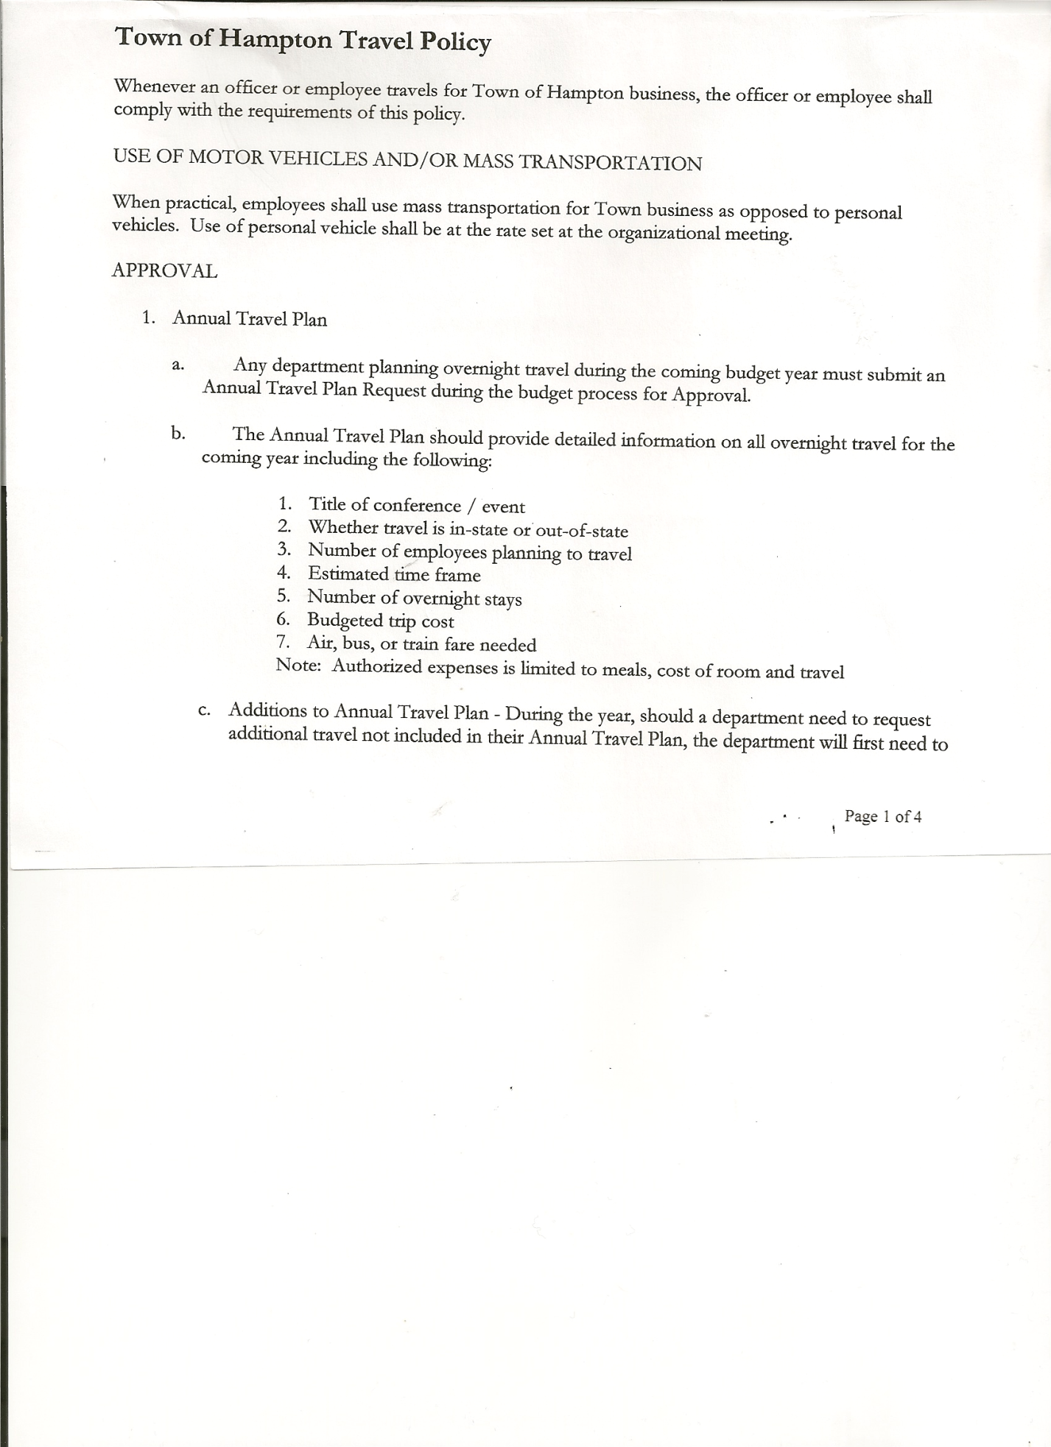
Michael Pietryka------------Councilman
Rebecca Jones---------------Town Clerk
Camilla Shaw----------------Tax Collector/Deputy Town Clerk
Herbert Sady, Jr.-------------Highway Superintendent

Planning Board Member(s): via Zoom… Bonnie Hawley, Chair;
Others present at the Town Hall: See attached list

The Regular Meeting was called to order by Supervisor O’Brien at 7:30pm, followed by the Pledge of Allegiance. Location of Fire Exits were given. Quorum of board members present.

RESOLUTION NO. 48-2021
APPROVAL OF THE MINUTES
On a motion of Councilman Sady, seconded by Councilman Pietryka, the following resolution was ADOPTED: AYES 4 O’Brien, Sady, Sweeney, Pietryka
NAYS 0
ABSENT 1 Taran
RESOLVED, that the Regular Town Board Minutes for May 20th, 2021, are approved.

Larry Carman, Dog Control Officer submitted his report, which was read by Supervisor O’Brien, copy of report is attached.

Camilla Shaw, Tax Collector….Attended an online training with the New York State Association of Tax Collectors. No other activity. Submitted Bank Statement to the Board for review and signatures.

Bonnie Hawley, Chair gave Planning Board Report……At the June 9th meeting Ginny and Renee were updated on the Rt 4 issue that was discussed at the May meeting. No action has been seen with the Food truck by Maggie Ingerson at the former Flubberbusters.
A card of best wishes was sent to the new Brookside Pub in Hampton signed by the Planning Board members.
On Tuesday (June 15th,) the County had a 1 ½ hour webinar on Solar. Bonnie asked if Hampton has opted out of a New York law that solar automatically gets a break on solar assessment. It was confirmed that Hampton residents pay full assessed value in Hampton. A 60-acre parcel is needed to have enough power and without a substation nearby not practical for Hampton at this time.
Still hoping for the Ag Grant to come through in November.

TOWN BOARD MEETING
JUNE 17, 2021 PAGE 2

Herbert Sady, Jr., Highway Superintendent submitted his report, copy of which, is attached.
Following a discussion on the contract price for mowing the roadsides for the County in the Town, the following Resolution was introduced:
RESOLUTION NO. 49-2021
COUNTY ROADSIDE MOWING CONTRACT
On a motion of Councilman Sady, seconded by Councilman Pietryka, the following resolution was ADOPTED: AYES 4 O’Brien, Sady, Sweeney, Pietryka
NAYS 0
ABSENT 1 Taran
RESOLVED that, Herbert Sady, Jr. Highway Superintendent, be authorized to sign the Washington County Mowing Contract for 2021.

The Highway Superintendent ad has been in the paper. Herb and Tyler are going to meet about how to approach the new process. The tour of town roads is still being planned for board members to view roads with Herb and Tyler to see the conditions and needs. Hopefully, this can happen before a Special Meeting to plan highway steps for the future.

RESOLUTION NO. 50-2021
SPECIAL MEETING FOR HIGHWAY MATTERS
On a motion of Councilman Pietryka, seconded by Councilman Sady, the following resolution was ADOPTED: AYES 4 O’Brien, Sady, Sweeney, Pietryka
NAYS 0
ABSENT 1 Taran
RESOLVED to set a Special Meeting of the Town Board to discuss and prepare a plan for the Highway Department on Monday, July 12th, 2021, at 6:30pm.

SUPERVISOR’S REPORT/ COUNTY UPDATES/ COMMUNICATIONS

RESOLUTION NO. 51-2021
APPROVAL OF SUPERVISOR’S MONTHLY REPORT
On a motion of Councilman Pietryka, seconded by Councilman Sady, the following resolution was ADOPTED: AYES 4 O’Brien, Sady, Sweeney, Pietryka
NAYS 0
ABSENT 1 Taran
RESOLVED that, the Supervisor’s Monthly report be accepted as submitted for MAY
4/30/21 5/31/21
ACCOUNT BALANCE RECEIPTS DISBURSEMENTS BALANCE
General Fund $ 58,841.48 $ 892.83 $ 8,035.20 $ 51,699.11
Highway Fund $228,091.81 $ 6.31 $ 19,139.17 $ 208,958.95
Equipment Reserve $ 79,907.18 $ 2.21 $ 0.00 $ 79,909.39
Fire #1 $ 43,297.00 $ 0.00 $ 0.00 $ 43,297.00
Fire #2 $ 10,200.00 $ 0.00 $ 0.00 $ 10,200.00
Cemetery $ 1,748.16 $ 1.53 $ 0.00 $ 1,749.69
Totals $422,085.63 $ 902.88 $ 27,174.37 $395,814.14
All Board Members present signed Supervisor’s Report.

TOWN BOARD MEETING
JUNE 17, 2021 PAGE 3

OLD BUSINESS

Cannabis Opt Out/In ….. Discussion and views from board members on whether to permit the establishment of a Cannabis Retail Dispensary Licenses and/or On-Site Consumption Licenses within our Town. Since not all members were present a decision was not made. The issue will be tabled until the July meeting.

Special Election…held on April 20th, 2021, from 12:00pm to 7:00pm at the Town Hall, regarding changing the Highway Superintendent position. Total votes were 131. Keep the position Elected was 55; change to an Appointed position was 76. An Appointed Highway Superintendent will start on January 1, 2022.

Ramp Covering…..Three quotes were received.
- Fred Wilson,Comstock,NY………………...$ 3,500.00
- RJR Construction, Shushan, NY………….. $12,325.00
- B. Carter Construction, Granville, NY……..$11,900.00
Fred Wilson withdrew his quote. The Town Board was polled prior to the meeting on which one should be selected so the work could begin. B. Carter Construction was selected.
RESOLUTION NO. 52-2021
CONTRACTOR FOR RAMP COVERING
On a motion of Councilman Sady, seconded by Councilwoman Sweeney, the following resolution was ADOPTED: AYES 4 O’Brien, Sady, Sweeney, Pietryka
NAYS 0
ABSENT 1 Taran
RESOLVED, to accept the quote from B. Carter Construction for $11,900.00 for the roof and enclosure for the Town Hall ramp.

NEW BUSINESS

Suzanne Carpenter, owner of Brookside Pub, Campbell Lane, Hampton came before the board with a request to waive the 30day waiting period to apply for a liquor license. Following a discussion, the following Resolution was introduced:
RESOLUTION NO. 53-2021
APPROVAL OF WAIVER
On a motion of Councilman Pietryka, seconded by Councilman Sady, the following resolution was ADOPTED: AYES 4 O’Brien, Sady, Sweeney, Pietryka
NAYS 0
ABSENT 1 Taran
RESOLVED, to approve waiver of 30-day waiting period for liquor license application.

Supervisor O’Brien has been asked by ATV riders in town to request the Town Board to approve the use of town roads by ATV’s. Some towns do approve parts of a road to connect trails to other trails. There have been complaints about ATVs on town roads speeding and not wearing helmets. After discussion by board members and no one in attendance to speak on behalf of the ATV riders, the issue was not approved. The Town Board welcomes ATV riders to come in and talk with them and provide specifics as to what that they are looking for.

TOWN BOARD MEETING
JUNE 17, 2021 PAGE 4

PUBLIC COMMENTS/COUNCIL COMMENTS
There have been calls about free-range chickens by neighbors of the chicken owners. Any livestock on another person’s property is considered trespassing, and a complaint can be filed with the Sheriff’s office or State Police.

Several residents from Carvers Falls Road came requesting a noise ordinance be put in place. Supervisor O’Brien will contact our Town Attorney and find out what is involved in putting a noise ordinance in effect.

RESOLUTION NO. 54 -2021
AUDIT OF CLAIMS
On a motion of Councilman Pietryka, seconded by Councilman Sady the following resolution was ADOPTED: AYES 4 O’Brien, Sady, Sweeney, Pietryka
NAYS 0
ABSENT 1 Taran
RESOLVED that the bills have been reviewed by the Town Board and are authorized for payment in the following amounts.
General Fund No. 79 through No. 94 $ 8,424.77
Highway Fund No. 60 through No. 71 $ 14,497.92
Total both funds $ 22,922.69

The Town Clerk’s report for May 2021 was submitted to the Board. The Town Clerk had Board Members review and sign bank reconciliation statements for the Town Clerk Account and Special Clerk Account dated May 31, 2021.

RESOLUTION NO. 55-2021
MEETING ADJOURNED
On a motion of Councilman Sady, seconded by Councilwoman Sweeney, the following resolution was ADOPTED: AYES 4 O’Brien, Sady, Sweeney, Pietryka
NAYS 0
ABSENT 1 Taran
RESOLVED that the meeting adjourned at 8:43pm.

Respectfully submitted,

Rebecca S. Jones, RMC
Town Clerk

