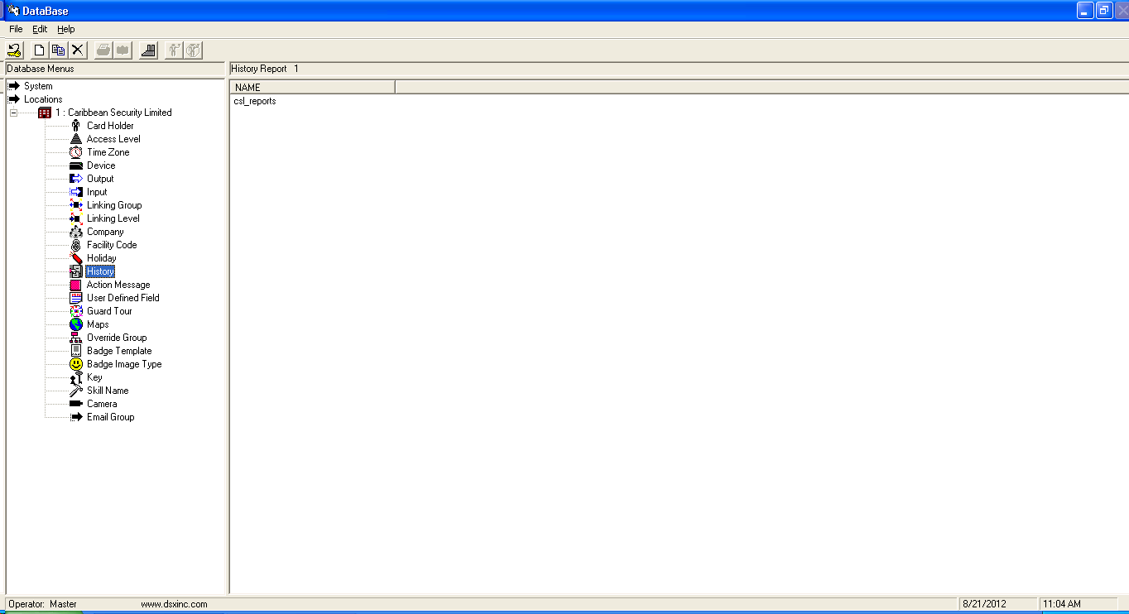

First Click on history under locations then click on new give the report a name in this instance I named it csl-reports.

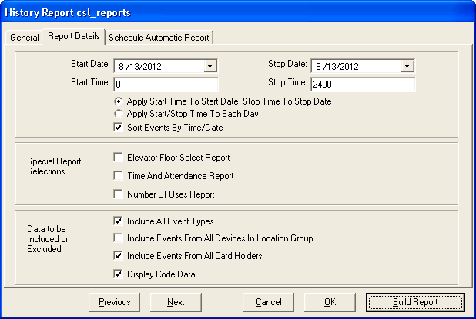

Be sure to set the start date and stop date correctly

Now under report details tab uncheck “Include Events From All Devices in Location Group”

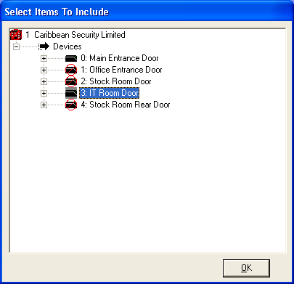

When this dialog screen pops up double click on CSL then devices then double right click any door to take off the red circle. This means that in this instance only a report on the main entrance door and it room door will show up in in the report build.

Click ok



click build report

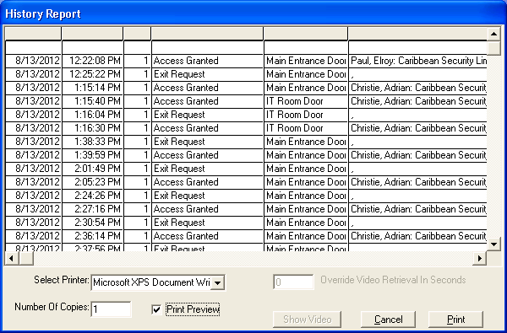

Now ensure that you check the box Print Preview then click on print button to see report

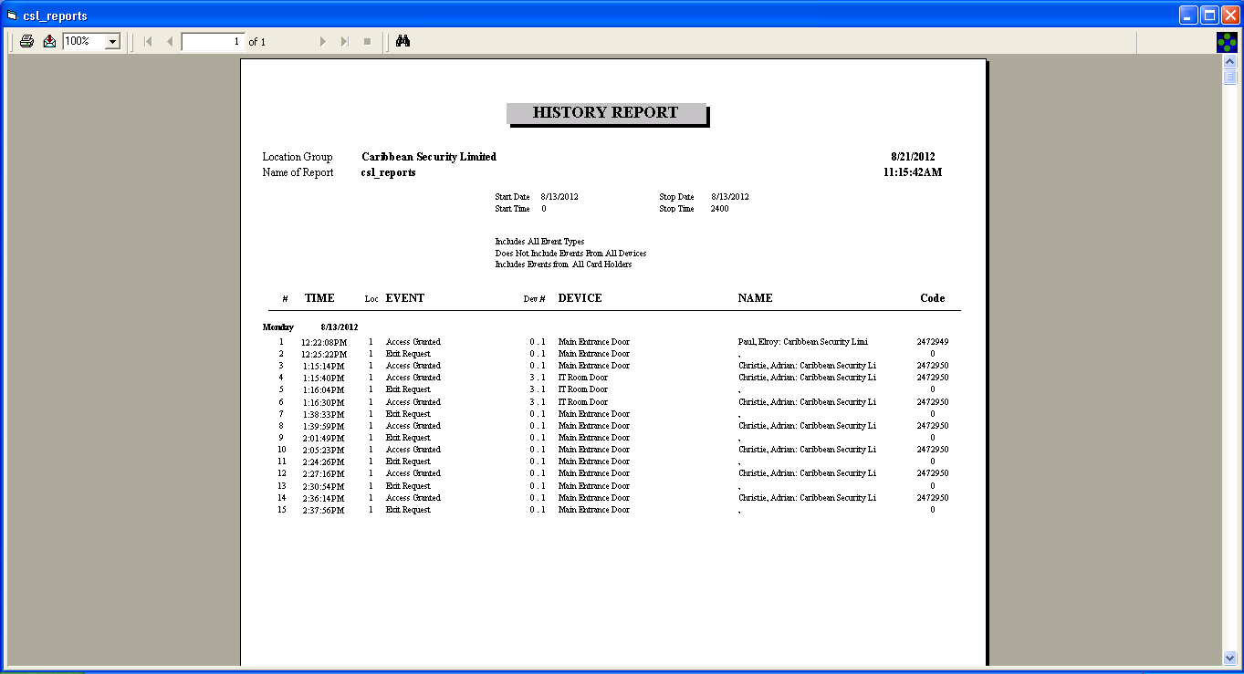

This report is an example of how to create a report showing all access to a particular door or doors.

Now for a report showing where a particular card was used first recheck the box “Include Events From All Devices in Location Group” then uncheck the box “include events from all cardholders”

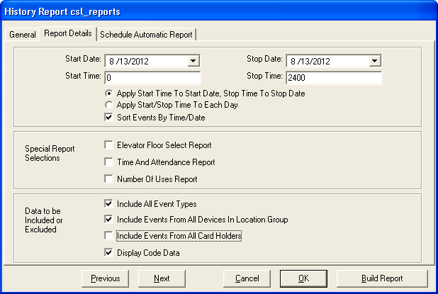

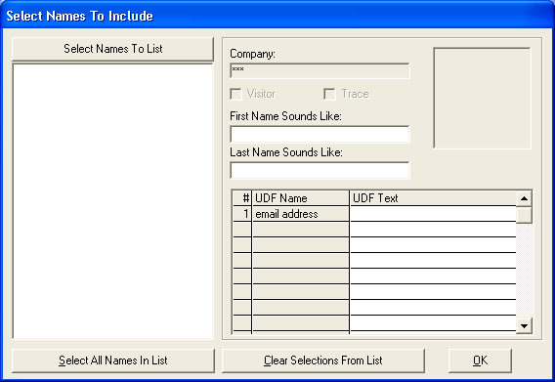

When this screen pops up click on “Select Names To List”

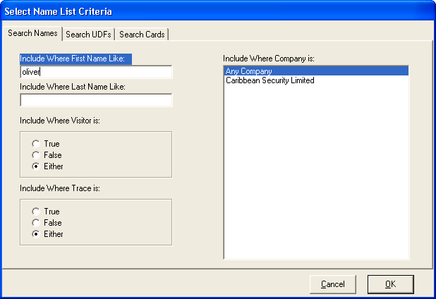

When this screen pops up type employee name example oliver

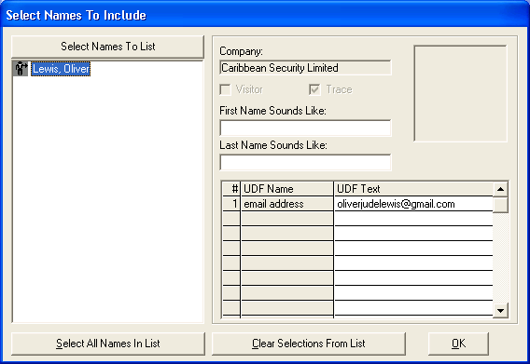

After selecting Lewis Oliver be sure to double right click as this screen shot shows it click ok



Click build report and check print preview box then click print to see report

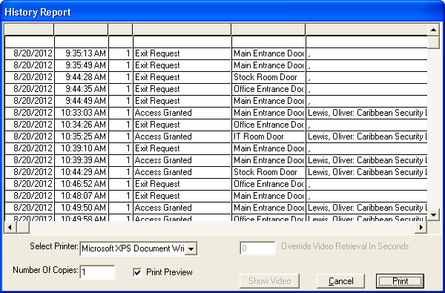

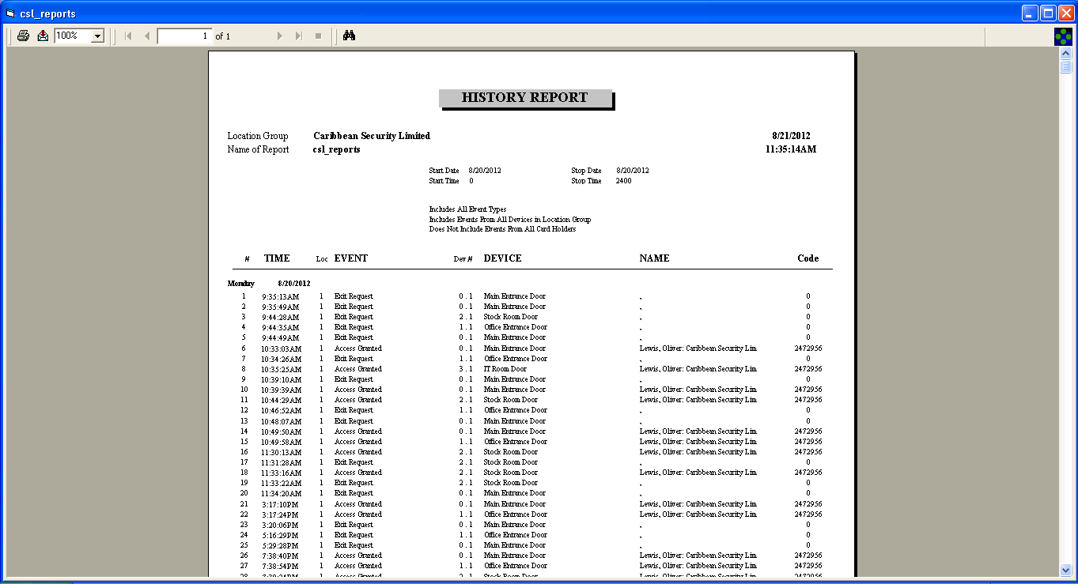

This report is an example of how to create a report showing “where a particular card was used”