South Carolina Department of Agriculture
Hugh E. Weathers, Commissioner
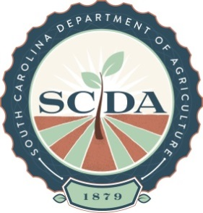

**Media Contact:** Clint Leach, jcleach@scda.sc.gov; 803-734-2210

**FOR IMMEDIATE RELEASE –** Friday, October 19, 2018

**Dates Set for Fall Waste Pesticide Collections**

**COLUMBIA, S.C.** –The South Carolina Department of Agriculture (SCDA) is offering South Carolina residents the opportunity to safely dispose of outdated, unusable or unwanted pesticides.

The pesticide and chemical program is open to all private, commercial and non-commercial pesticide applicators in the state, as well as homeowners. SCDA staff will be on site to monitor pesticide collection and disposal and will have final authority on acceptance of products.

* Chemical and pesticide quantities accepted will be limited to 2500 pounds of solid and 300 gallons of liquid at no charge.
* Pesticide products accepted include herbicides, insecticides, nematicides, fungicides and similar products used in agricultural production or around the home.
* Rinsate will not be accepted.
* Fertilizer will not be accepted unless it is combined or co-packed with a pesticide such as weed and feed.
* No compressed gas cylinders (metal cylinder with a valve) or empty pesticide containers will be collected.
* Collection events may be cancelled due to inclement weather and will be posted on SCDA’s website ([www.agriculture.sc.gov](http://www.agriculture.sc.gov)). Possible makeup dates will be announced at a later date.

Collection Dates and Locations:

|  |  |
| --- | --- |
| **November 6, 2018 – Florence County**  Pee Dee Research and Education Center  GPS address:  2200 Pocket Road  Darlington SC 29532  9:00 am – 3: 00 pm  **November 7, 2018 – Abbeville County**  Abbeville County Extension Office  265 Industrial Blvd  Abbeville, SC 29620  9:00 am – 3:00 pm | **November 13, 2018 – Orangeburg County**  Mixon Seed Company  1438 Joe S Jeffords Highway  Orangeburg, SC 29115  9:00 am – 3:00 pm  **November 14, 2018 – Charleston County**  Carolina Eastern Outdoors  4744 Highway 162  Hollywood, SC 29449  9:00 am – 3:00 pm |

For more information contact SCDA’s John Stokes at 803-737-9696 or jstokes@scda.sc.gov.