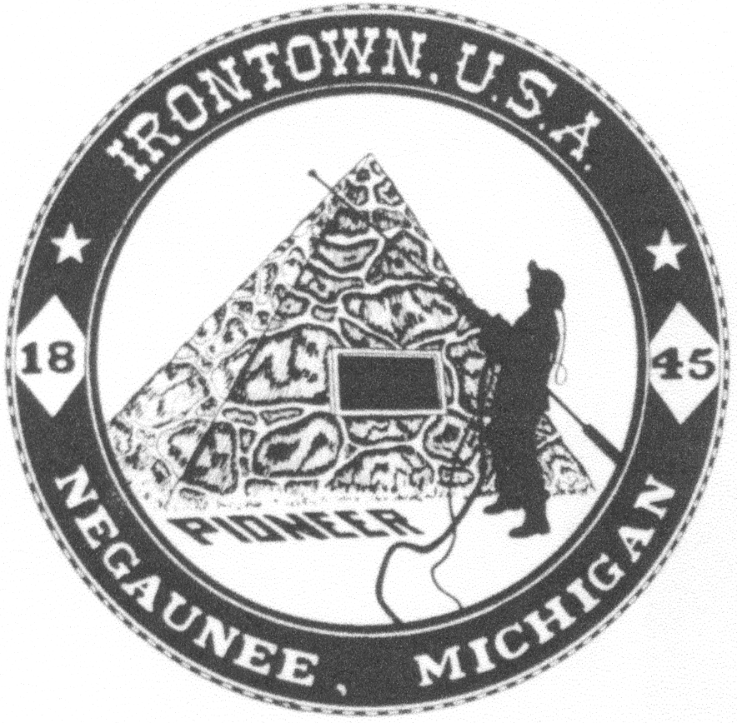
Negaunee Irontown Association

P.O. Box 128 Negaunee, MI 49866
www.negauneeirontown.com

2023 Community Service Scholarship Guidelines

ORIGIN: Established in 1996 by the Board of Directors of the Negaunee Irontown Association to salute young people who have displayed commitment to the area through community service.

ELIGIBILITY: Recipients must meet the following criteria:

• Senior at Negaunee High School who plans to attend a college or university.

• Student who has displayed a commitment to community service through volunteer, non-paid efforts.

Applicants should submit a letter to the Irontown Association by the specified deadline of each year outlining their community service and educational goals. Application must include at least two letters of support from teachers, clergy, administrators, or others who have been involved with–and directly observed-- the student’s volunteer efforts.

Letters should be addressed to:
Scholarship Committee
Negaunee Irontown Association
P.O. Box 128
Negaunee, MI 49866

The final decision will be made by Irontown’s Scholarship Committee.

AWARD: May vary depending upon interest income received during given year.

NUMBER: One or more awards per year. This will be decided by a board vote.

PROVISIONS: This is an endowed fund created by the Negaunee Irontown Association. Interest earned will be utilized to fund the annual award, additional donations may be sought from the Irontown Association if interest income alone is not enough to fund the award. The Irontown Board maintains the right to elect to make no awards, if they believe a suitable candidate has not applied or if no applications are received; in this case, the funds will be reinvested for future awards.

DEADLINE: Postmarked on or before April 21, 2023

