Location
Shiloh, Ohio

Facility Type
Solid Waste Landfill

Client
Allied Waste, Industries, Inc.

Services Provided
- Engineering Design
- Construction Inspection/Quality
Assurance
- Construction Certification
- Reporting
- Project Management
- Soils Pre-qualification

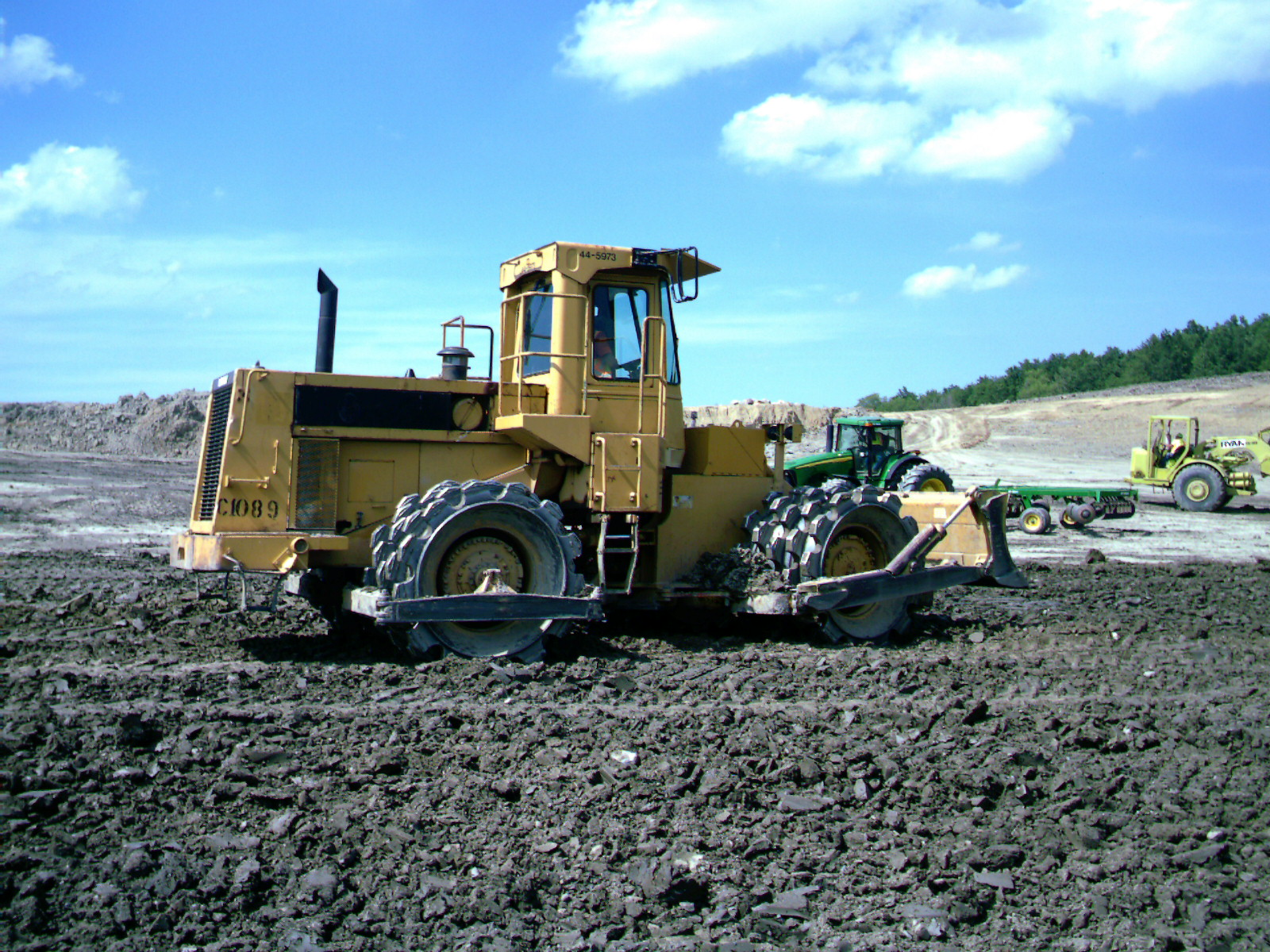

Re-compacted Soil Liner Installation

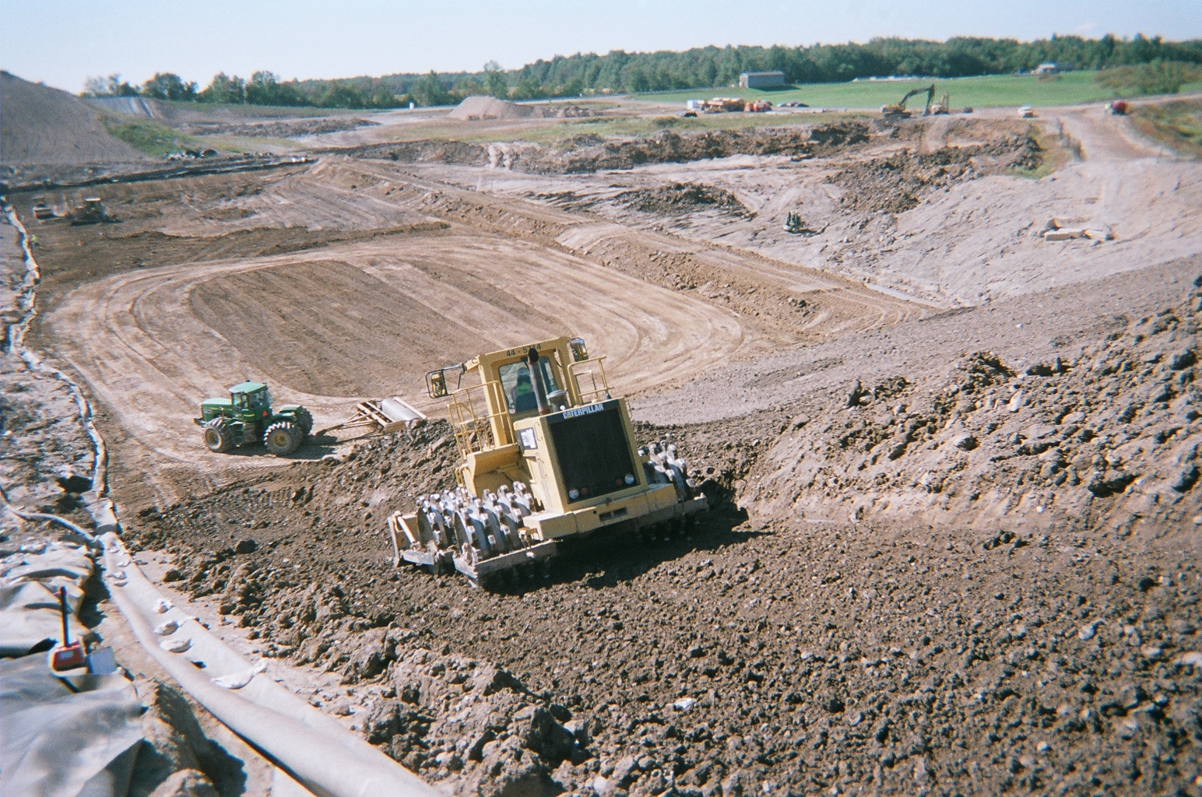

Project Descriptions
NPE has provided engineering design, soils pre-qualification, construction quality assurance and certification services for the following projects:

Geotechnical engineering (2012) - geotechnical engineering analysis for lateral expansion of landfill

Cell 5 (2012) – 8 acre disposal cell

Cell 4B-N (2008) - 2.8 acre disposal cell and northern sedimentation basin

- Cell 4B-C (2006) - 4.3 acre disposal cell

- Cell 4B-S/Partial 4B-N (2005) - 2.1 acre disposal cell

Active Landfill Gas Extraction Systems (2005 - 2012) – gas extraction wells, condensate, header and lateral piping and skid-mounted flare station

- Cell 4A (2004) - 9.4-acre disposal cell

- Cell 3C (2003) - 4.0-acre disposal cell

Typical elements of the constructed cells have included a recompacted soil liner, structural fill embankments, sand pocket excavation and replacement with added geologic material, 60 mil HDPE geomembrane, leachate collection and forcemain piping, leachate drainage layer, dual sided geocomposite drainage layer, rain flaps and separation berms.



