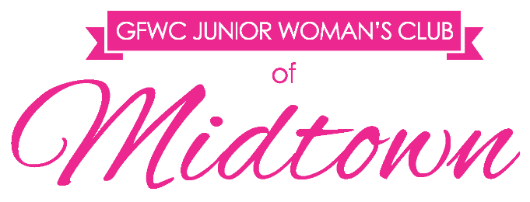
2017 CRAWL FOR A CAUSE APPLICATION

Organization: Your answer here.

1. If selected by the JWCM as our charity of choice, please explain how the funds will be utilized and how they will directly affect Leon County?
Your answer here.

2. Why is your organization best suited for this opportunity?
Your answer here.

3. Should your organization be selected, how could the JWCM work with you in the future by actively participating in events or other volunteer opportunities, preferably where the funds will have been utilized?
Your answer here.

4. Please let us know if there is any other information you think is important for us to know during the selection process:
Your answer here.

Please feel free to allow your answers, and the below portion to extend on to additional pages.

Applications must be submitted by
Monday, May 2, 2016 at 5 p.m. via e-mail to midtownjuniors@gmail.com.
Include a copy of your 501(c)3 form with your application.

GFWC Junior Woman’s Club of Midtown | PO Box 14643 | Tallahassee, FL 32317 | gfwcmidtownjuniors.org | midtownjuniors@gmail.com | facebook.com/JWCMidtown

