BUSI 406 Principles of Marketing

Sections 001, 002, 003, 004, 005, 006
Spring 2020 Research Requirement Information

Important Notes
- There are four ways to fulfill your research requirement for BUSI 406: (1) write three critiques of articles written in scholarly management journals, (2) write one critique and participate in two research studies, (3) write two critiques and participate in one research study, and (4) participate in three research studies.
- If you choose to write one or more critiques, please see your BUSI 406 syllabus for more information on how to fulfill this requirement. You may also contact BUSI 406 research manager, Professor Claudia Kubowicz Malhotra (Claudia@unc.edu) with any questions and/or for acceptable article recommendations. All critiques must be submitted to your BUSI 406 instructor or the BUSI 406 research manager NO LATER THAN 5PM THURSDAY, April 23, 2020. (No exceptions!).
- If you choose (2) or (3) or (4), you will need to register online to participate in studies. This handout describes how to sign up for research studies. Please keep this handout as a reference. All of the information you need to register for and participate in the research studies is contained in this document.

Official schedule for the Spring 2020 MARKETING Research Requirement Studies

Week 1: February 3 - 7 Week 2: March 2 - 6 Week 3: March 30 – April 3

To participate in a research study, you will need to complete two easy steps:

- Register on the research studies scheduling website.
- Over the course of the semester, three studies will be posted to the website and available for you to sign up. You will need to register for, and complete (!), ALL THREE studies if you want to fulfill your entire research requirement by participating in studies.

Step I: Register on the research studies scheduling website

[Note: This system is the same as the one used in BUSI 405 (Organizational Behavior)]. If you are taking both classes, you can use the same login for the Marketing and Organizational Behavior studies; just make sure that you select the correct course for receiving credit.

- To register, go to http://kfbs.sona-systems.com and click on “Request Account”

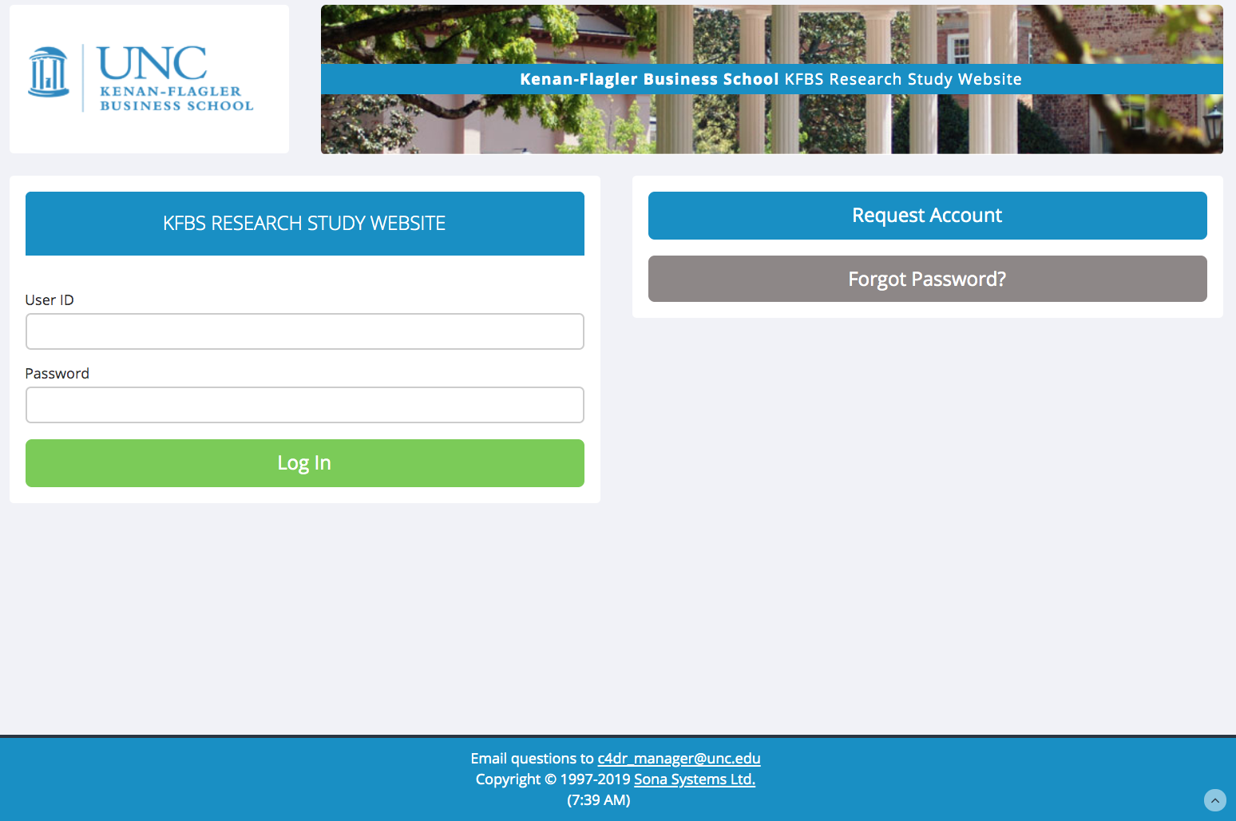

2. You will be taken to an Account Information screen. Enter your first name and your last name. Then, create a “User ID” and enter and reenter your email address. Please enter an email address you use regularly. All communication regarding these studies will be sent to the email address you enter. Entering your phone number is optional, but highly recommended in that it provides another way for us to communicate with you if the need arises.

Then, select your course and professor using the scroll menu. **Note: if you are taking both BUSI 406 (Marketing) and BUSI 405 (OB), hold the Control or Apple key and click on both courses, along with the corresponding instructors.** DO NOT DELTE prior courses. If you delete a prior course, your past participation will block your account not allowing you to signup for studies this semester. Please ADD the course/s you are taking this semester so that the system can maintain records of past partipation while enabling signups for studies corresponding to yout currently enrolled courses.

For BUSI 406 (Marketing), please be careful to select the correct section. The BUSI 406 Spring 2020 schedule is copied below for your reference and convenience.

Section 001 | MW | 9:30AM – 10:45AM | Professor Kyuhong Han
Section 002 | MW | 11:00AM – 12:15PM | Professor Kyuhong Han
Section 003 | MW | 12:30PM – 1:45PM | Professor Nicholas Didow
Section 004 | R | 8:00AM – 9:15AM | Professor Claudia Kubowicz Malhotra
Section 005 | R | 9:30AM – 10:45AM | Professor Claudia Kubowicz Malhotra
Section 006 | R | 11:00AM – 12:15PM | Professor Claudia Kubowicz Malhotra

Finally, click on “Request Account”. This will automatically generate an email to you that provides your new password for the site.

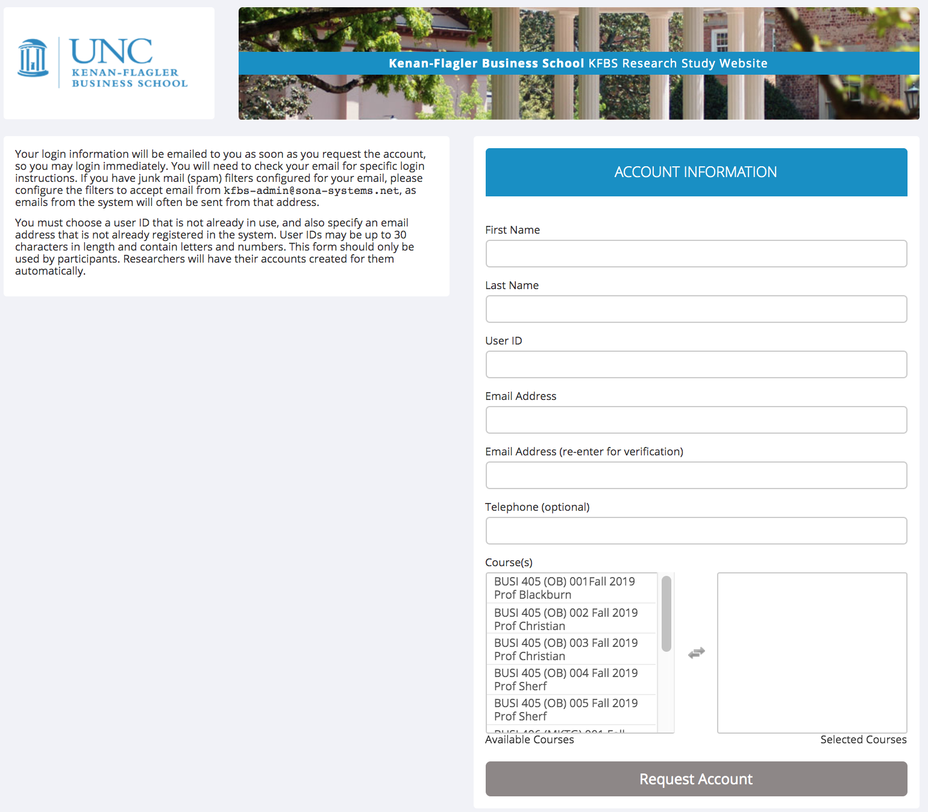

3. Check your email for a message from KFBS Research Study Website.
Go to http://kfbs.sona-systems.com and log in with your user name and password from the email:

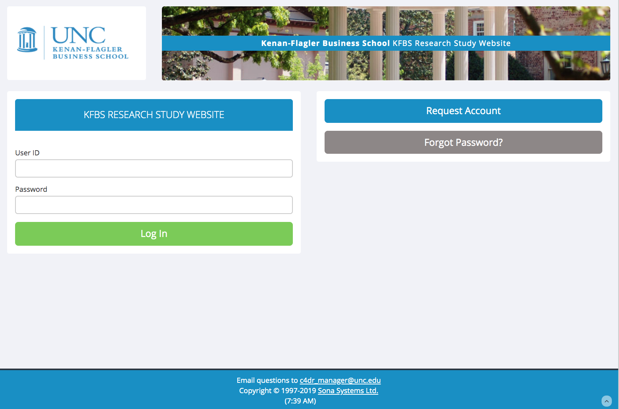

Important Note: If your browser is set on ‘high security’, you will need to make some changes in order to register. For the login to work you need to allow Sona Systems to set cookies. You can selectively add just this site to your list of trusted sites. Instructions on how to make these changes for Internet Explorer can be found here: http://kfbs.sona-systems.com/cookie_help.asp

4. You will then be directed to the following screen. Click on “Start Pretest”, which will take you to an initial set of questions that you need to answer before you can begin signing up for the studies.

5. Answer the questions in the pretest and then click on “Record Responses”. You will then be taken to this screen, where you should click on “Save Pretest”:

You will then be eligible to sign up for studies…

Step II: Sign up for Studies

Studies may not be available right away, but over the course of the semester there will be three opportunities to sign up and complete studies to fulfill your BUSI 406 research requirement. Please see schedule on page 1 of this document. You be notified when a new study has been added to the system. Your BUSI 406 instructor may also make an announcement in class. It is a good idea to check the website regularly to see if anything has been posted – it is your responsibility to make sure you sign up for studies if you want to participate in them.

To sign up for a study, go to http://kfbs.sona-systems.com and log in using your email and password. As studies post, you will see the study names. Click on the name of a study, and then click on “View Time Slots for This Study”. You will then see a list of time slots and room numbers in which the study is taking place. When you find a time slot that works for you, select the appropriate course to credit, and then click Sign Up.

Monday, February 3, 2020 11:00AM -
In general, you will want to sign up for a study as soon as you’re notified to ensure that you can sign up for a timeslot that is convenient for your schedule. If you wait, and try to sign up for a study at the last minute, you may find that all of your preferred times have already been taken by other students.

When you sign up for a study, you will commit to a specific date, time, and location. Make sure your scheduled session does not interfere with your classes and that you can arrive at the specified location on time. It is your responsibility to know where to be and when to be there! Studies will start on time and no latecomers will be admitted. If you are late you will need to reschedule for a later session, if any are available (if not, you will miss your opportunity to complete that study, and will need to complete a research critique instead). Keep in mind that if you sign up for a specific slot and you do not show up, you take away another student’s opportunity to participate, so please be considerate of your fellow classmates.

You should only sign up if you are sure you can attend the session. However, unpredictable events do happen, so if you cannot make it to the session, you can cancel up to 3 hours in advance using the website. In order to cancel, click on the “Appointments” tab. Note that you cannot sign up for another slot of the same study unless you cancel your previously assigned slot.

When you arrive at a study, the experimenter will check you in. After the study is completed, the experimenter will credit your attendance on the website. You can check your credits by clicking the “Completed” tab under “Appointments.” If you feel that you have not been credited for a study you participated in, please contact the BUSI 406 research manager, Professor Claudia Kubowicz Malhotra (Claudia@unc.edu).

Frequently Asked Questions

- What are these studies about?
Studies are conducted by marketing faculty members and graduate students, and thus may cover a wide range of topics, such as consumer decision-making. These studies do not require any specific knowledge about marketing. The researchers are only interested in your honest opinion as a study participant. Participating in research is a valuable way for you to receive first-hand experience with marketing research methods and to learn about the research conducted by KFBS faculty and Ph.D. students. In addition, your involvement in research will help faculty and graduate students at KFBS continue to develop state-of-the-art management thought, which ultimately is brought back into the classroom.

- How long are research studies?
Each session will last no more than 60 minutes.

- Where do the research studies meet?
All studies will be conducted at KFBS, but the exact location for any given study varies. When you sign up for a study, the classroom or lab where the study will be conducted will be clearly specified.

- Do I need to bring anything when I participate in a study?
It is a good idea to bring a pen or pencil. Other than that, everything you need to participate will be provided for you.

- How many studies do I need to do?
You can fulfill the research requirement in one of four ways: (1) Participate in 3 research studies, (2) Review 3 Marketing journal articles, (3) Participate in 2 studies and review 1 article or (4) Participate in 1 study and review 2 articles. Thus, if you want to fulfill your research requirement entirely by participating in studies, you must complete three studies.

- How many studies will be offered during the semester?
Three studies will be offered during the semester. Generally, the studies are spaced so that there are a few weeks separating each of them.

- How do I get credit for my participation?
The experimenter in charge of the session will note your participation in the online system. You can check whether you got credit by logging onto the website and clicking on the “Completed” tab under “Appointments.” Please allow at least 1 week after the completion of all sessions for your credit to post. If you feel that you have not been credited for a study in which you participated, please contact the BUSI 406 research manager, Professor Claudia Kubowicz Malhotra (Claudia@unc.edu).

- What if I cannot make it to a session?
You can cancel your participation up to 3 hours in advance using the web site by clicking on the “My Schedule/Credits” tab and then clicking on the Cancel box.

- What if I did not attend a session? Are there make-up sessions?
Once a study has ended, then the opportunity to participate in that study has passed. No make-up sessions will be offered. To receive research credit, you will need to prepare an article critique.

- What do I do if I have trouble logging in?
Be sure to remember and type in your User Id and password correctly. Also see FAQ Nr. 12 on how to get further assistance.

- What do I do if I forgot my password?
Go to http://kfbs.sona-systems.com and click on “Lost your password?” at the bottom left of the screen.

- What do I do when I have problems with this system?
If you feel that you have read all instructions carefully, and you are still having difficulties, please email BUSI 406 research manager, Professor Claudia Kubowicz Malhotra (Claudia@unc.edu) who will try to respond to your questions within 24 hours.

