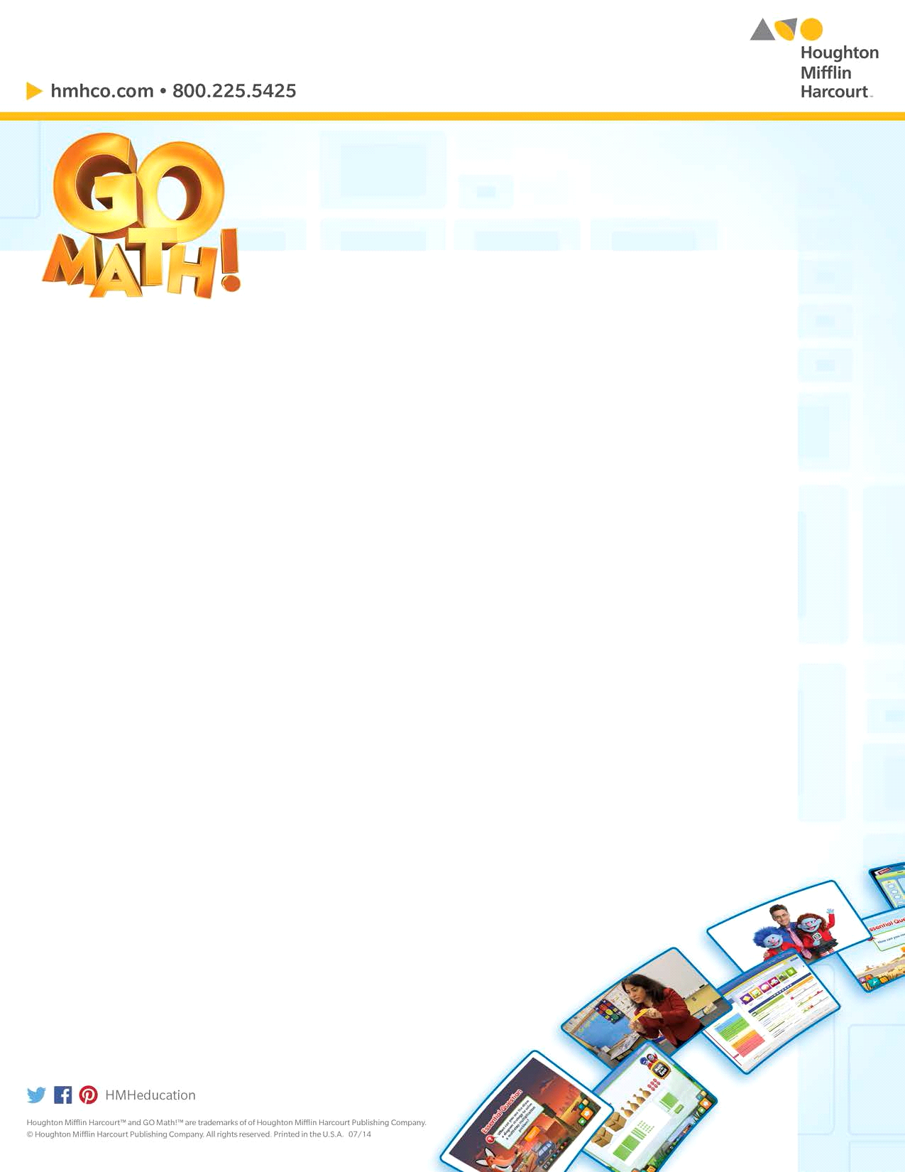
Welcome to Houghton Mifflin Harcourt
GO Math!

Dear Parents,

This year your child will be using a new math program called GO Math! that offers an engaging and interactive approach to covering the CT Core Standards. The program emphasizes understanding, computational fluency, and real life applications.
GO Math! is currently being used by over seven million students across the country!

Some Unique Features of GO Math!

- A Write-in Student Edition - The write-in book at every grade allows students to problem solve, record, and practice right in their own book. No time is lost in copying from book to paper and students have an ongoing record of their work. Each lesson also includes 2 pages of practice and homework!
- Interactive Student Edition - The iSE provides an online interactive approach to developing the lesson concepts. It works on computers and tablets. The iSE will also link to Math On The Spot Videos and The Personal Math Trainer powered by Knewton™.
- Math On The Spot Videos – instructional videos featuring GO Math! authors provide an engaging video tutorial for every lesson to demonstrate important concepts and skills. QR codes in the print Student book allow you and your child to view the videos at home by scanning the code with a smart phone or tablet.
- The Personal Math Trainer powered by Knewton™ – this online resource includes personalized practice, homework, and assessment.

How does GO Math! develop a deep understanding of math concepts?

Each lesson in GO Math! begins with an Essential Question that sets the stage for the lesson topic. Real world problems that are instructionally sound and relevant to students are presented within each GO Math! lesson. Strategies and conceptual understanding are highlighted through visual representations, mathematical models, and student explorations. The student edition facilitates engagement with the mathematics from the beginning of instruction because of its interactive, write- in format. Depth of understanding is reinforced through the use of Math Talk and Write Math questions provided within the lessons to support verbal and written communication around important mathematical topics.

What is Math Talk?

You will notice questions within each lesson that are labeled Math Talk. These questions encourage students to explain their thinking. Having students verbalize their thinking is important in developing a deep understanding of concepts. You really understand a concept or procedure when you can explain it to others!

How does GO Math develop math vocabulary?

It’s important for students to understand the language of math. Each chapter in the GO Math! Student book includes the vocabulary words for the chapter on cut apart cards.
In addition, there are vocabulary activities, games and writing activities that begin every chapter. New vocabulary is highlighted within the lessons along with writing opportunities for students to use their math vocabulary words.

hmhco.com/gomath

How does GO Math! provide real world connections and applications?

Problem solving is practiced daily in lesson practice sets that include real life application problems. You will notice the Real World problem solving logo used throughout the student book lessons. The problem solving skill or strategy lessons provide strong reading support, and problem solving practice moves from specific strategy practice to mixed strategy practice. Students learn how to use models and representations to help them solve problems.

How can I help my child with math at home?

- Encourage your child to solve everyday problems involving numbers.
- Talk about the importance of math and how it is used in daily life.
- Review your child’s homework and ask them to explain how they arrived at their solutions to problems.
- Your child’s teacher may send a letter home that provides you with an overview of the math in the chapter, the math vocabulary, and an activity to do at home.
- At grades K-2 there is a Home Activity at the bottom of the fourth page of each lesson in the Student Book.
- Have your child practice using the math vocabulary for the chapter.
- Play the math vocabulary game at the beginning of each chapter with your child.
- View the Math on The Spot videos with your child for concepts or skills he or she may be having difficulty with.
- Talk with your child’s teacher about any questions you have about the math your child is learning.

hmhco.com/gomath

