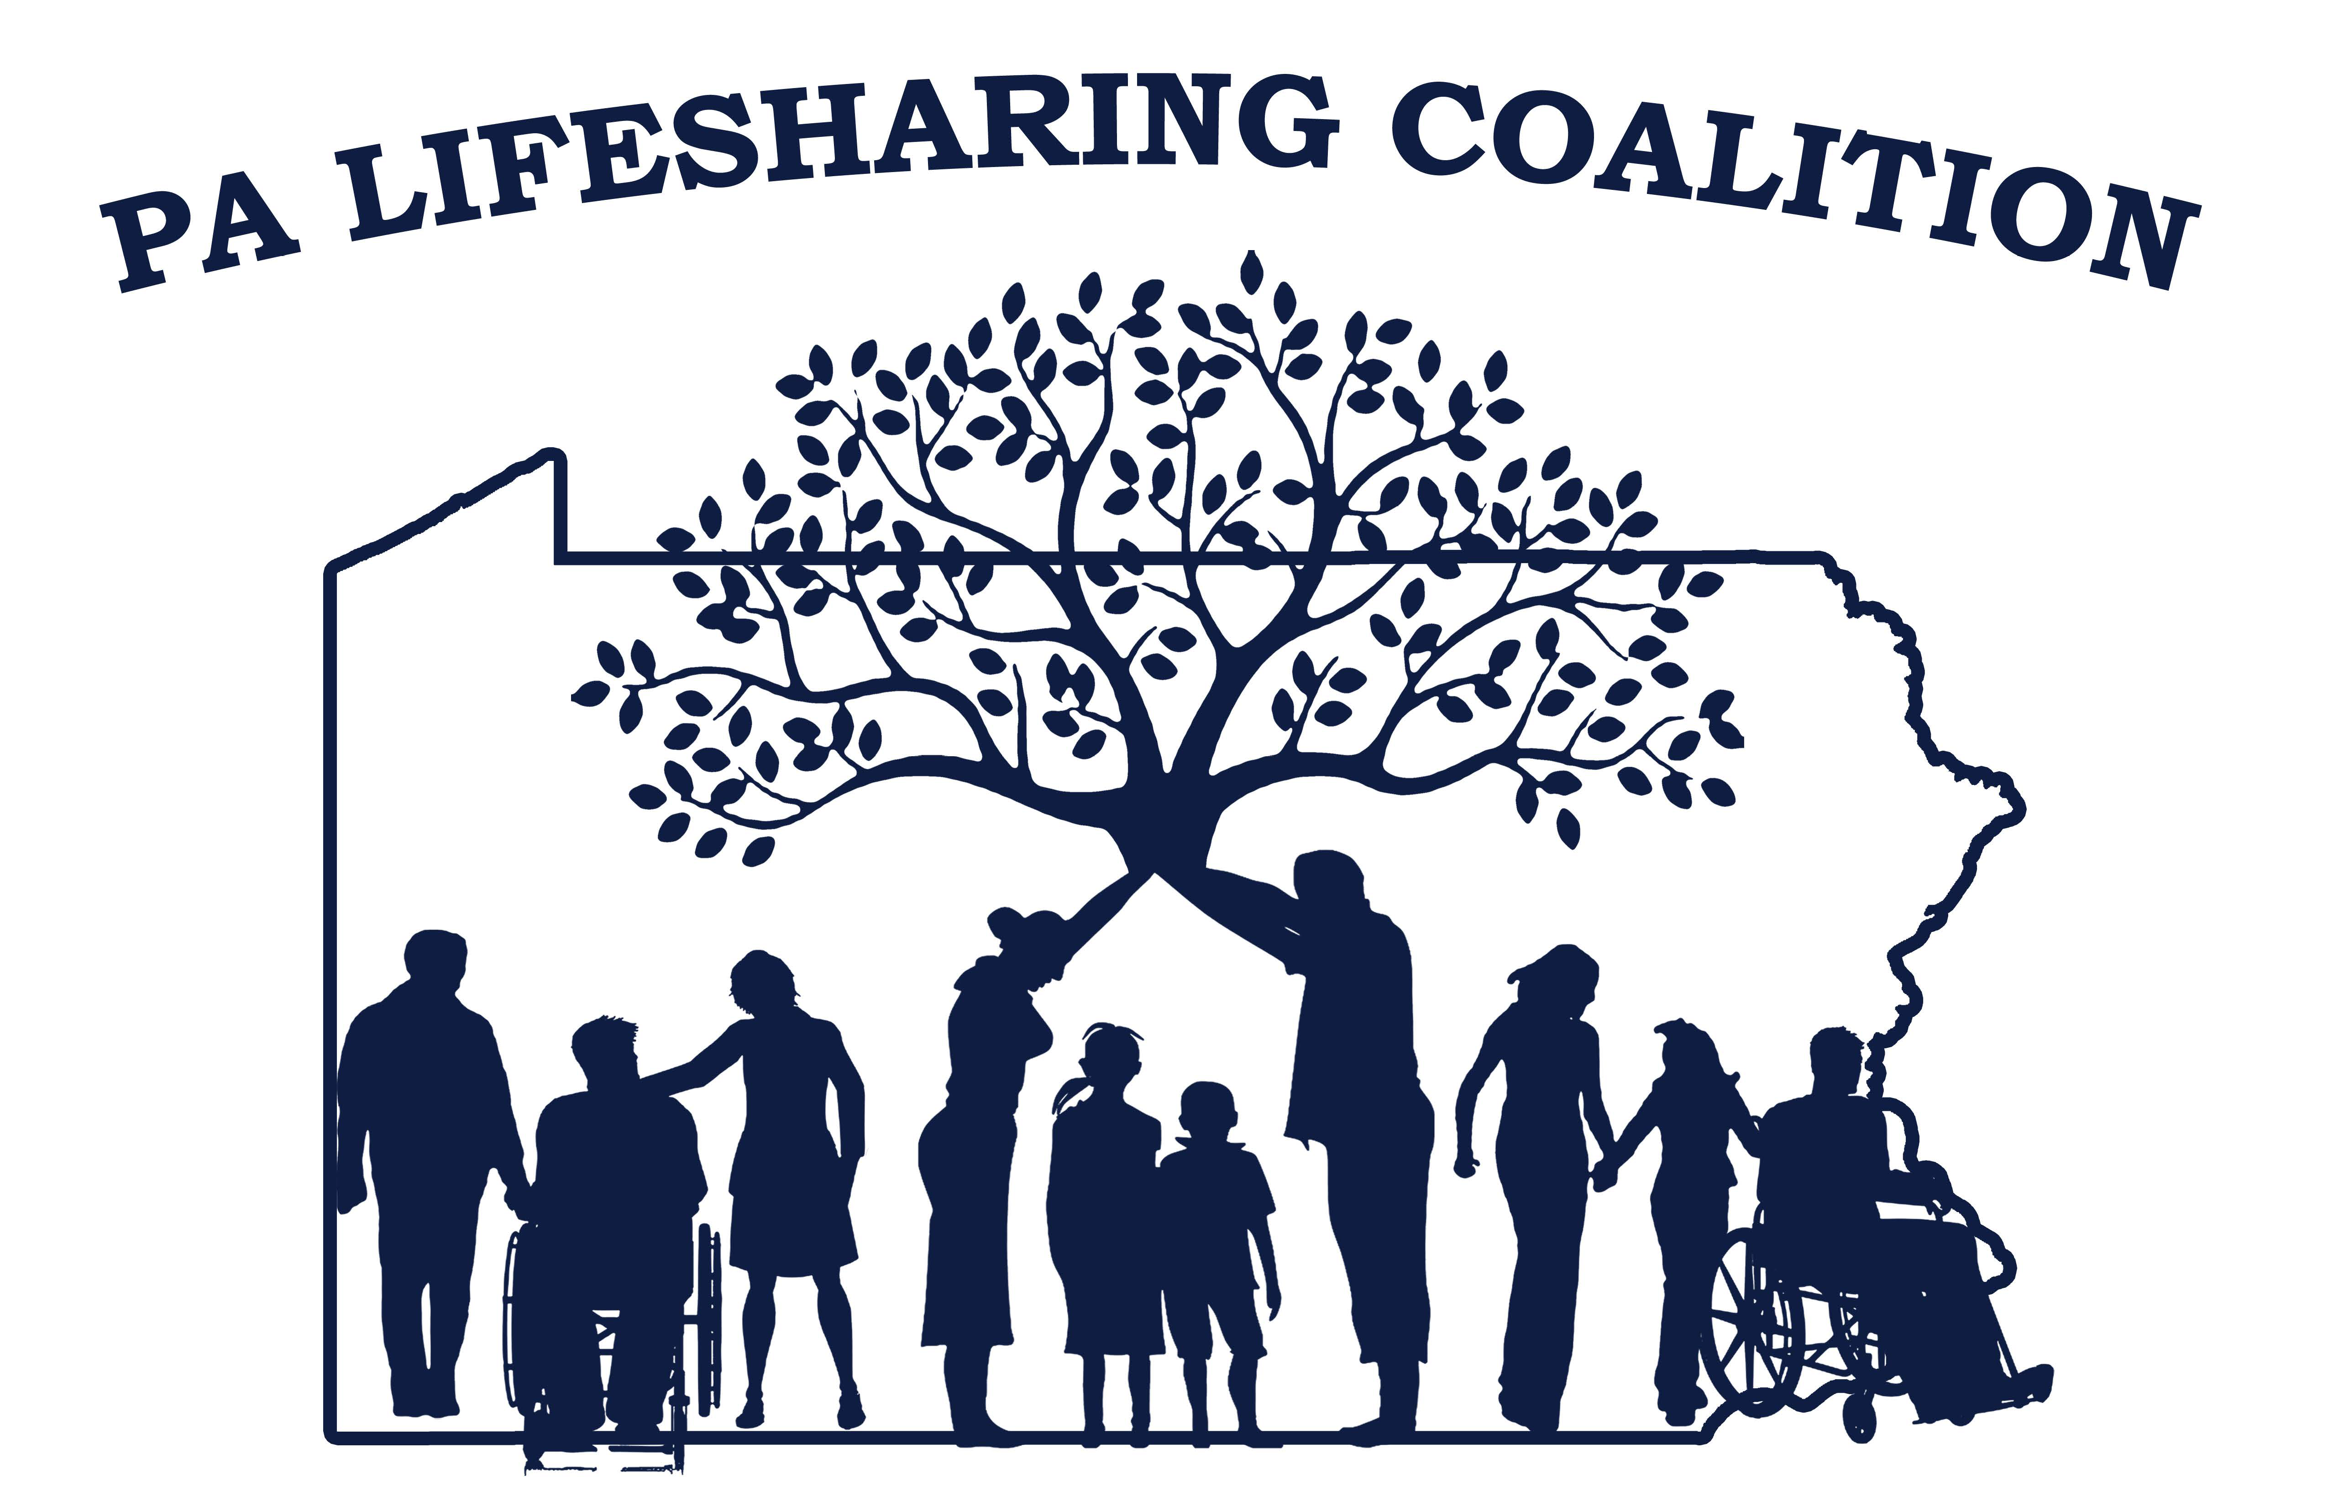

Northeast Lifesharing Coalition Meeting –September 11, 2018

**Mission: The Mission of the Pennsylvania Lifesharing Coalition is to promote, support and embrace the concept of *Lifesharing* and the**

**philosophy of self-determination and everyday lives.**

**tab**

|  |  |  |  |  |  |
| --- | --- | --- | --- | --- | --- |
| **Question or topic** | **Owner** | **Decision/ Information** | **Outcome** | **Come Prepared to** | **Allotted Time** |
| Opening Round--Introductions | Joe | **Sign-in sheet attached** | Introductions |  | 5 minutes |
| 2018 LIfesharing Picnic | Jen &  Alison | **Information/Feedback/Decision**  **Discussed good turnout but location issues.**  **Suggestions including Beltsville, Hickory Run, Mtn. View Park, Knobels discussed. Welcomed group to join picnic committee to be part of the ongoing conversation regarding venues.**  **Selfie winner** **Janet K. and Joyce B. won $25 gift card. Will ask Cody K. to post on LS Coal. website with additional 2018 picnic photos.** | Picnic was a HUGE success!! Thanks to all who contributed. Largest crowd ever 168+  Selfie Contest winner?  Next year July 19, 2019—same or different venue |  | 10 minutes |
| New Brochure |  |  | Copies distributed |  | 5 minutes |
| ODP Updates |  | **1.**  **Tim Little, ODP Regional Lifesharing representative shared he is hopeful for a smooth transition as Kristen has been involved with Nancy and Lifecourse philosophy. Joe K. added she has had past involvement with the coalition and thinks she’ll be supportive.**  **. Tim spoke to group providing facts about event with provider, Blossom in Phila. and then discussed his involvement with Hamburg trans. to CLA’s. Focusing on findings of persons coming into the community and a disconnect with doc. in ISP’s, orders, training and DSP day to day practices. ODP is monitoring by making visits to sites to promote best practice, consistency of treatment. There is a disconnect, lack of communication. Examples of diet, consistency of food, training for staff, protocols are recommended for individuals that break down their specific needs. IE sit next to individual when eating, take sips of drink between bites, that may be different for someone else on same diet.**  **Request for ODP to release training to save copy to LS Coal. Website instead of links. Tim will inquire but likely have to continue to link to ODP.**  **Recommended video better than power points for provider trainings.** | 1.  Nancy Thaler has retired; Kristen Ahrens is acting Deputy  2.  071-18 Approve Program Capacity and Noncontiguous Clearance  **Joe reported has done this. Process a little confusing. 2nd part of process - was asked for copy of lic. and approved program capacity? Tim will take question back to Marie Craven, ODP.**  3.  Developing Good Plans of Correction  **Alison shared copy of ODP doc. for review**.  4.  Kepro to take over the SIS.  **Joe briefly reported initiating request for SIS is thru ODP.**  **Jen T. request for Tim to share that SIS tool as written is not accurately assessing the population we serve, resulting in inaccurate scores. Barrier for Lifesharing growth and longevity.**  5.  Choking Alert/Fatal Four:  **Tim shared ODP Power Point.**  **Will scan and attach. With minutes. Bob Conklin is calling providers and then AE’s for follow up to address IM issues.**  **Alison received document provided by HCQU that will be scanned as attachment with minutes.** |  | 15 minutes |
| ODP September Newsletter |  |  | ODP established Special Populations Unit within Bureau of Autism—led by Lea Sheffield and will oversee Harry M; Michelle Swain Perrine—new Deaf Services Coordinator; unit will also include 2 communication specialists |  | 5 minutes |
| Rate Changes |  | Information:  **Hard to determine moving forward to make rate changes. Some have, some have not. Rate structures also vary from agency to agency.**  **Discussion ensued re: tech guide –**  **Need for daily service notes apparent. Some utilizing electronic versions of daily note, some continue had written notes. Two providers shared their daily note; attached. Some providers requiring electronic for all, some moving forward in contract with new providers…** | Anyone want to share? |  | 5-10 minutes |
| Respite/substitute care |  | **Providers continue to primarily utilize substitute care. Some 15 min. respite billed separate service.** | Anyone using respite? Do contract or pay by hour? Is it the same for both 15mins and 24hr respite. |  | 5-10 minutes |
| Conference Committee Update |  | Information  **Items for NE Regional Conference basket to go to Alison Karnish, Spectrum.**  **Issues with link for registration. Be sure Sandy, chair, is aware. 68 and counting so far.** | Registration is now open—getting down to the final preparations; looking for guitar player for bonfire; donations for regional basket |  | 5 minutes |
| State Coalition PATH   * Birth Families as Lifesharers * Lifesharing Expansion * Service definitions, ISP Manual, Chapter 6100’s Regs/RCG |  | **Birth Families: Joe reported pre-service agreement complete and part of training session at conference. Also forming trainings to be accessed on webpage focusing on best practices for birth families.**  **People are developing birth family providers. 4 and 2 developing from those present for today’s meeting (6 agencies, 1 AE, and ODP represented.)**  **Lifesharing Expansion: No report**  **RCG: 14 recommendations forwarded from workgroup submitted by regions to leadership which went onto ODP for consideration. Continue sending in statement form.**  **RCG call 9/21 @ 11:30am.**  **RCG discussion and will likely be looking at 6100’s.** | Are any agencies providing the service? How is it going? Conference Training.  Statewide Coalition RCG group continues to look for any comments regarding regulation and the regulatory compliance guide being developed by ODP; send any suggestions to Jen Tomaino.  New requirements under the 6100 regulations. |  | 5-10 minutes |
| Community Living Wavier |  | **Not getting enough or correct information when referred. Finding not adequate time, usually emergency, to properly transition/match. Finding CLW not adequate to cover costs, needs of those in LS. They enter LS but then as develop no funding for additional services.** | Do any of your Lifesharing Individuals have the wavier? **No one present.** |  | 5 minutes |
| Recent licensing experiences | Joe | **Joe Reported no concerns last experience in Central Region. Received citations but warranted. Respectful of host families.**  **Tim briefly discussed licensing from region to region.**  **Encouraged ongoing reports to RCG workgroup with relevant lic. experiences.** |  |  | 10 minutes |
| 2018 Dates—State Dates | Joe | **Note December date clarification.** | October 15-16, 2018—Conference—Seven Springs  December 13, 2018—Camp Hill-Giant |  | 5 minutes |
| 2018 Dates—NE Regional Dates | Joe | **Dates and locations of meetings to be established at November meeting.** | November 13th—Keystone, 3722 Lehigh St., Suite 403, Whitehall |  | 5 minutes |
| 2019 State Dates | Joe |  | February 21-Camp Hill  April 18—State College  June 20—State College  August 15—Camp Hill  December 12-Camp Hill |  |  |
| Next State Meeting | Joe |  | Conference at Seven Springs |  |  |
| Next Northeast Meeting | Joe |  | November 13th—Keystone, 3722 Lehigh St., Suite 403, Whitehall |  |  |
| Burning Issues | Joe |  |  |  |  |
| Closing Round: | Joe |  |  |  |  |

* Next NE Coalition meeting will be November 13th at Keystone

|  |  |  |  |
| --- | --- | --- | --- |
| Facilitator | Joe Karpinski | Leadership |  |
| Agenda Builder | Alison Karnish | Leadership |  |
| Note Taker | Jen Tomaino | NE Region |  |

|  |  |  |  |
| --- | --- | --- | --- |
| **Agenda Item** | **Agreed Actions** | **By Whom** | **By When** |
|  |  |  |  |
|  |  |  |  |
|  |  |  |  |
|  |  |  |  |