
The Learner’s Workshop:
Welcome Back to School Kit

Welcome back to a new year of teaching! There are about a zillion things for you to do before the kids arrive, so here are a few templates that I hope will make life easier for you. They contain a bunch of items I always wanted for my classroom, but didn’t have the time to make or the money to buy. I hope they’ll liven up your Back to School rush. Prepare the materials using a color inkjet printer. To save ink, you may set the printer to fast or draft mode, if you are satisfied with the quality at that level. Each item comes as a Microsoft® Word file and as a PDF file. Use the one that works best for you. (You’ll have to personalize the PDF files by hand.)

The items on the pages are grouped together so you’ll have to ungroup them if you want to move them around or replace them. Here’s how to do that:
- Select an item on the page
- Go to the Format menu
- Select Group
- Select Ungroup as many times as needed until the item you want to change can be isolated by itself.

If you want to replace a picture, isolate it (see above), right click on it and choose “Change picture…” Follow the menu items to choose the replacement image and Word will automatically resize the picture to fit the space.

After you’ve made all the changes you want, continue to select Regroup until you have the items all back together. This will help keep everything in place. Do this if you want to remove items and text boxes. If you just want to add text or change text in a box all you have to do is select the text.

Here are the items you’ll find in this “Learner’s Workshop Welcome Back to School Kit”:

Class List: Click in each box to add a student name. Run off a bunch and keep them in a folder so you can grab a new one whenever needed. Use them to keep track of assignments, items the students need to return, small group activities, and anything else you need to keep track of!
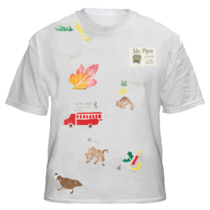
Field Trip T-Shirts: Your students can make a field trip T-shirt that will become a memory shirt by the end of the year. Have each student bring in a white T-shirt. Double click the word “Student” and their names on the “name tag”. Do the same thing to add your school information, and run them off on T-shirt transfer paper. (Your printer will reverse the image to make it correctly when you select t-shirt transfer as your paper type. If your printer doesn’t have this as a paper type, you might not be able to reverse the print.) Have a classroom volunteer help each student iron their transfer on their T-shirt. After each trip or classroom special event have the students draw with fabric crayons or use fabric paints to make a picture about the event. You won’t have to worry about nametags for your trips and your students will have a great shirt of memories at the end of the year!

If your printer doesn’t support t-shirt transfer paper, just print the name badges on cover stock, and laminate them. You can still use them, just not on a t-shirt.

Communication Folder labels: Type your students’ names on the name label and have the children cut and glue the labels onto their communication folders on the first day of school. This will help organize what papers to leave at home and what to return to school.

A Letterhead for your parent communications: Type in your own information, and use it as a template for all your classroom correspondence. If you have a current version of Adobe Reader, you may be able to type on the PDF file. It’s not near as good as using Word, but it’s better than nothing!

Note paper: Type your name and then run off lots of pages. Cut in fourths and stack in your desk for quick notes to colleagues, parents, and students.

Reward Tickets: Type your signature onto each ticket and then run off lots. Cut them apart and keep them in a stack nearby so you can use them freely. (You might want to remove the date so you don’t have to fill it in: select the date, hit backspace.)

Incentive Charts: 2 sizes, use the one you prefer. Both charts will accommodate ½ inch stickers. You could also use Crayola stampers or just draw stars, checkmarks, or put in finger prints!

Newsletter Template: The newsletter has been formatted with a header on the first page and a footer on the second page. If you need to add spaces between the school name and the room number, put the insertion point in the middle and press the space bar. The rest of the space is in two columns. Just click in the left space under the header to begin your news. The text will automatically flow. Use just the first page if you don’t have enough news for both sides.

Door Sign: Just type your name and room number to make your own personal sign. If you are using the letter size, trim the margins, tape the two sides together on the back, and laminate. If you have access to a large format printer (or take the file to a copy shop), you can print the door sign directly on ledge paper. Then you won’t have to trim and tape.

Desk Labels: Type in your students’ names for customized desk labels. If you have your school’s preferred font on your computer you can change the font on the label to match. Just select the words “Student Name” and change the font to the one you want. You may have to adjust the size a bit to fit correctly. (You can also use the ungroup option and move the text box until it fits.) There are two different labels. Choose the one more appropriate for your grade.

Welcome to the Learner’s Workshop postcard: Send these postcards home before the school year begins to get your kiddos revved up. Replace the sample text and then print the front and the back double sided on cover stock. Later, change the “Welcome to” text with “Good News from” and you can use the postcards throughout the year to send home happy thoughts.

I hope to be able to offer quality materials at a low cost. The best way I can do that is to sell the electronic files and avoid printing and shipping costs. I want to make this easy for you, so I would appreciate any feedback you would like to offer. Please contact me at sflynn@thematicteacher.com with any suggestions you have and if you are looking for materials you can’t find, I’d be happy to consider developing them for you. If you want them, others probably will, too! I hope you will feel a little like you have your own personal publisher!

I hope you will find these items helpful, fun, and easy to use. Thanks for giving them a try!
Sandie Flynn
Sandie Flynn
Integreat! Thematic Units
www.thematicteacher.com

Copyright © 2010 Integreat! Thematic Units
All rights reserved.

All materials included in this kit are copyrighted. No part of this publication may be reproduced, stored in a retrieval system or transmitted in any form or by any means, electronic, mechanical, photocopying, recording, scanning or otherwise, without prior, written permission from the author.

Limited reproduction license: Permission to reproduce the classroom materials provided in this unit is given to the individual who purchased this publication for use with their own students or clients in a single classroom. Individuals who purchased electronic versions of this publication may store their copy on one computer and may make one back up copy. They may change the publication to make it more suitable for their own personal use. They may not copy or distribute the publication, any changes thereof, or any materials included in it to other people by any means including, electronic, mechanical, photocopying, recording, scanning, or otherwise.

February 21, 2012

Dear Parents,

Type the body of your letter here.

Sincerely,
Your Name

Your Name

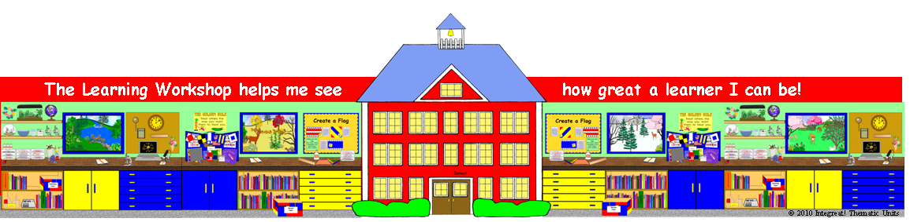
A note from
Your Name
From me to you...
Your Name
FYI from
Your Name
Keeping in touch!
Your Name

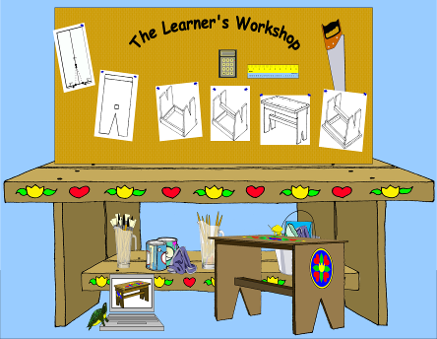
was a great friend today!
© 2010 Integreat! Thematic Units
Date
Signature
had a
wonderful day!
© 2010 Integreat! Thematic Units
Date
Signature
what I did today!
Date
© 2010 Integreat! Thematic Units
Summer, fall, winter, spring—I am learning LOTS of things!
Signature
© 2010 Integreat! Thematic Units
Date
Signature
© 2010 Integreat! Thematic Units
Signature
Date
© 2010 Integreat! Thematic Units
uncovering secrets unknown to all!
Signature
Learn to love.
Love to learn.
Date
Signature
© 2010 Integreat! Thematic Units
© 2010 Integreat! Thematic Units
an amazing
project at the
Learner’s Workshop!
Signature
Date

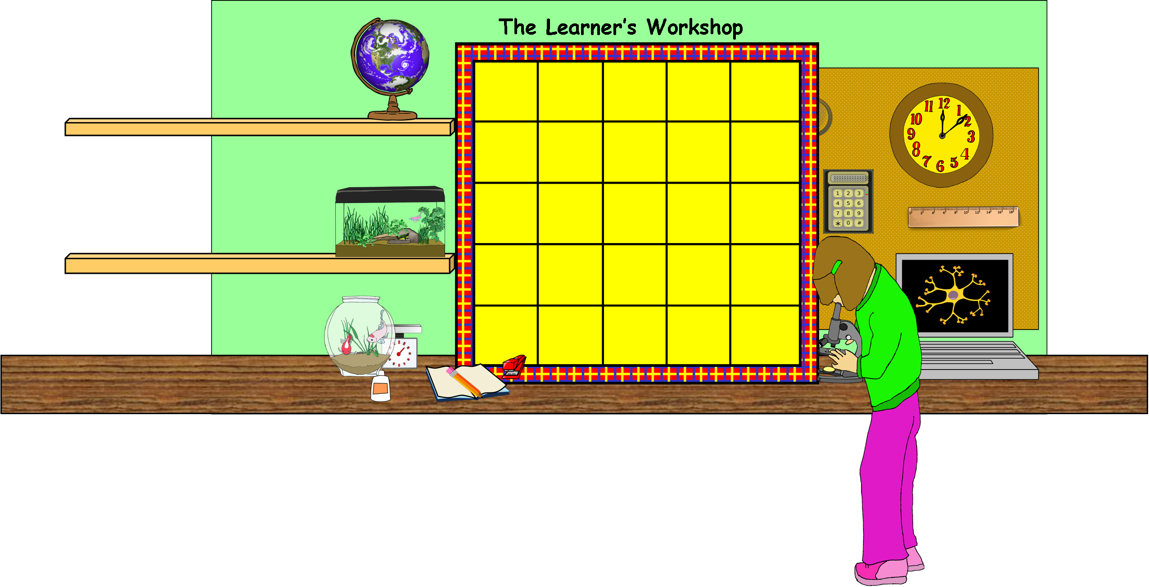

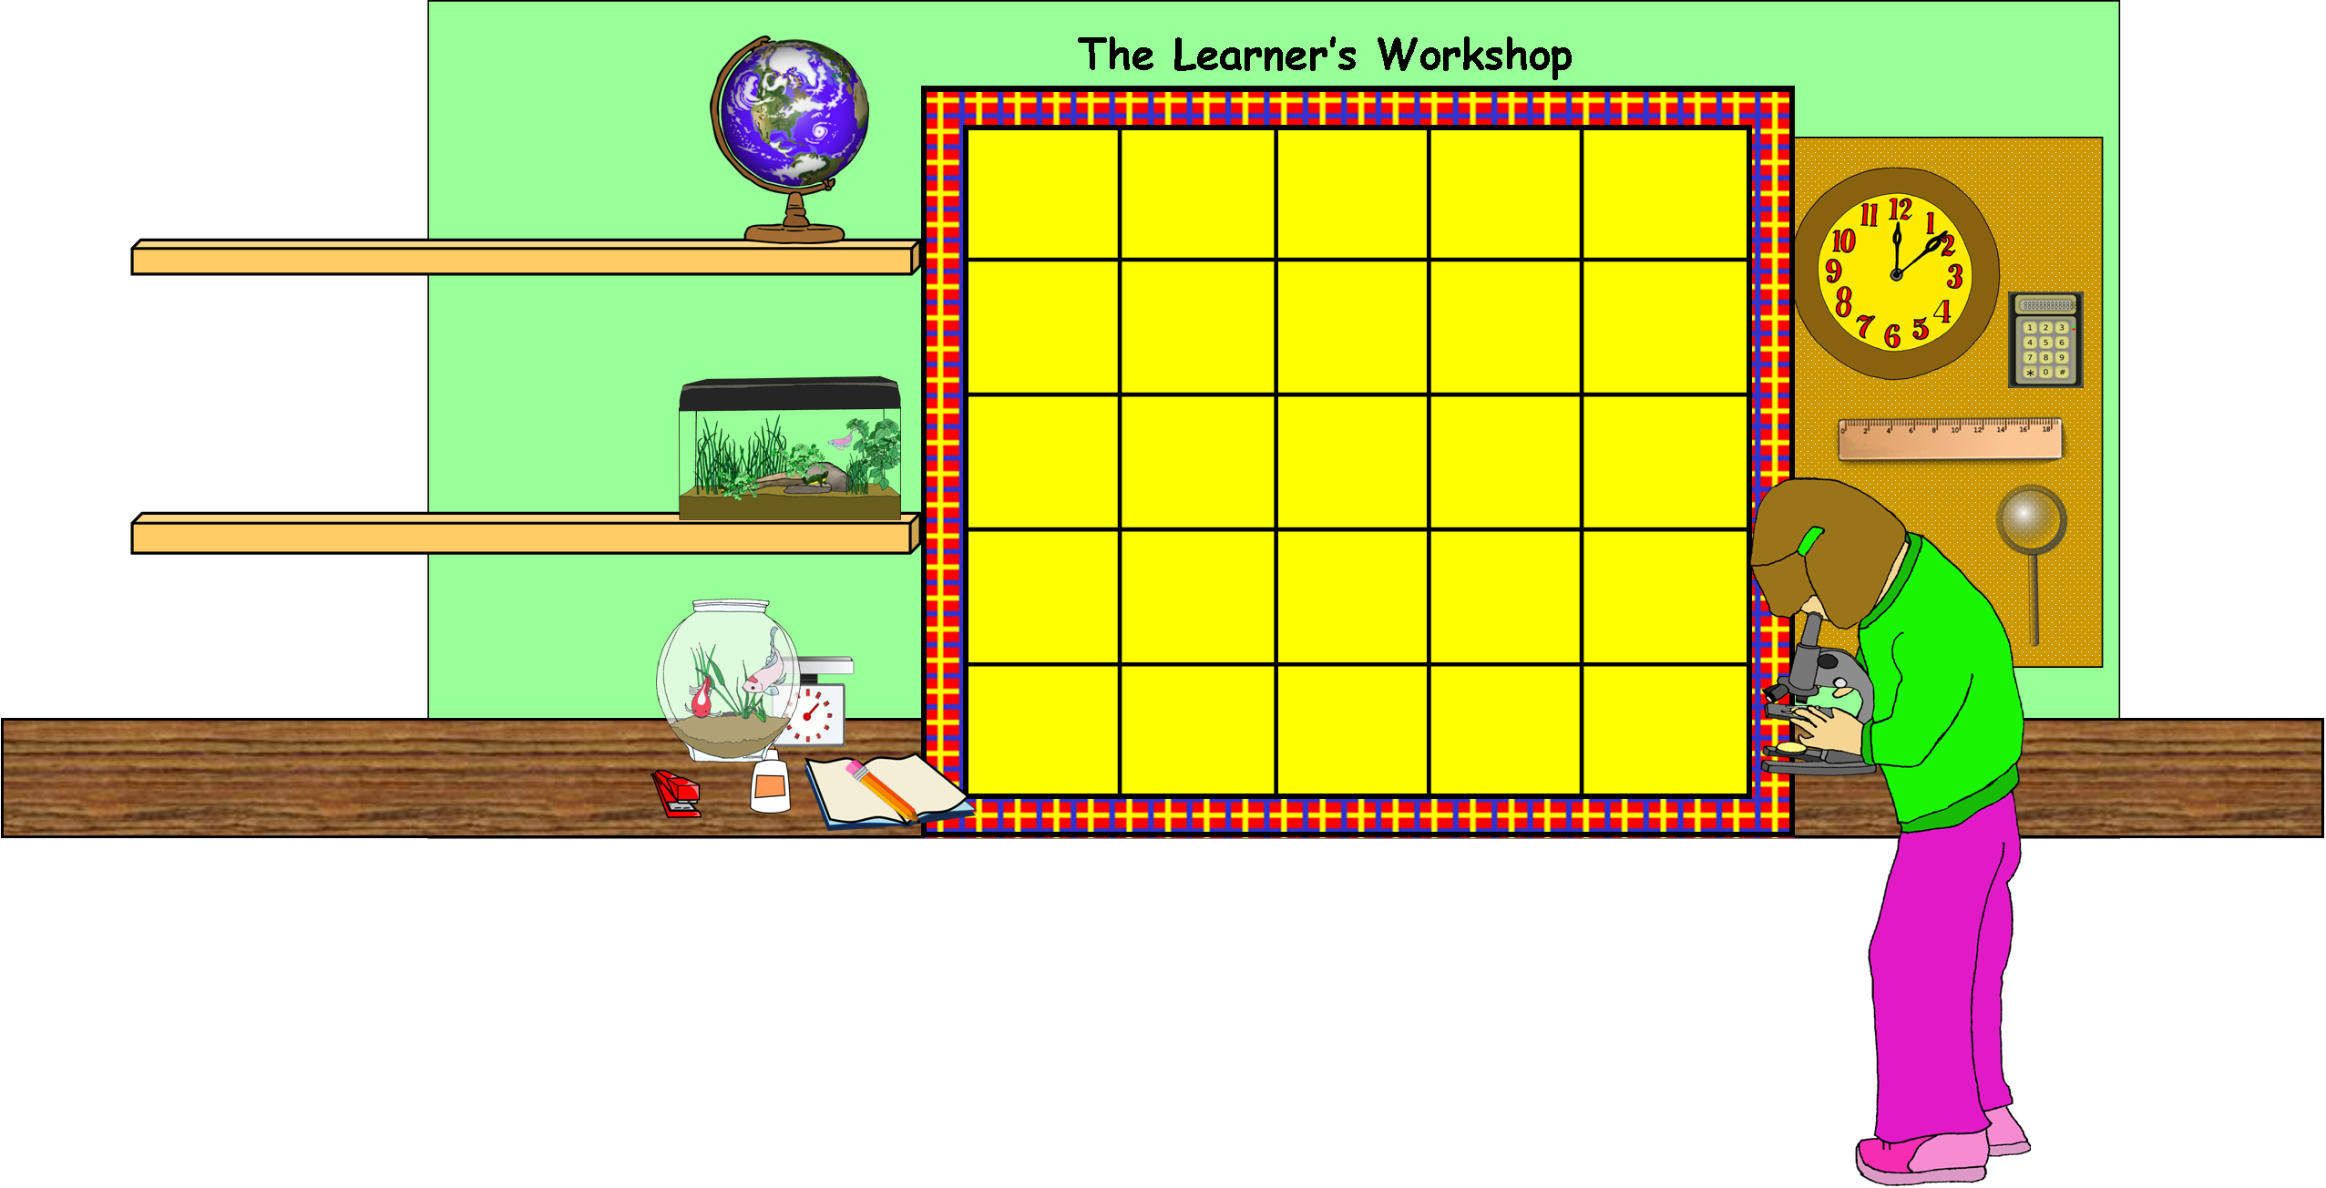

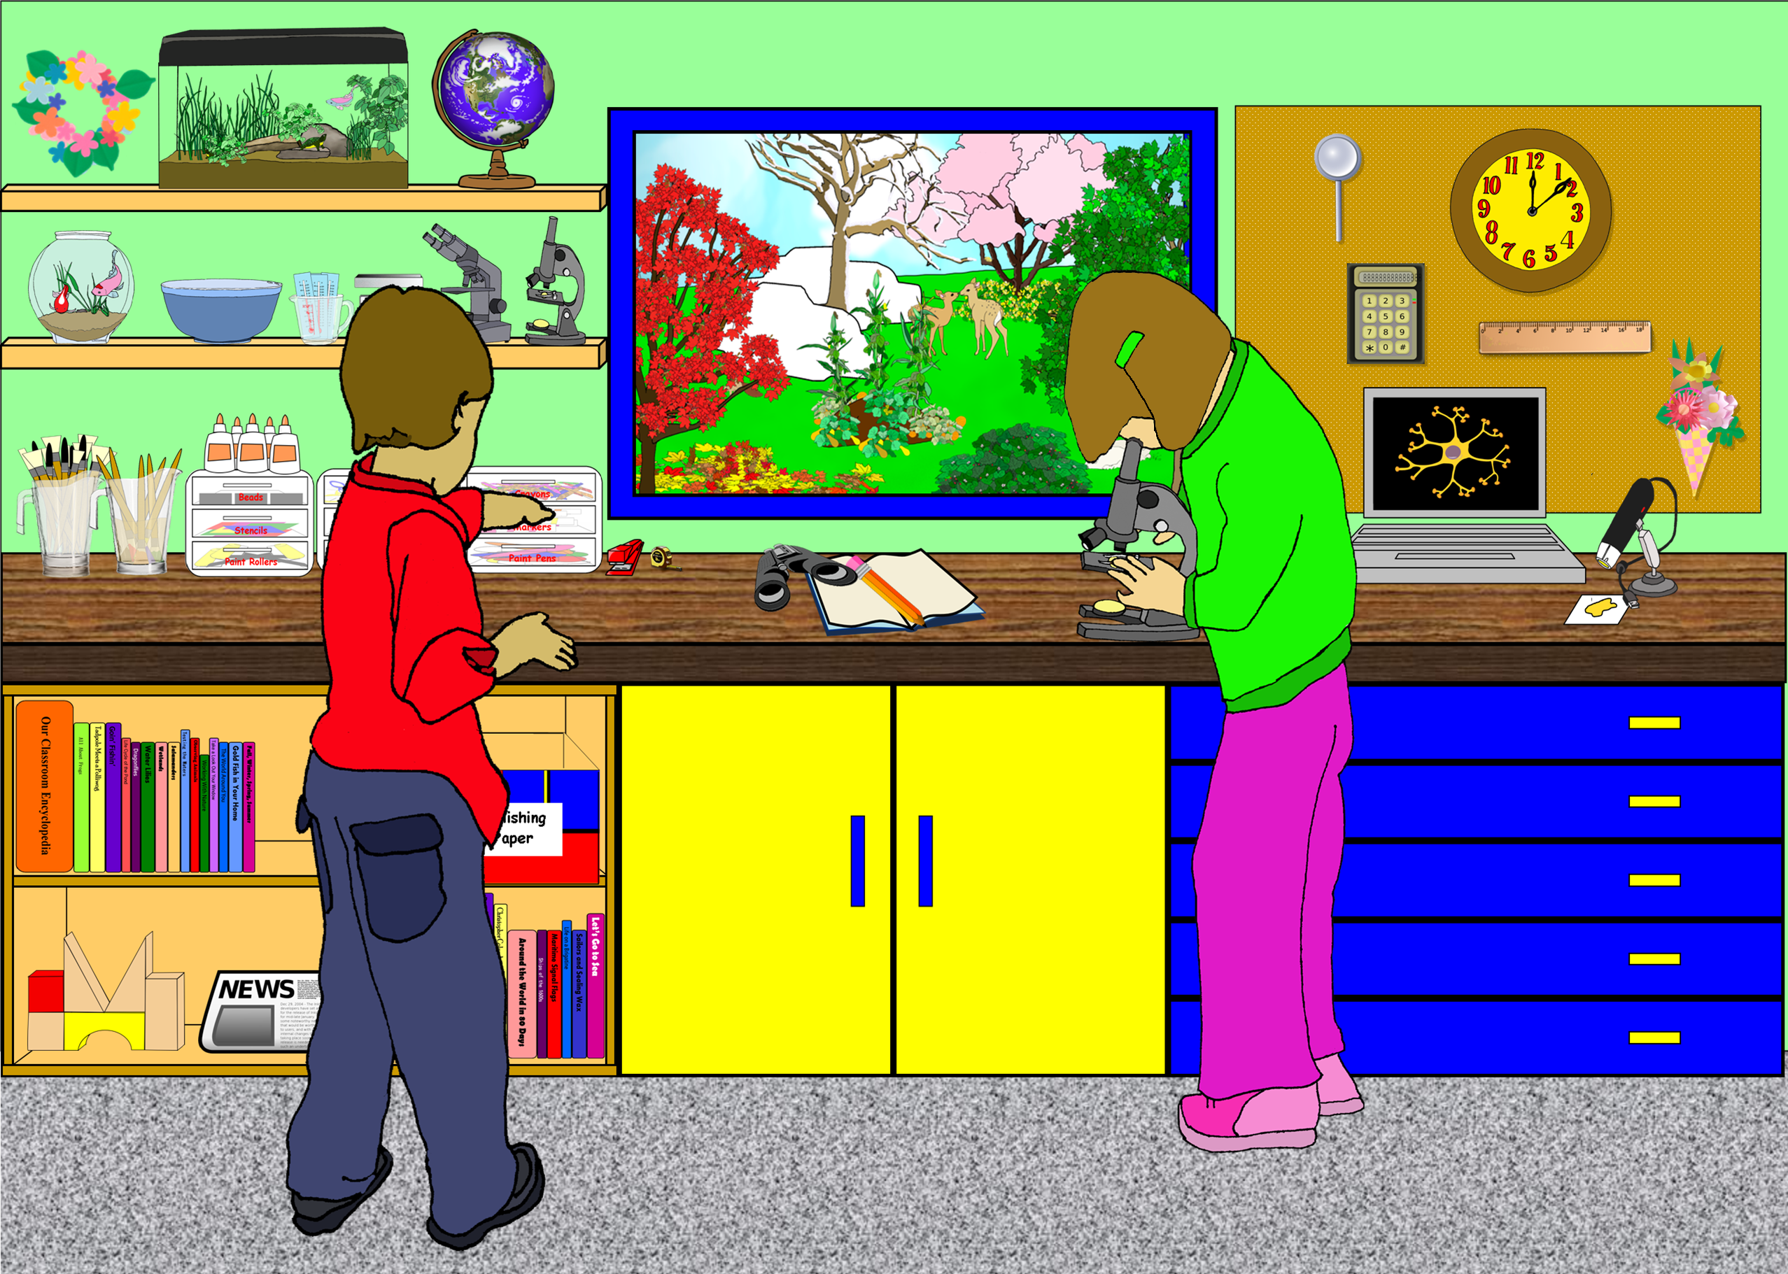
Learner’s Workshop
The
School Name Room #
February 21, 2012

Start typing your newsletter here.

Continue to type your text here.
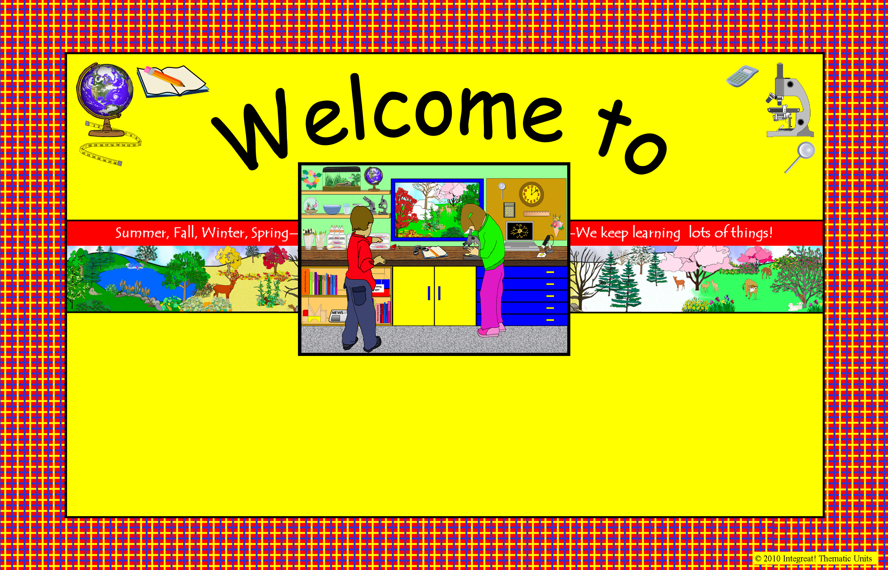
Ms. Teacher

Room #

Room 10
Room 10
Room 10
Room 10

Room 10
Room 10
Room 10

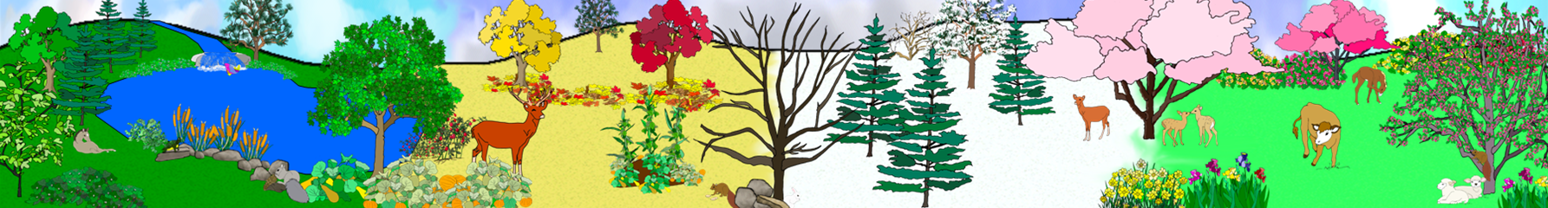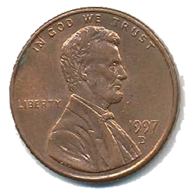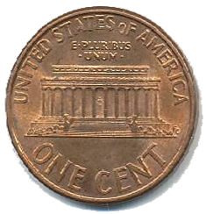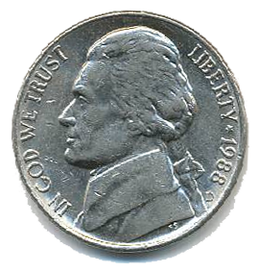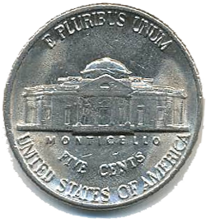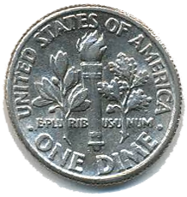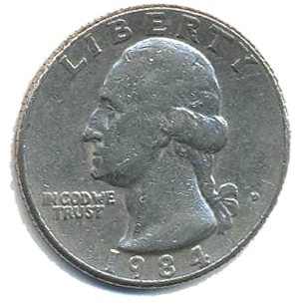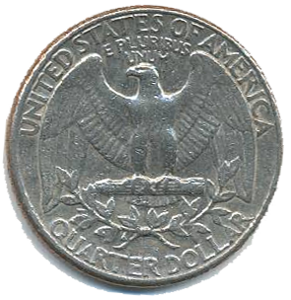
Aa Bb Cc Dd Ee Ff Gg Hh Ii Jj Kk Ll Mm Nn Oo Pp Qq Rr Ss Tt Uu Vv Ww Xx Yy Zz
0 1 2 3 4 5 6 7 8 9 10 11 12 13 14 15 16 17 18 19 20 21 22 23 24 25
Welcome to the Learner’s Workshop!
Penny = 1¢
Nickel = 5¢
Dime=10¢
Quarter=25 ¢
Student Name
Aa Bb Cc Dd Ee Ff Gg Hh Ii Jj Kk Ll Mm Nn Oo Pp Qq Rr Ss Tt Uu Vv Ww Xx Yy Zz
0 1 2 3 4 5 6 7 8 9 10 11 12 13 14 15 16 17 18 19 20 21 22 23 24 25
Welcome to the Learner’s Workshop!
Penny = 1¢
Nickel = 5¢
Dime=10¢
Quarter=25 ¢
Student Name
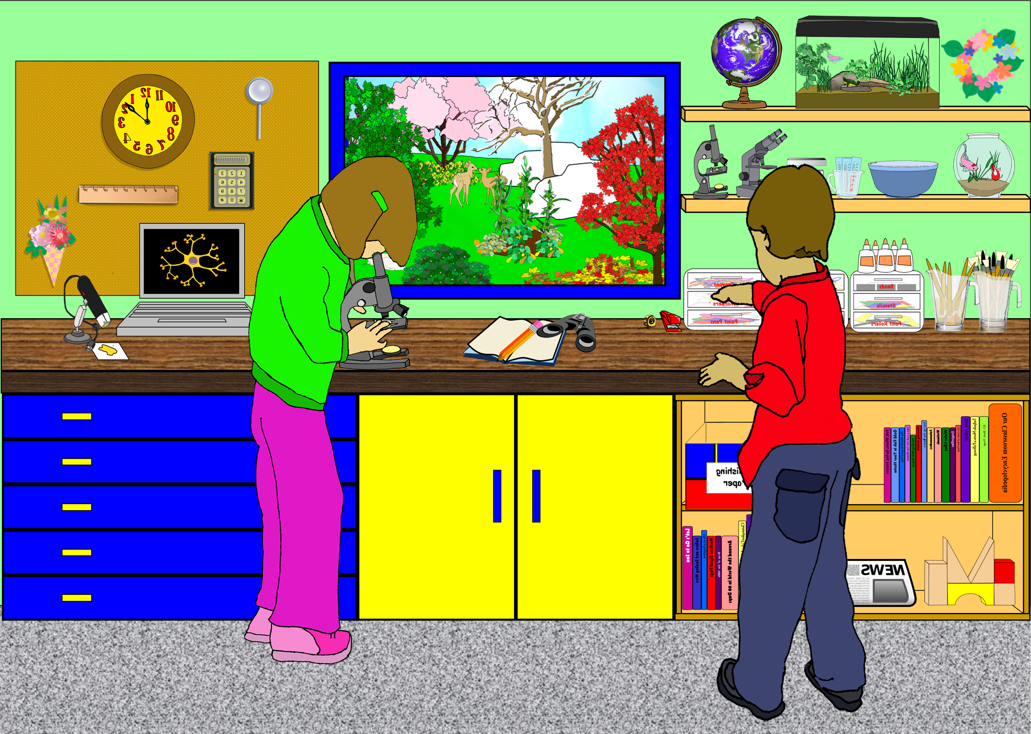
Student Name
Welcome to the Learner’s Workshop!
Observe
Infer
Measure
Classify
Predict
–20 –19 –18 –17 –16 –15 –14 –13 –12 –11 –10 –9 –8 –7 –6 –5 –4 –3 –2 –1 0 1 2 3 4 5 6 7 8 9 10 11 12 13 14 15 16 17 18 19 20
Communicate
Scientific Processes
Student Name
Welcome to the Learner’s Workshop!
Observe
Infer
Measure
Classify
Predict
–20 –19 –18 –17 –16 –15 –14 –13 –12 –11 –10 –9 –8 –7 –6 –5 –4 –3 –2 –1 0 1 2 3 4 5 6 7 8 9 10 11 12 13 14 15 16 17 18 19 20
Communicate
Scientific Processes

© 2010 Integreat! Thematic Units
© 2010 Integreat! Thematic Units
Welcome to
the
Learner’s Workshop
© 2010 Integreat! Thematic Units
© 2010 Integreat! Thematic Units
Welcome to
the
Learner’s Workshop
© 2010 Integreat! Thematic Units
© 2010 Integreat! Thematic Units
Welcome to
the
Learner’s Workshop
© 2010 Integreat! Thematic Units
© 2010 Integreat! Thematic Units
Welcome to
the
Learner’s Workshop

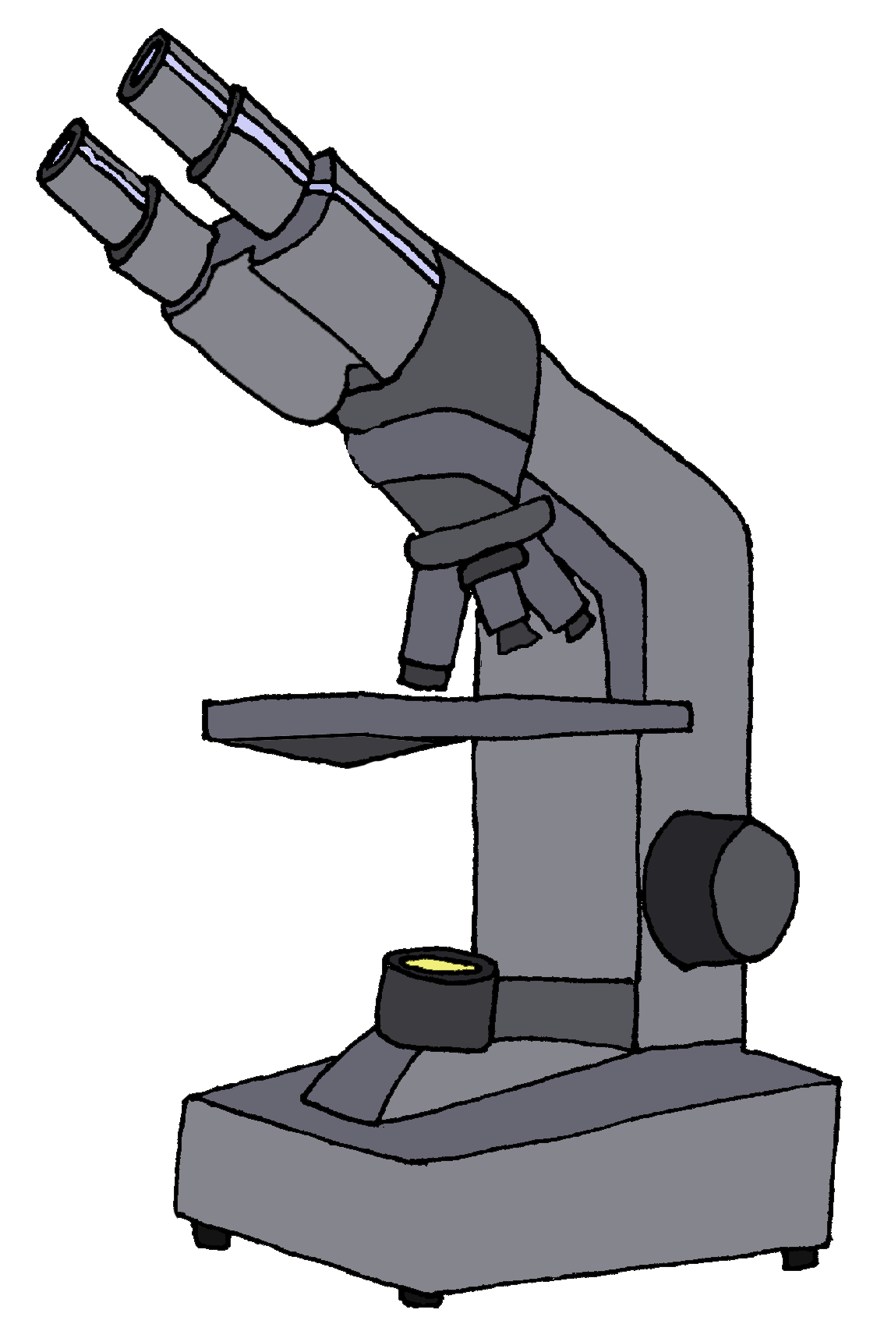
Welcome to our Learner’s Workshop!
Dear Student,

I am really looking forward to meeting you and working with you this new school year in our Learner’s Workshop found in Room Number. School will start at 8:00 AM on Tuesday, August 17. I will meet the class out on the playground. Look for the “Learner’s Workshop” sign—it will show you where to line up. I’ll see you then!

Ms. Flynn
25¢
Welcome to our Learner’s Workshop!
Dear Student,

I am really looking forward to meeting you and working with you this new school year in our Learner’s Workshop found in Room Number. School will start at 8:00 AM on Tuesday, August 17. I will meet the class out on the playground. Look for the “Learner’s Workshop” sign—it will show you where to line up. I’ll see you then!

Ms. Flynn
25¢
Welcome to our Learner’s Workshop!
Dear Student,

I am really looking forward to meeting you and working with you this new school year in our Learner’s Workshop found in Room Number. School will start at 8:00 AM on Tuesday, August 17. I will meet the class out on the playground. Look for the “Learner’s Workshop” sign—it will show you where to line up. I’ll see you then!

Ms. Flynn
25¢
Welcome to our Learner’s Workshop!
Dear Student,

I am really looking forward to meeting you and working with you this new school year in our Learner’s Workshop found in Room Number. School will start at 8:00 AM on Tuesday, August 17. I will meet the class out on the playground. Look for the “Learner’s Workshop” sign—it will show you where to line up. I’ll see you then!

Ms. Flynn
25¢

