+ FIRST CONGREGATIONAL CHURCH
An Open and affirming congregation of the
United Church of Christ, Saugus, Massachusetts
Service of Worship 10 a.m.
3rd Sunday of Easter, April 15, 2018
*Indicates for those who are able to, please stand.
Bold print indicates congregational response.
NCH = New Century Hymnal (black cover)
HOP = Spiral bound cover

Scripture Reader and Coffee Hour Host is Betty Neth.
Deacon of the Month & Greeter is Terri Leander

PRELUDE “In Christ Alone” (Getty/Townsend) Rebecca Harrold
WELCOME & ANNOUNCEMENTS
LIGHTING THE PEACE CANDLE “Surely the Presence” HOP 74
Surely the presence of the Lord is in this place;
I can feel his mighty power and his grace.
I can hear the brush of angel’s wings,
I see glory on each face;
surely the presence of the Lord is in this place.

CALL TO WORSHIP (“God, we’re here!”)
L: We celebrate the risen Christ but ask, Where is Jesus now?
P: Jesus is with us when we break bread together.
L: We are Easter people who believe Christ lives.
P: Jesus is among us when we forgive one another.
L: We see, feel, and hear Christ near to us when we need him.
P: Jesus is present wherever the peacemakers are.
L: We thank God for sending Jesus to us in as many ways as there are people.
All: Our Easter celebration continues as we witness to the Almighty Power of God to change our lives!

*OPENING HYMN: “I Sing the Mighty Power of God” NCH12

CHILDREN’S MESSAGE

*PRAYER OF CONFESSION (“God, we’re sorry”): Holy God, we confess that, like the disciples, we are easily scared by the unknown. We are overcome with worries about our lives and the world as a whole. We demand that you answer us when we call to you. But often we do not know how to listen for you or seek your unexpected, grace-filled presence in our troubles. Forgive us. Be gracious to us and hear the longing in our prayers. Amen.

CHORAL RESPONSE: “Thy Word” HOP 92

Thy word is a lamp unto my feet and a light unto my path. (2x)

*ASSURANCE OF PARDON (“God forgives us”), in unison: Loving God, thank you for reminding us that your light shines in all moments of our good and difficult lives. Thank you for letting us feel the gladness you have placed in each of our hearts, and for your sweet forgiveness of our sins and faults. In our waking and in our sleeping, give us peace. Amen.

*GLORY TO GOD “Holy, Holy, Holy” NCH #277
Holy, holy, holy, God the Almighty! Early in the morning we praise your majesty./ Holy, holy, holy! Merciful and mighty/ God in three persons/ blessed Trinity!

SCRIPTURE: Luke 24:36-48 (SP749, LP1641)
(SP=Small print Bible; LP=Large print Bible)

MESSAGE: “A Hungry Jesus” Rev. Martha Leahy

PRAYER INTRO: “Sanctuary” HOP 135

Lord, prepare me to be a sanctuary/pure and holy,

tried and true./With thanksgiving, I’ll be a living

sanctuary for you.

PASTORAL PRAYER & LORD’S PRAYER
Our Father, who art in heaven, hallowed be thy name.
Thy kingdom come, thy will be done, on earth as it is in heaven. Give us this day our daily bread; and forgive us our trespasses, as we forgive those who trespass against us; and lead us not into temptation, but deliver us from evil. For thine is the kingdom, the power and the glory forever. Amen.

PRAYER RESPONSE: “Take My Life & Let it Be” HOP 129 Take my life and let it be/Consecrated Lord, to thee./ Take my hands and let them move at the impulse of thy love/ At the impulse of thy love.

OFFERTORY INVITATION (“God, we give back”), in unison: Beloved family in Christ, we strive to be children of God because of God’s love for us, a love which is as both tender and powerful. Let us offer our gifts in order to care for God’s family in this church and throughout the world. Amen.

OFFERTORY: “You Are Mine” HOP 56

*DOXOLOGY: NCH #778 lyrics; NCH 780 tune
Praise God from whom all blessings flow;
Praise God all creatures here below;
Praise God for all that love has done.
Creator, Christ and Spirit, One. Amen.

*PRAYER OF DEDICATION FOR OUR GIFTS & PLEDGES (“God bless our gifts”), in unison: Life-Giving God, may you bless our gifts and send them from us out into the world, to benefit all of your children with your wisdom, compassion, and imagination. Amen.

*CLOSING HYMN: “Canticle of the Turning” HOP 75

*COMMISSION AND BLESSING (“God, we will try”), in unison: God of Easter, we will try to better connect with the risen Christ among us. We will try to reach out to those with whom we differ and to those in greater need than ourselves. We will try to remember that we are held together by Creator, Christ, and Holy Spirit. Amen.

BENEDICTION (“God, please bless us”):
L: We celebrate the risen Christ but ask, Where is Jesus now?
P: Jesus is with us when we break bread together.
L: We are Easter people who believe Christ lives.
P: Jesus is among us when we forgive one another.
L: We see, feel, and hear Christ near to us when we need him.
P: Jesus is present wherever the peacemakers are.
L: We thank God for sending Jesus to us in as many ways as there are people.
All: Our Easter celebration continues as we witness to the Almighty Power of God to change our lives!

*CHORAL BENEDICTION: HOP 77 v1-2
Put peace into each other’s hands and like a treasure hold it.
Protect it like a candle flame, with tenderness enfold it.
Put peace into each other’s hands, with loving expectation;
Be gentle in your ways and ways, in touch with God’s creation.

POSTLUDE: “Just a Closer Walk with Thee/
I Want to Walk as a Child of the Light” arr. Rebecca Harrold

Today’s liturgy is adapted from the UCC’s Worship Ways.

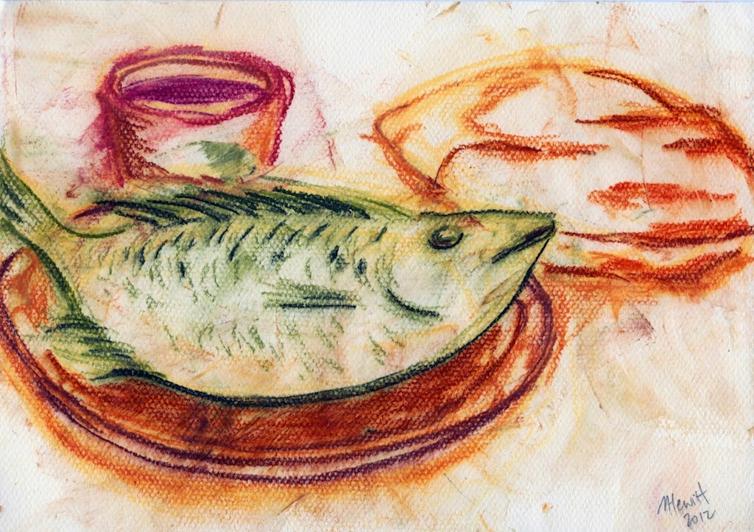
upperclydeparish.blogspot.com/2015/04/

“A Hungry Jesus”
3rd Sunday of Easter
April 15, 2018
First Congregational Church, United Church of Christ
300 Central Street, Saugus, MA 01906
Rev. Martha Leahy, Pastor
Office 781-233-3028 Cell phone 617-763-7354
Carolyn Davis, Secretary
Rebecca Harrold, Music Director
E-mail address: uccsaugus@verizon.net
Website: http://1stchurchsaugus.org
Facebook: https:www.facebook.com/uccsaugus
Healing Circle: https://facebook.com/healingcirclesaugus

Jesus Appears to the Disciples
Luke 24:36-48

36 While they were still talking about this, Jesus himself stood among them and said to them, “Peace be with you.”

37 They were startled and frightened, thinking they saw a ghost. 38 He said to them, “Why are you troubled, and why do doubts rise in your minds? 39 Look at my hands and my feet. It is I myself! Touch me and see; a ghost does not have flesh and bones, as you see I have.”

40 When he had said this, he showed them his hands and feet. 41 And while they still did not believe it because of joy and amazement, he asked them, “Do you have anything here to eat?” 42 They gave him a piece of broiled fish, 43 and he took it and ate it in their presence.

44 He said to them, “This is what I told you while I was still with you: Everything must be fulfilled that is written about me in the Law of Moses, the Prophets and the Psalms.”

45 Then he opened their minds so they could understand the Scriptures. 46 He told them, “This is what is written: The Messiah will suffer and rise from the dead on the third day, 47 and repentance for the forgiveness of sins will be preached in his name to all nations, beginning at Jerusalem. 48 You are witnesses of these things.”

