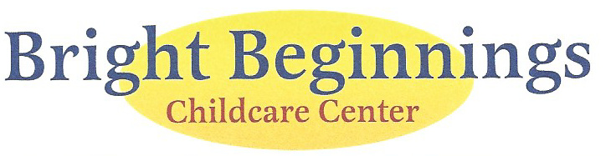

Communicable Disease Reporting Agreement

I (We) agree to notify Bright Beginnings within 24 hours, or the next business day if my child/children or any member of the immediate household has developed any reportable communicable disease, as defined by the State Board of Health except for life threatening illnesses which must be reported immediately.

Name (print) ______________________________________
Signature: _________________________________________
Date: _____________________________________________

