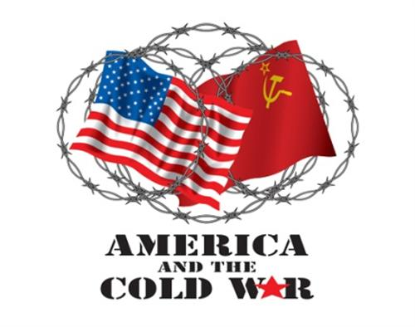
THIS IS A TRADITIONAL ASSIGNMENT.
PRINT AND COMPLETE IN INK.

The Early Cold War
APUSH Review Guide AMSCO chapter 26 o(or other resource covering events from 1945-1950s)

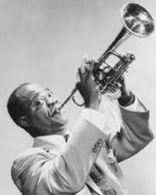
DirectionsPrint document and take notes in the spaces provided. Read through the
guide before you begin reading. This step will help you focus on the most significant ideas
and information as you read. This guide can earn bonus points for students completing guide
IN ITS ENTIRETY BY QUIZ DATE.

From the College Board Content Outline for Period 8
Key Concept 8.1: The United States responded to an uncertain and unstable postwar world by asserting and working to maintain a
position of global leadership, with far-reaching domestic and international consequences.
Key Concept 8.2: New movements for civil rights and liberal efforts to expand the role of government generated a range of political and cultural responses.
Key Concept 8.3: Postwar economic and demographic changes had far-reaching consequences for American society, politics, and culture.

Section 1 Period 8 Overview, page 556
Read the overview and alternate view of Period 8, and answer the following questions.
- What were the three forces that impacted American lives post WWII?

a.

b.

c.
2. How did liberalism as inspired by Franklin Roosevelt continue into the 1950s-1970s?

3. In what way did the U.S. and U.S.S.R. confront each other in this era?

4. List the forces that gave way to a conservative resurgence in the late 60s and 70s?
a.
b.
c.
Section 2 Guided Reading pp 557-572
5. Truman and the Cold War, 1945-1952, pp 557-558
Main Ideas | Definitions/Explanations/Notes | Analysis
Postwar economic, demographic, and technological changes had a far-reaching impact on American society, politics, and the environment.  Rapid economic and social changes in American society fostered a sense of optimism in the postwar years, as well as underlying concerns about how these changes were affecting American values.  A burgeoning private sector, continued federal spending, the baby boom, and technological developments helped spur economic growth, middle-class suburbanization, social mobility, a rapid expansion of higher education, and the rise of the “Sun Belt” as a political and economic force. | Truman and the Cold War, 1945-1952…  Postwar America…  GI Bill—Help for Veterans…  Baby Boom…  Suburban Growth…  Rise of the Sunbelt…  Postwar Politics… | Explain how living through the Great Depression and the rationing of WWII war effort impacted the state of the economy when soldiers returned home in 1945.  How did the government encourage continued, positive economic growth in the years following WWII?  Explain how the baby boom illustrates a break from Depression Era American life.  How did the role of women change from the Rosie the Riveter of WWII to the baby boom of the postwar years?  Identify one negative consequence o f suburbanization.  What was the most significant reason for abandoning the Rust Belt for the Sun Belt?

6. Economic Program and Civil Rights, pp 559-561
Main Ideas | Definitions/Explanations/Notes | Analysis
Liberalism, based on anticommunism abroad and a firm belief in the efficacy of governmental and especially federal power to achieve social goals at home, reached its apex in the mid-1960s and generated a variety of political and cultural responses.  Seeking to fulfill Reconstruction-era promises, civil rights activists and political leaders achieved some legal and political successes in ending segregation, although progress toward equality was slow and halting. | Economic Program and Civil Rights…  Employment Act of 1946…  Inflation and Strikes…  Civil Rights…  Republican Control of the Eightieth Congress…  Twenty-second Amendment (1951)…  Taft-Hartley Act (1947)…  The Election of 1948… (see next page)  The Fair Deal… | What did Truman have in common with Obama?  Why did Republicans in Congress attempt to lower taxes?  How were the Republicans successful in stemming the tide of FDR liberalism?  To what extent was President Harry Truman’s policies a continuation of President Franklin Roosevelt’s policies? Defend your answer with evidence.  FDR desegregated the war industries. What did Truman desegregate?

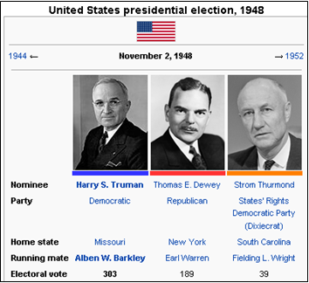
…continued from previous page… The Election of 1948 (page 560)
a. Candidates
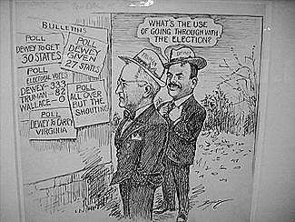
b. Surprising results

c. Who were the Dixiecrats, and what is significance about this party?

d. Why did so many people think Dewey won this election?
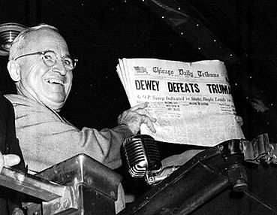

- What were “Give em Hell Harry!” speeches? What was purpose?

Read the excerpt from Truman’s inaugural address and then answer the question that follows regarding the Point Four program described.
“ It may be our lot to experience… a major turning point in the long history of the human race. The first half of this century has been marked by unprecedented and brutal attacks on the rights of man, and by the two most frightful wars in history. The supreme need of our time is for men to learn to live together in peace and harmony… we must embark on a bold new program for making the benefits of our scientific advances and industrial progress available for the improvement and growth of underdeveloped areas. More than half the people of the world are living in conditions approaching misery. Their food is inadequate. They are victims of disease. Their economic life is primitive and stagnant. Their poverty is a handicap and a threat both to them and to more prosperous areas. For the first time in history, humanity possesses the knowledge and skill to relieve suffering of these people. The United States is pre-eminent among nations in the development of industrial and scientific techniques. The material resources which we can afford to use for assistance of other peoples are limited. But our imponderable resources in technical knowledge are constantly growing and are inexhaustible…”

How did Point Four redefine the purpose of the United States and it’s government?

To what extent is this policy a continuation of the Puritan ideal of “City on a Hill” (or of American Exceptionalism)?

7. Origins of the Cold War, pp 561-563

Main Ideas | Definitions/Explanations/Notes | Analysis
The United States responded to an uncertain and unstable postwar world by asserting and attempting to defend a position of global leadership, with far-reaching domestic and international consequences.  After World War II, the United States sought to stem the growth of Communist military power and ideological influence, create a stable global economy, and build an international security system. | Origins of the Cold War…  U.S.-Soviet Relations to 1945…  Allies in WWII…  Postwar Cooperation and the U.N….  Satellite States in Eastern Europe…  Occupation Zones in Germany…  Iron Curtain… | Some historians postulate that FDR is largely responsible for the Cold War, because he mishandled and misunderstood Stalin at Yalta. Support or refute this assessment.  Do you support the viewpoint that Truman appeased Stalin at Potsdam? Why or why not?  To what extent did the United Nations relieve the growing tensions between the U.S. and the U.S.S.R.?  Explain how the Soviet declination of the World Bank illustrated a fundamental conflict at the heart of the Cold War.  Explain how these words, “Iron Curtain,” indicate Allied (British-American)  appeasement of Stalin.

8. Containment in Europe, pp 563-566

Main Ideas | Definitions/Explanations/Notes | Analysis
The United States responded to an uncertain and unstable postwar world by asserting and attempting to defend a position of global leadership, with far-reaching domestic and international consequences.  After World War II, the United States sought to stem the growth of Communist military power and ideological influence, create a stable global economy, and build an international security system.  The United States developed a foreign policy based on collective security and a multilateral economic framework that bolstered non-Communist nations.  The United States sought to “contain” Soviet-dominated communism through a variety of measures. | Containment in Europe…  The Truman Doctrine…  The Marshall Plan…  Effects…  The Berlin Airlift… | Support or refute the view that the Truman Doctrine polarized the world into pro- American and pro-Soviet divisions and thus exacerbating the hostile situation.  How did Truman use the foreign policy of Containment in response to the Soviet “betrayal” of Yalta (concerning the reconstruction plan for Germany)?  How was Containment policy in dealing with the U.S.S.R. following WWII different from the British and French foreign policy of appeasement with Hitler prior to WWII?  Walter Lippmann criticized containment, saying it over-simplified the “Cold War,” a term he coined. Is it fair to compare the Truman Doctrine to “bribing” unrestricted free agents on the open market? (Not wanting them to go to a rival team so you pay the players enough to stay)  How was the Marshall Plan different from the Treaty of Versailles?
…continued from previous page…

Main Ideas | Definitions/Explanations/Notes | Analysis
After World War II, the United States sought to stem the growth of Communist military power and ideological influence, create a stable global economy, and build an international security system.  The United States developed a foreign policy based on collective security and a multilateral economic framework that bolstered non-Communist nations.  The United States sought to “contain” Soviet-dominated communism through a variety of measures. | NATO and National Security…  National Security Act (1947)…  Explain the role of each department.  Dept. Defense:  Sec. Defense:  National Security Council:  CIA:  List the measures of NSC-68:  Atomic Weapons…  The arms race began when the Soviets worked to catch up (and steal) atomic technology to/from the U.S. It took t hem only 4 years to successfully explode their first atomic bomb thanks to Americans who were willing to sell the secrets to the Russians.  Next came the hydrogen bomb, a thousand times more powerful. Truman didn’t heed warnings by some scientists, such as Einstein, who worried these bombs risked “annihilation of any life on earth has been brought within the range of technical possibilities.” In a quest for nuclear superiority, he furthered the competitive arms race with the Soviets by completing the H-Bomb in 1952,” triggering” the Soviets’ completion of the bomb in 1953.  Evaluating U.S. Policy… | What would President George Washington have said about NATO?  What does the National Security Act foreshadow about the Cold War?  Although the arms race created a frightful threat of world annihilation, the technology along with leadership of NATO essentially reduced the threat of war and maintained a balance of power with the Soviets for decades. Defend or refute this statement.
9. Cold War in Asia, pp 566-569

Main Ideas | Definitions/Explanations/Notes | Analysis
As the United States focused on containing communism, it faced increasingly complex foreign policy issues, including decolonization, shifting international alignments and regional conflicts, and global economic and environmental changes.  The United States sought to “contain” Soviet-dominated communism through a variety of measures. | Cold War in Asia…  Japan…  U.S. – Japanese Security Treaties…  The Philippines and the Pacific…  China…  U.S. Policy…  Two Chinas… | How did the era of imperialism impact post Cold War relations?  What would President Theodore Roosevelt have said about the U.S.-Japanese Security Treaties?  The Philippines were finally independent following WWII. How long had it been that they were not controlled –at some level—by a foreign power?  To what extent was the Open Door Policy responsible for China’s ‘descent’ into communism?  We formally recognized China in 1979, and they are now one of the most important parts of our economy. Today, the United States is still fearful of Chinese / communist expansion as they have increased control over regions including Tibet and threatened take over of areas like Taiwan. The Chinese are currently building up their military at a time when the U.S. is scaling back. Do you think we should still fear China?
…continued from previous page…

Main Ideas | Definitions/Explanations/Notes | Analysis
As the United States focused on containing communism, it faced increasingly complex foreign policy issues, including decolonization, shifting international alignments and regional conflicts, and global economic and environmental changes.  The United States sought to “contain” Soviet-dominated communism through a variety of measures, including military engagements in Korea.  Postwar decolonization and the emergence of powerful nationalist movements in Asia, Africa, and the Middle East led both sides in the Cold War to seek allies among new nations, many of which remained nonaligned. | The Korean War…  Invasion…  Counterattack…  Truman Versus MacArthur…  Armistice…  The 1953 an armistice set up the Demilitarized Zone (DMZ). To this day, the two nations are essentially still at war and the DMZ is heavily guarded.  Political Consequences… | Compare the response of the United Nations to the invasion of South Korea to the League of Nations’ response to the Japanese invasion of Manchuria 20 years earlier. Was this later reaction a “lesson learned” or a “tragic error?” Explain your reasoning.  Who had the better approach… Truman’s “limited war” or MacArthur’s “no substitute for victory?” Explain your reasoning.  North Korea announced that it will no longer abide by the armistice at least 6 times… 1994, 1996, 2003, 2006, 2009, and 2013. They have also stated they are free to attack the South, develop nuclear weapons, and develop their own independent peace treaty with the South (ignoring U.N. resolutions and protocol). The U.S. military is active in South Korea to defend them if needed. Why are we still dedicated to defending South Korea if the Cold War ended in 1989?

10. The Second Red Scare, pp 569-572

Main Ideas | Definitions/Explanations/Notes | Analysis
Cold War policies led to continued public debates over the power of the federal government, acceptable means for pursuing international and domestic goals, and the proper balance between liberty and order.  Americans debated policies and methods designed to root out Communists within the United States even as both parties tended to support the broader Cold War strategy of containing communism. | The Second Red Scare…  Security and Civil Rights…  Prosecutions Under the Smith Act…  McCarran Internal Security Act (1950)  (Congress overrode Truman’s veto)  three provisions of the McCarran Act.  a)  b)  c)  Un-American Activities…  Cultural Impact…  Espionage Cases…  Hiss Case…  Rosenberg Case… | What did the First Red Scare have in common with the Second Red Scare?  Starting around 1947, employers increasingly demanded that their employees take loyalty oaths to the United States; teachers especially were subject to this. Is the current Texas state law that mandates we stand up and say the pledge of allegiance each day the same thing as a loyalty oath? Explain your reasoning.  Why did Truman veto McCarran?  Although some doubted Hiss’s guilt at the time, it was later proven beyond a shadow of a doubt that he was guilty. Was Nixon (as a member of HUAC committee) a hero for exposing an American traitor or was he an illustration of American paranoia? Explain your reasoning.  If the Rosenberg’s were guilty (and they were), why did their execution cause a civil rights debate?
…continued from previous page…

Main Ideas | Definitions/Explanations/Notes | Analysis
Cold War policies led to continued public debates over the power of the federal government, acceptable means for pursuing international and domestic goals, and the proper balance between liberty and order.  Americans debated policies and methods designed to root out Communists within the United States even as both parties tended to support the broader Cold War strategy of containing communism. | The Rise of Joseph McCarthy…  McCarthy’s Tactics…  Army-McCarthy Hearings…  Truman in Retirement… | What finally ended the Second Red Scare?  How were McCarthy’s tactics similar to the Salem Witch Trials?  Consider all of the events and policies under Truman. Why did the Republicans blame Truman for the “mess in Washington,” and what exactly did they mean by “mess?”

11. Section 3: Historical Perspectives: WHO STARTED THE COLD WAR? PAGE 572
Explain each argument/viewpoint as if you were defending each one individually.
The Soviet Union was to blame… | The United States was to blame… | Both were to blame…

Reading Guide written by Rebecca Richardson, Allen High School
Sources include but are not limited to: 2015 edition of AMSCO’s United States History Preparing for the Advanced Placement Examination and the 2012 & 2015 Revised College Board Advanced Placement United States History Framework

