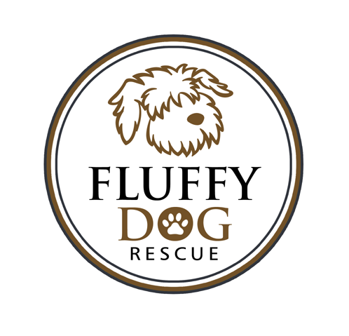
Fluffy Dog Rescue
Foster Care Instructions

Thank You!

First of all, it is important that you know how much we appreciate what you are doing. Without the support of caring foster homes, Fluffy Dog Rescue would be severely limited in the number of dogs we could save. We will do whatever we can to assist you through the process. The information contained in this document is provided as guide to help you through some general questions. Feel free to contact us for assistance throughout your fostering experience.

Foster Care Package Supplies:
- Food (if needed by the foster home)
- Flea Protection (April – Oct.)
- Heartworm pills (April - Oct.)
- Leash/Collar/ID Tag

Bringing home your foster dog:

- Your foster dog may or may not want to eat when you first bring them home. Offer a small amount of food and fresh water. Do not be surprised if the dog does not eat for a couple days.

- It is not uncommon for recently our dogs to have diarrhea. They are stressed when they move home and are eating different food. Let us know if it persists more than three days.

- The first couple of weeks are a transition time for your foster dog. He/she is learning to trust you and new routines. See the letter titled, “ Note from your new dog”, on our Resources page for recommendations on helping them adjust. Also, google the 3-3-3 Rule for valuable information.

Veterinary Appointments

- Fluffy Dogs receive vet care from a variety of vets. We currently work with vets in Pt. Washington, Hartland, Waukesha and Madison.

- All dogs will need spaying and neutering before adoption. This may have happened in Alabama, our care, or will need to be done in your care. All dogs arrive with rabies and distemper vaccines, and most are heartworm tested.

- If you dog needs to be altered you will be notified of the date to bring your foster dog to the vet. Dogs are not to have anything to after midnight the night before surgery. Water is fine.

- Please be sure to follow the instructions after altering is complete. Dogs are not to be running, jumping or bathed for 14 days. Please notify us if any complications arise after surgery. Most dogs now are glued, externally vs. being stitched, so you do not have to worry about suture removal, but you will want to check and watch the site. Please don’t allow them to lick the site. If you need a cone, just let us know.

- WI State law requires that every dog have a vet inspection, called CVI, prior to being adopted. The dogs come to WI with a Health Certificate that is good for 30 days, so your foster will only need the CVI done if they have been in WI more than 30 days. If your dog needs a CVI it will be indicated in the approval letter the approved adopter receives and you are copied on.

Medical Care

- If your foster dog is coughing (dry, barky/gagging sound), it is possible it was exposed to Kennel Cough at the shelter or on transport. The stress does weaken the immune system, making them more likely to contract an illness they were exposed to. Please contact us if your dog is coughing excessively.

- Fleas are part of what we do. Hopefully we have the fleas covered with the bath and flea protection. Sometimes certain fleas become immune to these products, so we use what is working in the areas where the dogs come from.

- All dogs are wormed prior to going to foster. If you see what looks to be grains of rice in the stool. These are tapeworm segments. They are from swallowing a live flea and are not contagious. Roundworms look like spaghetti in the stool and hookworms and whipworms are microscopic. If a dog did have worms they may need two or three doses of wormer, as worms have eggs and they hatch. We provide you with this. Because of the potential of worms, pick up the stool from your rescue dog.

- If your dog requires medical treatment, you must contact us about getting an apt. at one of the vet clinics that we work with. Typically we do not see emergency situations with dogs. I am available almost 24 hrs. a day.

- In the event that your foster dog requires emergency medical treatment, please take the dog to your vet or the nearest emergency facility. A cough, runny nose, and diarrhea are not emergencies.

- Although we do attempt to manage costs, our first concern is the well being of the animal. Veterinary bills will be reimbursed by Fluffy Dog Rescue if they are approved prior to the vet visit.

The Adoption Process

- Once applications are received there is a review of the application and a vet history is done.

- A volunteer from Fluffy Dog will then contact the applicant to conduct a virtual home visit. This is partially an inspection of the home, but also, similar to your home visit, a sharing of information and question and answer opportunity.

- If all goes well with the home visit, an approval email with next steps will be sent to the applicant and you will be copied. This email contains your name and email address, and the approved applicant will contact you directly by email. It also indicates whether the CVI (Vet Inspection) needs to be done, and does have a clause that if you are not pleased with what goes on at the meeting you can stop the adoption process. Note that you will never be contacted by an applicant unless you have received the approval email.

- Set a meeting at your mutual convenience, but this should take place within a week of application. This is application, not approval. Do not meet the applicant anywhere other than your home. This is a red flag and sign of a “bad rescue”. Also, the dog can get loose if you meet them in a parking lot or park, and you want them to meet the dog in the surroundings he/she is comfortable with.
- The approval email indicates that the applicant is to bring the Adoption Contract and fee to you. Do not accept the contract and fee if they are not taking the dog home at that time. We only accept cash and checks. Most dogs are adopted at the first meeting, but we will hold the dog for 24 hours if they choose to “think about it”.

- Your Foster can go home if all goes well at the meeting. The collar and leash belongs to the dog and goes home with them unless the adopter wants to donate it back to us. The ID tag belongs to Fluffy Dog.

- Please notify Lori once your foster dog has gone home, so she can send out the vet records and update the website. Vet records will be sent directly to the adopter within seven days. All vet records are held in the Fluffy Dog Rescue office.

- You can either drop off the signed contract and fee at our facility, or mail to our office.

Reminders:

- Dogs should always be monitored outdoors – regardless of whether they are in a fenced area, and never be off leash.

- Your dog should be wearing his/her collar with the Fluffy Dog ID tag at all times. Please notify us if your dog is missing.

- Often these dogs are not housebroken. These dogs often come to us with very little history. It is best to have a crate to protect your belongings and also for the safety of the dog. We have crates available for your use.

- Please ensure your animals are current on vaccinations at all times during fostering. These dogs do come from shelter environments, and it is recommended that you have your dog vaccinated for Bordatella. Bordatella is an optional vaccine to help in the prevention of Kennel Cough (KC).

Promotion of the Fluffy Dogs:

- You are welcome to promote your Fluffy Foster, but please make sure you read the home page of our site so you know what our policies are. The worst thing that can happen is for someone to meet and fall in love with a dog, only to find out that they will not be approved to adopt.

- We encourage you to update your foster’s information and photos as much as you like. Updates are sent to the email below. Many of our fosters use facebook pages to promote their foster dogs. Just email us the facebook page name, so we can add it to the dog’s listing.

- We are very fortunate that Petfinder does a good enough job for us that we don’t have to have many events. We also have a great network of people sharing the good work that we do with others, so word gets out.

We allow fosters to adopt their foster dogs after they have fostered and adopted out three dogs, but we need to know that you are thinking of this. Once an application is received, we can’t ethically go back and tell the applicant the dog is not available. If you have any intention of keeping your foster dog, just let us know and we can let you know when we receive an application. You then have 24 hours to make a final decision.

Contact Information

fluffydogrescue@gmail.com

