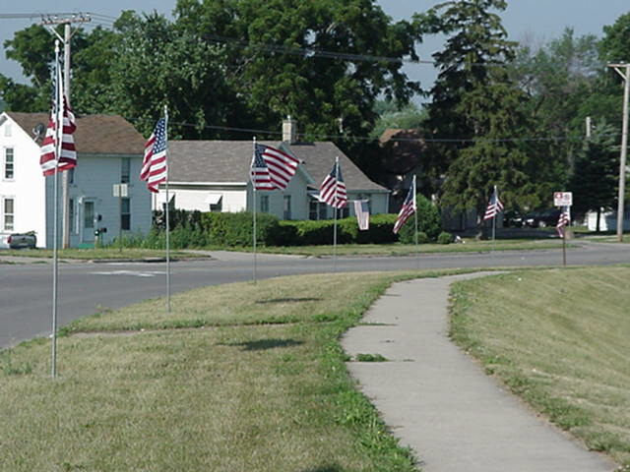  Sponsored by  Morning Optimist Club of Marshalltown | Avenues of Red,  White & Blue  Thanks for your support of local Youth Projects!  The Marshalltown Morning Optimist Club offers you the opportunity to have a flag displayed in front of your home (or that of a recipient of your gift) on five holidays.
Available in Marshalltown only.  For $40 per year, the club will display the American flag from sunrise to sunset on Memorial Day, Flag Day, Independence Day, Labor Day and Veterans Day.  Service is subject to weather permitting. Lightning or Snow Cover may cause delay or cancellation of delivery.  A ten-foot pole with a 3’x5’ nylon flag will be flown from the terrace/parking on the above days. You already have a holder installed in your lawn. The club is responsible for replacement of any flag soiled, damaged or stolen as well as storing the flags throughout the year. The Marshalltown City Council has approved this project. For specific questions, contact Dorothy McHone at 750-9275. | Join your neighbors by submitting your subscription in this colorful and patriotic program  or  Give a Gift that lasts throughout the year!
Renewal Information:
Complete the information below and attach your $40 check. Mail to: Morning Optimist Club Flag Project, PO Box 1236, Marshalltown, IA 50158.

Name______________________________________________________________________

Address____________________________________________________________________

Phone_____________ Email___________________________________________________
If this is a gift*:

Recipient of this gift___________________________________________________

Address where the gift flag will be flown_________________________________________________
*Gift cards can be provided for you to send if requested.

