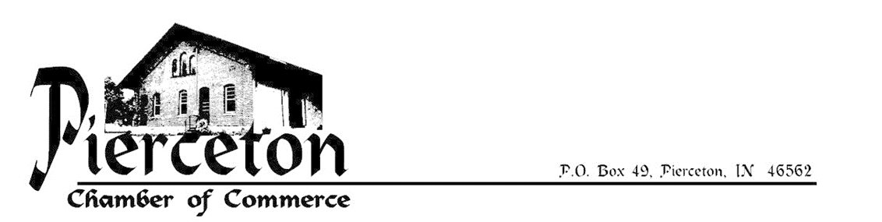

Dear Prospective 2017 Chamber Member:

Being a member of our chamber truly has many privileges. Through many opportunities of community service throughout the year, the Pierceton Chamber offers many benefits to not just our members but also to the general public. Membership also provides networking opportunities to increase business contacts along with access to free advertising.

Our newly designed website, www.piercetonchamber.com, provides your organization an opportunity of linking community members to your individual websites. Also, as a member you would have access to free advertising on our Facebook page, Pierceton Chamber of Commerce. On this page, we are able to promote any activity you may be having or any other exciting news your business or organization may be experiencing.

In addition to acting as the primary advocate for the community, the Pierceton Chamber of Commerce advocates to help grow your business or organization. The chamber is a constantly evolving organization shaped by volunteers who are dedicated to the social and economic vitality of the town of Pierceton and surrounding area. We are always open for discussion, suggestions, comments or concerns on how the Pierceton Chamber of Commerce can assist your business or organization in the future.

To submit your membership, please complete the enclosed form and return it with payment to:

Pierceton Chamber of Commerce
P.O. Box 49
Pierceton, IN 46562

Upon receiving your form, you will receive a membership certificate to display in your business. We do have several new ideas and events coming this year thus we encourage your attendance at our meeting on December 20th, 2016 at 5:30pm at the Pierceton Community Building. Please feel free to contact me should you have any questions, concerns or would like to arrange a time to discuss the coming year’s events or the future of your business or organization.

Sincerely,

Alicia Elder, President
aelder615@yahoo.com
(260) 609-6982

Membership Application and Renewal Form (Please Print)

Date ___/___/___

Business Name _______________________________________________________________________

Contact Person __________________________________________Position______________________

P.O. Address ________________________City_________________________Zip_________________

Phone Number ( ______ ) ___________________________________________

E-mail Address _____________________________________________________ (If none, write none)

Facebook Page ______________________________________________________ (If none, write none)

Website Address ____________________________________________________ (If none, write none)

Description of your business or organization (Limit of 30 characters or less as it is used on website)

_________________________________________________________________________________

Hyperlink on our website preferred to be to: _______ Facebook Page ________ Website

Type of business or organization: (Check all that apply)
_____Retail _____Service _____Manufacturing _____Church _____Club _____ Town Government

Years in business or year established ________ Number of full time employee’s __________

Annual dues are based on the number of employees. In the case of organizations and government bodies, dues are on an Individual basis. All businesses and individuals have full voting privileges.
Individual dues $35 per year.
Businesses with under 10 employees, $50 per year.
Businesses with over 10 employees, $100 per year.

Enclosed are dues for _____Individual _____Small Business _____Large Business
Date_____________________ Amount $ ______________ Check Number _________________
Make checks payable to: Pierceton Chamber of Commerce P.O. Box 49, Pierceton, IN 46562 or at meetings
**All memberships are due on January 1 of the following year and will expire on December 31**

