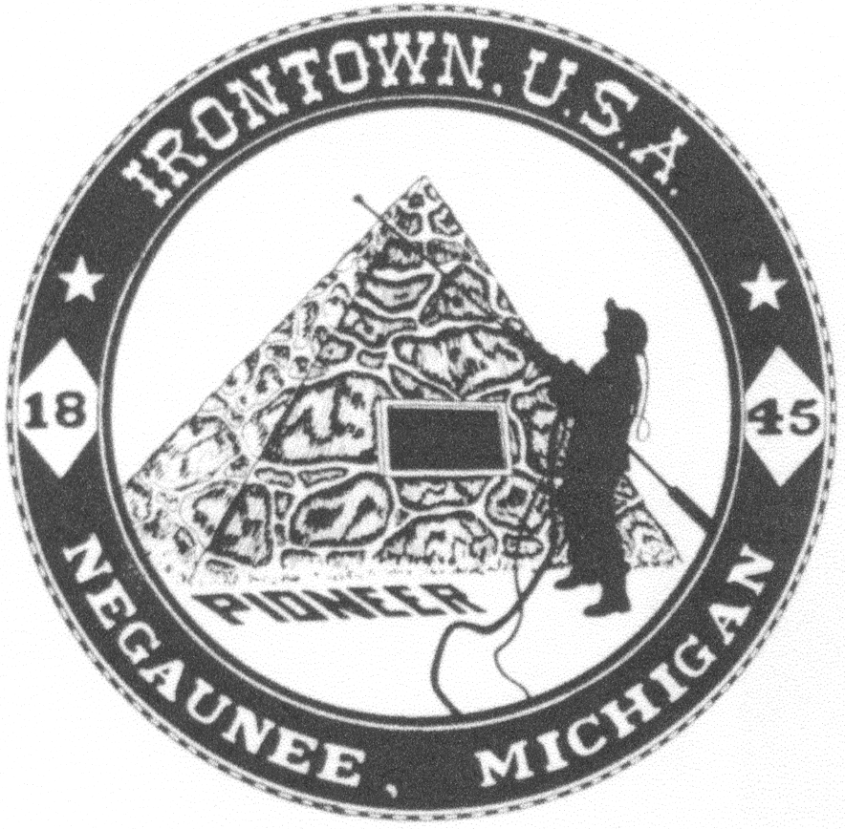
Negaunee Irontown Association

P.O. Box 128 Negaunee, MI 49866 Phone: 906-486-8084
www.negauneeirontown.com

2019 Parade Information Sheet
The Negaunee Irontown Association invites you and/or your organization to participate in this year’s Pioneer Days parade. Any type of entry, large or small, is welcome. To participate, please complete the registration form and return it by June 28th.
THEME: “____________________”

PARADE: Saturday, July 13, 2019
10:30 a.m. line-up time
11:30 a.m. parade start

Please report to any Negaunee Twp. Fireman along the side streets to receive your line-up assignment.

ROUTE: Start at the corner of Iron and Tobin streets Head east on Iron to Pioneer Avenue; North on Pioneer to Main Street; East on Main Street to Brown Avenue; Brown Avenue north to Mitchell Street, where the parade will dissipate.
TROPHY
CATEGORIES: Best Commercial Entry
Best Non-commercial Entry
Best Marching Unit Entry
Best Overall Entry

- NO water guns, water balloons or buckets.
- NO alcoholic beverages
- NO fireworks
- Animal entries MUST provide clean-up
- Performance should not stop flow of the parade
- Late entries will proceed to end of parade and will not be included in parade judging
- We cannot guarantee parade placement

Political candidate entries are encouraged to make a donation.

The parade committee reserves the right to effectively manage the number of entries permitted and to accept or reject any entry it deems unsuitable or not representative of the parade’s purpose and/or theme. Please complete the attached form and return it by June 28, 2019, to Negaunee Irontown Association; P.O. Box 128; Negaunee, MI 49866. Please save this sheet for your reference.
* Late entries are to arrive at 10:30am on Snow St. and will not be included in parade judging. Please see Negaunee Township Fireman for placement.

Negaunee Irontown Association

P.O. Box 128 Negaunee, MI 49866 Phone: 906-486-8084
www.negauneeirontown.com

July 13, 2019, Parade Entry Form

Please provide us with your contact information.

Contact person’s name__ ___________________________

Organization name______________________________

Address_______________________________________

City, State, Zip_____________________________

Phone number_______________E-mail____________________________

Type of Entry—Please circle all that apply.

Truck Truck w/trailer Float Car Multiple cars

Marching Unit Fire truck Multiple fire trucks Walkers

Scooters/bikes Horses/animals Other___________________________________

Will you have music playing from your entry, either instruments or radio/speakers? ___

____________________________________________________________________________

Please list any special requests or needs.

______________________________________________________________________________

______________________________________________________________________________

______________________________________________________________________________

Please return this completed form by June 28, 2019, to
Negaunee Irontown Association; P.O. Box 128; Negaunee, MI 49866
Late entries are to arrive at 10:30am on Snow St and will not be included in parade judging.
Please see Negaunee Township Fireman for placement.

