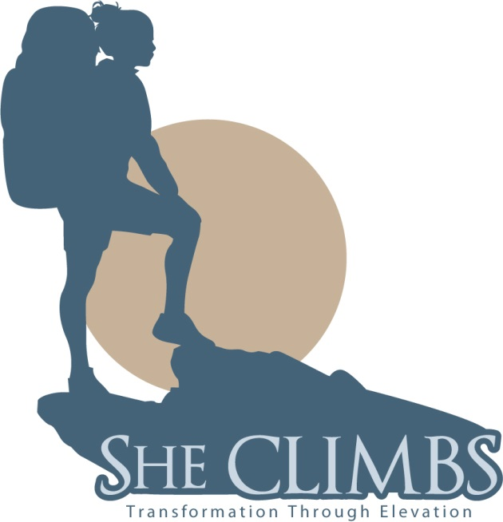

Kilimanjaro Trek 2015

“MACHAME ROUTE”

28th Dec 2015
Upon your arrival at Kilimanjaro international airport, you will meet up with She CLIMBS and Active Kilitop & Safaris (contact info below) representatives who will introduce you the driver and transfer you to the hotel.

29th Dec 2015
This is acclimatization day in Arusha. Clients will have option to walk around the town and wait for the evening briefing of Kilimanjaro and gear check up from the guides.

30th Dec 2015 Overnight: Machame Camp (10, 000 ft)
After breakfast, we depart from our hotel at approximately 8:00 AM for the Machame village where you begin the trek. From the park entrance gate (Machame), you will walk for about two to three hours trek through a dense forest of fig and rubber trees, begonia flowers, and other tropical vegetation. A stop for lunch will be made halfway to this evening's campsite. As you continue your ascent, you will find that the tropical forest has given way to tall grasses and giant heather. You will be walking on a ridge, to the left of which is the Semira stream, and on the right, the Weruweru. Depending on the pace of the climbers, arrival at Machame Camp is usually between 5:00 PM and 6:00 PM. Your camp is set up near to ranger hut.
This initial stage of the climb is tranquil and relatively easy. There is no point in rushing to get to the camp, as there is little to do there. Guides tend to recommend a slow ascent, even at this point, for gradual acclimatization. Do NOT try to keep up with your porters, who will usually bind ahead. Instead, take time to admire the beauty of the rainforest. If you are interested in botany, you should carry a small reference book - Guides are knowledgeable about flora and fauna found on rain forest.

31st Dec 2015 Shira Camp (12,500 ft)
On this and subsequent mornings, wake-up call is at around 6:00 AM. You will be greeted with a steaming cup of tea or coffee, and weather permitting, by a fabulous view of Uhuru peak. Today's trek takes you up a steep track through a savannah of tall grasses, volcanic rock, and bearded heather. You will encounter giant groundsels as you hike through a ghostly landscape of volcanic lava, caves, and foamy streams. Today’s hike will be about six hours in length.

Lunch will be taken just below the Shira Plateau, about three to four hours from Shira Camp. The hike to the next campsite takes approximately six hours and you should arrive between 2:00 PM and 3:00 PM. Most climbers tend to pace themselves, walking slowly and resting about every half-hour. Many will feel lethargic and have headaches by the time they reach camp. Guides advise those with symptoms of altitude sickness to drink tea and sleep a lot and there is no better advice to follow at this stage.

1st Jan 2016: Barranco Camp (13,000 ft)
The entire Shira Plateau greets you this morning with sweeping vistas across to Meru and the Shira Needles. A steady walk takes you up to the pass at Lava Tower (15,000 ft), where you stop to have lunch. Crossing the Bastains stream, you will begin to descend towards Barranco Camp. The descent takes you along an immense canyon called Grand Barranco. Along the way, you will see numerous waterfalls, which are fed, by streams coming from the mountain, converging here to form the Umbwe River. Your camp is set at almost the same altitude as the night before. Today's trek lasts for about six hours and arrival at camp is between 4:30PM and 5:30PM.

2nd Jan 2016: Karanga Camp (13,000 ft)
You will have a bit of real trekking today as you travel along the Barranco Wall; however, this will be a light day (about four hours of trekking) with no increase in elevation to allow you time to rest and adjust to the increasingly higher altitudes.

3rd Jan2016: Barafu Camp (15,200 ft
Another short trek and day of acclimatization as you are near the mountain’s peak. Today’s hike is four to five hours to Barafu Camp. The scenic climb to Barafu is mostly on a moraine with a view of Mawenzi peak towering majestically to the right, and overhead, Kibo peak seemingly just out of reach. The alpine desert terrain encountered at this point is mostly a mineral environment with few lichens and mosses. Lunch will be taken along at Barafu Camp around 2:30PM. You will be encouraged to turn in early this evening as tomorrow will be your longest day.

4th Jan 2016: Ascent to Summit (19,430 ft) / Descent to Mweka camp (10,200ft).
You will be awakened at midnight and after a light breakfast, start your final ascent at around 12:00 AM. It is at this stage that the climb becomes much more difficult. Here, very few will not be suffering from altitude sickness in some form or another; and climbers should carry as little as possible on this portion of the climb. Temperatures will range from -4° to 5° Fahrenheit. Making your way up a path that is flanked by the Ratzel and Rebman glaciers, you will climb for about six hours before reaching the edge of Kilimanjaro crater, between Stella and Hans Meyer points. Another hour of climbing brings you to the summit. Uhuru stands at 19,340 feet and is the highest point on the continent of Africa.
The track around the edge of the crater is rocky and icy concentrate on your feet,follow your guide very closely for this portion of the journey. The descent is no easier than the ascent. You will reach Barafu camp after about three hours (around 11:30 AM). Climbers will be given the opportunity to rest and have some refreshments before continuing to Mweka Camp for the night. Arriving into camp at around 5:00PM, you will have trekked a total of thirteen hours today.

5th Jan 2016: Mweka Camp to the Gate (6000ft).
On the final day of the journey, climbers descend from Mweka camp to the base. The descent to the gate will take approximately 5 hours and climbers usually arrive before noon. Upon arrival at the gate climbers will be rewarded with certificates attesting their success at climbing Mount Kilimanjaro.
After finishing your climb you will be given a hot lunch, before driving back to your Hotel in Arusha, where a warm shower and a comfortable bed will be waiting for you.

6th Jan 2016: Kilimanjaro airport.

You will have full day in Arusha for shopping and transferred to the airport at the evening for the international flight back home.

End of the service.

$2600 She CLIMBS Trek Cost (excluding airfare)

Above cost includes: 3 nights accommodations and meals as stated above, all transfers as per the itinerary, Park fees for both Kilimanjaro and safari driver allowances, guides, cooks and Porters salaries, safety equipment, camping equipment, meals--on mountain, government tax.

Cost excludes: Beverages-off mountain, laundry, day snacks while hiking, all flights, visa, traveler insurance, telephone calls, tips and all other items of personal nature.

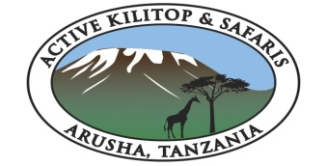

Arusha Office  Mshono  PO Box 16796,  Arusha,Tanzania  Email:  kilitopandsafari@aol.com  kadamun@yahoo.com | (Mobile,)  +255 732979166  +255 787 489448 (Mobile)  America  +17708512949

