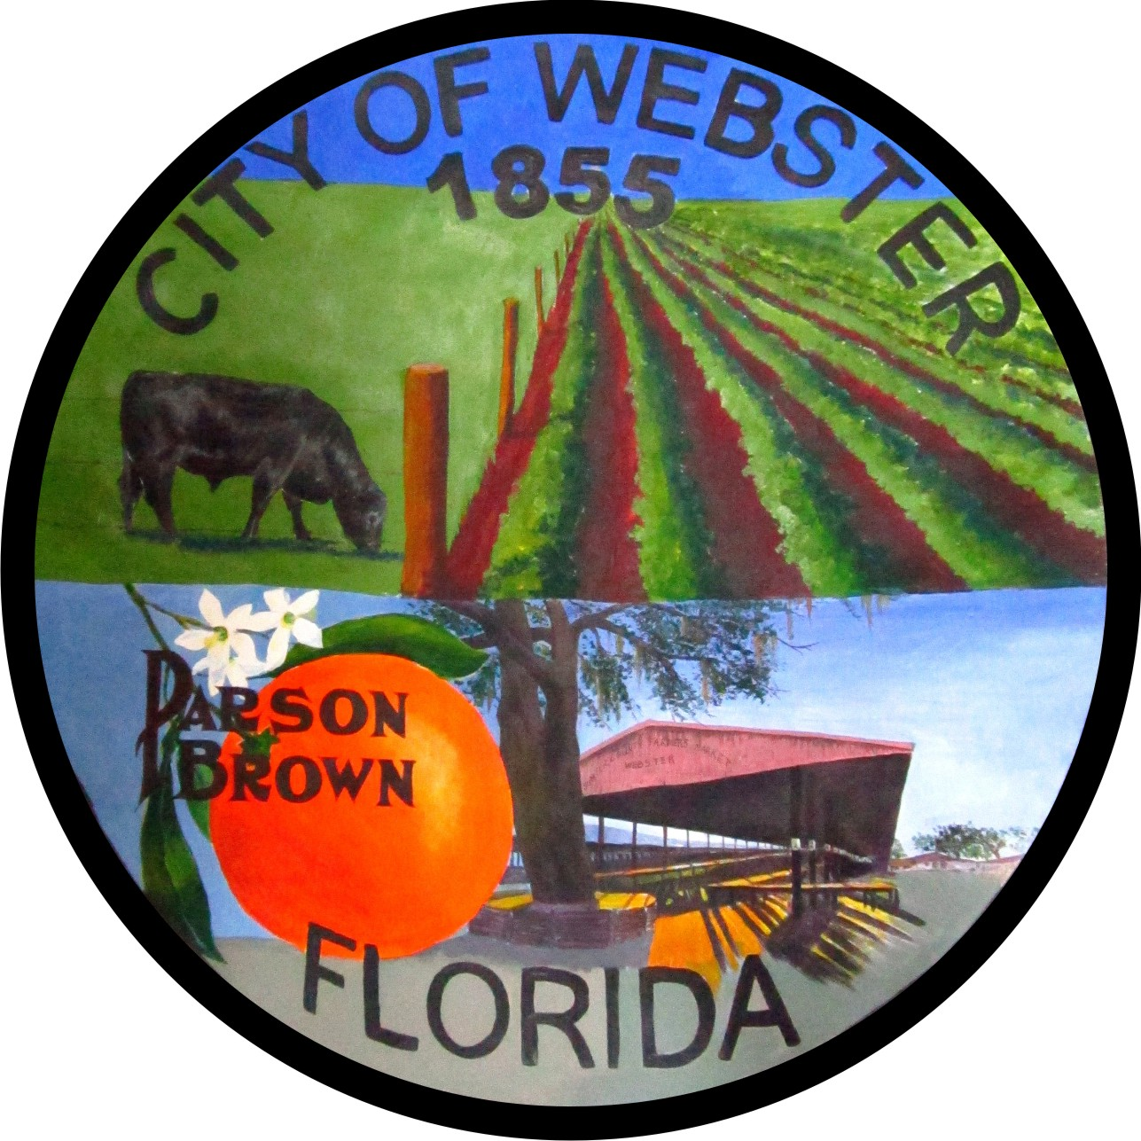

AGENDA
CITY OF WEBSTER
Regular Council Meeting
Webster City Hall, 85 E. Central Avenue
February 16, 2023 - 6:00 P.M.

I. CALL TO ORDER

Pledge of Allegiance, Invocation
Roll Call and Determination of Quorum

Note. All public comment will be limited to 3 minutes per speaker. Anyone wishing to speak during citizen’s forum or on an agenda item must fill out a speaker card and present it to the City Clerk prior to being recognized. All comments will be addressed after all speakers have spoken during citizen’s forum or on a particular agenda item.

II. APPROVAL OF MINUTES

Regular Council Meeting – January 19, 2022
M_______________S_______________ Roll Call Vote

III. CONSENT AGENDA
Proclamation-Better Cities for Pets

IV. CITIZENS FORUM

V. CORRESPONDENCE TO NOTE

Law Enforcement City Newsletter Report

VI. PUBLIC HEARINGS

Second Reading of Ordinance 2023-01 -- Annexation of Parcel ID’s N36-101 and N36-219-John and Alice Wintersteen
M_______________S_______________ Roll Call Vote to Read by Title Only

M_______________S_______________ Roll Call Vote for Approval

Second Reading of Ordinance 2023-02 – Approval of the Webster Unified Comprehensive Plan Amendment
M_______________S_______________ Roll Call Vote to Read by Title Only

M_______________S_______________ Roll Call Vote for Approval

First Reading of Development and Utility Services Agreement-New Strategy Holdings, LLC.

M_______________S_______________ Roll Call Vote to Read by Title Only

M_______________S_______________ Roll Call Vote for Approval

VII. NEW BUSINESS

Parcel Q31B088-Faiz Hoosain-Interest for the City to purchase property.

Dough J’s-Trimming of palm trees-Jermaine Canty

VIII. CITY ATTORNEY’S REPORT AND REQUESTS

IX. MAYOR’S AND COUNCIL MEMBER’S REPORTS AND REQUESTS

X. STAFF REPORTS

Sheriff’s Office Planning and Development Services City Manager

XI. ADJOURNMENT

M___________S_________-Roll Call Vote.

PLEASE NOTE IN ACCORDANCE WITH FLORIDA STATUTE 286.105, ANY PERSON WHO DESIRES TO APPEAL ANY DECISION AT THIS MEETING WILL NEED A RECORD OF THE PROCEEDINGS AND FOR THIS PURPOSE MAY NEED TO ENSURE THAT A VERBATIM RECORD OF THE PROCEEDINGS IS MADE WHICH INCLUDES THE TESTIMONY AND EVIDENCE UPON WHICH THE APPEAL IS BASED. ALSO, IN ACCORDANCE WITH FLORIDA STATUTE 286.26; PERSONS WITH DISABILITIES NEEDING ASSISTANCE TO PARTICIPATE IN ANY OF THE PROCEEDINGS SHOULD CONTACT THE OFFICE OF THE CITY CLERK; 85 E. CENTRAL AVENUE; WEBSTER, FLORIDA; (352) 793-2073; 48 HOURS IN ADVANCE.

