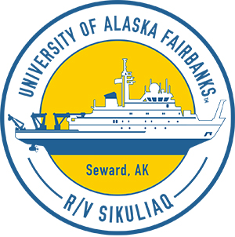
Arctic Shelf Growth, Advection, Respiration and Deposition (ASGARD) Rate Measurements Project
  - Seth Danielson (sldanielson@alaska.edu), University of Alaska Fairbanks, and colleagues

Research questions
- With faster ice retreat, does the ecosystem redistribute the spring bloom’s biomass into different parts of the food web?
- Will the food available for seals, whales, and walrus remain the same or change?

Why we should care
How the Bering Sea and Chukchi Sea ecosystem and food webs function and how they might respond to a changing climate is important because communities rely on these marine resources for subsistence. This research will help us better understand reasons for future changes in abundance and location of subsistence food items.

What we will measure
We will measure water physics (currents, temperature, salinity, light), chemistry (nutrients), microbes, plankton, mud, fish, seafloor invertebrates, marine mammals, and birds. We will study how quickly animals and plants consume food and how fast these items are replenished.

General 2018 cruise plan
Process stations (yellow squares) will be occupied from south to north. Survey stations (black dots) will then be occupied from north to south. We will service moorings (stars) that were deployed in 2017.

Timeline
June 1: Depart Seward
June 6–12: Northern Bering Sea
June 13–21: Southern Chukchi Sea between Bering Strait and Cape Lisburne
June 21–24: Northern Bering Sea
June 24: Arrive at Nome
Provisional dates are noted on the map at left. Dates and locations are subject to change based on weather, ice, or subsistence activities.

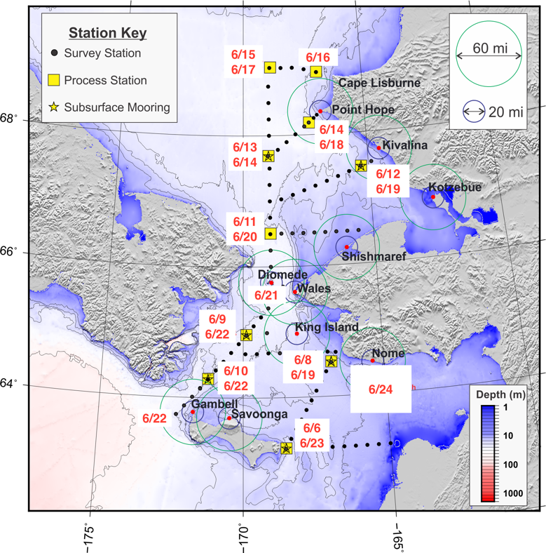
Cruise track

Daily science updates and additional information
We will have a community observer on board as part of our science party. Daily updates will be sent out by the Sikuliaq Second Mate and the bridge will radio the vessel’s position and course every six hours. Let Seth Danielson know at sldanielson@alaska.edu if you want to be on the email list. The project will be on Facebook and Instagram and will have a blog.

