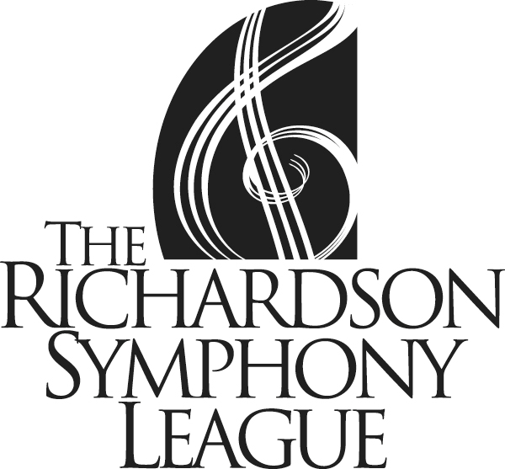

Obligations:
Parent/Sponsor Requirements

- Must attend/work:
  - Four general meetings of the RSL
  - Chaperone one RSO concert and Deb/HG service project
  - Serve on a Ball committee
  - Contribute at least once to a hospitality event such as RSO rehearsal lunch, senior tea, Young Artist competition, etc.)

Expenses:
- Membership dues $150
- Purchase “Friends of the League” byline ad (in
the ball program) $50
- Purchase minimum of one Ball ticket $125 - 150
- Solicit advertising, goods or services for the
Ball Auction $100
- Nametag $10
- Purchase one season subscription, or the equivalent, to the Richardson Symphony
during annual Orientation Meeting Price Varies

