RSAI 2023 Legislative Priority:
Opportunity Equity for High-Poverty Students
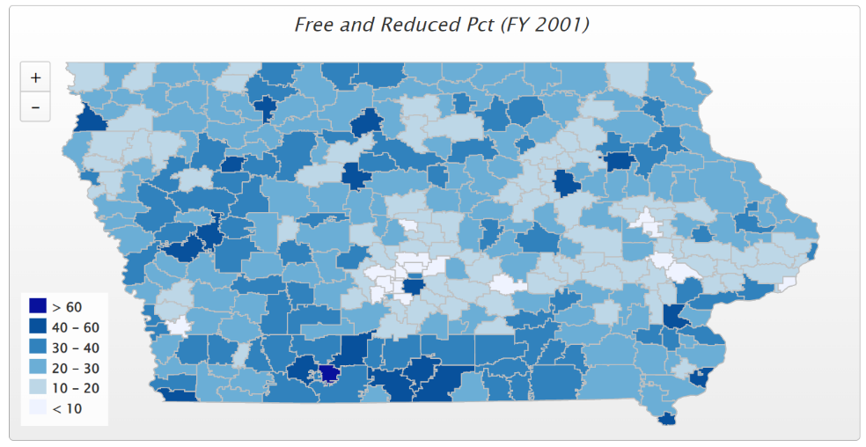
Background: Iowa’s funding formula does not sufficiently recognize poverty as a driver of at-risk student programing.
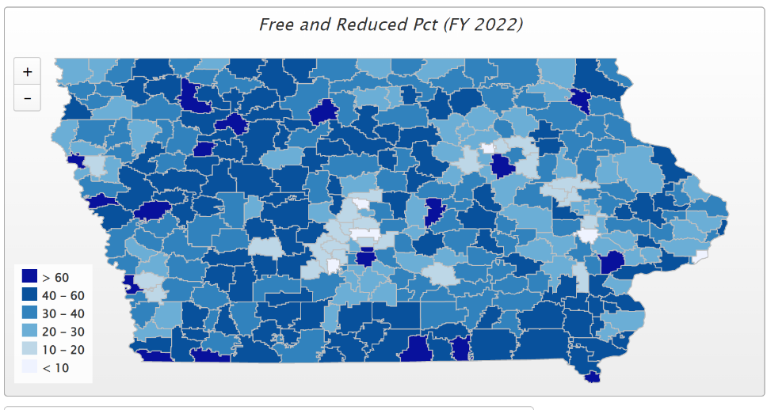
2001 Statistics: 27% of students were eligible for Free/ Reduced Price Lunch (FRPL). Only 6 districts had more than 50% of students eligible for FRPL. Of those 6, Waterloo was the only urban district, the others were Keokuk, East Monona, Fox Valley, Wayne and Diagonal, which was the state high at 60.2% or students on FRPL.
2022 Statistics: 40.7% of students were eligible for FRPL (2022 enrollment may be understated with free lunch temporarily available to all students due to COVID-19 federal directives). Of the 63 districts with more than half of their students on FRPL, only 19 are urban, leaving 54 rural. 18 districts have more than 60% of students eligible for FRPL. Districts above 70% include Postville, Storm Lake, Council Bluffs, Waterloo, South Page, Hamburg, and Des Moines, which was the state high of 77.8%.
Legislative Status: The December 2019 School Finance Interim Committee passed a unanimous and bipartisan recommendation to study the impact of poverty on educational outcomes. The study was directed to review other states’ formulas that provide resources for students from low-income families which are showing successful student achievement outcomes for at-risk students. HF 2490 Poverty Weighting Study was approved with strong bipartisan support in the House Education Committee in the 2020 Session, but the issues have received no action since. This bill serves as a good starting point for continued conversation.
Funding for At-risk in Iowa is not aligned to poverty. Dropout Prevention funding is based on total enrollment, not the percentage of students at-risk. Although flexibility for the use of DoP funds has been expanded, DoP capacity is still limited to 2.5% of the total regular program district cost or up to 5% of regular program district cost based on historical practice.

Current Reality: In FY 2022, 40.7% of students, or 195,760 children, were FRPL eligible, according to the Iowa Department of Education’s reporting.
- Poverty is now found throughout the state. It is indeed a rural challenge. The previous page’s map’s darkest color shows districts with 60% or more of enrolled students eligible for FRPL.
- Iowa’s funding for at-risk and dropout prevention is less than 10% funding commitment for students in poverty, well short of the national average 29% beyond the base for low-income students. (AIR, Study of a new Method of Funding for Public Schools in Nevada, Sept. 2012)
- Students from low-income families are more likely to begin school academically behind, exhibit nonproficient literacy skills, especially in early elementary, and fall further behind over summer breaks unless schools have the resources, staff and programs to meet their needs.
- Low-income rural students are an important piece of Iowa’s workforce puzzle, will stay in Iowa, and either be the backbone of rural communities’ potential or a drain on future resources.
- Districts must waive fees for FRPL-eligible families, meaning districts with concentrated poverty have fewer resources for textbooks and drivers’ education, further stressing the general fund.
- High-poverty School Investments boost achievement. Education Week, Student Outcomes: Does More Money Really Matter? Fresh research bolsters the case for K-12 cash—and a rough road without it, Daarel Burnette II, June 4, 2019 reports: "More money does, in fact, make a difference, they (researchers) say—provided that you spend enough, and in the right manner. They point to research in the past five years that provides examples of instances where politicians and taxpayers invested more money in teacher salaries, school construction, and schools with high populations of low-income students and saw students’ test scores jump.”
- The McCourt School of Public Policy, Georgetown, FutureEd, State Education Funding; The Poverty Equation, March 2020, states, “What’s more, when poverty is concentrated in a school—that is, when a significant portion of students in a school come from low-income households—the impact on performance is compounded. A body of research suggests that there is a ‘tipping point,’ somewhere between 50 to 60 percent of a school’s students living in poverty, where performance for all students there drastically declines.”

Opportunity Equity: resources based on at-risk need, in addition to enrollment. All school boards should have the opportunity to access up to 5% dropout prevention funding. School districts should be granted spending authority for FRPL waived fees. Iowa should study the impact of poverty on educational outcomes and best practices of other states in closing associated achievement gaps, leading toward a significant and urgent update to Iowa’s School Foundation Formula in funding programs for Iowa’s neediest students. Investments in programs for at-risk students prepare them for full participation in the workforce, improve school safety for all students, minimize tax increases to remediate social costs later and improve outcomes for students and families.

