During the game of soccer, the ball travels many miles, being kicked off of players’ feet, hit off players’ heads, bounced off goal posts, and more! But when is the ball actually considered out of play? Let’s find out!

The ball is considered out of play when it has wholly crossed the goal line or touch line whether on the ground or in the air, or play has been stopped by the referee.

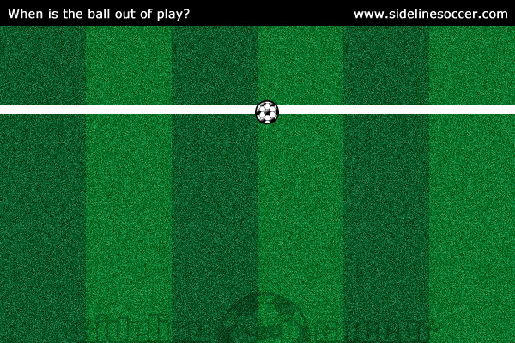

In the above diagram, the ball is still in play because it has not fully crossed over the touch line.

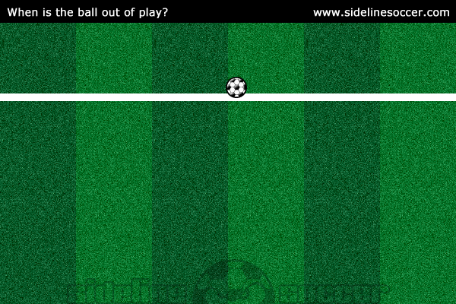

In the above diagram, the ball is still in play because it has not fully crossed the touch line.

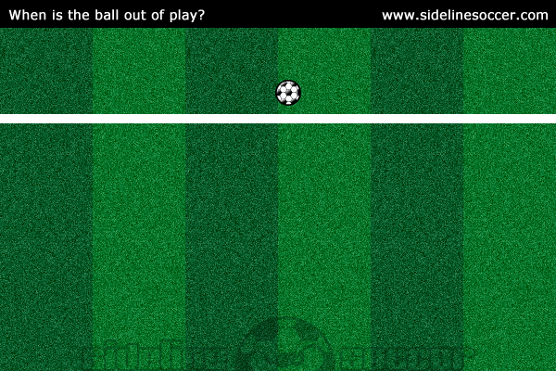

In the above diagram, the ball is now considered out of play because it fully crossed the touch line.

If a ball rebounds off a goal post, crossbar, corner flag, or referee and stays within the field, meaning it doesn’t fully cross a goal line or touch line, then it is considered in play.